OpenCellular - Connect1  GBC Test Specifications | Version 1.0

History.
SL no | Date | Version | Author | Comments
1 | February 9th, 2017 | 1.0 | OpenCellular Team | First Release

Contents
List of Figures 5
List of Tables 6
1. Purpose and Scope 14
2. Abbreviation 15
3. Front Panel Sub-system 16
3.1 Test Purpose and Description 16
3.2 Front Panel Sub-system constitutes of below components 16
3.2.1 Solar Supply Input 16
3.2.2 Auxiliary Supply input 21
3.2.3 PoE IN 25
3.2.4 PoE – Data 30
3.2.5 Protection 32
4. Power Sub-system 38
4.1 Test Purpose and Description 38
4.2 Power Sub-system constitutes of below components 38
4.2.1 PoE 39
4.2.2 Isolated DC-DC 46
4.2.3 Lead Acid Battery 50
4.2.4 Lithium Ion Battery 63
4.2.5 Buck-Boost 76
4.2.6 TIVA power supply 85
4.2.7 FET Switch 91
4.2.8 PMIC 96
4.2.9 System Power sequence 103
5. CPU Sub-system 110
5.1 Test Purpose and Description 110
5.2 CPU Sub-system constitutes of below components 110
5.2.1 Intel Atom 111
5.2.2 PMIC – I2C (IDTP9145_R1P15) 117
5.2.3 DDR - SMB (TS512MSK64W6H-I) 123
5.2.4 PCU – SMB (ADT7481) 129
5.2.5 Springville 1 – MDI 135
5.2.6 TIVA - UART 140
5.2.7 Memory - DDR 144
5.2.8 Memory SPI NOR Flash 152
5.2.9 Storage - mSATA 156
5.2.10 Springville1 - PCIe 160
5.2.11 Springville2 - PCIe 163
5.2.12 TRXFE - GPIO 166
5.2.13 TIVA - GPIO 171
5.2.14 TRXFE – FX3 – USB2.0 176
5.2.15 TRXFE – FX3 – USB3.0 182
5.2.16 Debug USB2.0 186
5.2.17 Debug USB3.0 188
5.2.18 Debug Ethernet 190
5.2.19 Display - HDMI 192
5.2.20 Debug - UART 194
5.2.21 RFSDR – PCIe 196
6. TIVA 198
6.1 Test Purpose and Description 198
6.2 TIVA Sub-system constitutes of below components 198
6.2.1 TIVA 199
6.2.2 PSE – I2C (LTC4274AIUHF) 203
6.2.3 Power Monitor – I2C (INA226) 209
6.2.4 RF-SDR board – I2C (PCA9557PW, 118) 215
6.2.5 Temp Sensor – I2C (SE98ATP, 547) 221
6.2.6 Sync board – I2C (PCA9557PW, 118) 227
6.2.7 LED board – I2C (SX1509BIULTRT) 233
6.2.8 TIVA GPIO 239
6.2.9 TIVA GPIO 241
6.2.10 ETH SW MGMT Interface 243
7. Ethernet 245
7.1 Test Purpose and Description 245
7.2 Ethernet Sub-system constitutes of below components 245
7.2.1 PoE (PD) - MDI 245
7.2.2 TIVA Ethernet 249
8. Clock 253
8.1 Test Purpose and Description 253
8.2 Clock Sub-system constitutes of below components 253
8.2.1 Clock Sources 254
8.2.2 PCIe - GBE clock 258
8.2.3 40 MHz - GPSDO clock 263
8.2.4 HDMI clock 269
8.2.5 GPS – 1pps clock 273

List of Figures
Figure 1. Solar Supply Input - Test Setup Diagram 16
Figure 2. Auxiliary Supply Input - Test Setup Diagram 21
Figure 3. PoE IN - Test Setup Diagram 25
Figure 4. Protection - Test Setup Diagram 32
Figure 5. PoE- Test Setup Diagram 39
Figure 6. Isolated DC-DC - Test Setup Diagram 46
Figure 7. Lead Acid battery - Test Setup Diagram 50
Figure 8. Lithium Ion battery - Test Setup Diagram 63
Figure 9. Buck-Boost - Test Setup Diagram 76
Figure 10. TIVA power supply - Test Setup Diagram 85
Figure 11. FET Switch - Test Setup Diagram 91
Figure 12. PMIC - Test Setup Diagram 96
Figure 13. System Power sequence - Test Setup Diagram 103
Figure 14. Reset - Test Setup Diagram 107
Figure 15. Intel Atom - Test Setup Diagram 111
Figure 16. PMIC I2C - Test Setup Diagram 118
Figure 17. DDR SMB- Test Setup Diagram 123
Figure 18. PCU SMB- Test Setup Diagram 129
Figure 19.INTEL Springville 1 MDI - Test Setup Diagram 136
Figure 20.TIVA UART- Test Setup Diagram 140
Figure 21. Memory DDR - Test Setup Diagram 144
Figure 22. Memory SPI NOR Flash - Test Setup Diagram 152
Figure 23. Storage mSATA- Test Setup Diagram 156
Figure 24. SpringVille1 – PCIe- Test Setup Diagram 160
Figure 25. SpringVille2 – PCIe- Test Setup Diagram 163
Figure 26. TRXFE GPIO - Test Setup Diagram 166
Figure 27. TIVA GPIO - Test Setup Diagram 171
Figure 28. TRXFE FX3 USB2.0 - Test Setup Diagram 176
Figure 29. TRXFE – FX3 – USB3.0 - Test Setup Diagram 182
Figure 30. Debug USB2.0 - Test Setup Diagram 186
Figure 31. Debug USB3.0 - Test Setup Diagram 188
Figure 32. Debug Ethernet - Test Setup Diagram 190
Figure 33. Display HDMI - Test Setup Diagram 192
Figure 34. Debug UART - Test Setup Diagram 194
Figure 35. RFSDR – PCIe- Test Setup Diagram 196
Figure 36. TIVA - Test Setup Diagram 199
Figure 37. PSE I2C -- Test Setup Diagram 203
Figure 38. Power Monitor I2C - Test Setup Diagram 209
Figure 39. RF-SDR board I2C - Test Setup Diagram 215
Figure 40. Temp Sensor I2C - Test Setup Diagram 221
Figure 41. Sync board I2C - Test Setup Diagram 228
Figure 42. LED board I2C - Test Setup Diagram 233
Figure 43. TIVA GPIO - Test Setup Diagram 239
Figure 44. TIVA GPIO - Test Setup Diagram 241
Figure 45.INTEL POE (PD) - MDI - Test Setup Diagram 245
Figure 46.TIVA Ethernet - Test Setup Diagram 249
Figure 47. Clock Sources - Test Setup Diagram 254
Figure 48. PCIe – GBE Clock - Test Setup Diagram 258
Figure 49. 40 MHz GPSDO– Clock - Test Setup Diagram 264
Figure 50. HDMI– Clock - Test Setup Diagram 269
Figure 51. GPS 1pps Clock - Test Setup Diagram 273

List of Tables

Table 1. Impact of Failure – Solar Voltage Accuracy 17
Table 2. Measurement Locations – Solar Voltage Accuracy 17
Table 3. Test Condition – Solar Voltage Accuracy 18
Table 4. Requirements – Solar Voltage Accuracy 18
Table 5. Impact of Failure – Solar Input Voltage Range 19
Table 6. Measurement Locations – Solar Input Voltage Range 19
Table7. Test Condition – Solar Input Voltage Range 20
Table 8. Requirements – Solar Input Voltage Range 20
Table 9. Impact of Failure – auxiliary Voltage Accuracy 21
Table 10. Measurement Locations – auxiliary Voltage Accuracy 22
Table 11. Test Condition – auxiliary Voltage Accuracy 22
Table 12. Requirements – Auxiliary Voltage Accuracy 23
Table 13. Impact of Failure – Auxiliary Input Voltage Range 23
Table 14. Measurement Locations – auxiliary Input Voltage Range 24
Table 15. Test Condition – auxiliary Input Voltage Range 24
Table 16. Requirements – auxiliary Input Voltage Range 25
Table 17. Impact of Failure – Voltage Accuracy 26
Table 18. Measurement Locations – Voltage Accuracy 26
Table 19. Test Condition – Voltage Accuracy 27
Table 20. Requirements – Voltage Accuracy 27
Table 21. Impact of Failure – Input Supply Range 28
Table 22. Measurement Locations – Input Supply Range 28
Table 23. Test Condition – Input Supply Range 29
Table 24. Requirements – Input Supply Range 29
Table 25. Impact of Failure – Voltage Limit Accuracy 32
Table 26. Measurement Locations – Voltage Limit Accuracy 33
Table 27. Test Condition – Voltage Limit Accuracy 33
Table 28. Requirements – Voltage Limit Accuracy 34
Table 29. Impact of Failure – Solar AUX Present test 35
Table 30. Measurement Locations – Solar AUX Present test 35
Table 31. Test Condition – Solar AUX Present test 35
Table 32. Requirements – Solar AUX Present test 36
Table 33. Impact of Failure – Protection Limit 36
Table 34. Measurement Locations – Protection Limit 37
Table 35. Test Condition – Protection Limit 37
Table 36. Requirements – Protection Limit 38
Table 37. Impact of Failure – Ripple Measurement 39
Table 38. Measurement Locations – Ripple Measurement 40
Table 39. Test Condition – Ripple Measurement 40
Table 40. Requirements – Ripple Measurement 40
Table 41. Impact of Failure – Supply Present Check 41
Table 42. Measurement Locations – Supply Present Check 41
Table 43. Test Condition – Supply Present Check 42
Table 44. Requirements – Supply Present Check 42
Table 45. Impact of Failure – Data Transfer Validation 43
Table 46. Test Condition – Data Transfer Validation 44
Table 47. Impact of Failure of PoE Power delivery 44
Table 48. Test Condition – PoE Power delivery 45
Table 49. Requirements – PoE Power delivery 45
Table 50. Impact of Failure – Output Voltage Accuracy 47
Table 51. Measurement Locations – Output Voltage Accuracy 47
Table 52. Test Condition – Output Voltage Accuracy 47
Table 53. Requirements – Output Voltage Accuracy 48
Table 54. Impact of Failure – Output Voltage Accuracy 48
Table 55. Measurement Locations – Output Voltage Accuracy 49
Table 56. Test Condition – Output Voltage Accuracy 49
Table 57. Requirements – Output Voltage Accuracy 50
Table 58. Impact of Failure – Lead Acid battery 51
Table 59. Measurement Locations – Lead Acid Battery Output Voltage Accuracy 51
Table 60. Test Condition – Lead Acid Battery Output Voltage Accuracy 52
Table 61. Requirements - Lead Acid Battery Output Voltage Accuracy 52
Table 62. Test Condition – Lead Acid Battery Charge Current Measurement 53
Table 63. Test Condition – Lead Acid Battery Load Current Measurement 55
Table 64. Measurement Locations – Lead Acid battery LDO Output Voltage 56
Table 65. Test Condition – Lead Acid battery LDO Output Voltage 56
Table 66. Requirements – – Lead Acid battery LDO Output Voltage 56
Table 67. Measurement Locations – Lead acid battery charger temperature measurement 57
Table 68. Test Condition – Lead acid battery charger temperature measurement 58
Table 69. Requirements – Lead acid battery charger temperature 58
Table 70. Test Condition – Lead acid battery charger Charge Control measurement 59
Table 71. Requirements – Lead acid battery charger Charge Control measurement 59
Table 72. Measurement Locations – Battery OR-ing Circuit 60
Table 73. Test Condition – Battery OR-ing Circuit 60
Table 74. Requirements – Battery OR-ing Circuit 61
Table 75. Impact of Failure of Lead acid battery charger - Power delivery 61
Table 76. Test Condition – Lead acid battery charger - Power delivery 62
Table 77. Requirements – Lead acid battery charger - Power delivery 62
Table 78. Failure Impact – Lithium Ion Battery Output Voltage Accuracy 63
Table 79. Measurement Locations – Lithium Ion Battery Output Voltage Accuracy 64
Table 80. Test Condition – Lithium Ion Battery Output Voltage Accuracy 64
Table 81. Requirements – Lithium Ion Battery Output Voltage Accuracy 64
Table 82. Test Condition – Lithium Ion Battery Output Voltage Accuracy 66
Table 83. Test Condition – Lithium Ion Battery Load Current Measurement 67
Table 84. Measurement Locations – Lithium Ion Charger LDO Output Voltage 68
Table 85. Test Condition – Lithium Ion Charger LDO Output Voltage 68
Table 86. Requirements – Lithium Ion Charger LDO Output Voltage 69
Table 87. Measurement Locations – Lithium Ion battery charger temperature measurement 69
Table 88. Test Condition – Lead acid battery charger temperature measurement 70
Table 89. Requirements – Lead acid battery charger temperature measurement Test 70
Table 90. Test Condition – Lithium Ion battery charger temperature measurement 71
Table 91. Requirements – Lithium Ion battery charger temperature measurement 71
Table 92. Measurement Locations – Battery OR-ing Circuit 72
Table 93. Test Condition – Battery OR-ing Circuit 73
Table 94. Requirements – Battery OR-ing Circuit 73
Table 95. Test Condition – Lithium Ion Battery Charge Time Measurement 74
Table 96. Impact of Failure of Lithium Ion Battery charger - Power delivery 75
Table 97. Test Condition – Lithium Ion Battery charger - Power delivery 75
Table 98. Requirements – Lithium Ion Battery charger - Power delivery 76
Table 99. Impact of Failure of line regulation 77
Table 100. Test Condition for line regulation 78
Table 101. Requirements for line regulation 78
Table 102. Impact of Failure of load regulation 79
Table 103. Test Condition for load regulation 79
Table 104. Requirements for load regulation 80
Table 105. Impact of Failure of Ripple measurement 80
Table 106. Test Condition for ripple measurement 81
Table 107. Requirements for ripple measurement 81
Table 108. Impact of Failure of load current measurement 82
Table 109. Test Condition for load current measurement 83
Table 110. Requirements for load current measurement 83
Table 111. Impact of Failure of Temperature measurement 84
Table 112. Test Condition for temperature measurement 84
Table 113. Requirements for temperature measurement 85
Table 114. Impact of Failure of ripple measurement 86
Table 115. Test Condition for ripple measurement 87
Table 116. Requirements for ripple measurement 87
Table 117. Impact of Failure of Load current measurement 88
Table 118. Test Condition for Load current measurement 88
Table 119. Requirements for Load current measurement 89
Table 120. Impact of Failure of Temperature measurement 89
Table 121. Test Condition for temperature measurement 90
Table 122. Requirements for temperature measurement 90
Table 123. Impact of Failure of Ripple measurement 91
Table 124. Test Condition for Ripple measurement 92
Table 125. Requirements for Ripple measurement 92
Table 126. Impact of Failure of Load current measurement 93
Table 127. Test Condition for Load current measurement 94
Table 128. Requirements for Load current measurement 94
Table 129. Impact of Failure of Temperature measurement 94
Table 130. Test Condition for temperature measurement 95
Table 131. Requirements for temperature measurement 95
Table 132. Impact of Failure of Voltage accuracy of all output voltages 97
Table 133. Test Condition for Voltage accuracy of all output voltages 97
Table 134. Requirements for Voltage accuracy of all output voltages 98
Table 135. Impact of Failure of Secondary supplies enable functionality 99
Table 136. Test Condition for Secondary supplies enable functionality 99
Table 137. Requirements for Secondary supplies enable functionality 100
Table 138. Impact of Failure of PMIC debug circuit functionality 101
Table 139. Test Condition for PMIC debug circuit functionality 101
Table 140. Requirements for PMIC debug circuit functionality 102
Table 141. Impact of Failure of Power-up Sequence 103
Table 142. Test Condition for Power-up Sequence 104
Table 143. Requirements for Power-up Sequence 104
Table 144. Impact of Failure of Power-down Sequence 105
Table 145. Test Condition for Power-down Sequence 106
Table 146. Requirements for Power-down Sequence 106
Table 147. Impact of Failure of Soft Reset 107
Table 148. Test Condition for Soft Reset 108
Table 149. Requirements for Soft Reset 108
Table 150. Impact of Failure of Hard Reset 109
Table 151. Test Condition for Hard Reset 109
Table 152. Requirements for Hard Reset 110
Table 153. Impact of Failure of Boot Configuration 112
Table 154. Test Condition for Boot Configuration 112
Table 155. Impact of Failure of Power-on sequence – Intel Atom 113
Table 156. Test Condition for Power-on sequence – Intel Atom 114
Table 157. Requirements for Power-on sequence – Intel Atom 114
Table 158. Impact of Failure of Power-down sequence – Intel Atom 116
Table 159. Test Condition for Power-down sequence – Intel Atom 116
Table 160. Requirements for Power-down sequence – Intel Atom 117
Table 161. Impact of Failure of EV – PMIC I2C 118
Table 162. Test Condition for EV – PMIC I2C 119
Table 163. Requirements for EV – PMIC I2C 119
Table 164. Impact of Failure of SI – PMIC I2C 120
Table 165. Test Condition for SI – PMIC I2C 121
Table 166. Requirements for SI – PMIC I2C 121
Table 167. Impact of Failure of FV – PMIC I2C 122
Table 168. Test Condition for FV – PMIC I2C 122
Table 169. Requirements for FV – PMIC I2C 123
Table 170. Impact of Failure of EV – DDR SMB 124
Table 171. Test Condition for EV – DDR SMB 124
Table 172. Requirements for EV – DDR SMB 125
Table 173. Impact of Failure of SI – DDR SMB 126
Table 174. Test Condition for SI – DDR SMB 127
Table 175. Requirements for SI – DDR SMB 127
Table 176. Impact of Failure of FV – DDR SMB 128
Table 177. Test Condition for FV – DDR SMB 128
Table 178. Requirements for FV – DDR SMB 129
Table 179. Impact of Failure of EV – PCU SMB 130
Table 180. Test Condition for EV – PCU SMB 130
Table 181. Requirements for EV – PCU SMB 131
Table 182. Impact of Failure of SI – PCU SMB 132
Table 183. Test Condition for SI – PCU SMB 133
Table 184. Requirements for SI – PCU SMB 133
Table 185. Impact of Failure of FV – PCU SMB 134
Table 186. Test Condition for FV – PCU SMB 135
Table 187. Requirements for FV – PCU SMB 135
Table 188. Impact of Failure of SI – Springville 1 MDI 136
Table 189. Test Condition for SI – Springville 1 MDI 137
Table 190. Requirements for SI – Springville 1 MDI 137
Table 191. Impact of Failure of FV – Springville 1 MDI 138
Table 192. Test Condition of FV – Springville 1 MDI 139
Table 193. Requirements for FV – Springville 1 MDI 139
Table 194. Impact of Failure of SI – TIVA UART 140
Table 195. Test Condition for SI – TIVA UART 141
Table 196. Requirements for SI – TIVA UART 142
Table 197. Impact of Failure of FV – TIVA UART 142
Table 198. Test Condition for FV – TIVA UART 143
Table 199. Requirements for FV – TIVA UART 143
Table 200. Impact of Failure of Reference voltage measurement – Memory DDR 145
Table 201. Test Condition for Reference voltage measurement – Memory DDR 145
Table 202. Requirements for Reference voltage measurement – Memory DDR 146
Table 203. Impact of Failure of Schmoo Test – Memory DDR 146
Table 204. Test Condition for Schmoo Test – Memory DDR 147
Table 205. Requirements for Schmoo Test – Memory DDR 148
Table 206. Impact of Failure of FV – Memory DDR 149
Table 207. Test Condition for FV – Memory DDR 150
Table 208. Requirements for FV – Memory DDR 150
Table 209. Impact of Failure of Throughput measurement – Memory DDR 151
Table 210. Test Condition for Throughput measurement – Memory DDR 151
Table 211. Impact of Failure of EV – Memory SPI NOR Flash 153
Table 212. Test Condition for EV – Memory SPI NOR Flash 153
Table 213. Requirements for EV – Memory SPI NOR Flash 154
Table 214. Impact of Failure of SI – Memory - SPI NOR Flash 154
Table 215. Test Condition for SI – Memory - SPI NOR Flash 155
Table 216. Requirements for SI – Memory - SPI NOR Flash 156
Table 217. Impact of Failure of SI – Storage mSATA 157
Table 218. Test Condition for SI – Storage mSATA 158
Table 219. Requirements for SI – Storage mSATA 158
Table 220. Impact of Failure of I/O Stress – Storage mSATA 159
Table 221. Test Condition for I/O Stress – Storage mSATA 159
Table 222. Requirements for I/O Stress – Storage mSATA 160
Table 223. Impact of Failure – Springville1 – PCIe Lane1 161
Table 224. Measurement Locations – Transmitter Springville1 – PCIe Lane1 161
Table 225. Measurement Locations – Receiver Springville1 – PCIe Lane1 161
Table 226. Test Condition – Springville1 – PCIe Lane1 162
Table 227. Impact of Failure – Springville2 – PCIe Lane2 164
Table 228. Measurement Locations – Transmitter Springville2 – PCIe Lane2 164
Table 229. Measurement Locations – Receiver Springville2 – PCIe Lane2 164
Table 230. Test Condition – Springville2 – PCIe Lane2 165
Table 231. Impact of Failure of Control outputs FV – TRXFE GPIO 167
Table 232. Test Condition for Control outputs FV – TRXFE GPIO 168
Table 233. Requirements for Control outputs FV – TRXFE GPIO 168
Table 234. Impact of Failure of SI – TRXFE GPIO 168
Table 235. Test Condition for SI – TRXFE GPIO 169
Table 236. Requirements for SI – TRXFE GPIO 170
Table 237. Impact of Failure of Control inputs FV – TIVA GPIO 171
Table 238. Test Condition for Control inputs FV – TIVA GPIO 172
Table 239. Requirements for Control inputs FV – TIVA GPIO 172
Table 240. Impact of Failure of Control outputs FV – TIVA GPIO 173
Table 241. Test Condition for Control outputs FV – TIVA GPIO 174
Table 242. Requirements for Control outputs FV – TIVA GPIO 174
Table 243. Impact of Failure of SI – TIVA GPIO 174
Table 244. Test Condition for SI – TIVA GPIO 175
Table 245. Requirements for SI – TIVA GPIO 176
Table 246. Impact of Failure of EV – TRXFE FX3 USB2.0 177
Table 247. Test Condition for EV – TRXFE FX3 USB2.0 178
Table 248. Impact of Failure of Throughput measurement – USB 2.0 179
Table 249. Test Condition for Throughput measurement – USB 2.0 179
Table 250. Requirements for Throughput measurement – USB 2.0 179
Table 251. Impact of Failure of TRXFE – FX3 – USB2.0 180
Table 252. Test Condition for FV – TRXFE – FX3 – USB2.0 181
Table 253. Requirements for FV – TRXFE – FX3 – USB2.0 181
Table 254. Impact of Failure of Throughput measurement – USB 3.0 182
Table 255. Test Condition for Throughput measurement – USB 3.0 183
Table 256. Requirements for Throughput measurement – USB 3.0 183
Table 257. Impact of Failure of TRXFE – FX3 – USB3.0 184
Table 258. Test Condition for FV – TRXFE – FX3 – USB3.0 185
Table 259. Requirements for FV – TRXFE – FX3 – USB3.0 185
Table 260. Impact of Failure of Debug USB2.0 186
Table 261. Test Condition for FV – Debug USB2.0 187
Table 262. Requirements for FV – Debug USB2.0 187
Table 263. Impact of Failure of Debug USB3.0 188
Table 264. Test Condition for FV – Debug USB3.0 189
Table 265. Requirements for FV – Debug USB3.0 189
Table 266. Impact of Failure of Debug Ethernet 190
Table 267. Test Condition for FV – Debug Ethernet 191
Table 268. Requirements for FV – Debug Ethernet 191
Table 269. Impact of Failure of FV – Display HDMI 192
Table 270. Test Condition for FV – Display HDMI 193
Table 271. Requirements for FV – Display HDMI 193
Table 272. Impact of Failure of FV – Debug UART 194
Table 273. Test Condition for FV – Debug UART 195
Table 274. Requirements for FV – Debug UART 195
Table 275. Impact of Failure – Transmitter RFSDR – PCIe Lane0 197
Table 276. Measurement Locations – Transmitter RFSDR – PCIe Lane0 197
Table 277. Test Condition – Transmitter RFSDR – PCIe Lane0 197
Table 278. Impact of Failure of TIVA Configuration 199
Table 279. Test Condition for TIVA Configuration 200
Table 280. Impact of Failure of System Reset sequence 201
Table 281. Test Condition for System Reset sequence 202
Table 282. Requirements for System Reset sequence 202
Table 283. Impact of Failure of EV – PSE I2C 203
Table 284. Test Condition for EV– PSE I2C 204
Table 285. Requirements for EV– PSE I2C 205
Table 286. Impact of Failure of SI – PSE I2C 205
Table 287. Test Condition for SI – PSE I2C 206
Table 288. Requirements for SI – PSE I2C 207
Table 289. Impact of Failure of FV – PSE I2C 207
Table 290. Test Condition for FV – PSE I2C 208
Table 291. Requirements for FV – PSE I2C 208
Table 292. Impact of Failure of EV – Power Monitor I2C 209
Table 293. Test Condition for EV – Power Monitor I2C 210
Table 294. Requirements for EV – Power Monitor I2C 210
Table 295. Impact of Failure of SI– Power Monitor I2C 211
Table 296. Test Condition for SI – Power Monitor I2C 212
Table 297. Requirements for SI – Power Monitor I2C 212
Table 298. Impact of Failure of FV – Power Monitor I2C 213
Table 299. Test Condition for FV – Power Monitor I2C 214
Table 300. Requirements for FV – Power Monitor I2C 214
Table 301. Impact of Failure of EV – RF-SDR board I2C 215
Table 302. Test Condition for EV – RF-SDR board I2C 216
Table 303. Requirements for EV – RF-SDR board I2C 217
Table 304. Impact of Failure of SI – RF-SDR board I2C 218
Table 305. Test Condition for SI – RF-SDR board I2C 218
Table 306. Requirements for SI – RF-SDR board I2C 219
Table 307. Impact of Failure of FV – RF-SDR board I2C 220
Table 308. Test Condition for FV – RF-SDR board I2C 220
Table 309. Requirements for FV – RF-SDR board I2C 221
Table 310. Impact of Failure of EV – Temp Sensor I2C 222
Table 311. Test Condition for EV – Temp Sensor I2C 223
Table 312. Requirements for EV – Temp Sensor I2C 223
Table 313. Impact of Failure of SI – Temp Sensor I2C 224
Table 314. Test Condition for SI – Temp Sensor I2C 225
Table 315. Requirements for SI – Temp Sensor I2C 225
Table 316. Impact of Failure of FV – Temp Sensor I2C 226
Table 317. Test Condition for FV – Temp Sensor I2C 227
Table 318. Requirements for FV – Temp Sensor I2C 227
Table 319. Impact of Failure of EV – Sync board I2C 228
Table 320. Test Condition for EV – Sync board I2C 229
Table 321. Requirements for EV – Sync board I2C 229
Table 322. Impact of Failure of SI – Sync board I2C 230
Table 323. Test Condition for SI – Sync board I2C 231
Table 324. Requirements for SI – Sync board I2C 231
Table 325. Impact of Failure of FV – Sync board I2C 232
Table 326. Test Condition for FV – Sync board I2C 232
Table 327. Requirements for FV – Sync board I2C 233
Table 328. Impact of Failure of EV – LED board I2C 234
Table 329. Test Condition for EV – LED board I2C 234
Table 330. Requirements for EV – LED board I2C 235
Table 331. Impact of Failure of SI – LED board I2C 236
Table 332. Test Condition for SI – LED board I2C 236
Table 333. Requirements for SI – LED board I2C 237
Table 334. Impact of Failure of FV – LED board I2C 237
Table 335. Test Condition for FV – LED board I2C 238
Table 336. Requirements for FV– LED board I2C 238
Table 337. Impact of Failure of Control inputs FV – TIVA GPIO 239
Table 338. Test Condition for Control inputs FV – TIVA GPIO 240
Table 339. Requirements for Control inputs FV – TIVA GPIO 240
Table 340. Impact of Failure of Control outputs FV – TIVA GPIO 241
Table 341. Test Condition for Control outputs FV – TIVA GPIO 242
Table 342. Requirements for Control outputs FV – TIVA GPIO 242
Table 343. Impact of Failure of ETH SW MGMT Interface 243
Table 344. Test Condition for ETH SW MGMT Interface 244
Table 345. Requirements for ETH SW MGMT Interface 244
Table 346. Impact of Failure of EV – POE (PD) - MDI 246
Table 347. Test Condition for EV – POE (PD) - MDI 247
Table 348. Requirements for EV – POE (PD) - MDI 247
Table 349. Impact of Failure of FV – POE (PD) MDI 248
Table 350. Test Condition of FV – POE (PD) MDI 248
Table 351. Requirements for FV – POE (PD) MDI 249
Table 352. Impact of Failure of EV – TIVA Ethernet 250
Table 353. Test Condition for EV – TIVA Ethernet 251
Table 354. Requirements for EV – TIVA Ethernet 251
Table 355. Impact of Failure of FV – TIVA Ethernet 252
Table 356. Test Condition of FV – TIVA Ethernet 252
Table 357. Requirements for FV – TIVA Ethernet 253
Table 358. Impact of failure - Clock Sources – Frequency Accuracy 254
Table 359. Measurement Locations – Clock Sources – Frequency Accuracy 255
Table 360. Test Condition – Clock Sources – Frequency Accuracy 255
Table 361. Requirements – Clock Sources – Frequency Accuracy 256
Table 362. Impact of failure - Clock Sources – Frequency Accuracy 256
Table 363. Measurement Locations – Clock Sources – Timing Jitter 257
Table 364. Test Condition – Clock Sources – Timing Jitter 257
Table 365. Requirements – Clock Sources – Timing Jitter 257
Table 366. Impact of failure - PCIe – GBE Clock – Frequency Accuracy 259
Table 367. Measurement Locations – PCIe – GBE Clock – Frequency Accuracy 259
Table 368. Test Condition – PCIe – GBE Clock – Frequency Accuracy 259
Table 369. Requirements – PCIe – GBE Clock – Frequency Accuracy 260
Table 370. Impact of failure - PCIe – GBE Clock – Signal Integrity 260
Table 371. Measurement Locations – PCIe – GBE Clock – Signal Integrity 260
Table 372. Test Condition – PCIe – GBE Clock – Signal Integrity 261
Table 373. Requirements – PCIe – GBE Clock – Signal Integrity 261
Table 374. Impact of failure - PCIe – GBE Clock – Timing Jitter 262
Table 375. Measurement Locations – PCIe – GBE Clock – Timing Jitter 262
Table 376. Test Condition – PCIe – GBE Clock – Timing Jitter 263
Table 377. Requirements – PCIe – GBE Clock – Timing Jitter 263
Table 378. Impact of failure – 40 MHz GPSDO– Clock – Frequency Accuracy 264
Table 379. Measurement Locations – 40 MHz GPSDO– Clock – Frequency Accuracy 264
Table 380. Test Condition – 40 MHz GPSDO– Clock – Frequency Accuracy 265
Table 381. Requirements – 40 MHz GPSDO– Clock – Frequency Accuracy 265
Table 382. Impact of failure – 40 MHz GPSDO– Clock – Signal Integrity 266
Table 383. Measurement Locations – 40 MHz GPSDO– Clock – Signal Integrity 266
Table 384. Test Condition – 40 MHz GPSDO– Clock – Signal Integrity 266
Table 385. Requirements – 40 MHz GPSDO– Clock – Signal Integrity 266
Table 386. Impact of failure – 40 MHz GPSDO– Clock – Timing Jitter 267
Table 387. Measurement Locations – 40 MHz GPSDO– Clock – Timing Jitter 267
Table 388. Test Condition – 40 MHz GPSDO– Clock – Timing Jitter 268
Table 389. Requirements – 40 MHz GPSDO– Clock – Timing Jitter 268
Table 390. Impact of failure – HDMI Clock – Frequency Accuracy 269
Table 391. Measurement Locations – HDMI Clock – Frequency Accuracy 270
Table 392. Test Condition – HDMI Clock – Frequency Accuracy 270
Table 393. Requirements – HDMI Clock – Frequency Accuracy 270
Table 394. Impact of failure – HDMI Clock – Signal Integrity 271
Table 395. Measurement Locations – HDMI Clock – Signal Integrity 271
Table 396. Test Condition – HDMI Clock – Signal Integrity 272
Table 397. Requirements – HDMI Clock – Signal Integrity 272
Table 398. Impact of failure – GPS 1pps Clock – Frequency Accuracy 273
Table 399. Measurement Locations – GPS 1pps Clock – Frequency Accuracy 273
Table 400. Test Condition – GPS 1pps Clock – Frequency Accuracy 274
Table 401. Requirements – GPS 1pps Clock – Frequency Accuracy 274
Table 402. Impact of failure – GPS 1pps Clock – Signal Integrity 275
Table 403. Measurement Locations – GPS 1pps Clock – Signal Integrity 275
Table 404. Test Condition – GPS 1pps Clock – Signal Integrity 276
Table 405. Requirements – GPS 1pps Clock – Signal Integrity 276

Purpose and Scope

The purpose of this document is to capture validation and verification requirements for General Purpose Baseband Computing (GBC) module as part of Open Cellular Base Transceiver Station (BTS). The document is intended to provide fundamental set of test specifications required to ensure consistent and reliable operation of GBC in a BTS system under all supported operating and environmental conditions.
These test specifications cover following subsystems of GBC:
  - Front Panel Sub-system
  - Power Sub-System
  - CPU Sub-system
  - TIVA Sub-system
  - Ethernet Sub-system
  - Clock Sub-system

Abbreviation

GBC General Purpose Baseband Controller
PoE Power over Ethernet
PD Powered device
PSE Power Sourcing Equipment
EV Electrical Validation
SI Signal Integrity
FV Functional Validation
RF-SDR Radio frequency Software-Defined Radio\
BTS Base Transceiver Station

Front Panel Sub-system

The Front Panel Sub-System constitutes of power input section. There are three input power sources for GBC board- Solar panel input, Auxiliary supply and PoE.

Test Purpose and Description
The purpose of this test is to ensure the accuracy and range of all the supply inputs with which GBC can be powered.

Front Panel Sub-system constitutes of below components
- Solar supply input
- AUX supply input
- PoE input
- PSE out
- Protection

Solar Supply Input

Test Setup
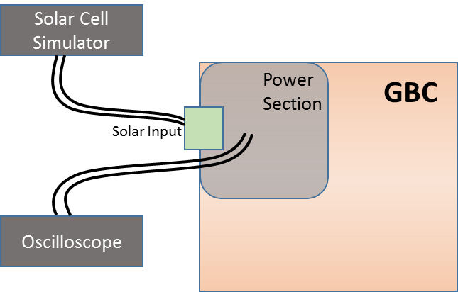
Figure 1. Solar Supply Input - Test Setup Diagram

Test Case: Voltage Accuracy (Test ID: FP.1.1)

Description
- Purpose
Solar power input is designed to work in the range of 16 to 22V. The purpose of the test case is to ensure the accuracy of the solar supply voltage is as per the designed margins.

- Impact of failure of test case on system

Impact | Applicable | Description
Functional | Yes | GBC will not be powered up if PoE and/or Batteries are absent.
Performance | Yes
Compliance | NA | NA
Table 1. Impact of Failure – Solar Voltage Accuracy

- Measurement Locations
Measurement Parameter | Measurement location
VPSOLAR | JTB10A.1
VSLR_OVUVOUT | R1304.2
VSLRPOE_VOUT | C3M171.1
VPS_VOUT | C1685.1
Table 2. Measurement Locations – Solar Voltage Accuracy

Test Equipment List
1. Solar cell array simulator: Agilent E4350B
2. Digital Oscilloscope: MSO9404A

Equipment Settings
- Solar cell array simulator: Configure the equipment in Array Simulator mode
- Oscilloscope: MSO9404A
Voltage per division: 1V
Time scale: 50ms
Bandwidth: 20MHz

Hardware Requisites
- GBC board

Software Requisites
- Keysight Command Expert

Test Condition
Test condition | Value | Remarks
Voltage | 18V | Nominal input voltage
Temperature | +25 C | Normal Room temperature
Table 3. Test Condition – Solar Voltage Accuracy

DUT Settings
- Isolated input side of Tiva controller by removing the resistor R10054.
- Isolated input side of Intel microprocessor by removing the resistor R10067.

Requirements
Measurement Parameter | JTB10A.1 | R1304.2 | C3M171.1 | C1685.1
Input Voltage(V) | 16 to 22 | 16 to 22 | 16 to 22 | 16 to 22
Table 4. Requirements – Solar Voltage Accuracy

Test Procedure
- Remove resistor R10067 and R10054 in order to isolate Intel processor and TIVA respectively.
- Configure Solar Cell simulator to simulate a solar voltage of 18V
- Measure the voltage at R1304.2 and make sure the voltage is 18V+/- 5%.

Reference
Further details can be found in Page 40, 48 and 53 of GBC schematic Ver. Life-2.

Test Case: Input Voltage Range (Test ID: FP.1.2)

Description
- Purpose
Solar power input is designed to work in the range of 16 to 22V. The purpose of the test case is to validate the range of solar input voltages for which GBC will be functional.
- Impact of failure of test case on system

Impact | Applicable | Description
Functional | Yes | GBC will not be powered up if PoE and/or Batteries are absent or Aux/Solar power is less than 16.27V
Performance | Yes
Compliance | NA | NA
Table 5. Impact of Failure – Solar Input Voltage Range

- Measurement Locations
Measurement Parameter | Measurement location
VPSOLAR | JTB10A.1
VSLR_OVUVOUT | R1304.2
VSLRPOE_VOUT | C3M171.1
12V_IN | R10044.2
Table 6. Measurement Locations – Solar Input Voltage Range

Test Equipment List
1. Solar cell array simulator: Agilent E4350B
2. Digital Oscilloscope: MSO9404A

Equipment Settings
- Solar cell array simulator: Configure the equipment in Array Simulator mode
- Oscilloscope: MSO9404A
Voltage per division: 1V
Time scale: 50ms
Bandwidth: 20MHz

Hardware Requisites
- GBC board

Software Requisites
- Keysight Command Expert

Test Condition
Test condition | Value | Remarks
Voltage | 18V | Nominal input voltage
Temperature | +25 C | Normal Room temperature
Table7. Test Condition – Solar Input Voltage Range

DUT Settings
- Isolated input side of Tiva controller by removing the resistor R10054.
- Isolated input side of Intel microprocessor by removing the resistor R10067.

Requirements
Measurement Parameter | JTB10A.1 | R1304.2 | C3M171.1 | R10044.2
Voltage(V) | 16 to 22 | 16 to 22 | 16 to 22 | 12
Table 8. Requirements – Solar Input Voltage Range

Test Procedure
- Remove resistor R10067 and R10054 in order to isolate Intel processor and TIVA respectively.
- Configure Solar Cell simulator to give a voltage in the range of 16V to 22V
- Varying the simulator for voltages in steps of 2V, measure the input voltage at JTB10A.1, R1304.2 and C3M171.1 and make sure the voltages are in the range of 16V to 22V
- For every step of solar input voltage, measure the output voltage of Buck-Boost converter (U88) at R10044.2.
- The Buck-Boost output should be 12V to ensure proper functionality of GBC module

Reference
Further details can be found in Page 40, 48 and 53 of GBC schematic Ver. Life-2

Auxiliary Supply input

Test Setup
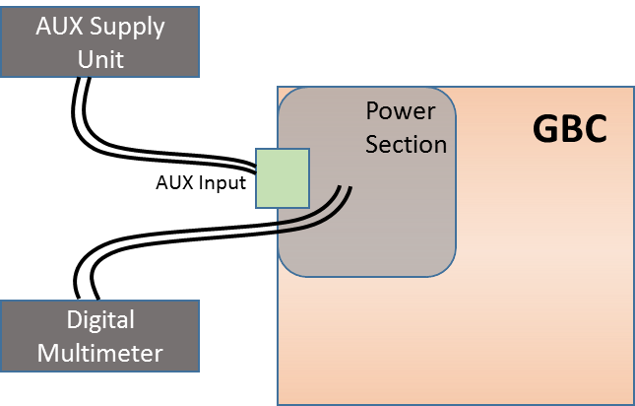
Figure 2. Auxiliary Supply Input - Test Setup Diagram

Test Case: Voltage Accuracy (Test ID: FP.2.1)

Description
- Purpose
AUX power supply input is designed to work with the voltage in range of 16V to 24V. The purpose of this test case is to validate the input voltage accuracy of AUX input voltage.
- Impact of failure of test case on system

Impact | Applicable | Description
Functional | Yes | GBC will not be powered up if PoE and/or Batteries are absent.
Performance | NA
Compliance | NA | NA
Table 9. Impact of Failure – auxiliary Voltage Accuracy
- Measurement Locations
Measurement Parameter | Measurement location
VPSOLAR | JTB10A.1
VSLR_OVUVOUT | R1304.2
VPS_VOUT | C1685.1
VSLRPOE_VOUT | C3M171.1
Table 10. Measurement Locations – auxiliary Voltage Accuracy

Test Equipment List
- AUX Power supply unit: Agilent E3634A
- Oscilloscope: MSO9404A

Equipment Settings
- DC power supply: E3633A
Supply Voltage: 24V
Current Limit: 1.5A
OVP: 26V
OCP: 2A

- Oscilloscope: MSO9404A
Voltage per division: 1V
Time scale: 50ms
Bandwidth: 20MHz

Hardware Requisites
- GBC board

Software Requisites
NA

Test Condition
Test condition | Value | Remarks
Voltage | 16V - 24V | Nominal input voltage range
Temperature | +25 C | Normal Room temperature
Table 11. Test Condition – auxiliary Voltage Accuracy

DUT Settings
- Isolated input side of Tiva controller by removing the resistor R10054.
- Isolated input side of Intel microprocessor by removing the resistor R10067.

Requirements
Measurement Parameter | JTB10A.1 | R1304.2 | C3M171.1 | C1685.1
Input Voltage(V) | 16 - 24 | 16 - 24 | 16 - 24 | 16 - 24
Table 12. Requirements – Auxiliary Voltage Accuracy

Test Procedure
- Remove resistor R10067 and R10054 in order to isolate Intel processor and TIVA respectively.
- Configure AUX power supply to give a voltage in range of 16V to 24V.
- Measure the input voltage at JTB10A.1, R1304.2, C3M171.1, and C1685.1.
- The above measured voltage should be equal to the set voltages of AUX power supply unit to ensure proper functionality of GBC module.

Reference
Further details can be found in Page 40, 48 and 53 of GBC schematic Ver. Life-2.

Test Case: Input Voltage Range (Test ID: FP.2.2)

Description
- Purpose
AUX power supply input is designed to work in the range of 16 to 24V. The purpose of the test case is to validate the range of AUX input voltages for which GBC will be functional.

- Impact of failure of test case on system

Impact | Applicable | Description
Functional | Yes | GBC will not be powered up if PoE and/or Batteries are absent and Aux/Solar power is less than 16.27V
Performance | NA
Compliance | NA | NA
Table 13. Impact of Failure – Auxiliary Input Voltage Range

- Measurement Locations
Measurement Parameter | Measurement location
VPSOLAR | JTB10A.1
VSLR_OVUVOUT | R1304.2
VSLRPOE_VOUT | C3M171.1
12V_IN | R10044.2
Table 14. Measurement Locations – auxiliary Input Voltage Range

Test Equipment List
1. AUX Power supply unit: Agilent E3634A
2. Digital Oscilloscope: MSO9404A

Equipment Settings
- DC power supply: E3633A
Supply Voltage: 24V
Current Limit: 1.5A
OVP: 26V
OCP: 2A

- Oscilloscope: MSO9404A
Voltage per division: 1V
Time scale: 50ms
Bandwidth: 20MHz

Hardware Requisites
- GBC board

Software Requisites
NA

Test Condition
Test condition | Value | Remarks
Voltage | 18V | Nominal input voltage
Temperature | +25 C | Normal Room temperature
Table 15. Test Condition – auxiliary Input Voltage Range

DUT Settings
- Isolated input side of Tiva controller by removing the resistor R10054.
- Isolated input side of Intel microprocessor by removing the resistor R10067.

Requirements
Measurement Parameter | JTB10A.1 | R1304.2 | C3M171.1 | R10044.2
Voltage(V) | 16 to 24 | 16 to 24 | 16 to 24 | 12
Table 16. Requirements – auxiliary Input Voltage Range

Test Procedure
- Remove resistor R10067 and R10054 in order to isolate Intel processor and TIVA respectively.
- Configure AUX power supply to give a voltage in the range of 16V to 24V
- Varying the AUX supply for voltages in steps of 2V, measure the input voltage at JTB10A.1, R1304.2, C3M171.1, and make sure the voltages are in the range of 16V to 24V.
- For every step of AUX input voltage, measure the output voltage of Buck-Boost converter (U88) at R10044.2.
- The Buck-Boost output should be 12V to ensure proper functionality of GBC module.

Reference
Further details can be found in Page 40, 48 and 53 of GBC schematic Ver. Life-2

PoE IN

Test Setup
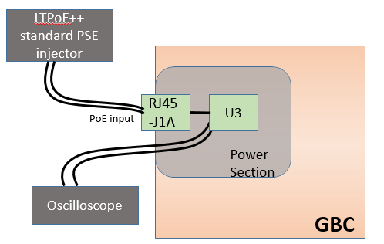
Figure 3. PoE IN - Test Setup Diagram

Test Case: Voltage accuracy (Test ID: FP.3.1)

Description

- Purpose
The purpose of this test case is to check the voltage accuracy of input side voltage rails when GBC is powered through PoE.
- Impact of failure of test case on system

Impact | Applicable | Description
Functional | Yes | If input voltage is less than or more than the designed limit, the powering on of GBC will be affected.
Performance | Yes | Designed for 30W, to work in LTPoE++ standard, if this condition is not met, the overall power budget of the board is affected.
Compliance | NA
Table 17. Impact of Failure – Voltage Accuracy

- Measurement Locations
Measurement Parameter | Measurement location
VPORTA_P | C1811.1
PV18POE | C3M103.1
VSLRPOE_VOUT | C3M171.1
VPS_VOUT | C1685.1
VPOUT_BUCK | C3M96.1
Table 18. Measurement Locations – Voltage Accuracy

Test Equipment List
1. LTPoE++ PSE injector - PS-201G++
2. Digital Oscilloscope: MSO9404A

Equipment Settings
- LTPoE++ PSE injector - PS-201G++
Supply Voltage: 56V
Current Limit: 1.6A

- Oscilloscope: MSO9404A
Voltage per division: 5V
Bandwidth: 20MHz

Hardware Requisites
- GBC board

Software Requisites
NA

Test Condition
Test condition | Value | Remarks
Voltage | 56V | Nominal injector input voltage
Temperature | +25 C | Normal Room temperature
Table 19. Test Condition – Voltage Accuracy

DUT Settings
- Isolated input side of Tiva controller by removing the resistor R10054.
- Isolated input side of Intel microprocessor by removing the resistor R10067.

Requirements
Measurement Parameter | Measurement location | Range
Input Voltage (V) | C1811.1 | 56V
48V-18V buck converter Output | C3M103.1 | 10.8 - 28V
Output voltage of U91 | C1685.1 | Working condition: Should follow the input voltage i.e. 18V
Buck-Boost Input voltage(V) | C3M96.1 | Working condition:  Should follow output of U91 i.e. 18V
Table 20. Requirements – Voltage Accuracy

Test Procedure
- Remove resistor R10067 and R10054 in order to isolate Intel processor and TIVA respectively.
- A constant input voltage of 56V is given from PoE injector (PS-201G++) to J1A connector.
- Measure the output voltage at C3M103.1, C3M171.1, C1685.1 and C3M96.1.

Reference
Further details can be found in Page 41 and 43 of GBC schematic Ver. Life-2.

Test Case: Input Supply Range (Test ID: FP.3.2)

Description
- Purpose
PoE input supply range must comply with LTPoE++ standard, i.e. it is designed to work in the range of 53.75V to 56V. The purpose of the test case is to validate the range for LTPoE++ voltage range for which GBC will be functional.
- Impact of failure of test case on system

Impact | Applicable | Description
Functional | Yes | If the voltage range is not between 53.75V to 56V, then the GBC will not be in LTPoE++ standard.
Performance | Yes | Designed for 30W, to work in LTPoE++ standard, if this condition is not met, the overall power budget of the board is affected.
Compliance | NA
Table 21. Impact of Failure – Input Supply Range
- Measurement Locations
Measurement Parameter | Measurement location
VPORTA_P | C2005.1
VSLRPOE_VOUT | C3M171.1
Table 22. Measurement Locations – Input Supply Range

Test Equipment List
1. LTPoE++ PSE injector - PS-201G++
2. Digital Oscilloscope: MSO9404A

Equipment Settings
- LTPoE++ PSE injector - PS-201G++
Supply Voltage: 53.75 to 56V
Current Limit: 1.6A

- Oscilloscope: MSO9404A
Voltage per division: 5V
Bandwidth: 20MHz

Hardware Requisites
- GBC board

Software Requisites
NA

Test Condition
Test condition | Value | Remarks
Voltage | 53.75V to 56V | Injector input voltage
Temperature | +25 C | Normal Room temperature
Table 23. Test Condition – Input Supply Range

DUT Settings
- Isolated input side of Tiva controller by removing the resistor R10054.
- Isolated input side of Intel microprocessor by removing the resistor R10067.

Requirements
Measurement Parameter | Measurement location | Range
Input Voltage (V) | C2005.1 | 53.75V to 56V
Output voltage of U38 | C3M171.1 | Working condition: Should be equal to 18V
Table 24. Requirements – Input Supply Range

Test Procedure
- Remove resistor R10067 and R10054 in order to isolate Intel processor and TIVA respectively.
- Vary the input voltage of PoE injector from 53.75V to 56V in steps of 1V. Measure the input voltage at C1811.1.
- Load GBC up to 30W using an external electronic load.
- For every change in input voltage, measure the output voltage of 48V to 18V isolated converter (U38) at C3M171.1 and should read 18V.

Reference
Further details can be found in Page 41 and 43 of GBC schematic Ver. Life-2.

PoE – Data

Test Setup
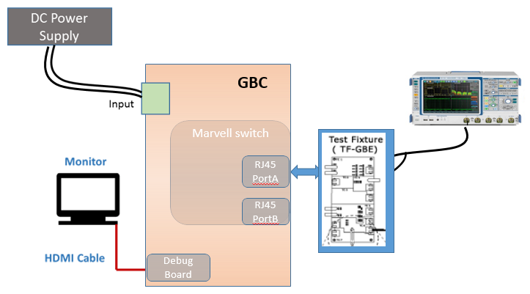

Test Case: Ethernet Compliance (Test ID: FP.5.1)

The test procedure and test setup for Ethernet compliance has been performed as per IEEE 802.3 standards and comprises of Template, Differential Output Voltage, Amplitude Symmetry, Rise Time, Fall Time, Rise/Fall Time Symmetry, Waveform Overshoot, Jitter, Duty Cycle Distortion and return loss.
- Use TC2 of the test fixture for this test. Make the connections as shown in the above diagram
- Set the DUT to transmit scrambled idles
- Connect the Ethernet cable to J490 and test port of the DUT
- Connect the Differential Probe to P9 and configured channel of the oscilloscope
- Select the test to be performed and click “Run Test” in TDSET3 Ethernet compliance software
- For return loss measurement, Use TC1 of the test fixture and ensure calibration for “OPEN”, “LOAD” and “SHORT” is performed before executing on actual DUT
- Connect the Ethernet cable to J200 and test port of the DUT Connect a BNC Cable to (AWG/AFG)+ and Channel 1 of Arbitrary Waveform Generator/Arbitrary Function Generator
- Connect a BNC Cable to (AWG/AFG)– and Channel 2 of Arbitrary Waveform Generator/Arbitrary Function Generator
- To test Transmitter, connect the Differential Probes to P1 (J240) and P2 (J230), and configured channels of the oscilloscope
- To test Receiver, connect the Differential Probe to P3 (J241) and P4 (J231), and configured channels of the oscilloscope.

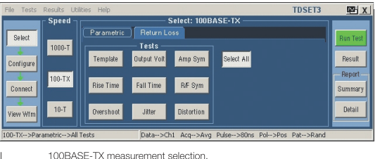
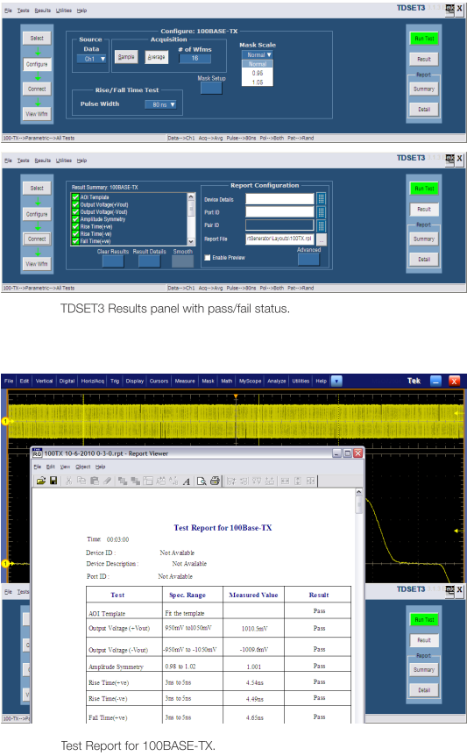

Protection

Test Setup
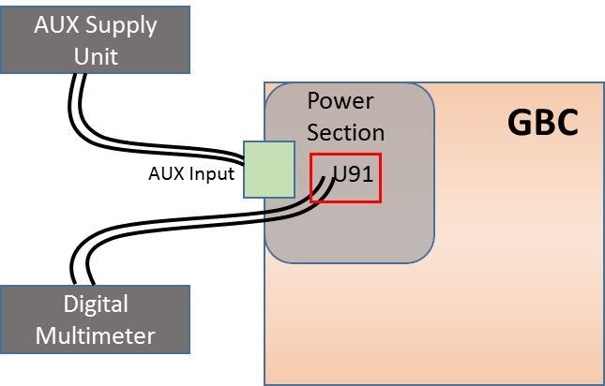
Figure 4. Protection - Test Setup Diagram

Test Case: Voltage limit accuracy (Test ID: FP.6.1)

Description
- Purpose
LT4256 (U91) is used as the protection IC for under voltage and over current protection. This test is to ensure that GBC will not be functional below the designed threshold voltage.
- Impact of failure of test case on system

Impact | Applicable | Description
Functional | Yes | If input voltage is less than or more than the designed limit, the powering on of GBC will be affected.
Performance | NA
Compliance | NA
Table 25. Impact of Failure – Voltage Limit Accuracy
- Measurement Locations
Measurement Parameter | Measurement location
VSLRPOE_VOUT | C3M171.1
VPS_VOUT | R1056.1
Node voltage at UV pin of U91 | R1053.2
VPOUT_BUCK | R10071.1
Table 26. Measurement Locations – Voltage Limit Accuracy

Test Equipment List
1. AUX Power supply unit: Agilent E3634A
2. Digital Oscilloscope: MSO9404A

Equipment Settings
- DC power supply: E3633A
Supply Voltage: 24V
Current Limit: 1.5A
OVP: 26V
OCP: 2A

- Oscilloscope: MSO9404A
Voltage per division: 1V
Time scale: 50ms
Bandwidth: 20MHz

Hardware Requisites
- GBC board

Software Requisites
NA

Test Condition
Test condition | Value | Remarks
Voltage | 18V | Nominal input voltage
Temperature | +25 C | Normal Room temperature
Table 27. Test Condition – Voltage Limit Accuracy

DUT Settings
- Isolated input side of Tiva controller by removing the resistor R10054.
- Isolated input side of Intel microprocessor by removing the resistor R10067.

Requirements
Measurement Parameter | Measurement location | Range
Input Voltage (V) | C3M171.1 | 10.5V to 11.5V
Node voltage at UV pin of U91 | R1053.2 | Working condition: >3.96 V
Output voltage(V) of U91 | R1056.1 | Working condition: Should follow the input voltage
Buck-Boost output voltage(V) | R10071.1 | 12V
Table 28. Requirements – Voltage Limit Accuracy

Test Procedure
- Remove resistor R10067 and R10054 in order to isolate Intel processor and TIVA respectively.
- Set the AUX power supply to give a voltage in the range of 10.5V to 11.5V.
- Varying the AUX supply settings for voltages in steps of 0.2V, measure the input voltage at C3M171.1.
- Measure nodal voltage at R1053.2. If measured voltage is less than 3.96V, then the IC is in under voltage protection mode. The measured voltage should be greater than 3.96V for normal operation.

Reference
Further details can be found in Page 48 of GBC schematic Ver. Life-2.

Test Case: Solar AUX Present test (Test ID: FP.6.2)

Description
- Purpose
This test to conclude if Solar or AUX power is being used to power up the GBC board.
- Impact of failure of test case on system

Impact | Applicable | Description
Functional | Yes | GBC will not be powered up if Solar/Aux is absent and SOLAR_AUX_PRSNT_N is high
Performance | Yes | If Solar/Aux voltage source is not detected, the powering of GBC will be affected.
Compliance | NA | NA
Table 29. Impact of Failure – Solar AUX Present test
- Measurement Locations
Measurement Parameter | Measurement location
VSLRPOE_VOUT | R988.1
VPS_VOUT | R1056.1
SOLAR_AUX_PRSNT_N | R9957.2
Table 30. Measurement Locations – Solar AUX Present test

Test Equipment List
1. AUX Power supply unit: Agilent E3634A
2. Digital Oscilloscope: MSO9404A

Equipment Settings
- DC power supply: E3633A
Supply Voltage: 24V
Current Limit: 1.5A
OVP: 26V
OCP: 2A

- Oscilloscope: MSO9404A
Voltage per division: 1V
Time scale: 50ms
Bandwidth: 20MHz

Hardware Requisites
- GBC board

Software Requisites
NA

Test Condition
Test condition | Value | Remarks
Voltage | 18V | Nominal input voltage
Temperature | +25 C | Normal Room temperature
Table 31. Test Condition – Solar AUX Present test

DUT Settings
- Isolated input side of Tiva controller by removing the resistor R10054.
- Isolated input side of Intel microprocessor by removing the resistor R10067.

Requirements
Measurement Parameter | Measurement location | Range
Input Voltage (V) | R988.1 | 18V
Solar or AUX supply present_n | R9957.2 | <0.4V (U15 detects a low at voltage < 0.4V)
Output voltage(V) of U91 | R1056.1 | Working condition: Should follow the input voltage
Table 32. Requirements – Solar AUX Present test

Test Procedure
- Configure the AUX power supply to give 18V as input to the GBC board.
- Measure the input voltage at R988.1 and ensure that it is 18V.
- Measure the voltage at R9957.2. If the voltage is < 0.4V then it indicates that the GBC is powered from Solar or AUX supply. If this voltage is 3.3V then it indicates that Solar or AUX supply is absent.

Reference
Further details can be found in Page 48 and 63 of GBC schematic Ver. Life-2.

Test Case: Protection Limit (Test ID: FP.6.3)

Description
- Purpose
The purpose of this test case is to ensure the voltage protection limits are as per the designed value, i.e. input voltage to U91 (LT4256) is ≥11.5V.
- Impact of failure of test case on system

Impact | Applicable | Description
Functional | Yes | If the voltage applied is more than or less than the designed value, power section of GBC will be affected.
Performance | NA
Compliance | NA | NA
Table 33. Impact of Failure – Protection Limit

- Measurement Locations
Measurement Parameter | Measurement location
VSLRPOE_VOUT | C3M171.1
VPS_VOUT | R1056.1
12V_IN | R10044.2
Nodal Voltage at UV pin of U91 | R1053.2
Table 34. Measurement Locations – Protection Limit

Test Equipment List
1. AUX Power supply unit: Agilent E3634A
2. Digital Oscilloscope: MSO9404A

Equipment Settings
- DC power supply: E3633A
Supply Voltage: 10.5V to 11.5V
Current Limit: 1.5A
OVP: 20V
OCP: 2A

- Oscilloscope: MSO9404A
Voltage per division: 1V
Time scale: 50ms
Bandwidth: 20MHz

Hardware Requisites
- GBC board

Software Requisites
NA

Test Condition
Test condition | Value | Remarks
Voltage | 10.5V to 11.5V | Input voltage range
Temperature | +25 C | Normal Room temperature
Table 35. Test Condition – Protection Limit

DUT Settings
- Isolated input side of Tiva controller by removing the resistor R10054.
- Isolated input side of Intel microprocessor by removing the resistor R10067.

Requirements
Measurement Parameter | Measurement location | Range
Input Voltage (V) | C3M171.1 | 10.5V to 11.5V
Output of U91 | R1056.1 | Working condition: Should follow the input voltage
Output voltage(V) of U88 | R10044.2 | Working condition: Should be equal to 12V
Table 36. Requirements – Protection Limit

Test Procedure
- Set the AUX power supply to give a voltage in the range of 10.5V to 11.5V in steps of 0.2V
- Measure the input voltage at C3M171.1.
- Measure the voltage at R1056.1 and R10044.2.
- Input voltage for U91 should be greater than 11.5V for proper operation of GBC. This test fails if input voltage of U91 (VSLRPOE_VOUT) is less than 11.5V, or if the nodal voltage at R1053 and R1052 junction is greater than 3.96V.

Reference
Further details can be found in Page 48 and 53 of GBC schematic Ver. Life-2.

Power Sub-system

Test Purpose and Description
GBC system will have provision for varied power sources to various discrete voltage levels required by devices used in the system. The system also has provision for DC-DC converters for low noise regulated power supply to individual functional blocks and devices

Power Sub-system constitutes of below components
- PoE
- PSE
- Isolated DC-DC
- Lead Acid battery
- Lithium Ion Battery
- Buck-Boost
- TIVA power supply
- 2G module supply
- FET Switch
- PMIC
- System Power sequence

PoE

Test Setup
Figure 5. PoE- Test Setup Diagram

Test Case: Voltage Accuracy (Test ID: PWR.1.1)
Same as Test Case ID: FP.3.1

Test Case: Ripple Measurement (Test ID: PWR.1.2)

Description
- Purpose
The purpose of this test case is to check the maximum peak-to-peak ripple voltage of PoE supply.
- Impact of failure of test case on system

Impact | Applicable | Description
Functional | NA
Performance | Yes | If ripple voltage is more than expected, board noise will increase and leading to failure of capacitors.
Compliance | NA
Table 37. Impact of Failure – Ripple Measurement
- Measurement Locations
Measurement Parameter | Measurement location
PV18POE | C3M103.1
Table 38. Measurement Locations – Ripple Measurement

Test Equipment List
1. LTPoE++ PSE injector - PS-201G++
2. Digital Oscilloscope: MSO9404A

Equipment Settings
- LTPoE++ PSE injector - PS-201G++
Supply Voltage: 56V
Current Limit: 1.6A

Hardware Requisites
- GBC board

Software Requisites
NA

Test Condition
Test condition | Value | Remarks
Voltage | 56V | Nominal injector input voltage
Temperature | +25 C | Normal Room temperature
Table 39. Test Condition – Ripple Measurement

DUT Settings
- Isolated input side of Tiva controller by removing the resistor R10054.
- Isolated input side of Intel microprocessor by removing the resistor R10067.

Requirements
Measurement Parameter | Measurement location | Range
48V-18V buck converter Output | C3M103.1 | Working condition:  Output voltage should be equal to 18V. Allowable ripple is 900mV (±5% of 18V)
Table 40. Requirements – Ripple Measurement

Test Procedure
- Remove resistor R10067 and R10054 in order to isolate Intel processor and TIVA respectively.
- A constant input voltage of 56V is given from PoE injector (PS-201G++) to J1A connector.
- An Isolated DC-DC converter in turn converts 56V to 18V. Measure the output voltage at C3M103.1.

Reference
Further details can be found in Page 43 and 48 of GBC schematic Ver. Life-2.

Test Case: Supply Present Check (Test ID: PWR.1.3)

Description
- Purpose
The purpose of this test case is to check the presence of PoE as an input supply source.
- Impact of failure of test case on system

Impact | Applicable | Description
Functional | Yes | GBC will not be powered up if PoE supply is absent and PoE_PRSNT_N is high (given Solar and Aux input is absent)
Performance | Yes | If Solar/Aux voltage source is not detected, the powering of GBC will be affected. (given Solar and Aux input is absent)
Compliance | NA | NA
Table 41. Impact of Failure – Supply Present Check
- Measurement Locations
Measurement Parameter | Measurement location
POE_PRSNT_N | R9953.2
Table 42. Measurement Locations – Supply Present Check

Test Equipment List
1. LTPoE++ PSE injector - PS-201G++
2. Digital Oscilloscope: MSO9404A

Equipment Settings
- LTPoE++ PSE injector - PS-201G++
Supply Voltage: 56V
Current Limit: 1.6A

- Oscilloscope: MSO9404A
Voltage per division: 1V
Time scale: 50ms
Bandwidth: 20MHz

Hardware Requisites
- GBC board

Software Requisites
NA

Test Condition
Test condition | Value | Remarks
Voltage | 56V | Nominal injector input voltage
Temperature | +25 C | Normal Room temperature
Table 43. Test Condition – Supply Present Check

DUT Settings
- Isolated input side of Tiva controller by removing the resistor R10054.
- Isolated input side of Intel microprocessor by removing the resistor R10067.

Requirements
Measurement Parameter | Measurement location | Range
Input Voltage (V) | C1811.1 | 56V
PoE supply present_n | R9953.2 | <1.155V (U15 detects a low under this condition)
Input voltage(V) of U77 | C3M103.1 | Working condition: Should be equal to 18V
Table 44. Requirements – Supply Present Check

Test Procedure
- Remove resistor R10067 and R10054 in order to isolate Intel processor and TIVA respectively.
- A constant input voltage of 56V is given from PoE injector (PS-201G++) to J1A connector.
- An Isolated DC-DC converter in turn converts 56V to 18V.
- When PoE supply is present, the voltage on R9953.2 Resistor should measure <1.155V. Any voltage less than 1.155V is considered as low signal for Tiva thus indicating the presence of PoE supply.

Reference
Further details can be found in Page 43 and 63 of GBC schematic Ver. Life-2.

Test Case: Data Transfer Validation (Test ID: PWR.1.4)

Description
- Purpose
This test case indicates the data validation between PoE ports A and B.
- Impact of failure of test case on system

Impact | Applicable | Description
Functional | Yes | If data validation between ports fails, communication with external PC will be not possible.
Performance | NA
Compliance | NA
Table 45. Impact of Failure – Data Transfer Validation

- Measurement Locations
NA

Test Equipment List
1. LTPoE++ PSE injector - PS-201G++
2. Two CPU systems

Equipment Settings
- LTPoE++ PSE injector - PS-201G++
Supply Voltage: 56V
Current Limit: 1.6A

Hardware Requisites
- GBC board
- Two test PCs

Software Requisites
NA

Test Condition
Test condition | Value | Remarks
Voltage | 56V | Nominal injector input voltage
Temperature | +25 C | Normal Room temperature
Table 46. Test Condition – Data Transfer Validation

DUT Settings
- Isolated input side of Tiva controller by removing the resistor R10054.
- Isolated input side of Intel microprocessor by removing the resistor R10067.

Requirements
NA

Test Procedure
- Remove resistor R10067 and R10054 in order to isolate Intel processor and TIVA respectively.
- Connect Data In port of PoE injector to CPU1. Connect Port B of GBC to another machine (CPU2). Ping CPU2 from CPU1 and vice versa.
- The number of packets transferred from CPU1 to CPU2 and vice versa should have a loss of 0%, then data validation through PoE is successful.

Reference
Further details can be found in Page 43 of GBC schematic Ver. Life-2.

Test Case: Power Delivery (Test ID: PWR.1.5)

Description
- Purpose
The purpose of the test case is to validate the power delivery of PoE.
- Impact of failure of test case on system
Impact | Applicable | Description
Functional | NA
Performance | Yes | The System will not turn on if the required power is not delivered.
Compliance | NA
Table 47. Impact of Failure of PoE Power delivery
- Measurement Locations
R10044

Test Equipment List
- LTPoE++ PSE injector - PS-201G++
- DC power supply: E3633A

Equipment Settings
- LTPoE++ PSE injector - PS-201G++
Supply Voltage: 56V
Current Limit: 1.6A

- DC power supply: E3633A
Supply Voltage: 56V
Current Limit: 1.5A
OVP: 57V
OCP: 2A

Hardware Requisites
- GBC board

Software Requisites
NA

Test Condition
Test condition | Value | Remarks
Voltage | 56V | Nominal injector input voltage
Temperature | +25 C | Normal Room temperature
Table 48. Test Condition – PoE Power delivery

DUT Settings
NA

Requirements
Sl.No. | Parameters | Input Section | Output Section
1 | Probing points | NA | R10044
2 | Resistor Value (mΩ) | NA | 10
3 | Voltage (V) | 47.97 | 12
4 | Expected Power (W) | Output power = Input power
5 | Expected Efficiency (%) | 60 – 70 (Considering 1A load)
Table 49. Requirements – PoE Power delivery

Test Procedure
- Configure DC power supply to give a voltage of 56V.
- Measure PoE Voltage and Current by connecting input of the PoE injector to DC power supply.
- Measure the voltage at the output point of injector for input section.
- Measure the voltage at the sense resistor R10044 for output section.
- Calculate the current, power and efficiency.
- The efficiency is calculated as η = 100% * Pout / Pin.
- Make sure the measuring criteria for the signal satisfies the above mentioned requirements.

Reference
Further details can be found in Page 43 of GBC schematic Ver. Life-2.

Isolated DC-DC

Test Setup
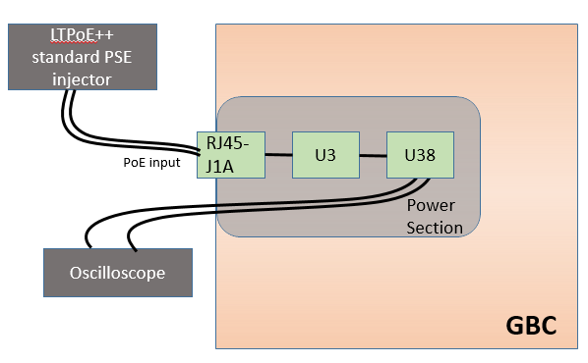
Figure 6. Isolated DC-DC - Test Setup Diagram

Test Case: Output Voltage accuracy (Test ID: PWR.3.1)

Description
- Purpose
The purpose of this test case is to check the voltage accuracy of output voltage rail of DC – DC converter when PoE input voltage is varied.
- Impact of failure of test case on system

Impact | Applicable | Description
Functional | Yes | If input voltage is less than or more than the designed limit, the power source for GBC will be affected.
Performance | NA
Compliance | NA
Table 50. Impact of Failure – Output Voltage Accuracy
- Measurement Locations
Measurement Parameter | Measurement location
VPORTA_P | C2005.1
PV18POE | C1807.1
Table 51. Measurement Locations – Output Voltage Accuracy

Test Equipment List
1. LTPoE++ PSE injector - PS-201G++
2. Digital Oscilloscope: MSO9404A

Equipment Settings
- LTPoE++ PSE injector - PS-201G++
Supply Voltage: 56V
Current Limit: 1.6A

- Oscilloscope: MSO9404A
Voltage per division: 5V
Bandwidth: 20MHz

Hardware Requisites
- GBC board

Software Requisites
NA

Test Condition
Test condition | Value | Remarks
Voltage | 56V | Nominal injector input voltage
Temperature | +25 C | Normal Room temperature
Table 52. Test Condition – Output Voltage Accuracy

DUT Settings
- Isolated input side of Tiva controller by removing the resistor R10054.
- Isolated input side of Intel microprocessor by removing the resistor R10067.

Requirements
Measurement Parameter | Measurement location | Range
Input Voltage (V) | C2005.1 | 56V
48V-18V buck converter Output | C1807.1 | 18V typical
Table 53. Requirements – Output Voltage Accuracy

Test Procedure
- Remove resistor R10067 and R10054 in order to isolate Intel processor and TIVA respectively.
- A constant input voltage of 56V is given from PoE injector (PS-201G++) to J1A connector. Measure the input voltage at C2005.1.
- Measure the output voltage of DC-DC converter at C1807.1.

Reference
Further details can be found in Page 47 of GBC schematic Ver. Life-2.

Test Case: Solar AUX and PoE OR-ing Circuit (Test ID: PWR.3.2)

Description
- Purpose
The purpose of this test case is to check the switching between AUX/ Solar supply and PoE supply.
- Impact of failure of test case on system

Impact | Applicable | Description
Functional | Yes | GBC might be non-operational if switching between AUX/Solar and PoE is not detected properly.
Performance | NA
Compliance | NA
Table 54. Impact of Failure – Output Voltage Accuracy
- Measurement Locations
Measurement Parameter | Measurement location
VSLR_OVUVOUT | C3M102.1
PV18POE | C1807.1
VSLRPOE_VOUT | C3M171.1
Table 55. Measurement Locations – Output Voltage Accuracy

Test Equipment List
- LTPoE++ PSE injector - PS-201G++
- Digital Oscilloscope: MSO9404A
- AUX Power supply unit: Agilent E3634A

Equipment Settings
- LTPoE++ PSE injector - PS-201G++
Supply Voltage: 56V
Current Limit: 1.6A

- DC power supply: E3633A
Supply Voltage: 15V to 24V
Current Limit: 1.5A
OVP: 26V
OCP: 2A

- Oscilloscope: MSO9404A
Voltage per division: 5V
Bandwidth: 20MHz

Hardware Requisites
- GBC board

Software Requisites
NA

Test Condition
Test condition | Value | Remarks
Voltage | 56V and 15V to 24V | Nominal injector input voltage and AUX/Solar power supply
Temperature | +25 C | Normal Room temperature
Table 56. Test Condition – Output Voltage Accuracy

DUT Settings
- Isolated input side of Tiva controller by removing the resistor R10054.
- Isolated input side of Intel microprocessor by removing the resistor R10067.

Requirements
Measurement Parameter | Measurement location | Range
AUX / Solar Input Voltage (V) | C3M102.1 | 15V to 24V
48V-18V buck converter Output | C1807.1 | 18V typical
Output of OR-ing circuit U77(V) | C3M171.1 | NA
Table 57. Requirements – Output Voltage Accuracy

Test Procedure
- Remove resistor R10067 and R10054 in order to isolate Intel processor and TIVA respectively.
- A constant input voltage of 56V is given from PoE injector (PS-201G++) to J1A connector. Measure the voltage at C1807.1 (18V). Varying AUX / Solar input voltage is also given at JTB10A.1. Measure the input voltage at C3M102.1
- Output voltage should follow AUX/ Solar supply if AUX supply is greater than 16.3V; else output voltage will follow PoE. Measure the output voltage of DC-DC converter at C3M171.1.

Reference
Further details can be found in Page 47 and 48 of GBC schematic Ver. Life-2.

Lead Acid Battery

Test Setup
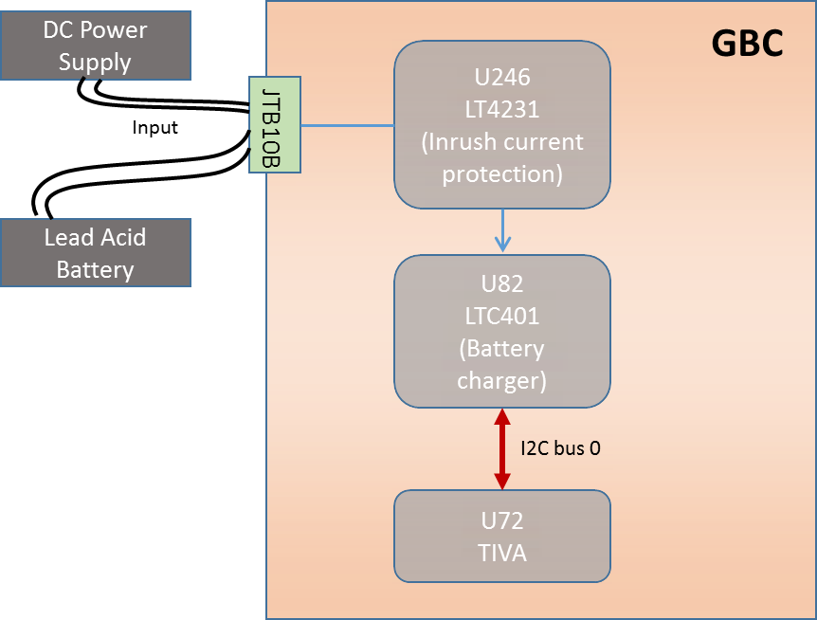
Figure 7. Lead Acid battery - Test Setup Diagram

Impact of failure of test case on system

Impact | Applicable | Description
Functional | Yes | Battery charging and discharging will be affected.
Performance | Yes | If GBC is not powered through AUX or PoE, then power supply should be switched to lead acid battery, else device will not be functional.
Compliance | NA | NA
Table 58. Impact of Failure – Lead Acid battery

Test Case: Output Voltage Accuracy (Test ID: PWR.4.1)

Description
- Purpose
The purpose of this test case is to check the output voltage accuracy of battery charger U82 (LTC4015).
- Measurement Locations

Measurement Parameter | Measurement Location
VPS_VOUT | C1685.1
LACID_VBAT_P | JTB10B.3
LT4231_BAT_CHRGR_LACID | C1741.1
VBC_LACID | C1686.1
Table 59. Measurement Locations – Lead Acid Battery Output Voltage Accuracy

Test Equipment List
1. Lead Acid Battery: 65Ah – Amaron Quanta 12AL065
2. Oscilloscope: MSO9404A

Equipment Settings
- Oscilloscope: MSO9404A
Voltage per division: 5V
Time scale: 50ms
Bandwidth: 20MHz

Hardware Requisites
- GBC board

Software Requisites
NA

Test Condition
Test condition | Value | Remarks
Battery Voltage | 12V | Nominal battery voltage. Varies from 9.5V to 13.8V
Temperature | +25 C | Normal Room temperature
Table 60. Test Condition – Lead Acid Battery Output Voltage Accuracy

DUT Settings
- Isolate input side of Intel microprocessor by removing the resistor R10067.

Requirements
Measurement Parameter | JTB10B.3 | C1686.1
Battery Voltage(V) | 9.5V to 13.8V | 9.5V to 13.8V
Table 61. Requirements - Lead Acid Battery Output Voltage Accuracy

Test Procedure
- Remove resistor R10067 in order to isolate Intel processor.
- Connect lead acid battery terminals between to JTB10B.3and JTB10B.4
- Measure the battery voltage at JTB10B.3.
- The above measured voltage should be equal to the output of the battery charger U82 measured at C1686.1 to ensure proper functionality of GBC module.

Reference
Further details can be found in Page 49 of GBC schematic Ver. Life-2.

Test Case: Charge Current Measurement (Test ID: PWR.4.2)

Description
- Purpose
Charge current for lead acid battery is designed for 10.6A.
i.e. $Charge current =\frac{32mV}{3mohm}=10.66A$
Charge current read from register Ibat having sub-address 0x3D, must be equal to the programmed charge current (10.66A).
Note: Charge current will decrease when charging voltage increases.
- Measurement Locations
NA

Test Equipment List
1. Lead Acid Battery: 65Ah – Amaron Quanta 12AL065
2. CCS software
3. AUX Power supply unit: Agilent E3634A

Equipment Settings
- DC power supply: E3633A
Supply Voltage: 18V
Current Limit: 2.0A
OVP: 20V
OCP: 2.5A

Hardware Requisites
- GBC board
- Debug board

Software Requisites
- TIVA RTOS code for lead acid battery configuration

Test Condition
Test condition | Value | Remarks
Battery Voltage | 12V | Nominal battery voltage. Varies from 9.5V to 13.8V
Temperature | +25 C | Normal Room temperature
Table 62. Test Condition – Lead Acid Battery Charge Current Measurement

DUT Settings
- Isolate input side of Intel microprocessor by removing the resistor R10067.

Requirements
Access TIVA (U72) I2C channel 0 through CCS software. Program the charge current for 10.66A by writing to register 0x1A. Read back the charge current from register 0x3D.
Programmed charge current must be equal to read charge current.
Note: Charge current will decrease when charging voltage increases.

Test Procedure
- Remove resistor R10067 in order to isolate Intel processor.
- Connect lead acid battery terminals between to JTB10B.3and JTB10B.4
- Connect a debug board to GBC board in order to access TIVA through CCS.
- Through I2C channel 0, lead acid battery charger U82 can be accessed. Program the charge current as 10.66A by writing into I_{charge} _target register at address 0x1A.
- Read register I_{bat} having sub-address 0x3D. This value gives the charging current of the lead acid battery.
- Repeat the same procedure for different values such as 2A, 4A, 6A and 8A as charge current for verification.
- Measure the charging current by measuring voltage across R9959. Charging current can be calculated by:
$Charging Current= \frac{measured voltage (mV)}{3}$

Reference
Further details can be found in Page 49 of GBC schematic Ver. Life-2.

Test Case: Load Current Measurement (Test ID: PWR.4.3)

Description
- Purpose
The purpose of this test case is to measure the current drawn from the battery when system is powered ON by lead acid battery.
- Measurement Locations
Access TIVA (U72) I2C channel 0 through CCS software. Read register 0x3E for load current measurement.

Test Equipment List
1. Lead Acid Battery: 65Ah – Amaron Quanta 12AL065
2. CCS software
3. AUX Power supply unit: Agilent E3634A

Equipment Settings
- DC power supply: E3633A
Supply Voltage: 18V
Current Limit: 2.0A
OVP: 20V
OCP: 2.5A

Hardware Requisites
- GBC board
- Debug board

Software Requisites
- TIVA RTOS code for lead acid battery configuration

Test Condition
Test condition | Value | Remarks
Battery Voltage | 12V | Nominal battery voltage. Varies from 9.5V to 13.8V
Temperature | +25 C | Normal Room temperature
Table 63. Test Condition – Lead Acid Battery Load Current Measurement

DUT Settings
- Isolate input side of Intel microprocessor by removing the resistor R10067.

Requirements
Access TIVA (U72) I2C channel 0 through CCS software.

Test Procedure
- Remove resistor R10067 in order to isolate Intel processor.
- Connect lead acid battery terminals between to JTB10B.3and JTB10B.4
- Connect a debug board to GBC board in order to access TIVA through CCS.
- Through I2C channel 0, lead acid battery charger U82 can be accessed.
- Read register IIN having sub-address 0x3E. This value gives the load current of GBC board.
- Load current is given by$\frac{\left[Voltage across 9960\left(mV\right)\right]}{\begin{aligned}R9960\left(mohm\right) \\ \end{aligned}}=\frac{\left[Voltage across R9960\left(mV\right)\right]}{2}$.

Reference
Further details can be found in Page 49 of GBC schematic Ver. Life-2.

Test Case: LDO Output Voltage (Test ID: PWR.4.4)

Description
- Purpose
The purpose of this test case is to measure the battery charger (U82) internal INTVCC LDO voltage.

- Measurement Locations
Measurement Parameter | Measurement location
INT_VCC_LACID | C1767.1
Table 64. Measurement Locations – Lead Acid battery LDO Output Voltage

Test Equipment List
1. Lead Acid Battery: 65Ah – Amaron Quanta 12AL065
2. Oscilloscope: MSO9404A

Equipment Settings
1. Oscilloscope: MSO9404A
Voltage per division: 5V
Time scale: 50ms
Bandwidth: 20MHz

Hardware Requisites
- GBC board

Software Requisites
NA

Test Condition
Test condition | Value | Remarks
Battery Voltage | 12V | Nominal battery voltage. Varies from 9.5V to 13.8V
Temperature | +25 C | Normal Room temperature
Table 65. Test Condition – Lead Acid battery LDO Output Voltage

DUT Settings
- Isolate input side of Intel microprocessor by removing the resistor R10067.

Requirements
Measurement Parameter | C1767.1
INTVcc (internal LDO voltage) | 5V
Table 66. Requirements – – Lead Acid battery LDO Output Voltage

Test Procedure
- Remove resistor R10067 in order to isolate Intel processor.
- Connect lead acid battery terminals between to JTB10B.3 and JTB10B.4
- Measure the battery charger U82 internal LDO output voltage at C1767.1
- The above measured voltage should be equal to 5V to ensure proper functionality of GBC module.

Reference
Further details can be found in Page 49 of GBC schematic Ver. Life-2.

Test Case: Temperature Measurement (Test ID: PWR.4.5)

Description
- Purpose
The purpose of this test case is to measure the temperature of battery charger IC U82 when it’s fully operational.
- Measurement Locations
Measurement Parameter | Measurement location
Temperature | Internal temperature of U82
Table 67. Measurement Locations – Lead acid battery charger temperature measurement

Test Equipment List
- Lead Acid Battery: 65Ah – Amaron Quanta 12AL065
- CCS software

Equipment Settings
NA

Hardware Requisites
- GBC board
- Debug board

Software Requisites
- TIVA RTOS code for lead acid battery configuration

Test Condition
Test condition | Value | Remarks
Battery Voltage | 12V | Nominal battery voltage. Varies from 9.5V to 13.8V
Temperature | +25 C | Normal Room temperature
Table 68. Test Condition – Lead acid battery charger temperature measurement

DUT Settings
- Isolate input side of Intel microprocessor by removing the resistor R10067.

Requirements
Measurement Parameter | U82
Temperature | Within -40º C to +125º C
Table 69. Requirements – Lead acid battery charger temperature

Test Procedure
- Remove resistor R10067 in order to isolate Intel processor.
- Connect lead acid battery terminals between to JTB10B.3and JTB10B.4
- Connect lead acid battery. Connect a debug board to GBC board in order to access TIVA through CCS. Through I2C channel 0 lead acid battery charger, U82 can be accessed. Read register DIE_TEMPERATURE having sub-address 0x3F.

Reference
Further details can be found in Page 49 of GBC schematic Ver. Life-2.

Test Case: Charge Control (Test ID: PWR.4.6)

Description
- Purpose
This test case indicates the programmed charge current for lead acid battery.
- Measurement Locations
NA

Test Equipment List
1. Lead Acid Battery: 65Ah – Amaron Quanta 12AL065
2. CCS software
3. AUX Power supply unit: Agilent E3634A

Equipment Settings
- DC power supply: E3633A
Supply Voltage: 18V
Current Limit: 12.0A
OVP: 20V
OCP: 15A

Hardware Requisites
- GBC board
- Debug board

Software Requisites
- TIVA RTOS code for lead acid battery configuration

Test Condition
Test condition | Value | Remarks
Battery Voltage | 12V | Nominal battery voltage. Varies from 9.5V to 13.8V
Temperature | +25 C | Normal Room temperature
Table 70. Test Condition – Lead acid battery charger Charge Control measurement

DUT Settings
- Isolate input side of Intel microprocessor by removing the resistor R10067.

Requirements
Measurement Parameter | U82
ICHARGE_TARGET | Register 0x1A
Table 71. Requirements – Lead acid battery charger Charge Control measurement

Test Procedure
- Remove resistor R10067 in order to isolate Intel processor.
- Connect lead acid battery terminals between to JTB10B.3and JTB10B.4
- Connect lead acid battery. Connect a debug board to GBC board in order to access TIVA through CCS. Through I2C channel 0, lead acid battery charger U82 can be accessed.
- Write the desired charge current to register 0x1A, ICHARGE_TARGET. Read the register 0x3D to measure the charge current.

Reference
Further details can be found in Page 49 of GBC schematic Ver. Life-2.

Test Case: Lead Acid and Li-ion battery OR-ing circuit (Test ID: PWR.4.7)

Description
- Purpose
The purpose of this test case is to ensure that power supply will be switched between external battery (Lead acid battery) and internal battery (Lithium - ion battery) at the designed voltage.
Detects Lead acid battery if battery voltage is greater than 11.5V.
Detects Lithium Ion battery if battery voltage is greater than 11.2V.
- Measurement Locations
Measurement Parameter | Measurement location
VBC_LACID | C3M97.1
VBC_LION | C3M98.1
Table 72. Measurement Locations – Battery OR-ing Circuit

Test Equipment List
- Lead Acid Battery: 65Ah – Amaron Quanta 12AL065
- Lithium Ion Battery: 3000mAH - LP103090TB
3. Oscilloscope: MSO9404A

Equipment Settings
- Oscilloscope: MSO9404A
Voltage per division: 5V
Time scale: 50ms
Bandwidth: 20MHz

Hardware Requisites
- GBC board

Software Requisites
NA

Test Condition
Test condition | Value | Remarks
Battery Voltage | 12V | Nominal battery voltage. To be greater than 11.5V
Temperature | +25 C | Normal Room temperature
Table 73. Test Condition – Battery OR-ing Circuit

DUT Settings
- Isolate input side of Intel microprocessor by removing the resistor R10067.

Requirements
Measurement Parameter | C3M97.1 | C3M98.1
VBC_LACID | >11.5V | NA
VBC_LION | NA | <11.2V
Table 74. Requirements – Battery OR-ing Circuit

Test Procedure
- Remove resistor R10067 in order to isolate Intel processor.
- Connect lead acid battery terminals between to JTB10B.3and JTB10B.4
- Measure the battery voltage at JTB10B.3.
- If lead acid battery voltage is greater than 10.35V then measured voltage at C3M96.1 should be equal to lead acid battery voltage indicating that lead acid battery is present as the power source for GBC.

Reference
Further details can be found in Page 46 and 52 of GBC schematic Ver. Life-2.

Test Case: Power Delivery (Test ID: PWR.4.8)

Description
- Purpose
The purpose of the test case is to validate the power delivery of Lead Acid battery.
- Impact of failure of test case on system

Impact | Applicable | Description
Functional | NA
Performance | Yes | The System will not turn on if the required power is not delivered.
Compliance | NA
Table 75. Impact of Failure of Lead acid battery charger - Power delivery
- Measurement Locations
R9959, R10044

Test Equipment List
- DC power supply: Agilent E3634A
- Lead Acid Battery: 65Ah – Amaron Quanta 12AL065

Equipment Settings
- DC power supply: E3633A
Supply Voltage: 18V
Current Limit: 12.0A
OVP: 20V
OCP: 15A

Hardware Requisites
- GBC board

Software Requisites
NA

Test Condition
Test condition | Value | Remarks
Battery Voltage | 12V | Nominal battery voltage. Varies from 9.5V to 13.8V
Temperature | +25 C | Normal Room temperature
Table 76. Test Condition – Lead acid battery charger - Power delivery

DUT Settings
NA

Requirements
Sl. No. | Parameters | Input Section | Output Section
1 | Probing points | R9959 | R10044
2 | Resistor Value (mΩ) | 5 | 10
3 | Voltage (V) | 11.89 | 12
6 | Expected Power (W) | Output power = Input power
7 | Expected Efficiency (%) | 60 – 70 (Considering 1A load)
Table 77. Requirements – Lead acid battery charger - Power delivery

Test Procedure
- Connect lead acid battery terminals between JTB10B.3 and JTB10B.4 of GBC board.
- Configure DC power supply to give a voltage of 18V.
- Measure the voltage at the sense resistors R9959 (for input section) and R10044 (output section)
- Calculate the current, power and efficiency.
- The efficiency is calculated as η = 100% * Pout / Pin.
- Make sure the measuring criteria for the signal satisfies the above mentioned requirements.

Reference
Further details can be found in Page 49 of GBC schematic Ver. Life-2.

Lithium Ion Battery

Test Setup
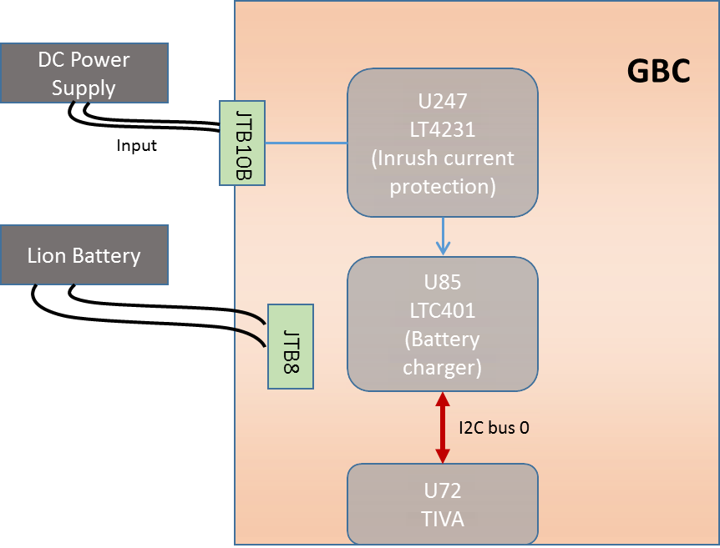
Figure 8. Lithium Ion battery - Test Setup Diagram

Impact of failure of test case on system

Impact | Applicable | Description
Functional | Yes | Battery charging and discharging will be affected.
Performance | Yes | If GBC is not powered through AUX or PoE, then power supply should be switched to lithium ion battery, else device will not be functional.
Compliance | NA | NA
Table 78. Failure Impact – Lithium Ion Battery Output Voltage Accuracy

Test Case: Output Voltage Accuracy (Test ID: PWR.5.1)

Description
- Purpose
Lithium ion battery is designed to work from voltage greater than 11.2V when AUX or solar input supply is absent. The purpose of this test case is to ensure the output voltage accuracy is within the desired level.
- Measurement Locations
Measurement Parameter | Measurement location
LT4231_LION_P | JTB8.1
VBC_LION | C1717.1
Table 79. Measurement Locations – Lithium Ion Battery Output Voltage Accuracy

Test Equipment List
1. Lithium Ion Battery: 3000mAH - LP103090TB
2. Oscilloscope: MSO9404A

Equipment Settings
- Oscilloscope: MSO9404A
Voltage per division: 5V
Time scale: 50ms
Bandwidth: 20MHz

Hardware Requisites
- GBC board

Software Requisites
NA

Test Condition
Test condition | Value | Remarks
Battery Voltage | 11.2V | Nominal battery voltage. Varies from 9V to 12.6V
Temperature | +25 C | Normal Room temperature
Table 80. Test Condition – Lithium Ion Battery Output Voltage Accuracy

DUT Settings
- Isolate input side of Intel microprocessor by removing the resistor R10067.

Requirements
Measurement Parameter | JTB8.1 | C1715.1 | C1718.1
Battery Voltage(V) | 9V to 12.6V | 9V to 12.6V | 18V
Table 81. Requirements – Lithium Ion Battery Output Voltage Accuracy

Test Procedure
- Remove resistor R10067 in order to isolate Intel processor.
- Connect lithium ion battery terminals between to JTB8.1 and JTB8.2
- Measure the battery voltage at JTB8.1
- The above measured voltage should be equal to the output of the battery charger U85 measured at C1715.1 and C1718.1 to ensure proper functionality of GBC module.

Reference
Further details can be found in Page 50 of GBC schematic Ver. Life-2.

Test Case: Charge Current Measurement (Test ID: PWR.5.2)

Description
- Purpose
Charge current for lithium ion battery is designed for 1.45A.
i.e. $Charge current =\frac{32mV}{22mohm}=1.45A$
Charge current read from register I_{bat} having sub-address 0x3D, must be equal to the programmed charge current (1.45A).
Note: Charge current will decrease when charging voltage increases.
- Measurement Locations
Access TIVA (U72) I2C channel 0 through CCS software. Read back the charge current from register 0x3D. Measure the current across R10039.

Test Equipment List
1. Lithium Ion Battery: 3000mAH - LP103090TB
2. CCS software
3. AUX Power supply unit: Agilent E3634A

Equipment Settings
- DC power supply: E3633A
Supply Voltage: 18V
Current Limit: 2.0A
OVP: 20V
OCP: 2.5A

Hardware Requisites
- GBC board
- Debug board

Software Requisites
- TIVA RTOS code for lead acid battery configuration

Test Condition
Test condition | Value | Remarks
Battery Voltage | 11.2V | Nominal battery voltage. Varies from 9V to 12.6V
Temperature | +25 C | Normal Room temperature
Table 82. Test Condition – Lithium Ion Battery Output Voltage Accuracy

DUT Settings
- Isolate input side of Intel microprocessor by removing the resistor R10067.

Requirements
Access TIVA (U72) I2C channel 0 through CCS software. Program the charge current for 1.45A by writing to register 0x1A. Read back the charge current from register 0x3D.
Programmed charge current must be equal to read charge current.
Note: Charge current will decrease when charging voltage increases.

Test Procedure
- Remove resistor R10067 in order to isolate Intel processor.
- Connect lithium ion battery terminals between to JTB8.1 and JTB8.2
- Connect a debug board to GBC board in order to access TIVA through CCS.
- Through I2C channel 0, lithium ion battery charger U85 can be accessed.
- Read register Ibat having sub-address 0x3D. This value gives the charging current of the lithium ion battery. Read value must be equal to the measured current across R10039.

Reference
Further details can be found in Page 50 of GBC schematic Ver. Life-2.

Test Case: Load Current Measurement (Test ID: PWR.5.3)

Description
- Purpose
Load current measurement is done by reading register IIN having sub-address 0x3E. Load current measured must be greater than charge current measured.
- Measurement Locations
Access TIVA (U72) I2C channel 0 through CCS software. Read register 0x3E for load current measurement.

Test Equipment List
1. Lithium Ion Battery: 3000mAH - LP103090TB
2. CCS software
3. AUX Power supply unit: Agilent E3634A

Equipment Settings
- DC power supply: E3633A
Supply Voltage: 18V
Current Limit: 2.0A
OVP: 20V
OCP: 2.5A

Hardware Requisites
- GBC board
- Debug board

Software Requisites
- TIVA RTOS code for lead acid battery configuration

Test Condition
Test condition | Value | Remarks
Battery Voltage | 11.2V | Nominal battery voltage. Varies from 9V to 12.6V
Temperature | +25 C | Normal Room temperature
Table 83. Test Condition – Lithium Ion Battery Load Current Measurement

DUT Settings
- Isolate input side of Intel microprocessor by removing the resistor R10067.

Requirements
Access TIVA (U72) I2C channel 0 through CCS software.

Test Procedure
- Remove resistor R10067 in order to isolate Intel processor.
- Connect lithium ion battery terminals between to JTB8.1 and JTB8.2
- Connect a debug board to GBC board in order to access TIVA through CCS.
- Through I2C channel 0, Lithium Ion battery charger U85 can be accessed.
- Read register IIN having sub-address 0x3E. This value gives the load current of GBC board.
- Measure the current across R9961.

Reference
Further details can be found in Page 50 of GBC schematic Ver. Life-2.

Test Case: LDO Output Voltage (Test ID: PWR.5.4)

Description
- Purpose
The purpose of this test case is to ensure the internal LDO output voltage of Lithium Ion battery charger U85 must be equal to 5V.
- Measurement Locations
Measurement Parameter | Measurement location
INT_VCC_LION | C1765.1
Table 84. Measurement Locations – Lithium Ion Charger LDO Output Voltage

Test Equipment List
1. Lithium Ion Battery: 3000mAH - LP103090TB
2. Oscilloscope: MSO9404A

Equipment Settings
1. Oscilloscope: MSO9404A
Voltage per division: 5V
Time scale: 50ms
Bandwidth: 20MHz

Hardware Requisites
- GBC board

Software Requisites
- TIVA RTOS code for lead acid battery configuration

Test Condition
Test condition | Value | Remarks
Battery Voltage | 11.2V | Nominal battery voltage. Varies from 9V to 12.6V
Temperature | +25 C | Normal Room temperature
Table 85. Test Condition – Lithium Ion Charger LDO Output Voltage

DUT Settings
- Isolate input side of Intel microprocessor by removing the resistor R10067.

Requirements
Measurement Parameter | C1765.1
INTVcc (internal LDO voltage) | 5V
Table 86. Requirements – Lithium Ion Charger LDO Output Voltage

Test Procedure
- Remove resistor R10067 in order to isolate Intel processor.
- Connect lithium ion battery terminals between to JTB8.1 and JTB8.2
- Measure the battery charger U85 internal LDO output voltage at C1765.1
- The above measured voltage should be equal to 5V to ensure proper functionality of GBC module.

Reference
Further details can be found in Page 50 of GBC schematic Ver. Life-2.

Test Case: Temperature Measurement (Test ID: PWR.5.5)

Description
- Purpose
The purpose of this test case is to measure the temperature of battery charger IC U85 when it’s fully operational.
- Measurement Locations
Measurement Parameter | Measurement location
Temperature | Of U85
Table 87. Measurement Locations – Lithium Ion battery charger temperature measurement

Test Equipment List
- Lithium Ion Battery: 3000mAH - LP103090TB
- CCS software

Equipment Settings
NA

Hardware Requisites
- GBC board
- Debug board

Software Requisites
- TIVA RTOS code for lead acid battery configuration

Test Condition
Test condition | Value | Remarks
Battery Voltage | 12V | Nominal battery voltage. Varies from 9.5V to 12.6V
Temperature | +25 C | Normal Room temperature
Table 88. Test Condition – Lead acid battery charger temperature measurement

DUT Settings
- Isolate input side of Intel microprocessor by removing the resistor R10067.

Requirements
Measurement Parameter | U82
Temperature | Within -40º C to +125º C
Table 89. Requirements – Lead acid battery charger temperature measurement Test

Procedure
- Remove resistor R10067 in order to isolate Intel processor.
- Connect lithium ion battery terminals between to JTB8.1 and JTB8.2
- Connect a debug board to GBC board in order to access TIVA through CCS. Through I2C channel 0, lithium ion battery charger U85 can be accessed.
- Read register DIE_TEMPERATURE having sub-address 0x3F.

Reference
Further details can be found in Page 50 of GBC schematic Ver. Life-2.

Test Case: Charge Control (JEITA) (Test ID: PWR.5.6)

Description
- Purpose
This test case indicates the current at which the lithium ion battery should be charged at a given temperature.
- Measurement Locations
NA

Test Equipment List
- Lithium Ion Battery: 3000mAH - LP103090TB
- CCS software
- AUX Power supply unit: Agilent E3634A

Equipment Settings
- DC power supply: E3633A
Supply Voltage: 18V
Current Limit: 3.0A
OVP: 20V
OCP: 4A

Hardware Requisites
- GBC board
- Debug board

Software Requisites
- TIVA RTOS code for lithium ion battery configuration

Test Condition
Test condition | Value | Remarks
Battery Voltage | 12V | Nominal battery voltage. Varies from 9.5V to 13.8V
Temperature | +25 C | Normal Room temperature
Table 90. Test Condition – Lithium Ion battery charger temperature measurement

DUT Settings
- Isolate input side of Intel microprocessor by removing the resistor R10067.

Requirements
Measurement Parameter | U82
IBAT | Register 0x3D
Table 91. Requirements – Lithium Ion battery charger temperature measurement

Test Procedure
- Remove resistor R10067 in order to isolate Intel processor.
- Connect lithium ion battery terminals between to JTB8.1 and JTB8.2
- Connect a debug board to GBC board in order to access TIVA through CCS. Through I2C channel 0, Lithium Ion battery charger U85 can be accessed.
- Write to registers from JEITA_T1 (sub- address 0x1F) to JEITA_T6 (sub- address 0x24) with temperature range from 0◦C to 60◦C.
- Read register DIE_TEMP (sub-address 0x3F) to know the temperature. The battery should charge with a current corresponding to the measured temperature.
- Measure the charging current by measuring voltage across R10039. Charging current can be calculated by:$Charging Current= \frac{measured voltage(mV)}{22}$ . Also read the register IBAT (sub-address 0x3D).

Reference
Further details can be found in Page 49 of GBC schematic Ver. Life-2.

Test Case: Lead Acid and Li-ion battery OR-ing circuit (Test ID: PWR.5.7)

Description
- Purpose
The purpose of this test case is to ensure that power supply will be switched between external battery (Lead acid battery) and internal battery (Lithium - ion battery) at the designed voltage. Detects Lead acid battery if battery voltage is greater than10.35V. Detects Lithium Ion battery if battery voltage is greater than 11.2V.

- Measurement Locations
Measurement Parameter | Measurement location
VBC_LACID | C3M97.1
VBC_LION | C3M98.1
VPOUT_BUCK | C3M96.1
Table 92. Measurement Locations – Battery OR-ing Circuit

Test Equipment List
- Lead Acid Battery: 65Ah – Amaron Quanta 12AL065
- Lithium Ion Battery: 3000mAH - LP103090TB
- Oscilloscope: MSO9404A

Equipment Settings
- Oscilloscope: MSO9404A
Voltage per division: 5V
Time scale: 50ms
Bandwidth: 20MHz

Test Condition
Test condition | Value | Remarks
Battery Voltage | 11.2V | Nominal battery voltage. To be greater than 11.2V and lead acid battery voltage < 11.5V
Temperature | +25 C | Normal Room temperature
Table 93. Test Condition – Battery OR-ing Circuit

DUT Settings
- Isolate input side of Intel microprocessor by removing the resistor R10067.

Requirements
Measurement Parameter | R1274.2 | R1275.1 | C3M97.1 | C3M98.1
VBC_LACID | NA | NA | <10.35V | NA
VBC_LION | NA | NA | NA | >11.2V
Table 94. Requirements – Battery OR-ing Circuit

Test Procedure
- Remove resistor R10067 in order to isolate Intel processor.
- Connect lithium ion battery terminals between to JTB8.1and JTB8.2
- Measure the battery voltage at JTB8.1.
- If lithium ion battery voltage is greater than 11.2V and lead acid battery voltage is less than 10.35V, then measured voltage at VPS_VOUT at C3M96. Indicating that lithium ion battery is present as the power source for GBC.

Reference
Further details can be found in Page 46 and 52 of GBC schematic Ver. Life-2.

Test Case: Charge Time (Test ID: PWR.5.8)

Description
- Purpose
Charge time can be programmed by writing into register MAX_CHARGE_TIME at address 0x1E.
- Measurement Locations
Access TIVA (U72) I2C channel 0 through CCS software. Read MAX_CHARGE_TIMER register 0x30 to obtain maximum charge time.

Test Equipment List
1. Lithium Ion Battery: 3000mAH - LP103090TB
2. CCS software
3. AUX Power supply unit: Agilent E3634A

Equipment Settings
- DC power supply: E3633A
Supply Voltage: 18V
Current Limit: 2.0A
OVP: 20V
OCP: 2.5A

Hardware Requisites
- GBC board
- Debug board

Software Requisites
- TIVA RTOS code for lead acid battery configuration

Test Condition
Test condition | Value | Remarks
Battery Voltage | 11.2V | Nominal battery voltage. Varies from 9V to 12.6V
Temperature | +25 C | Normal Room temperature
Table 95. Test Condition – Lithium Ion Battery Charge Time Measurement

DUT Settings
- Isolate input side of Intel microprocessor by removing the resistor R10067.

Requirements
Access TIVA (U72) I2C channel 0 through CCS software.

Test Procedure
- Remove resistor R10067 in order to isolate Intel processor.
- Connect lithium ion battery terminals between to JTB8.1and JTB8.2
- Connect a debug board to GBC board in order to access TIVA through CCS.
- Through I2C channel 0, lithium ion battery charger U85 can be accessed.
- Read register MAX_CHARGE_TIME having sub-address 0x30. This register outputs the value of total time (in seconds) the lithium ion battery is in charging state.

Reference
Further details can be found in Page 50 of GBC schematic Ver. Life-2

Test Case: Power Delivery (Test ID: PWR.5.9)

Description
- Purpose
The purpose of the test case is to validate the power delivery of Lithium Ion Battery.
- Impact of failure of test case on system

Impact | Applicable | Description
Functional | NA
Performance | Yes | The System will not turn on if the required power is not delivered
Compliance | NA
Table 96. Impact of Failure of Lithium Ion Battery charger - Power delivery
- Measurement Locations
R10039, R10044

Test Equipment List
- DC power supply: Agilent E3634A
- Lead Acid Battery: 65Ah – Amaron Quanta 12AL065

Equipment Settings
- DC power supply: E3633A
Supply Voltage: 18V
Current Limit: 12.0A
OVP: 20V
OCP: 15A

Hardware Requisites
- GBC board

Software Requisites
NA

Test Condition
Test condition | Value | Remarks
Battery Voltage | 11.2V | Nominal battery voltage. Varies from 9V to 12.6V
Temperature | +25 C | Normal Room temperature
Table 97. Test Condition – Lithium Ion Battery charger - Power delivery

DUT Settings
NA

Requirements
Sl.No. | Parameters | Input Section | Output Section
1 | Probing points | R10039 | R10044
2 | Resistor Value (mΩ) | 22 | 10
3 | Voltage (V) | 12.48 | 12
6 | Expected Power (W) | Output power = Input power
7 | Expected Efficiency (%) | 60 – 70 (Considering 1A load)
Table 98. Requirements – Lithium Ion Battery charger - Power delivery

Test Procedure
- Connect lithium ion battery terminals between JTB8.1 and JTB8.2 of GBC board.
- Configure DC power supply to give a voltage of 18V.
- Measure the voltage at the sense resistors R10039 (for input section) and R10044 (output section)
- Calculating the current and power and efficiency.
- The efficiency is calculated as η = 100% * P_{out} / P_{in}.
- Make sure the measuring criteria for the signal satisfies the above mentioned requirements.

Reference
Further details can be found in Page 50 of GBC schematic Ver. Life-2.

Buck-Boost

Test Setup
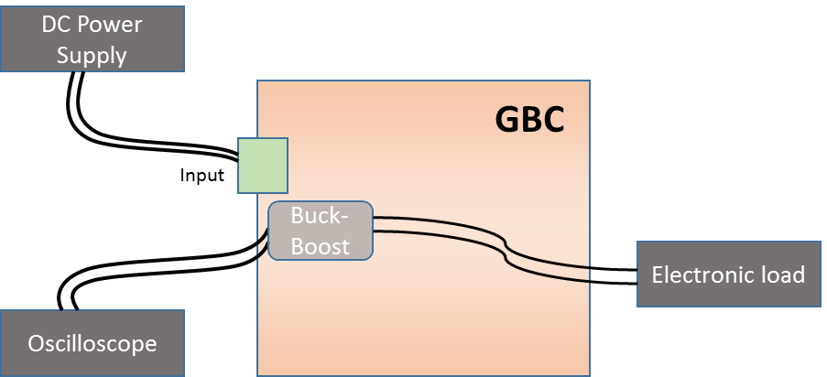
Figure 9. Buck-Boost - Test Setup Diagram

Test Case: line regulation (Test ID: PWR.6.1)

Description
- Purpose
The purpose of this test case is to check the ability of the Buck-Boost converter to maintain its specified output voltage over changes in the input line voltage.
- Impact of failure of test case on system
Impact | Applicable | Description
Functional | NA
Performance | Yes | If the output voltage is not as expected with the varying input voltage, then the end devices will not power up or will get damage.
Compliance | NA
Table 99. Impact of Failure of line regulation
- Measurement Locations
- R10044.2

Test Equipment List
- Oscilloscope: MSO9404A
- DC power supply: E3633A
- Electronic load

Equipment Settings
- Oscilloscope: MSO9404A
Voltage scale: 5V
- DC power supply: E3633A
Supply Voltage: +9V DC to 22V DC
Current Limit: 2A
OVP: 23V
OCP: 2.1A
- Electronic load
Current Limit: 0.5A - 1.5A

Hardware Requisites
- GBC board

Software Requisites
NA

Test Condition
Test condition | Value | Remarks
Voltage | +9V DC to 22V DC | Varied input voltage
Temperature | +25 C | Normal Room temperature
Table 100. Test Condition for line regulation

DUT Settings
- Remove R10071 resistor to isolate input side of buck boost (U88).
- Remove R10054 and R10067 resistors to isolate output side of buck boost from TIVA and Intel.

Requirements
Voltage Rail | Measuring Point | Input Voltage(V) | Load current(A) | Expected Output Voltage(V) | Accuracy/Pass criteria
12V_IN | R10044.2 | 9 - 22 | 0.5 – 1.5 | 12 | ±2%
Table 101. Requirements for line regulation

Test Procedure
- This test is conducted by configuring power supply to give a voltage in the range of 9V to 22V.
- Connect load at R10044.2 (output of buck- boost).
- Vary the input voltage.
- Vary load current from 0.5 to 1.5 in steps of 0.5.
- Measure output voltage at R10044.2 and make sure the measured voltage should be within the tolerance limit (±2%) as mentioned in the above requirement table.

Reference
Further details can be found in Page 53, 55 and 28 of GBC schematic Ver. Life-2.

Test Case: Load regulation (Test ID: PWR.6.2)

Description
- Purpose
The purpose of this test case is to check the capability of Buck-Boost converter to maintain a constant output voltage over changes in the load.

- Impact of failure of test case on system
Impact | Applicable | Description
Functional | NA
Performance | Yes | If the output voltage is not as expected with the varying output load, then the end devices will get damage.
Compliance | NA
Table 102. Impact of Failure of load regulation
- Measurement Locations
R10044.2

Test Equipment List
- Oscilloscope: MSO9404A
- DC power supply: E3633A
- Electronic load

Equipment Settings
- Oscilloscope: MSO9404A
Voltage scale: 5V
- DC power supply: E3633A
Supply Voltage: 18V DC
Current Limit: 2A
OVP: 19V
OCP: 2.1A
- Electronic load
Current Limit: 0.5A - 1.5A

Hardware Requisites
- GBC board

Software Requisites
NA

Test Condition
Test condition | Value | Remarks
Voltage | +18V DC | Nominal voltage
Temperature | +25 C | Normal Room temperature
Table 103. Test Condition for load regulation

DUT Settings
- Remove R10071 resistor to isolate input side of buck boost (U88).
- Remove R10054 and R10067 resistors to isolate output side of buck boost from TIVA and Intel.

Requirements
Voltage Rail | Measuring Point | Input Voltage(V) | Load current(A) | Expected Output Voltage(V) | Accuracy/Pass criteria
12V_IN | R10044.2 | 18 | 0.5 – 1.5 | 12 | ±2%
Table 104. Requirements for load regulation

Test Procedure
- This test is conducted by configuring power supply to give a voltage of 18V.
- Connect load at R10044.2 (output of buck- boost).
- Vary load current from 0.5 to 1.5 in steps of 0.5.
- Measure output voltage at R10044.2 and make sure the measured voltage should be within the tolerance limit (±2%) as mentioned in the above requirement table.

Reference
Further details can be found in Page 53, 55 and 28 of GBC schematic Ver. Life-2.

Test Case: Ripple measurement (Test ID: PWR.6.3)

Description
- Purpose
The purpose of this test case is to check the maximum peak-to-peak ripple voltage of Buck-Boost converter output under different load conditions and input voltage.
- Impact of failure of test case on system
Impact | Applicable | Description
Functional | NA
Performance | Yes | If ripple voltage is more than expected, board noise will increase and leading to failure of capacitors.
Compliance | NA
Table 105. Impact of Failure of Ripple measurement
- Measurement Locations
C1990

Test Equipment List
- Oscilloscope: MSO9404A
- DC power supply: E3633A
- Electronic load

Equipment Settings
- Oscilloscope: MSO9404A
Voltage scale: 100mV
- DC power supply: E3633A
Supply Voltage: +9V DC to 22V DC
Current Limit: 2A
OVP: 23V
OCP: 2.1A
- Electronic load
Current Limit: 0.5A - 1.5A

Hardware Requisites
- GBC board

Software Requisites
NA

Test Condition
Test condition | Value | Remarks
Voltage | +9V DC to 22V DC | Varied input voltage
Temperature | +25 C | Normal Room temperature
Table 106. Test Condition for ripple measurement

DUT Settings
- Remove R10071 resistor to isolate input side of buck boost (U88).
- Remove R10054 and R10067 resistors to isolate output side of buck boost from TIVA and Intel.

Requirements
Voltage Rail | Measuring Point | Input Voltage(V) | Load current(A) | Maximum Ripple Voltage
12V_IN | C1990 | 9V – 22V | 0.5 – 1.5 | ±5%*input voltage
Table 107. Requirements for ripple measurement

Test Procedure
- This test is conducted by configuring power supply to give a voltage in the range of 9V to 22V.
- Connect load at R10044.2 (output of buck- boost).
- Vary the input voltage.
- Vary load current from 0.5 to 1.5 in steps of 0.5.
- Measure ripple voltage at C1990 and make sure the measured ripple voltage should be less than ±5% of input voltage as mentioned in the above requirement table.

Reference
Further details can be found in Page 53, 55 and 28 of GBC schematic Ver. Life-2.

Test Case: Load current measurement (Test ID: PWR.6.4)

Description
- Purpose
The purpose of this test case is to measure the current drawn by Buck-Boost Converter when it is fully operational.
- Impact of failure of test case on system
Impact | Applicable | Description
Functional | NA
Performance | NA
Compliance | NA
Table 108. Impact of Failure of load current measurement
- Measurement Locations
- R10044

Test Equipment List
- DC power supply: E3633A
- Digital multimeter: 34401A

Equipment Settings
- DC power supply: E3633A
Supply Voltage: 18V DC
Current Limit: 1.5A
OVP: 19V
OCP: 1.6A
- Digital multimeter: 34401A

Hardware Requisites
- GBC board

Software Requisites
NA

Test Condition
Test condition | Value | Remarks
Voltage | +18V DC | Nominal voltage
Temperature | +25 C | Normal Room temperature
Table 109. Test Condition for load current measurement

DUT Settings
NA

Requirements
Voltage Rail | Measuring Point | Input Voltage(V) | Expected Load current(A)
 |  |  | Min | Max
12V_IN | R10044 | 18 | 0.4 | 0.8

Table 110. Requirements for load current measurement
NOTE: As per the design spec maximum GBC standalone load current is 0.8A.

Test Procedure
- This test is conducted by configuring power supply to give a voltage of 18V.
- Measure voltage across sense resistor R10044 (0.01ohm).
- Using measured voltage derive current drawn by the system.
- Make sure the derived current should match the system load current as mentioned in the above requirement table.

Reference
Further details can be found in Page 53 of GBC schematic Ver. Life-2.

Test Case: Temperature measurement (Test ID: PWR.6.5)

Description
- Purpose
The purpose of this test case is to measure the operating junction temperature of Buck Boost converter when it is fully operational under ambient temperature.
- Impact of failure of test case on system
Impact | Applicable | Description
Functional | Yes | Failure of this test case will result in damage of IC (U88).
Performance | NA
Compliance | NA
Table 111. Impact of Failure of Temperature measurement
- Measurement Locations
- U88

Test Equipment List
- DC power supply: E3633A
- Fluke 59 Mini IR Thermometer

Equipment Settings
- DC power supply: E3633A
Supply Voltage: 18V DC
Current Limit: 1.5A
OVP: 19V
OCP: 1.6A

Hardware Requisites
- GBC board

Software Requisites
NA

Test Condition
Test condition | Value | Remarks
Voltage | +18V DC | Nominal voltage
Temperature | +25 C | Normal Room temperature
Table 112. Test Condition for temperature measurement

DUT Settings
NA

Requirements
Test device | Measuring Point | Expected operating temperature (in degree Celsius)
Buck Boost(LT3790EFE) | U88 | -40°C to 125°C
Table 113. Requirements for temperature measurement

Test Procedure
- This test is conducted by configuring power supply to give a voltage of 18V.
- Measure the case temperature on U88 using Fluke 59 Mini IR Thermometer.
- Using the following formula calculate operating junction temperature.
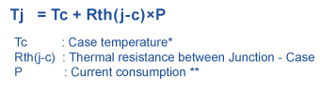
- Ensure the derived operating junction temperature should be within the range of expected operating temperature as mentioned in the above requirement table.

Reference
Further details can be found in Page 53 of GBC schematic Ver. Life-2.

TIVA power supply

Test Setup: TIVA power supply
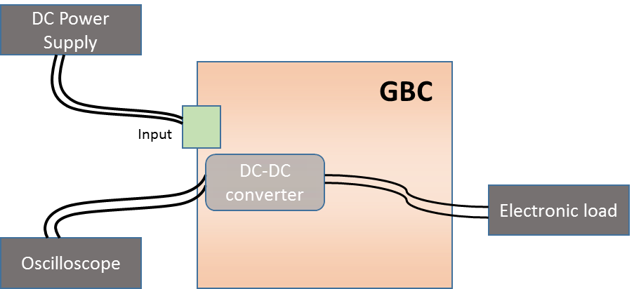
Figure 10. TIVA power supply - Test Setup Diagram

Test Case: Ripple measurement (Test ID: PWR.7.3)

Description
- Purpose
The purpose of this test case is to check the maximum peak-to-peak ripple voltage of DC-DC converter output under typical load and typical input voltage condition.
- Impact of failure of test case on system

Impact | Applicable | Description
Functional | NA
Performance | Yes | If ripple voltage is more than expected, board noise will increase and leading to failure of capacitors
Compliance | NA
Table 114. Impact of Failure of ripple measurement
- Measurement Locations
C502

Test Equipment List
- Oscilloscope: MSO9404A
- DC power supply: E3633A

Equipment Settings
- Oscilloscope: MSO9404A
Voltage scale: 20mV

- DC power supply: E3633A
Supply Voltage: +18V DC
Current Limit: 1A
OVP: 19V
OCP: 1.5A

Hardware Requisites
- GBC board

Software Requisites
NA

Test Condition
Test condition | Value | Remarks
Voltage | 18VDC | Nominal voltage
Temperature | +25 C | Normal Room temperature
Table 115. Test Condition for ripple measurement

DUT Settings
NA

Requirements
Voltage Rail | Measuring Point | Input Voltage(V) | Load current(A) | Maximum Ripple Voltage(mV)
3.3VD_TIVA | C502 | 18V | Operating /Typical load | 10mVp-p
Table 116. Requirements for ripple measurement

Test Procedure
- This test is conducted by configuring power supply to give a voltage of 18V.
- Measure ripple voltage at C502 and make sure the measured ripple voltage should be less than 10mVp-p as per the LT8640EUDC specification.

Reference
Further details can be found in Page 55 of GBC schematic Ver. Life-2.

Test Case: Load current measurement (Test ID: PWR.7.4)

Description
- Purpose
The purpose of this test case is to measure the current drawn by TIVA microcontroller when it is fully operational.

- Impact of failure of test case on system

Impact | Applicable | Description
Functional | NA
Performance | NA
Compliance | NA
Table 117. Impact of Failure of Load current measurement
- Measurement Locations
R10054

Test Equipment List
- DC power supply: E3633A
- Digital multimeter: 34401A

Equipment Settings
- DC power supply: E3633A
Supply Voltage: 18V DC
Current Limit: 1.5A
OVP: 19V
OCP: 1.6A

- Digital Multimeter: 34401A

Hardware Requisites
- GBC board

Software Requisites
NA

Test Condition
Test condition | Value | Remarks
Voltage | 18VDC | Nominal voltage
Temperature | +25 C | Normal Room temperature
Table 118. Test Condition for Load current measurement

DUT Settings
NA

Requirements
Voltage Rail | Measuring Point | Input Voltage(V) | Expected Load current(A)
12V_VIN_TIVA | R10054 | 18V | Measured current should be equal to Current read through I2C ± 10mA
Table 119. Requirements for Load current measurement

Test Procedure
- This test is conducted by configuring power supply to give a voltage of 18V.
- Measure voltage across sense resistor R10054 (0.002ohm).
- Using measured voltage derive current drawn by the system.
- Make sure the derived current should match the current read through I2C as mentioned in the above requirement table.

Reference
Further details can be found in Page 55 of GBC schematic Ver. Life-2.

Test Case: Temperature measurement (Test ID: PWR.7.5)

Description
- Purpose
The purpose of this test case is to measure the operating junction temperature of TIVA microcontroller when it is fully operational under ambient temperature.
- Impact of failure of test case on system

Impact | Applicable | Description
Functional | Yes | Failure of this test case will result in damage of IC (U72).
Performance | NA
Compliance | NA
Table 120. Impact of Failure of Temperature measurement
- Measurement Locations
U72

Test Equipment List
- DC power supply: E3633A
- Fluke 59 Mini IR Thermometer

Equipment Settings
- DC power supply: E3633A
Supply Voltage: 18V DC
Current Limit: 2A
OVP: 19V
OCP: 2.1A

Hardware Requisites
- GBC board

Software Requisites
NA

Test Condition
Test condition | Value | Remarks
Voltage | +18V DC | Nominal voltage
Temperature | +25 C | Normal Room temperature
Table 121. Test Condition for temperature measurement

DUT Settings
NA

Requirements
Test device | Measuring Point | Expected operating temperature (in degree Celsius)
TIVA (TM4C1294NCPDT-128-TQFP) | U72 | -40°C to 85°C
Table 122. Requirements for temperature measurement

Test Procedure
- This test is conducted by configuring power supply to give a voltage of 18V.
- Measure the case temperature on U72 using Fluke 59 Mini IR Thermometer.
- Using the following formula calculate operating junction temperature.
- Ensure the derived operating junction temperature should be within the range of expected operating temperature as mentioned in the above requirement table.

Reference
Further details can be found in Page 58, 59 and 60 of GBC schematic Ver. Life-2.

FET Switch

Test Setup: FET Switch
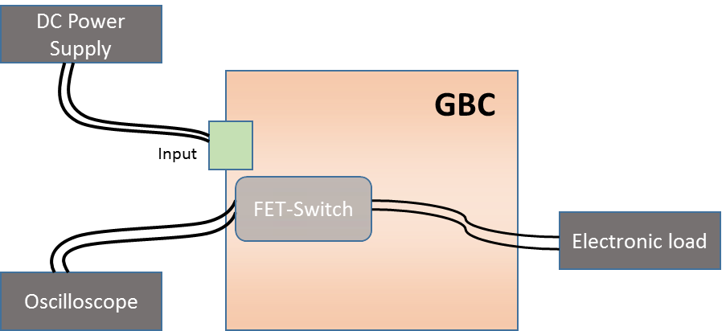
Figure 11. FET Switch - Test Setup Diagram

Test Case: Ripple measurement (Test ID: PWR.9.3)

Description
- Purpose
The purpose of this test case is to check the maximum peak-to-peak ripple voltage of FET switch.
- Impact of failure of test case on system

Impact | Applicable | Description
Functional | NA
Performance | Yes | If ripple voltage is more than expected, board noise will increase and leading to failure of capacitors
Compliance | NA
Table 123. Impact of Failure of Ripple measurement
- Measurement Locations
C1A4

Test Equipment List
- Oscilloscope: MSO9404A
- DC power supply: E3633A

Equipment Settings
- Oscilloscope: MSO9404A
Voltage scale: 50mV

- DC power supply: E3633A
Supply Voltage: +18V DC
Current Limit: 1A
OVP: 19V
OCP: 1.5A

Hardware Requisites
- GBC board

Software Requisites
NA

Test Condition
Test condition | Value | Remarks
Voltage | +18V DC | Nominal voltage
Temperature | +25 C | Normal Room temperature
Table 124. Test Condition for Ripple measurement

DUT Settings
NA

Requirements
Voltage Rail | Measuring Point | Input Voltage(V) | Load current(A) | Maximum Ripple Voltage
V12_A | C1A4 | 18V | Operating load | 600mVp-p
Table 125. Requirements for Ripple measurement

Test Procedure
- This test is conducted by configuring power supply to give a voltage of 18V.
- Measure ripple voltage at C1A4 and make sure the measured ripple voltage should be less than 600mVp-p as mentioned in the above requirement table.

Reference
Further details can be found in Page 28 and 29 of GBC schematic Ver. Life-2.

Test Case: Load current measurement (Test ID: PWR.9.4)

Description
- Purpose
The purpose of this test case is to measure the current drawn by FET switch when it is operational.
- Impact of failure of test case on system

Impact | Applicable | Description
Functional | NA
Performance | NA
Compliance | NA
Table 126. Impact of Failure of Load current measurement
- Measurement Locations
R10067

Test Equipment List
- DC power supply: E3633A
- Digital multimeter: 34401A

Equipment Settings
- DC power supply: E3633A
Supply Voltage: 18V DC
Current Limit: 1.5A
OVP: 19V
OCP: 1.6A

- Digital Multimeter: 34401A

Hardware Requisites
- GBC board

Software Requisites
NA

Test Condition
Test condition | Value | Remarks
Voltage | 18VDC | Nominal voltage
Temperature | +25 C | Normal Room temperature
Table 127. Test Condition for Load current measurement

DUT Settings
NA

Requirements
Voltage Rail | Measuring Point | Input Voltage(V) | Expected Load current(A)
V12_ATOM_IN | R10067 | 18V | Measured current should be equal to Current read through I2C ± 10mA
Table 128. Requirements for Load current measurement

Test Procedure
- This test is conducted by configuring power supply to give a voltage of 18V.
- Measure voltage across sense resistor R10067 (0.002ohm).
- Using measured voltage derive current drawn by the system.
- Make sure the derived current should match the current read through I2C as mentioned in the above requirement table.

Reference
Further details can be found in Page 28 of GBC schematic Ver. Life-2.

Test Case: Temperature measurement (Test ID: PWR.9.5)

Description
- Purpose
The purpose of this test case is to measure the operating junction temperature of FET switch U248 when it is fully operational under ambient temperature.
- Impact of failure of test case on system
Impact | Applicable | Description
Functional | Yes | Failure of this test case will result in damage of IC (U248).
Performance | NA
Compliance | NA
Table 129. Impact of Failure of Temperature measurement
- Measurement Locations
U248

Test Equipment List
- Fluke 59 Mini IR Thermometer
- DC power supply: E3633A

Equipment Settings
- DC power supply: E3633A
Supply Voltage: 18V DC
Current Limit: 1.5A
OVP: 19V
OCP: 1.6A

Hardware Requisites
- GBC board

Software Requisites
NA

Test Condition
Test condition | Value | Remarks
Voltage | +18V DC | Nominal voltage
Temperature | +25 C | Normal Room temperature
Table 130. Test Condition for temperature measurement

DUT Settings
NA

Requirements
Test device | Measuring Point | Expected operating temperature (in degree Celsius)
FET (TPS259241) | U248 | -40°C to 125°C
Table 131. Requirements for temperature measurement

Test Procedure
- This test is conducted by configuring power supply to give a voltage of 18V.
- Measure the case temperature on U248 using Fluke 59 Mini IR Thermometer.
- Using the following formula calculate operating junction temperature.
- Ensure the derived operating junction temperature should be within the range of expected operating temperature as mentioned in the above requirement table.

Reference
Further details can be found in Page 28 of GBC schematic Ver. Life-2.

PMIC

Test Setup: PMIC
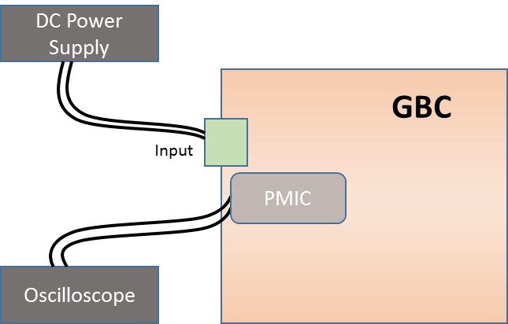
Figure 12. PMIC - Test Setup Diagram

Test Case: Voltage accuracy of all output voltages (Test ID: PWR.10.2)

Description
- Purpose
The purpose of the test case is to measure the output voltage rails of PMIC and to ensure that these voltages are in specified limits for the proper operation of Intel SoC.
- Impact of failure of test case on system

Impact | Applicable | Description
Functional | Yes | Failure of this test case will result in not powering the Intel and subsequent IC’s.
Performance | NA
Compliance | NA
Table 132. Impact of Failure of Voltage accuracy of all output voltages
- Measurement Locations
C3M17, C4M10, C3M24, C3M8, C3M30, C3M22, C2N9, C2N11, C4P17, C1B7, C3M10, C3M11, C2B34, C2B1, C1B4, C3M180, C3M19 and C3L18

Test Equipment List
- DC power supply: E3633A
- Digital Multimeter

Equipment Settings
- DC power supply: E3633A
Supply Voltage: 18V
Current Limit: 1A
OVP: 19V
OCP: 1.1A

Hardware Requisites
- GBC board

Software Requisites
NA

Test Condition
Test condition | Value | Remarks
Voltage | +18V DC | Nominal voltage
Temperature | +25 C | Normal Room temperature
Table 133. Test Condition for Voltage accuracy of all output voltages

DUT Settings
NA

Requirements
Voltage Rail | Measuring Points | Output Voltage Specification
 |  | Min(V) | Max(V)
V1P8_A | C3M17 | 1.764 | 1.836
VDDQ | C4M10 | 1.323 | 1.377
V5_A | C3M24 | 4.9 | 5.1
V1P5_S | C3M8 | 1.47 | 1.53
VSFR_SX | C3M30 | 1.323 | 1.377
V1P35_S | C3M22 | 1.323 | 1.377
V1P2_A | C2N9 | 1.225 | 1.275
V1P2_S | C2N11 | 1.225 | 1.275
VTT_DDR | C4P17 | 0.62775 | 0.72225
V1P8_IFSUP | C1B7 | 1.764 | 1.836
VUSBPHY | C3M10 | 3.234 | 3.366
V3P3_A | C3M11 | 3.234 | 3.366
VCC_S | C2B34 | 0.98 | 1.02
VNN_S | C2B1 | 0.931 | 0.969
VDDQ | C1B4 | 1.323 | 1.377
V1P05_S | C3M180 | 1.029 | 1.071
V1P0_A | C3M19 | 0.98 | 1.02
V12_A | C3L18 | 11.76 | 12.24
Table 134. Requirements for Voltage accuracy of all output voltages

Test Procedure
- Conduct the test by configuring power supply to give a voltage of 18V.
- Measure Voltage rails by probing at appropriate locations as mentioned in the above requirement table.
- Make sure the measured voltages should be within the tolerance limit as mentioned in the above requirement table.

Reference
Further details can be found from Page 30 to 33 of GBC schematic Ver. Life-2.

Test Case: Secondary supplies enable functionality (Test ID: PWR.10.3)

Description
- Purpose
Purpose of the test case is to validate secondary supply rails of PMIC by checking status of dependency rails with respect to change in status (high or low).
- Impact of failure of test case on system

Impact | Applicable | Description
Functional | Yes | Dependency power rails will not enable/disable as per the requirement if this test case fails.
Performance | NA | .
Compliance | NA
Table 135. Impact of Failure of Secondary supplies enable functionality
- Measurement Locations
C3M30, C3B21, C3M30, C3B21, c3M180, C2N11, C3M8, C3M22, c3M180, C2N11, C3M8 and C3M22

Test Equipment List
- DC power supply: E3633A
- Oscilloscope: MSO9404A

Equipment Settings
- Oscilloscope: MSO9404A
Voltage scale: 1V

- DC power supply: E3633A
Supply Voltage: 18V
Current Limit: 1A
OVP: 19V
OCP: 1.1A

Hardware Requisites
- GBC board

Software Requisites
NA

Test Condition
Test condition | Value | Remarks
Voltage | +18V DC | Nominal voltage
Temperature | +25 C | Normal Room temperature
Table 136. Test Condition for Secondary supplies enable functionality

DUT Settings
NA

Requirements
Power rail | Power rail Status | Dependency rails | Measuring Points | Dependency rail status
PMIC_SLP_S0IX | High | VSFRX | C3M30 | Enable
 |  | V1P0SX_EN | C3B21 | Enable
 | Low | VSFRX | C3M30 | Disable
 |  | V1P0SX_EN | C3B21 | Disable
PMIC_SLP_S3 | High | V1P05_S | c3M180 | Enable
 |  | V1P02_S | C2N11 | Enable
 |  | V1P5_S | C3M8 | Enable
 |  | V1P35_S | C3M22 | Enable
 | Low | V1P05_S | c3M180 | Disable
 |  | V1P02_S | C2N11 | Disable
 |  | V1P5_S | C3M8 | Disable
 |  | V1P35_S | C3M22 | Disable
Table 137. Requirements for Secondary supplies enable functionality

Test Procedure
- Conduct the test by configuring power supply to give a voltage of 18V.
- Validate the secondary supply rails (PMIC_SLP_S0IX and PMIC_SLP_S3) by
Measuring the dependency voltage rails status with respect to change in status of secondary supplies by probing at appropriate locations as mentioned in the above requirement table.
- Make sure the measured voltage rails status should be as mentioned in the above requirement table.

Reference
Further details can be found in Page 33 of GBC schematic Ver. Life-2.

Test Case: PMIC debug circuit functionality (Test ID: PWR.10.5)

Description
- Purpose
The purpose of the test case is to validate debug circuit of PMIC
- Impact of failure of test case on system

Impact | Applicable | Description
Functional | Yes | Dependency power rails of debug circuit rails will not enable/disable as per the requirement if this test case fails.
Performance | NA
Compliance | NA
Table 138. Impact of Failure of PMIC debug circuit functionality
- Measurement Locations
C3M30, C3B21, C3M30, C3B21, c3M180, C2N11, C3M8, C3M22, c3M180, C2N11, C3M8 and C3M22

Test Equipment List
- DC power supply: E3633A
- Oscilloscope: MSO9404A

Equipment Settings
- Oscilloscope: MSO9404A
Voltage scale: 1V

- DC power supply: E3633A
Supply Voltage: 18V
Current Limit: 1A
OVP: 19V
OCP: 1.1A

Hardware Requisites
- GBC board

Software Requisites
NA

Test Condition
Test condition | Value | Remarks
Voltage | +18V DC | Nominal voltage
Temperature | +25 C | Normal Room temperature
Table 139. Test Condition for PMIC debug circuit functionality

DUT Settings
NA

Requirements
Power rail | Power rail Status | Dependency rails | Measuring Points | Dependency rail status
PMIC_SLP_S0IX | High | VSFRX | C3M30 | Enable
 |  | V1P0SX_EN | C3B21 | Enable
 | Low | VSFRX | C3M30 | Disable
 |  | V1P0SX_EN | C3B21 | Disable
PMIC_SLP_S3 | High | V1P05_S | C3M180 | Enable
 |  | V1P02_S | C2N11 | Enable
 |  | V1P5_S | C3M8 | Enable
 |  | V1P35_S | C3M22 | Enable
 | Low | V1P05_S | C3M180 | Disable
 |  | V1P02_S | C2N11 | Disable
 |  | V1P5_S | C3M8 | Disable
 |  | V1P35_S | C3M22 | Disable
PMIC_THERMTRIP | High | All Power rails |  | Enable
 | Low | All Power rails |  | Disable
Table 140. Requirements for PMIC debug circuit functionality

Test Procedure
- Conduct the test by configuring power supply to give a voltage of 18V.
- Validate the PMIC debug circuit power rails (PMIC_SLP_S0IX, PMIC_SLP_S3 and PMIC_THERMTRIP) by measuring dependency voltage rails status with respect to change in status of the debug power rails by probing at appropriate locations as mentioned in the above requirement table.
- Make sure the measured voltage rails status should be as mentioned in the above requirement table.

Reference
Further details can be found in Page 33 of GBC schematic Ver. Life-2.

System Power sequence

Test Setup: System Power sequence
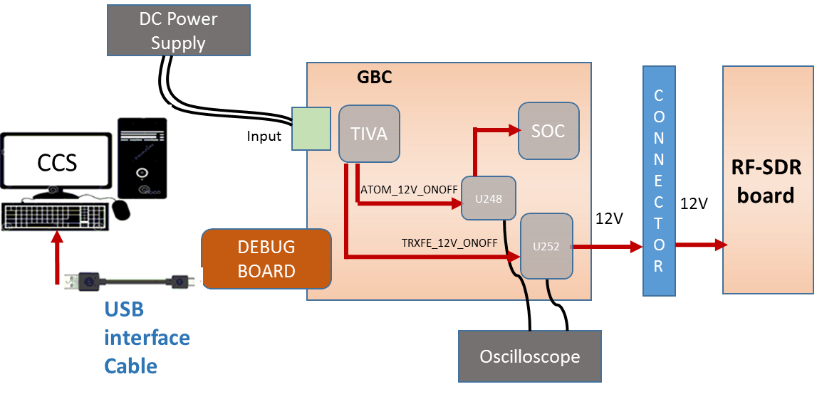
Figure 13. System Power sequence - Test Setup Diagram

Test Case: Power-up (Test ID: PWR.11.1)

Description
- Purpose
The purpose of the test case is to validate the Power-up sequence of the system including GBC and RF-SDR board.
- Impact of failure of test case on system

Impact | Applicable | Description
Functional | Yes | Failure of this test case will result in abnormal functionality of the system.
Performance | NA
Compliance | NA
Table 141. Impact of Failure of Power-up Sequence
- Measurement Locations
R10753, R10580

Test Equipment List
- Oscilloscope: MSO9404A
- DC power supply: E3633A

Equipment Settings
- Oscilloscope: MSO9404A
Voltage per division: 1V
Time scale: 1ms

- DC power supply: E3633A
Supply Voltage: 18V
Current Limit: 1.5A
OVP: 19V
OCP: 2A

Hardware Requisites
- GBC board
- Debug board
- RF-SDR board

Software Requisites
- Code Composer Studio Tool
- Power Sequence code

Test Condition
Test condition | Value | Remarks
Voltage | 18V | Nominal input voltage
Temperature | +25 C | Normal Room temperature
Table 142. Test Condition for Power-up Sequence

DUT Settings
NA

Requirements
Sl. No | Expected sequence | Measurement Points
1 | ATOM_12V_ONOFF | R10753
2 | TRXFE_12V_ONOFF | R10580
Table 143. Requirements for Power-up Sequence

Test Procedure
- Connect Debug board to GBC board to flash the code.
- Connect a Test PC with CCS to debug board.
- Import the code in Code Composer Studio.
- Run the code in CCS.
- Configure DC power supply to give a voltage of 18V.
- Probe the I2C signal at R10753, R10580 to measure the power up sequence of Intel Atom processor and RF-SDR board respectively.
- Make sure the measuring criteria for the signal satisfies the above mentioned requirements.

Reference
Further details can be found in Page 28, 60 and 82 of GBC schematic Life-2.

Test Case: Power-down (Test ID: PWR.11.2)

Description
- Purpose
The purpose of the test case is to validate the Power-down sequence of the system including GBC and RF-SDR board.
- Impact of failure of test case on system

Impact | Applicable | Description
Functional | Yes | Failure of this test case will result in abnormal functionality of the system.
Performance | NA
Compliance | NA
Table 144. Impact of Failure of Power-down Sequence
- Measurement Locations
R10753, R10580

Test Equipment List
- Oscilloscope: MSO9404A
- DC power supply: E3633A

Equipment Settings
- Oscilloscope: MSO9404A
Voltage per division: 1V
Time scale: 1ms

- DC power supply: E3633A
Supply Voltage: 18V
Current Limit: 1.5A
OVP: 19V
OCP: 2A

Hardware Requisites
- GBC board
- Debug board
- RF-SDR board

Software Requisites
- Code Composer Studio Tool
- Power Sequence code

Test Condition
Test condition | Value | Remarks
Voltage | 18V | Nominal input voltage
Temperature | +25 C | Normal Room temperature
Table 145. Test Condition for Power-down Sequence

DUT Settings
NA

Requirements
Sl. No | Expected sequence | Measurement Points
1 | TRXFE_12V_ONOFF | R10580
2 | ATOM_12V_ONOFF | R10753
Table 146. Requirements for Power-down Sequence

Test Procedure
- Connect Debug board to GBC board to flash the code.
- Connect a Test PC with CCS to debug board.
- Import the code in Code Composer Studio.
- Run the code in CCS.
- Configure DC power supply to give a voltage of 18V.
- Probe the I2C signal at R10753, R10580 to measure the power up sequence of Intel Atom processor and RF-SDR board respectively.
- Make sure the measuring criteria for the signal satisfies the above mentioned requirements.

Reference
Further details can be found in Page 28, 60 and 82 of GBC schematic Life-2.

Test Setup: Reset
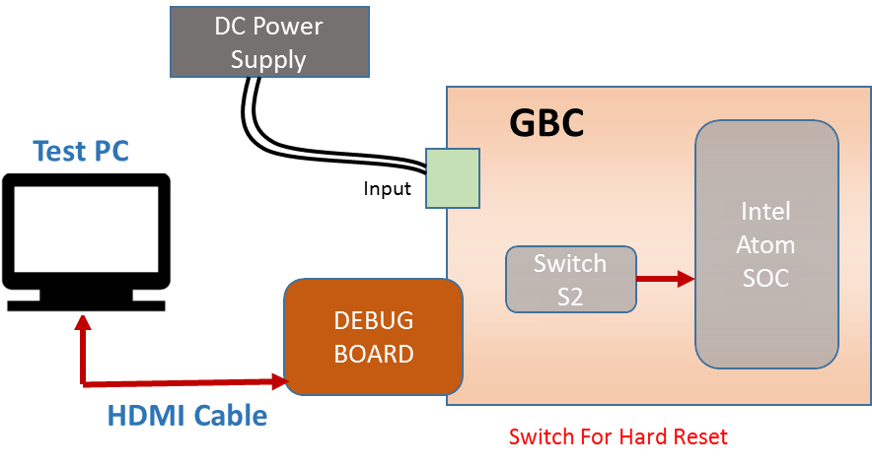
Figure 14. Reset - Test Setup Diagram

Test Case: Soft Reset (Test ID: PWR.11.3)

Description
- Purpose
The purpose of the test case is to validate the soft reset for the system.

- Impact of failure of test case on system

Impact | Applicable | Description
Functional | Yes | Failure of this test case will result in difficulty to debug on system crash or critical system failure.
Performance | NA
Compliance | NA
Table 147. Impact of Failure of Soft Reset

Test Equipment List
- DC power supply: E3633A

Equipment Settings
- DC power supply: E3633A
Supply Voltage: 18V
Current Limit: 1.5A
OVP: 19V
OCP: 2A

Hardware Requisites
- GBC board
- Debug board
- Monitor

Software Requisites
- OS loaded MSATA

Test Condition
Test condition | Value | Remarks
Voltage | 18V | Nominal input voltage
Temperature | +25 C | Normal Room temperature
Table 148. Test Condition for Soft Reset

DUT Settings
NA

Requirements
Test | Measuring Parameter | Result
Soft Reset | System reset | System Restarts
Table 149. Requirements for Soft Reset

Test Procedure
- Connect Debug board to GBC board with MSATA.
- Connect a monitor to debug board using HDMI cable.
- Configure DC power supply to give a voltage of 18V.
- After the system boots up, restart the system in Linux.

Reference
Further details can be found in Page 9 of GBC schematic Life-2.

Test Case: Hard Reset (Test ID: PWR.11.4)

Description
- Purpose
The purpose of the test case is to validate the hard reset of the system.
- Impact of failure of test case on system

Impact | Applicable | Description
Functional | Yes | Failure of this test case will result in difficulty to debug on system crash or critical system failure.
Performance | NA
Compliance | NA
Table 150. Impact of Failure of Hard Reset

Test Equipment List
- DC power supply: E3633A

Equipment Settings
- DC power supply: E3633A
Supply Voltage: 18V
Current Limit: 1.5A
OVP: 19V
OCP: 2A

Hardware Requisites
- GBC board
- Debug board
- Monitor

Software Requisites
- OS loaded MSATA

Test Condition
Test condition | Value | Remarks
Voltage | 18V | Nominal input voltage
Temperature | +25 C | Normal Room temperature
Table 151. Test Condition for Hard Reset

DUT Settings
NA

Requirements
Test | Measuring Parameter | Result
Hard Reset | System reset | System Restarts
Table 152. Requirements for Hard Reset

Test Procedure
- Connect Debug board to GBC board with MSATA.
- Connect a monitor to debug board using HDMI cable.
- Configure DC power supply to give a voltage of 18V.
- After the system boots up, restart the system using switch (S2).

Reference
Further details can be found in Page 77 of GBC schematic Life-2.

CPU Sub-system

Test Purpose and Description
Intel ATOM E3825 is chosen as the main processor for running OpenBTS / OSMOBTS & OpenTRX SW Stack. It is having enough MIPS to be able to support processing requirements for running above mentioned SW stacks for 4 chains

CPU Sub-system constitutes of below components
- Intel Atom
- PMIC - I2C
- Springville1 – SMB
- Springville2 – SMB
- DDR-SMB
- PCU – SMB
- Springville 1 – MDI
- TIVA- UART
- Memory – DDR
- Memory - SPI NOR Flash
- Storage – mSATA
- SpringVille1 – PCIe
- SpringVille2- PCIe
- TRXFE – GPIO
- TIVA – GPIO
- TIVA - USB 2.0
- TRXFE- FX3 - USB 2.0
- TRXFE- FX3 - USB 3.0
- Debug USB 2.0
- Debug USB 3.0
- Debug – Ethernet
- Display-HDMI
- Debug-UART
- RFSDR-PCIe

Intel Atom

Test Setup
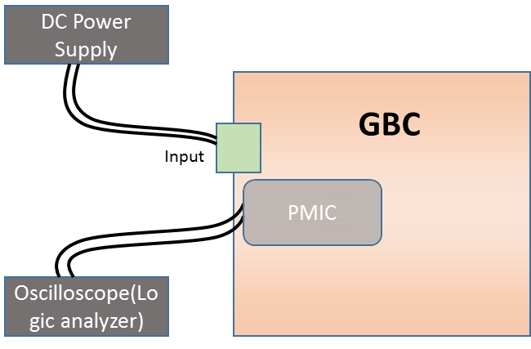
Figure 15. Intel Atom - Test Setup Diagram

Test Case: Boot configuration (Test ID: CPU.1.1)

Description
- Purpose
The purpose of the test case is to validate SPI NOR Flash memory by accessing the device and loading the Core Boot bios for system boot operation.

- Impact of failure of test case on system

Impact | Applicable | Description
Functional | Yes | An incorrect Bios selection or flawed manipulation, can corrupt the memory content and prevent the system from being able to reboot
Performance | NA
Compliance | NA
Table 153. Impact of Failure of Boot Configuration
- Programming Header Location
J16

Test Equipment List
- SF100 ISP IC programmer
- USB Cable
- ISP flat cable

Equipment Settings
NA

Hardware Requisites
- GBC board

Software Requisites
CoreBoot Bios

Test Condition
Test condition | Value | Remarks
Voltage | 18V | Nominal input voltage
Temperature | +25 C | Normal Room temperature
SF100 Programmer |  | Connected to DUT and device detection
Table 154. Test Condition for Boot Configuration

DUT Settings
NA

Requirements
- Dediprog software.
- SF100 ISP programmer and its accessories.
- GBC Board

Test Procedure
- Connect the programmer to the host computer via the USB cable
  - The green LED of the programmer will be switched ON
- The programmer is used to update directly the serial Flash on board by connecting it on the GBC ISP header / connector (J16)
  - Ensure pin of programming header on board and color identity on the cable
- Open the Dediprog software on the computer.
- Click the “Detect” Icon to detect the memory on board
- Click the “File” Icon to choose the code file
- Click the “Prog” Icon or start button to program
  - The SF100 programmer LED will indicate to the operator the operation on going:
  - - Green LED ON: update successful
  - - Orange LED: Busy in processing current execution / instruction from user
  - - Red LED Flashing: Update failed

Reference
Further details can be found in Page 20 of GBC schematic Ver. Life-2.

Test Case: Power-on sequence (Test ID: CPU.1.2)

Description
- Purpose
The purpose of the test case is to validate sequence of PMIC power rails while powering on the system.
- Impact of failure of test case on system

Impact | Applicable | Description
Functional | Yes | Functionality of the IC’s will not be in sequence as expected if this test case fails.
Performance | NA
Compliance | NA
Table 155. Impact of Failure of Power-on sequence – Intel Atom
- Measurement Locations
R2B40.1, C1B7.1, C3M10, C3M19.1, C2N9.2, C3M17.1, C4M10.2, C2B34.1, C3M8.1, C3M22.1, C3B33.1

Test Equipment List
- Oscilloscope (Logic analyzer): MSO9404A
- DC power supply: E3633A

Equipment Settings
- Oscilloscope (Logic analyzer): MSO9404A
Threshold setting: 550mV
Time scale: 100ms

- DC power supply: E3633A
Supply Voltage: 18V
Current Limit: 1.5A
OVP: 19V
OCP: 2A

Hardware Requisites
- GBC board

Software Requisites
NA

Test Condition
Test condition | Value | Remarks
Voltage | 18V | Nominal input voltage
Temperature | +25 C | Normal Room temperature
Table 156. Test Condition for Power-on sequence – Intel Atom

DUT Settings
NA

Requirements
Power-on sequence
Expected Sequence | Measurement Points | Pass Criteria
PWRBTNIN | R2B40.1 | Measured sequence order should match with the expected sequence.
V1P8_IFSUP | C1B7.1
VUSBPHY | C3M10
V1P0_A | C3M19.1
V1P2_A | C2N9.2
V1P8_A | C3M17.1
VDDQ | C4M10.2
VCC | C2B34.1
V1P5_S | C3M8.1
V1P35_S | C3M22.1
COREPWROK | C3B33.1
Table 157. Requirements for Power-on sequence – Intel Atom

Test Procedure
- Configure DC power supply to give a voltage of 18V.
- Set the trigger to PWRBTNIN (550mV).
- While powering on the device probe power rails at appropriate locations using logic analyzer to check the sequence of power rails as mentioned in the above table.
- Make sure the measured sequence should be as per the IDT9145-I0 specification.

Reference
Further details can be found from Page 30 to 33 of GBC schematic Ver. Life-2.

Test Case: Power-down Sequence (Test ID: CPU.1.3)

Description
- Purpose
The purpose of the test case is to validate sequence of PMIC power rails while powering off the system.
- Impact of failure of test case on system

Impact | Applicable | Description
Functional | Yes | Functionality of the IC’s will not be in sequence as expected if this test case fails.
Performance | NA
Compliance | NA
Table 158. Impact of Failure of Power-down sequence – Intel Atom
- Measurement Locations
R2B13.1, C3B33.1, C2B22.1, C2B34.1, C3A12.1, C2B1.1, C2N9.2, C3M17.1, C3M19.1

Test Equipment List
- Oscilloscope (Logic analyzer): MSO9404A
- DC power supply: E3633A

Equipment Settings
- Oscilloscope (Logic analyzer): MSO9404A
Threshold setting: 550mV
Time scale: 100ms

- DC power supply: E3633A
Supply Voltage: 18V
Current Limit: 1.5A
OVP: 19V
OCP: 2A

Hardware Requisites
- GBC board

Software Requisites
NA

Test Condition
Test condition | Value | Remarks
Voltage | 18V | Nominal input voltage
Temperature | +25 C | Normal Room temperature
Table 159. Test Condition for Power-down sequence – Intel Atom

DUT Settings
NA

Requirements
Power-down sequence
Expected sequence | Measurement Points | Pass Criteria
PLTRST_B | R2B13.1 | Measured sequence order should match with the expected sequence.
COREPWROK | C3B33.1
VDDQ_VTT | C2B22.1
VCC | C2B34.1
V3P3S | C3A12.1
VNN | C2B1.1
V1P2_A | C2N9.2
V1P8_A | C3M17.1
V1P0_A | C3M19.1
Table 160. Requirements for Power-down sequence – Intel Atom

Test Procedure
- Configure DC power supply to give a voltage of 18V.
- Set the trigger to PLTRST (550mV).
- While powering off the device, probe power rails at appropriate locations using logic analyzer to check the sequence of power rails as mentioned in the above table.
- Make sure the measured sequence should be as per the IDT9145-I0 specification.

Reference
Further details can be found from Page 30 to 33 of GBC schematic Ver. Life-2.

PMIC – I2C (IDTP9145_R1P15)

Test Setup
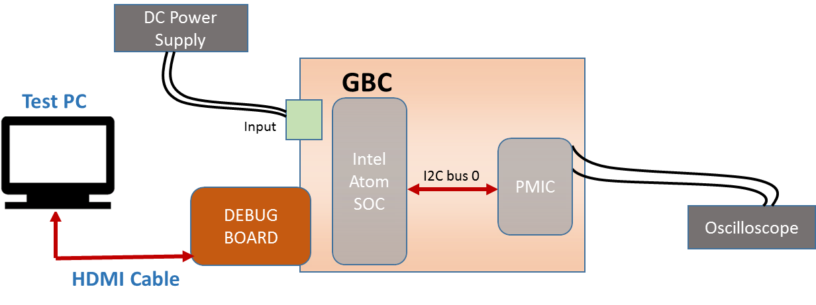
Figure 16. PMIC I2C - Test Setup Diagram

Test Case: Electrical Validation (Test ID: CPU.2.1)

Description
- Purpose
The purpose of the test case is to validate the electrical characteristics of I2C interface between Intel Atom processor and PMIC.

- Impact of failure of test case on system

Impact | Applicable | Description
Functional | NA
Performance | Yes | Failure of this test case will result in improper PMIC output voltages.
Compliance | NA
Table 161. Impact of Failure of EV – PMIC I2C
- Measurement Locations
R1B8.2, R1B14.2

Test Equipment List
- Oscilloscope: MSO9404A
- DC power supply: E3633A

Equipment Settings
- Oscilloscope: MSO9404A
Voltage per division: 1V
Time scale: 50µs

- DC power supply: E3633A
Supply Voltage: 18V
Current Limit: 1.5A
OVP: 19V
OCP: 2A

Hardware Requisites
- GBC board
- Debug board
- Monitor

Software Requisites
- Intel Atom processor - PMIC I2C code
- OS loaded MSATA

Test Condition
Test condition | Value | Remarks
Voltage | 18V | Nominal input voltage
Temperature | +25 C | Normal Room temperature
Table 162. Test Condition for EV – PMIC I2C

DUT Settings
NA

Requirements
Test | Measuring Point | Measuring Criteria | Specification
 |  |  | Min | Max
SOC_I2C_SCL | R1B14.2 | VLOW (max) (V) | -0.5 | 0.54
 |  | VHIGH (min) (V) | 1.26 | 2.3
 |  | Rise time (ns) | 0 | 300
 |  | Fall time (ns) | 0 | 300
 |  | Frequency (kHz) | 0 | 400
SOC_I2C_SDA | R1B8.2 | VLOW (max) (V) | -0.5 | 0.54
 |  | VHIGH (min) (V) | 1.26 | 2.3
 |  | Rise time (ns) | 0 | 300
 |  | Fall time (ns) | 0 | 300
Table 163. Requirements for EV – PMIC I2C

Test Procedure
- Connect Debug board to GBC board.
- Connect a monitor to debug board using HDMI cable.
- Configure DC power supply to give a voltage of 18V.
- Copy the code into the system after it boots up.
- Probe the I2C signal at R1B14.2 (SCL), R1B8.2 (SDA).
- Open the terminal and run the script.
- Make sure the measuring criteria for the signal satisfies the above mentioned requirements.

Reference
Further details can be found in Page 12 and 33 of GBC schematic Life-2.

Test Case: Signal Integrity (Test ID: CPU.2.2)

Description
- Purpose
The purpose of the test case is to validate the signal integrity of I2C interface between Intel Atom processor and PMIC.
- Impact of failure of test case on system

Impact | Applicable | Description
Functional | NA
Performance | Yes | Failure of this test case will result in improper PMIC output voltages.
Compliance | NA
Table 164. Impact of Failure of SI – PMIC I2C
- Measurement Locations
R1B8.2, R1B14.2

Test Equipment List
- Oscilloscope: MSO9404A
- DC power supply: E3633A

Equipment Settings
- Oscilloscope: MSO9404A
Voltage per division: 1V
Time scale: 50µs

- DC power supply: E3633A
Supply Voltage: 18V
Current Limit: 1.5A
OVP: 19V
OCP: 2A

Hardware Requisites
- GBC board
- Debug board
- Monitor

Software Requisites
- Intel Atom processor - PMIC I2C code
- OS loaded MSATA

Test Condition
Test condition | Value | Remarks
Voltage | 18V | Nominal input voltage
Temperature | +25 C | Normal Room temperature
Table 165. Test Condition for SI – PMIC I2C

DUT Settings
NA

Requirements
Test | Measuring Point | Measuring Criteria | Specification
 |  |  | Min | Max
SOC_I2C_SCL | R1B14.2 | Positive Over-shoot (%) | 0 | 10
 |  | Negative Over-shoot (%) | 0 | 10
SOC_I2C_SDA | R1B8.2 | Positive Over-shoot (%) | 0 | 10
 |  | Negative Over-shoot (%) | 0 | 10
 |  | Data set-up time (ns) | 100 | 2500
 |  | Data hold time (ns) | 300 | 2500
Table 166. Requirements for SI – PMIC I2C

Test Procedure
- Connect Debug board to GBC board.
- Connect a monitor to debug board using HDMI cable.
- Configure DC power supply to give a voltage of 18V.
- Copy the code into the system after it boots up.
- Probe the I2C signal at R1B14.2 (SCL), R1B8.2 (SDA).
- Open the terminal and run the script.
- Make sure the measuring criteria for the signal satisfies the above mentioned requirements.

Reference
Further details can be found in Page 12 and 33 of GBC schematic Life-2.

Test Case: Functional Validation (Test ID: CPU.2.3)

Description
- Purpose
The purpose of the test case is to validate the I2C interface of PMIC.

- Impact of failure of test case on system

Impact | Applicable | Description
Functional | Yes | Registers of PMIC become inaccessible on failure of this test case.
Performance | NA
Compliance | NA
Table 167. Impact of Failure of FV – PMIC I2C

Test Equipment List
- DC power supply: E3633A

Equipment Settings
- DC power supply: E3633A
Supply Voltage: 18V
Current Limit: 1.5A
OVP: 19V
OCP: 2A

Hardware Requisites
- GBC board
- Debug board
- Monitor

Software Requisites
- Intel Atom processor - PMIC I2C code
- OS loaded MSATA

Test Condition
Test condition | Value | Remarks
Voltage | 18V | Nominal input voltage
Temperature | +25 C | Normal Room temperature
Table 168. Test Condition for FV – PMIC I2C

DUT Settings
NA

Requirements
Test | Measuring Parameter | Result
I2C Interface | Chip revision register | Read Chip revision register, 0x05 from Address 0x01
Table 169. Requirements for FV – PMIC I2C

Test Procedure
- Connect Debug board to GBC board.
- Connect a monitor to debug board using HDMI cable.
- Configure DC power supply to give a voltage of 18V.
- Copy the code into the system after it boots up.
- Open the terminal and run the script.
- Validate the output as per the above requirement.

Reference
Further details can be found in Page 12 and 33 of GBC schematic Life-2.

DDR - SMB (TS512MSK64W6H-I)

Test Setup
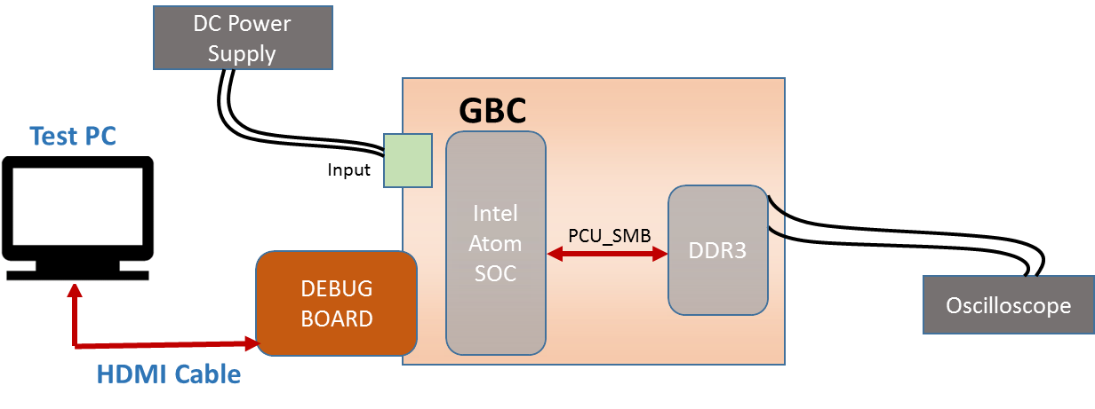
Figure 17. DDR SMB- Test Setup Diagram

Test Case: Electrical Validation (Test ID: CPU.5.1)

Description
- Purpose
The purpose of the test case is to validate the electrical characteristics of SMBus interface between Intel Atom processor and DDR3.
- Impact of failure of test case on system

Impact | Applicable | Description
Functional | NA
Performance | Yes | Failure of this test case will result in improper data.
Compliance | NA
Table 170. Impact of Failure of EV – DDR SMB
- Measurement Locations
U4D1.2, U4D1.3 and U4D1.7, U4D1.6

Test Equipment List
- Oscilloscope: MSO9404A
- DC power supply: E3633A

Equipment Settings
- Oscilloscope: MSO9404A
Voltage per division: 1V
Time scale: 50µs

- DC power supply: E3633A
Supply Voltage: 18V
Current Limit: 1.5A
OVP: 19V
OCP: 2A

Hardware Requisites
- GBC board
- Debug board
- Monitor

Software Requisites
- Intel Atom processor – DDR3 SMB code
- OS loaded MSATA

Test Condition
Test condition | Value | Remarks
Voltage | 18V | Nominal input voltage
Temperature | +25 C | Normal Room temperature
Table 171. Test Condition for EV – DDR SMB

DUT Settings
NA

Requirements
Test | Measuring Point | Measuring Criteria | Specification
 |  |  | Min | Max
Before Level Shifter
PCU_SMB_CLK | U4D1.2 | VLOW (max) (V) | -0.5 | 0.54
 |  | VHIGH (min) (V) | 1.26 | 5.5
 |  | Rise time (ns) | 0 | 1000
 |  | Fall time (ns) | 0 | 300
 |  | Frequency (kHz) | 0 | 100
PCU_SMB_DAT | U4D1.3 | VLOW (max) (V) | -0.5 | 0.54
 |  | VHIGH (min) (V) | 1.26 | 5.5
 |  | Rise time (ns) | 0 | 1000
 |  | Fall time (ns) | 0 | 300
After Level Shifter
SMB_DDR3_CLK | U4D1.7 | VLOW (max) (V) | -0.5 | 0.99
 |  | VHIGH (min) (V) | 2.31 | 3.8
 |  | Rise time (ns) | 0 | 1000
 |  | Fall time (ns) | 0 | 300
 |  | Frequency (kHz) | 0 | 100
SMB_DDR3_DAT | U4D1.6 | VLOW (max) (V) | -0.5 | 0.99
 |  | VHIGH (min) (V) | 2.31 | 3.8
 |  | Rise time (ns) | 0 | 1000
 |  | Fall time (ns) | 0 | 300
Table 172. Requirements for EV – DDR SMB

Test Procedure
- Connect Debug board to GBC board.
- Connect a monitor to debug board using HDMI cable.
- Configure DC power supply to give a voltage of 18V.
- Copy the code into the system after it boots up.
- Probe the I2C signal at U4D1.2 (SCLK), U4D1.3 (SDATA) for before level shifter and U4D1.7 (SCLK), U4D1.6 (SDATA) for after level shifter respectively.
- Open the terminal and run the script.
- Make sure the measuring criteria for the signal satisfies the above mentioned requirements.

Reference
Further details can be found in Page 12, 15 and 16 of GBC schematic Life-2.

Test Case: Signal Integrity (Test ID: CPU.5.2)

Description
- Purpose
The purpose of the test case is to validate the signal integrity of SMBus interface between Intel Atom processor and DDR3.

- Impact of failure of test case on system

Impact | Applicable | Description
Functional | NA | .
Performance | Yes | Failure of this test case will result in improper data.
Compliance | NA
Table 173. Impact of Failure of SI – DDR SMB
- Measurement Locations
U4D1.2, U4D1.3 and U4D1.7, U4D1.6

Test Equipment List
- Oscilloscope: MSO9404A
- DC power supply: E3633A

Equipment Settings
- Oscilloscope: MSO9404A
Voltage per division: 1V
Time scale: 50µs

- DC power supply: E3633A
Supply Voltage: 18V
Current Limit: 1.5A
OVP: 19V
OCP: 2A

Hardware Requisites
- GBC board
- Debug board
- Monitor

Software Requisites
- Intel Atom processor – DDR3 SMB code
- OS loaded MSATA

Test Condition
Test condition | Value | Remarks
Voltage | 18V | Nominal input voltage
Temperature | +25 C | Normal Room temperature
Table 174. Test Condition for SI – DDR SMB

DUT Settings
NA

Requirements
Test | Measuring Point | Measuring Criteria | Specification
 |  |  | Min | Max
Before Level Shifter
PCU_SMB_CLK | U4D1.2 | Positive Over-shoot (V) | 0 | 0.18
 |  | Negative Over-shoot (V) | 0 | 0.18
PCU_SMB_DAT | U4D1.3 | data set-up time (ns) | 250 | 10000
 |  | data hold time (ns) | 300 | 10000
 |  | Positive Over-shoot (V) | 0 | 0.18
 |  | Negative Over-shoot (V) | 0 | 0.18
After Level Shifter
SMB_DDR3_CLK | U4D1.7 | Positive Over-shoot (V) | 0 | 0.33
 |  | Negative Over-shoot (V) | 0 | 0.33
SMB_DDR3_DAT | U4D1.6 | data set-up time (ns) | 250 | 10000
 |  | data hold time (ns) | 300 | 10000
 |  | Positive Over-shoot (V) | 0 | 0.33
 |  | Negative Over-shoot (V) | 0 | 0.33
Table 175. Requirements for SI – DDR SMB

Test Procedure
- Connect Debug board to GBC board.
- Connect a monitor to debug board using HDMI cable.
- Configure DC power supply to give a voltage of 18V.
- Copy the code into the system after it boots up.
- Probe the I2C signal at U4D1.2 (SCLK), U4D1.3 (SDATA) for before level shifter and U4D1.7 (SCLK), U4D1.6 (SDATA) for after level shifter respectively.
- Open the terminal and run the script.
- Make sure the measuring criteria for the signal satisfies the above mentioned requirements.

Reference
Further details can be found in Page 12, 15 and 16 of GBC schematic Life-2.

Test Case: Functional Validation (Test ID: CPU.5.3)

Description
- Purpose
The purpose of the test case is to validate the SMBus interface of DDR.

- Impact of failure of test case on system

Impact | Applicable | Description
Functional | Yes | Registers of DDR become inaccessible on failure of this test case.
Performance | NA
Compliance | NA
Table 176. Impact of Failure of FV – DDR SMB

Test Equipment List
- DC power supply: E3633A

Equipment Settings
- DC power supply: E3633A
Supply Voltage: 18V
Current Limit: 1.5A
OVP: 19V
OCP: 2A

Hardware Requisites
- GBC board
- Debug board
- Monitor

Software Requisites
- Intel Atom processor – DDR3 SMB code
- OS loaded MSATA

Test Condition
Test condition | Value | Remarks
Voltage | 18V | Nominal input voltage
Temperature | +25 C | Normal Room temperature
Table 177. Test Condition for FV – DDR SMB

DUT Settings
NA

Requirements
Test | Measuring Parameter | Result
I2C Interface | Device register address | Read device register address from 128 to 145
Table 178. Requirements for FV – DDR SMB

Test Procedure
- Connect Debug board to GBC board.
- Connect a monitor to debug board using HDMI cable.
- Configure DC power supply to give a voltage of 18V.
- Copy the code into the system after it boots up.
- Open the terminal and run the script.
- Validate the output as per the above requirement.

Reference
Further details can be found in Page 12, 15 and 16 of GBC schematic Life-2.

PCU – SMB (ADT7481)

Test Setup
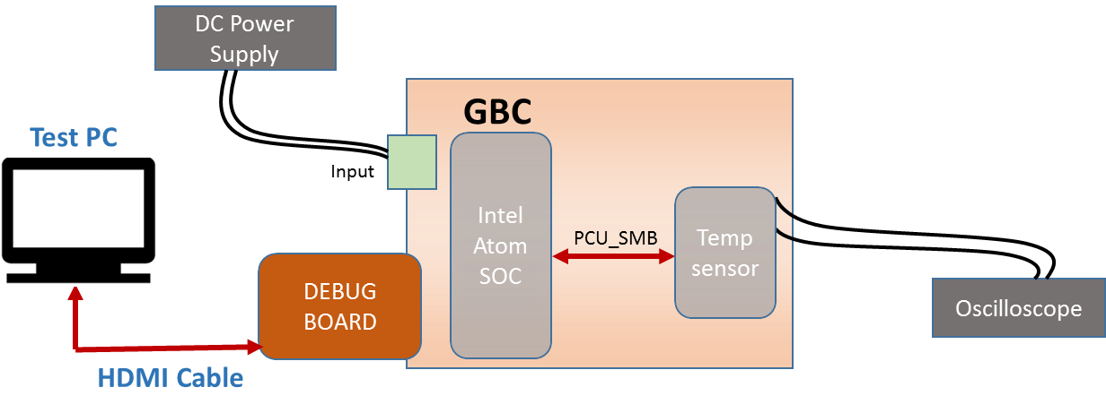
Figure 18. PCU SMB- Test Setup Diagram

Test Case: Electrical Validation (Test ID: CPU.6.1)

Description
- Purpose
The purpose of the test case is to validate the electrical characteristics of SMBus interface between Intel Atom processor and temperature sensor.
- Impact of failure of test case on system

Impact | Applicable | Description
Functional | NA
Performance | Yes | Failure of this test case will result in improper temperature readings.
Compliance | NA
Table 179. Impact of Failure of EV – PCU SMB
- Measurement Locations
U2A1.2, U2A1.3 and U3A1.10, U3A1.9

Test Equipment List
- Oscilloscope: MSO9404A
- DC power supply: E3633A

Equipment Settings
- Oscilloscope: MSO9404A
Voltage per division: 1V
Time scale: 50µs

- DC power supply: E3633A
Supply Voltage: 18V
Current Limit: 1.5A
OVP: 19V
OCP: 2A

Hardware Requisites
- GBC board
- Debug board
- Monitor

Software Requisites
- Intel Atom processor – Temp sensor SMB code
- OS loaded MSATA

Test Condition
Test condition | Value | Remarks
Voltage | 18V | Nominal input voltage
Temperature | +25 C | Normal Room temperature
Table 180. Test Condition for EV – PCU SMB

DUT Settings
NA

Requirements
Test | Measuring Point | Measuring Criteria | Specification
 |  |  | Min | Max
Before Level Shifter
PCU3_SMB_CLK | U2A1.2 | VLOW (max) (V) | -0.5 | 0.54
 |  | VHIGH (min) (V) | 1.26 | 5.5
 |  | Rise time (ns) | 0 | 1000
 |  | Fall time (ns) | 0 | 300
 |  | Frequency (kHz) | 0 | 100
PCU3_SMB_DAT | U2A1.3 | VLOW (max) (V) | -0.5 | 0.54
 |  | VHIGH (min) (V) | 1.26 | 5.5
 |  | Rise time (ns) | 0 | 1000
 |  | Fall time (ns) | 0 | 300
After Level Shifter
SMB_3P3_CLK | U3A1.10 | VLOW (max) (V) | -0.5 | 0.8
 |  | VHIGH (min) (V) | 2.1 | 3.8
 |  | Rise time (ns) | 0 | 1000
 |  | Fall time (ns) | 0 | 300
 |  | Frequency (kHz) | 0 | 100
SMB_3P3_DAT | U3A1.9 | VLOW (max) (V) | -0.5 | 0.8
 |  | VHIGH (min) (V) | 2.1 | 3.8
 |  | Rise time (ns) | 0 | 1000
 |  | Fall time (ns) | 0 | 300
Table 181. Requirements for EV – PCU SMB

Test Procedure
- Connect Debug board to GBC board.
- Connect a monitor to debug board using HDMI cable.
- Configure DC power supply to give a voltage of 18V.
- Copy the code into the system after it boots up.
- Probe the I2C signal at U2A1.2 (SCLK), U2A1.3 (SDATA) for before level shifter and U3A1.10 (SCLK), U3A1.9 (SDATA) for after level shifter respectively.
- Open the terminal and run the script.
- Make sure the measuring criteria for the signal satisfies the above mentioned requirements.

Reference
Further details can be found in Page 12, 15 and 38 of GBC schematic Life-2.

Test Case: Signal Integrity (Test ID: CPU.6.2)

Description
- Purpose
The purpose of the test case is to validate the signal integrity of SMBus interface between Intel Atom processor and temperature sensor.
- Impact of failure of test case on system

Impact | Applicable | Description
Functional | NA
Performance | Yes | Failure of this test case will result in improper temperature readings.
Compliance | NA
Table 182. Impact of Failure of SI – PCU SMB
- Measurement Locations
U2A1.2, U2A1.3 and U3A1.10, U3A1.9

Test Equipment List
- Oscilloscope: MSO9404A
- DC power supply: E3633A

Equipment Settings
- Oscilloscope: MSO9404A
Voltage per division: 1V
Time scale: 50µs

- DC power supply: E3633A
Supply Voltage: 18V
Current Limit: 1.5A
OVP: 19V
OCP: 2A

Hardware Requisites
- GBC board
- Debug board
- Monitor

Software Requisites
- Intel Atom processor – Temp sensor SMB code
- OS loaded MSATA

Test Condition
Test condition | Value | Remarks
Voltage | 18V | Nominal input voltage
Temperature | +25 C | Normal Room temperature
Table 183. Test Condition for SI – PCU SMB

DUT Settings
NA

Requirements
Test | Measuring Point | Measuring Criteria | Specification
 |  |  | Min | Max
Before Level Shifter
PCU3_SMB_CLK | U2A1.2 | Positive Over-shoot (V) | 0 | 0.18
 |  | Negative Over-shoot (V) | 0 | 0.18
PCU3_SMB_DAT | U2A1.3 | data set-up time (ns) | 250 | 10000
 |  | data hold time (ns) | 300 | 10000
 |  | Positive Over-shoot (V) | 0 | 0.18
 |  | Negative Over-shoot (V) | 0 | 0.18
After Level Shifter
SMB_3P3_CLK | U3A1.10 | Positive Over-shoot (V) | 0 | 0.33
 |  | Negative Over-shoot (V) | 0 | 0.33
SMB_3P3_DAT | U3A1.9 | data set-up time (ns) | 250 | 10000
 |  | data hold time (ns) | 300 | 10000
 |  | Positive Over-shoot (V) | 0 | 0.33
 |  | Negative Over-shoot (V) | 0 | 0.33
Table 184. Requirements for SI – PCU SMB

Test Procedure
- Connect Debug board to GBC board.
- Connect a monitor to debug board using HDMI cable.
- Configure DC power supply to give a voltage of 18V.
- Copy the code into the system after it boots up.
- Probe the I2C signal at U2A1.2 (SCLK), U2A1.3 (SDATA) for before level shifter and U3A1.10 (SCLK), U3A1.9 (SDATA) for after level shifter respectively.
- Open the terminal and run the script.
- Make sure the measuring criteria for the signal satisfies the above mentioned requirements.

Reference
Further details can be found in Page 12, 15 and 38 of GBC schematic Life-2.

Test Case: Functional Validation (Test ID: CPU.6.3)

Description
- Purpose
The purpose of the test case is to validate the SMBus interface of temperature sensor.

- Impact of failure of test case on system

Impact | Applicable | Description
Functional | Yes | Registers of the temperature sensor become inaccessible on failure of this test case.
Performance | NA
Compliance | NA
Table 185. Impact of Failure of FV – PCU SMB

Test Equipment List
- DC power supply: E3633A

Equipment Settings
- DC power supply: E3633A
Supply Voltage: 18V
Current Limit: 1.5A
OVP: 19V
OCP: 2A

Hardware Requisites
- GBC board
- Debug board
- Monitor

Software Requisites
- Intel Atom processor – Temp sensor SMB code
- OS loaded MSATA

Test Condition
Test condition | Value | Remarks
Voltage | 18V | Nominal input voltage
Temperature | +25 C | Normal Room temperature
Table 186. Test Condition for FV – PCU SMB

DUT Settings
NA

Requirements
Test | Measuring Parameter | Result
I2C Interface | Device ID | Read Device ID, 0x81 from Address 0x3D
 | Manufacturer ID | Read Manufacturer ID, 0x41 from Address 0x3E
Table 187. Requirements for FV – PCU SMB

Test Procedure
- Connect Debug board to GBC board.
- Connect a monitor to debug board using HDMI cable.
- Configure DC power supply to give a voltage of 18V.
- Copy the code into the system after it boots up.
- Open the terminal and run the script.
- Validate the output as per the above requirement.

Reference
Further details can be found in Page 12, 15 and 38 of GBC schematic Life-2.

Springville 1 – MDI

Test Setup
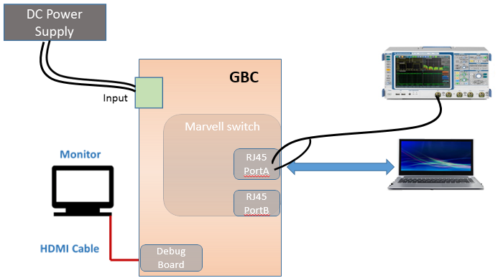
Figure 19.INTEL Springville 1 MDI - Test Setup Diagram

Test Case: Signal characteristics (Test ID: CPU.7.1)

Description
- Purpose
The purpose of this test case is to verify MDI signal characteristics (Interface between Marvell Switch (88E6071) to Springville PHY (WGI210AT)

- Impact of failure of test case on system

Impact | Applicable | Description
Functional | Yes | Packet loss and data inconsistency
Performance | Yes | Improper data transfer and loss of data
Compliance | NA
Table 188. Impact of Failure of SI – Springville 1 MDI
- Measurement Locations
R962.2, R963.2, L1M2.6, L1M2.8

Test Equipment List
- Oscilloscope: DPO7354C
- DC power supply: E3633A

Equipment Settings
- Oscilloscope: DPO7354C
Voltage per division: 500mV
Time scale: 50ns

- DC power supply: E3633A
Supply Voltage: 18V
Current Limit: 1.5A
OVP: 19V
OCP: 2A

Hardware Requisites
- GBC board
- Debug board
- HDMI Monitor

Software Requisites
- Ethernet driver
- OS loaded MSATA

Test Condition
Test condition | Value | Remarks
Voltage | 18V | Nominal input voltage
Temperature | +25 C | Normal Room temperature
Table 189. Test Condition for SI – Springville 1 MDI

DUT Settings
NA

Requirements
Test | Measuring Point | Measuring Criteria | Specification
 |  |  | Min | Max
MDIO – TX (From Springville to Switch)
MDI0P  MDI0N | R962.2  R963.2 | Vp-p (V) | 0.95 | 1.05
 |  | Overshoot (%) | 0 | 5
 |  | Undershoot (%) | 0 | 5
 |  | Data rate (Mbps) |  | 100
MDIO – RX (From Switch to Springville)
LAN_MDI1P  LAN_MDI1N | L1M2.6  L1M2.8 | Vp-p (V) | 0.95 | 1.05
 |  | Overshoot (%) | 0 | 5
 |  | Undershoot (%) | 0 | 5
 |  | Data rate (Mbps) |  | 100
Table 190. Requirements for SI – Springville 1 MDI

Test Procedure
- Connect Debug board to GBC board with OS and Ethernet driver installed
- Connect a monitor to debug board using HDMI cable
- Connect a Linux PC to port A of GBC board.
- Configure DC power supply to give a voltage of 18V.
- Assign static IP address at both GBC and Linux PC.
- Establish communication by pinging each other.
- The MDI transmit signals (from Springville to Switch) are measured at R962.2 (MDI0P) and R963.2 (MDI0N).
- The MDI receiving signals (from Switch to Springville) are measured at L1M2.6 (MDI1P) and L1M2.8 (MDI1N).
- Make sure the measuring criteria for the signal satisfies the above mentioned requirements.

Reference
Further details can be found in Page 23, 24 and 60 of GBC schematic Life-2.

Test Case: Functional Validation (Test ID: CPU.7.2)

Description
- Purpose
The purpose of the test case is to validate the function of springville1-MDI.

- Impact of failure of test case on system

Impact | Applicable | Description
Functional | Yes | Registers of SOC become inaccessible on failure of this test case and data transfer can be affected.
Performance | NA
Compliance | NA
Table 191. Impact of Failure of FV – Springville 1 MDI

Test Equipment List
- Oscilloscope: DPO7354C
- DC power supply: E3633A

Equipment Settings
- Oscilloscope: DPO7354C
Voltage per division: 500mV
Time scale: 50ns

- DC power supply: E3633A
Supply Voltage: 18V
Current Limit: 1.5A
OVP: 19V
OCP: 2A

Hardware Requisites
- GBC board
- Debug board
- HDMI Monitor

Software Requisites
- Ethernet driver
- OS loaded MSATA

Test Condition
Test condition | Value | Remarks
Voltage | 18V | Nominal input voltage
Temperature | +25 C | Normal Room temperature
Table 192. Test Condition of FV – Springville 1 MDI

DUT Settings
NA.

Requirements
Test | Measuring Parameter | Result
Ethernet Interface | IP Address | Ping each other using static IP address and ensure the data transfer with no packet loss
Table 193. Requirements for FV – Springville 1 MDI

Test Procedure

- Connect Debug board to GBC board with OS and Ethernet driver installed
- Connect a monitor to debug board using HDMI cable
- Connect a Linux PC to port A of GBC board.
- Configure DC power supply to give a voltage of 18V.
- Assign static IP address at both GBC and Linux PC.
- Establish communication by pinging each other.
- Validate the output as per the above requirement.

Reference
Further details can be found in Page 23, 24 and 60 of GBC schematic Life-2.

TIVA - UART

Test Setup
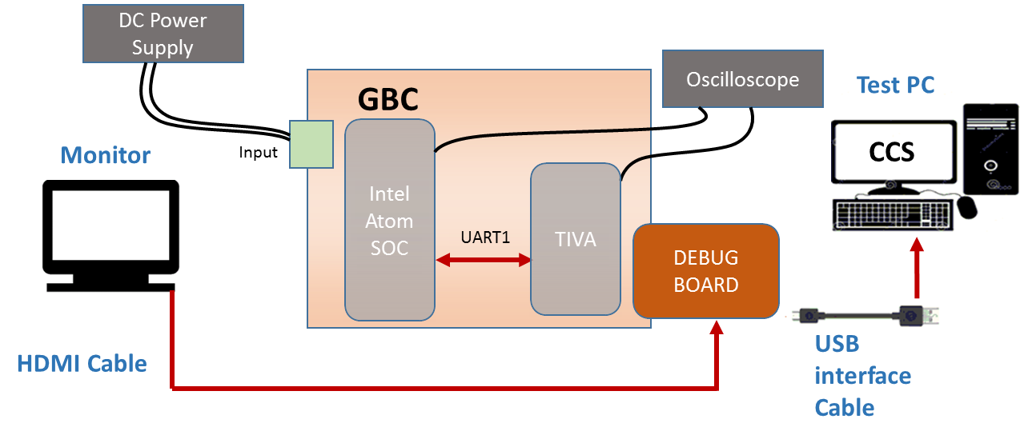
Figure 20.TIVA UART- Test Setup Diagram

Test Case: Signal characteristics (Test ID: CPU.8.1)

Description
- Purpose
The purpose of the test case is to validate the electrical characteristics of UART interface between Tiva controller and Intel Atom processor.
- Impact of failure of test case on system

Impact | Applicable | Description
Functional | NA
Performance | Yes | Improper data transfer between SOC and TIVA
Compliance | NA
Table 194. Impact of Failure of SI – TIVA UART
- Measurement Locations
R10550, R10472

Test Equipment List
- Oscilloscope: MSO9404A
- DC power supply: E3633A

Equipment Settings
- Oscilloscope: MSO9404A
Voltage per division: 1V
Time scale: 10µs

- DC power supply: E3633A
Supply Voltage: 18V
Current Limit: 1.5A
OVP: 19V
OCP: 2A

Hardware Requisites
- GBC board
- Debug board
- Monitor

Software Requisites
- Code Composer Studio Tool
- Tiva - Intel UART code
- OS loaded MSATA

Test Condition
Test condition | Value | Remarks
Voltage | 18V | Nominal input voltage
Temperature | +25 C | Normal Room temperature
Table 195. Test Condition for SI – TIVA UART

DUT Settings
Resistor R10511 is removed and Pin 2 of the resistor is connected to ground to enable the level shifter.

Requirements
Test | Measuring Point | Measuring Criteria | Specification
 |  |  | Min | Max
UART TX
ISO_TIVA_SOC_UART3_TX | R10550 | VLOW (V) | -0.378 | 0.63
 |  | VHIGH (V) | 1.17 | 2.232
 |  | Positive Overshoot (V) | 0 | 0.18
 |  | Negative Overshoot (V) | 0 | 0.18
UART RX
TIVA_SOC_UART3_RX | R10472 | VLOW (V) | 0 | 1.155
 |  | VHIGH (V) | 2.145 | 4
 |  | Positive Overshoot (V) | 0 | 0.33
 |  | Negative Overshoot (V) | 0 | 0.33
Table 196. Requirements for SI – TIVA UART

Test Procedure
- Connect Debug board to GBC board.
- Connect a Test PC with CCS to debug board.
- Import the code in Code Composer Studio.
- Connect a monitor to debug board using HDMI cable.
- Configure DC power supply to give a voltage of 18V.
- Probe the UART TX signal at R10550 and UART RX signal at R10472.
- Program TIVA firmware.
- Load and run the middleware in Intel SOC to request any status (Temperature, current) from TIVA and receive data on Console (SOC) through UART interface.
- Make sure the measuring criteria for the signal satisfies the above mentioned requirements.

Reference
Further details can be found in Page 9, 60 and 83 of GBC schematic Life-2.

Test Case: Functional Validation (Test ID: CPU.8.2)

Description
- Purpose
The purpose of the test case is to validate the function of UART interface between Tiva controller and Intel Atom processor.
- Impact of failure of test case on system

Impact | Applicable | Description
Functional | Yes | Registers of TIVA / SOC become inaccessible on failure of this test case and data transfer can be affected.
Performance | NA
Compliance | NA
Table 197. Impact of Failure of FV – TIVA UART

Test Equipment List
- DC power supply: E3633A

Equipment Settings
- DC power supply: E3633A
Supply Voltage: 18V
Current Limit: 1.5A
OVP: 19V
OCP: 2A

Hardware Requisites
- GBC board
- Debug board
- Monitor

Software Requisites
- Code Composer Studio Tool
- Tiva- Intel UART code
- OS loaded MSATA

Test Condition
Test condition | Value | Remarks
Voltage | 18V | Nominal input voltage
Temperature | +25 C | Normal Room temperature
Table 198. Test Condition for FV – TIVA UART

DUT Settings
Resistor R10511 is removed and Pin 2 of the resistor is connected to ground to enable the level shifter.

Requirements
Test | Measuring Parameter | Result
UART Interface | Intel temperature Reading | Send message from SOC to TIVA to request the temperature and get the response from TIVA.
Table 199. Requirements for FV – TIVA UART

Test Procedure
- Connect Debug board to GBC board.
- Connect a Test PC with CCS to debug board.
- Import the code in Code Composer Studio.
- Connect a monitor to debug board using HDMI cable.
- Configure DC power supply to give a voltage of 18V.
- Program TIVA firmware.
- Load and run the middleware in Intel SOC to request any status (Temperature, current) from TIVA and receive data on Console (SOC) through UART interface.
- Validate the output as per the above requirement.

Reference
Further details can be found in Page 9, 60 and 83 of GBC schematic Life-2.

Memory - DDR

Test Setup
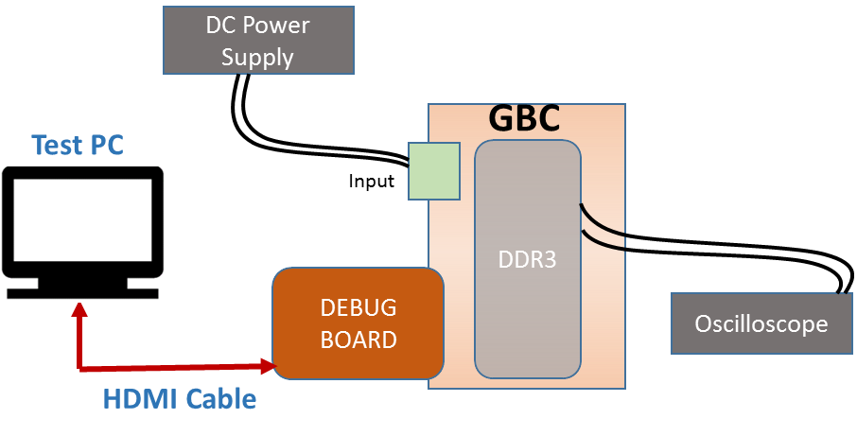
NOTE:
- For Reference voltage measurement, Test PC not required
- For Schmoo test, GBC board has to be put in thermal chamber.
Figure 21. Memory DDR - Test Setup Diagram

Test Case: Reference voltage measurement (Test ID: CPU.9.1)

Description
- Purpose
The purpose of the test case is to measure the reference voltages of DDR (DDR_VREF and DDR_VTT).
- Impact of failure of test case on system

Impact | Applicable | Description
Functional | Yes | Failure of this test case may cause the referencing signals never to trigger or to trigger prematurely.
Performance | NA
Compliance | NA
Table 200. Impact of Failure of Reference voltage measurement – Memory DDR
- Measurement Locations
R2P7.1/R3P12.1, C4P17.1, C3P14.1

Test Equipment List
- Oscilloscope: MSO9404A
- DC power supply: E3633A

Equipment Settings
- Oscilloscope: MSO9404A
Voltage per division: 1V
Time scale: 10ns

- DC power supply: E3633A
Supply Voltage: 18V
Current Limit: 1.5A
OVP: 19V
OCP: 2A

Hardware Requisites
- GBC board
- Debug board
- Monitor

Software Requisites
NA

Test Condition
Test condition | Value | Remarks
Voltage | 18V | Nominal input voltage
Temperature | +25 C | Normal Room temperature
Table 201. Test Condition for Reference voltage measurement – Memory DDR

DUT Settings
NA

Requirements
Sl. No. | Test | Probing Point | Expected Voltage(V) | Specification
 |  |  |  | Min(V) | Max(V)
1 | VDDQ | C3P14.1 | 1.35 | 1.28 | 1.45
2 | VREF/DQ | R2P7.1 | 0.675 | 0.64 | 0.725
3 | VREFCA | R3P12.1 | 0.675 | 0.64 | 0.725
4 | VTT_DDR | C4P17.1 | 0.675 | 0.64 | 0.725
Table 202. Requirements for Reference voltage measurement – Memory DDR

Test Procedure
- Configure DC power supply to give a voltage of 18V.
- Measure the voltages on GBC board at C3P14.1, R2P7.1, R3P12.1, and C4P17.1.
- Make sure the measuring criteria for the signal satisfies the above mentioned requirements.

Reference
Further details can be found in Page 17 GBC schematic Life-2.

Test Case: Schmoo Test (Test ID: CPU.9.2)

Description
- Purpose
The purpose of the test case is to validate the DDR module by varying VREF voltage within the limits at different temperatures.
- Impact of failure of test case on system

Impact | Applicable | Description
Functional | Yes | Failure of this test case can result in improper functioning of DDR in the specified temperature or Vref voltage.
Performance | NA
Compliance | NA
Table 203. Impact of Failure of Schmoo Test – Memory DDR
- Measurement Locations
R2P7, C3P14

Test Equipment List
- Oscilloscope: MSO9404A
- DC power supply: E3633A

Equipment Settings
- Oscilloscope: MSO9404A
Voltage per division: 1V
Time scale: 1µs

- DC power supply: E3633A
Supply Voltage: 18V
Current Limit: 1.5A
OVP: 19V
OCP: 2A

Hardware Requisites
- GBC board

Software Requisites
- OS loaded MSATA
- memtester utility

Test Condition
Test condition | Value | Remarks
Voltage | 18V | Nominal input voltage
Temperature | +25 C | Normal Room temperature
Table 204. Test Condition for Schmoo Test – Memory DDR

DUT Settings
R2P7, R3P12, R2P11, R3P6 values should be changed according to below mentioned requirements.

Requirements
Memory - DDR VREF measurement
Sl. No. | Probing Point |  | Temperature Condition (°C) | Resistor Value (kΩ) - R2P7/R3P12 |  | Resistor Value (kΩ) - R2P11/R3P6 | Expected Voltage (V) | Specification
 |  |  |  |  |  |  |  | Min(V) | Max(V)
1 | R2P7 |  | -20 | 4.42 |  | 4.7 | 0.654 | 0.64 | 0.725
2 |  |  | 0 | 4.42 |  | 4.7 | 0.654 | 0.64 | 0.725
3 |  |  | 20 | 4.42 |  | 4.7 | 0.654 | 0.64 | 0.725
4 |  |  | 25 | 4.42 |  | 4.75 | 0.651 | 0.64 | 0.725
5 |  |  | 40 | 4.42 |  | 4.7 | 0.654 | 0.64 | 0.725
6 |  |  | 70 | 4.42 |  | 4.7 | 0.654 | 0.64 | 0.725
7 |  |  | -20 | 4.99 |  | 4.7 | 0.695 | 0.64 | 0.725
8 |  |  | 0 | 4.99 |  | 4.7 | 0.695 | 0.64 | 0.725
9 |  |  | 20 | 4.99 |  | 4.7 | 0.695 | 0.64 | 0.725
10 |  |  | 25 | 4.99 |  | 4.7 | 0.695 | 0.64 | 0.725
11 |  |  | 40 | 4.99 |  | 4.7 | 0.695 | 0.64 | 0.725
12 |  |  | 70 | 4.99 |  | 4.7 | 0.695 | 0.64 | 0.725
13 |  |  | -20 | 5.11 |  | 4.42 | 0.724 | 0.64 | 0.725
14 |  |  | 0 | 5.11 |  | 4.42 | 0.724 | 0.64 | 0.725
15 |  |  | 20 | 5.11 |  | 4.42 | 0.724 | 0.64 | 0.725
16 |  |  | 25 | 5.11 |  | 4.42 | 0.724 | 0.64 | 0.725
17 |  |  | 40 | 5.11 |  | 4.42 | 0.724 | 0.64 | 0.725
18 |  |  | 70 | 5.11 |  | 4.42 | 0.724 | 0.64 | 0.725
Memory - DDR VDDQ measurement
Sl. No. | Probing Point | Temperature Condition (°C) |  |  | Resistor Value (kΩ) - R2P7/R3P12 | Resistor Value (kΩ) - R2P11/R3P6 | Expected Voltage (V) | Specification
 |  |  |  |  |  |  |  | Min(V) | Max(V)
1 | C3P14 | -20 |  |  | 4.42 | 4.7 | 1.35 | 1.28 | 1.45
2 |  | 0 |  |  | 4.42 | 4.7 | 1.35 | 1.28 | 1.45
3 |  | 20 |  |  | 4.42 | 4.7 | 1.35 | 1.28 | 1.45
4 |  | 25 |  |  | 4.42 | 4.75 | 1.35 | 1.28 | 1.45
5 |  | 40 |  |  | 4.42 | 4.7 | 1.35 | 1.28 | 1.45
6 |  | 70 |  |  | 4.42 | 4.7 | 1.35 | 1.28 | 1.45
7 |  | -20 |  |  | 4.99 | 4.7 | 1.35 | 1.28 | 1.45
8 |  | 0 |  |  | 4.99 | 4.7 | 1.35 | 1.28 | 1.45
9 |  | 20 |  |  | 4.99 | 4.7 | 1.35 | 1.28 | 1.45
10 |  | 25 |  |  | 4.99 | 4.7 | 1.35 | 1.28 | 1.45
11 |  | 40 |  |  | 4.99 | 4.7 | 1.35 | 1.28 | 1.45
12 |  | 70 |  |  | 4.99 | 4.7 | 1.35 | 1.28 | 1.45
13 |  | -20 |  |  | 5.11 | 4.42 | 1.35 | 1.28 | 1.45
14 |  | 0 |  |  | 5.11 | 4.42 | 1.35 | 1.28 | 1.45
15 |  | 20 |  |  | 5.11 | 4.42 | 1.35 | 1.28 | 1.45
16 |  | 25 |  |  | 5.11 | 4.42 | 1.35 | 1.28 | 1.45
17 |  | 40 |  |  | 5.11 | 4.42 | 1.35 | 1.28 | 1.45
18 |  | 70 |  |  | 5.11 | 4.42 | 1.35 | 1.28 | 1.45
Table 205. Requirements for Schmoo Test – Memory DDR

Test Procedure
- Connect Debug board to GBC board.
- Connect a monitor to debug board using HDMI cable.
- Configure DC power supply to give a voltage of 18V.
- Measure the voltages at R2P7, C3P14.
- Open the terminal and execute ‘memtester’ utility on SoC for different voltages of DDR_VREF at different temperatures.
- DDR_VREF can be varied by changing the voltage divide resistors, R2P11, R2P7, R3P6 and R3P12 such that there can be three co-ordinates within the specified range of DDR module.
- In each co-ordinate, memtester utility is executed at six different temperatures to validate VREF Schmoo.
- Make sure the measuring criteria for the signal satisfies the above mentioned requirements.

Reference
Further details can be found in Page 17 GBC schematic Life-2.

Test Case: Functional Validation (Test ID: CPU.9.3)

Description
- Purpose
The purpose of the test case is to validate the entire DDR memory using memtest option at boot stage.
- Impact of failure of test case on system

Impact | Applicable | Description
Functional | Yes | Failure of this test case can result the DDR to  - Not accept and correctly retain arbitrary patterns of data written to it.  - Cause errors where different bits of memory interact.  - Cause conflicts between memory addresses.
Performance | NA
Compliance | NA
Table 206. Impact of Failure of FV – Memory DDR

Test Equipment List
- DC power supply: E3633A

Equipment Settings
- DC power supply: E3633A
Supply Voltage: 18V
Current Limit: 1.5A
OVP: 19V
OCP: 2A

Hardware Requisites
- GBC board
- Debug board
- Monitor

Software Requisites
- OS loaded MSATA

Test Condition
Test condition | Value | Remarks
Voltage | 18V | Nominal input voltage
Temperature | +25 C | Normal Room temperature
Table 207. Test Condition for FV – Memory DDR

DUT Settings
NA

Requirements
Test | Measuring Parameter | Result
Memory DDR | Memtest function | Results of memtest are captured to check for any errors.
Table 208. Requirements for FV – Memory DDR

Test Procedure
- Connect Debug board to GBC board.
- Connect a monitor to debug board using HDMI cable.
- Configure DC power supply to give a voltage of 18V.
- Execute memtest function during boot stage.
- Validate the output as per the above requirement.

Reference
Further details can be found in Page 17 GBC schematic Life-2.

Test Case: Throughput measurement (Test ID: CPU.9.4)

Description
- Purpose
The purpose of the test case is to validate the DDR memory for its latency and bandwidth.

- Impact of failure of test case on system

Impact | Applicable | Description
Functional | Yes | System requirement will not be met in case of failure of this test case.
Performance | NA
Compliance | NA
Table 209. Impact of Failure of Throughput measurement – Memory DDR

Test Equipment List
- DC power supply: E3633A

Equipment Settings
- DC power supply: E3633A
Supply Voltage: 18V
Current Limit: 1.5A
OVP: 19V
OCP: 2A

Hardware Requisites
- GBC board
- Debug board
- Monitor

Software Requisites
- OS loaded MSATA with lmbench 3.0

Test Condition
Test condition | Value | Remarks
Voltage | 18V | Nominal input voltage
Temperature | +25 C | Normal Room temperature
Table 210. Test Condition for Throughput measurement – Memory DDR

DUT Settings
NA

Test Procedure
- Connect Debug board to GBC board.
- Connect a monitor to debug board using HDMI cable.
- Configure DC power supply to give a voltage of 18V.
- Lmbench 3.0 is a suite of simple, portable, ANSI/C micro benchmarks for UNIX/POSIX used for throughput measurement.
- Download the source code in to the target machine.
- Unpack the source code.
- Go to the original directory and run “make results see”.exe.
- The results will be saved in lmbench directory.
- Read / Write throughputs which are read in Mbps data speed which are there in the last result columns along with other tests results. Latencies for read / writes are also mentioned in nSec or suitable units.

Reference
Further details can be found in Page 17 GBC schematic Life-2.

Memory SPI NOR Flash

Test Setup
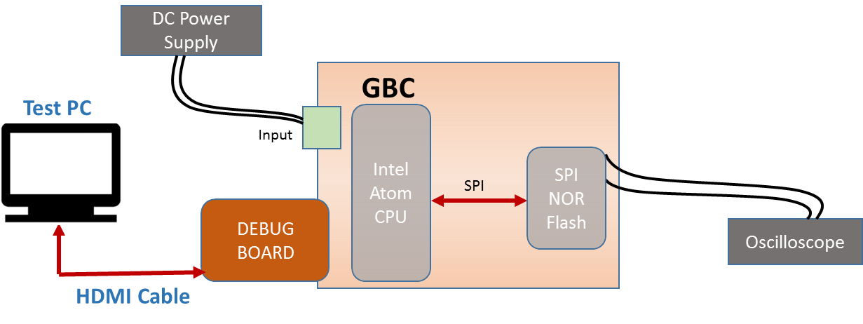
Figure 22. Memory SPI NOR Flash - Test Setup Diagram

Test Case: Electrical Validation (Test ID: CPU.10.1)

Description
- Purpose
The purpose of the test case is to validate the electrical characteristics of SPI interface of SPI NOR Flash.
- Impact of failure of test case on system

Impact | Applicable | Description
Functional | Yes | The failure of this test case will results not booting the system up.
Performance | NA
Compliance | NA
Table 211. Impact of Failure of EV – Memory SPI NOR Flash
- Measurement Locations
R10762.2, R1M11.2

Test Equipment List
- Oscilloscope: DPO7354C
- DC power supply: E3633A

Equipment Settings
- Oscilloscope: DPO7354C
Voltage per division: 1V
Time scale: 50µs

- DC power supply: E3633A
Supply Voltage: 18V
Current Limit: 1.5A
OVP: 19V
OCP: 2A

Hardware Requisites
- GBC board
- Debug board
- Monitor

Software Requisites
- Core boot

Test Condition
Test condition | Value | Remarks
Voltage | 18V | Nominal input voltage
Temperature | +25 C | Normal Room temperature
Table 212. Test Condition for EV – Memory SPI NOR Flash

DUT Settings
NA

Requirements
Test | Measuring Point | Measuring Criteria | Observation | Specification
 |  |  |  | Min | Max
SOC_FLASH_CLK | R10762.2 | VLOW (max) (V) | -4.47e-13 | -0.5 | 0.54
 |  | VHIGH (min) (V) | 1.64 | 1.26 | 2.2
 |  | Rise time (V/ns) | 0.1906 | 0.1 | 3
 |  | Fall time (V/ns) | 0.1682 | 0.1 | 3
 |  | Frequency (MHz) | 33.33 | 0 | 50
SOC_SPI_MISO | R1M11.2 | VLOW (max) (V) | 0.02 | -0.5 | 0.54
 |  | VHIGH (min) (V) | 1.82 | 1.26 | 2.2
 |  | Rise time (V/ns) | 0.2028 | 0.1 | 3
 |  | Fall time (V/ns) | 0.2025 | 0.1 | 3
Table 213. Requirements for EV – Memory SPI NOR Flash

Test Procedure
- Connect Debug board to GBC board.
- Connect a monitor to Debug board using HDMI cable.
- Configure DC power supply to give a voltage of 18V.
- Flash the core boot into SPI NOR FLASH.
- While system booting probe the SPI signals at R10762. (SOC_FLASH_CLK), R1M11.2 (SOC_SPI_MISO).
- Make sure the measuring criteria for the signal satisfies the above mentioned requirements.

Reference
Further details can be found in Page 20 and 9 of GBC schematic Ver. Life-2.

Test Case: Signal Integrity (Test ID: CPU.10.2)

Description
- Purpose
The purpose of the test case is to validate the signal integrity of SPI interface of SPI NOR Flash.
- Impact of failure of test case on system

Impact | Applicable | Description
Functional | Yes | The failure of this test case will results not booting the system up.
Performance | NA
Compliance | NA
Table 214. Impact of Failure of SI – Memory - SPI NOR Flash
- Measurement Locations
R10762.2, R1M11.2

Test Equipment List
- Oscilloscope: DPO7354C
- DC power supply: E3633A

Equipment Settings
- Oscilloscope: DPO7354C
Voltage per division: 1V
Time scale: 50µs

- DC power supply: E3633A
Supply Voltage: 18V
Current Limit: 1.5A
OVP: 19V
OCP: 2A

Hardware Requisites
- GBC board
- Debug board
- Monitor

Software Requisites
- Core boot

Test Condition
Test condition | Value | Remarks
Voltage | 18V | Nominal input voltage
Temperature | +25 C | Normal Room temperature
Table 215. Test Condition for SI – Memory - SPI NOR Flash

DUT Settings
NA

Requirements
Test | Measuring Point | Measuring Criteria | Specification
 |  |  | Min | Max
SOC_FLASH_CLK | R10762 | Positive Over-shoot (V) | 0 | 0.18
 |  | Negative Over-shoot (V) | 0 | 0.18
SOC_SPI_MISO | R1M11.2 | Positive Over-shoot (V) | 0 | 0.18
 |  | Negative Over-shoot (V) | 0 | 0.18
 |  | data set-up time (ns) | 2 | 100
 |  | data hold time (ns) | 3 | 100
Table 216. Requirements for SI – Memory - SPI NOR Flash

Test Procedure
- Connect Debug board to GBC board.
- Connect a monitor to Debug board using HDMI cable.
- Configure DC power supply to give a voltage of 18V.
- Flash the core boot into SPI NOR FLASH.
- While system booting probe the SPI signals at R10762. (SOC_FLASH_CLK), R1M11.2 (SOC_SPI_MISO).
- Make sure the measuring criteria for the signal satisfies the above mentioned requirements.

Reference
Further details can be found in Page 20 and 9 of GBC schematic Ver. Life-2.

Storage - mSATA

Test Setup
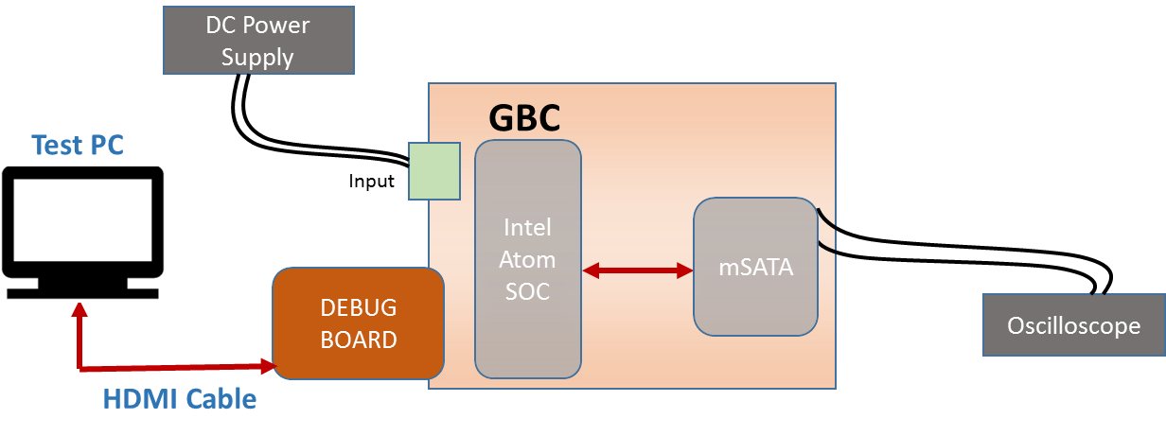
NOTE:
- Monitor required only for I/O Stress.
- Oscilloscope required only for Signal Integrity.
Figure 23. Storage mSATA- Test Setup Diagram

Test Case: Signal integrity (Test ID: CPU.11.1)

Description
- Purpose
The purpose of the test case is to validate the signal integrity of mSATA signals by plotting the eye diagram.
- Impact of failure of test case on system

Impact | Applicable | Description
Functional | NA
Performance | Yes | Failure of this test case can result in errors in the OS loaded in mSATA.
Compliance | NA
Table 217. Impact of Failure of SI – Storage mSATA
- Measurement Locations
C1833.1 and C1834.1, C1835.2 and C1836.2

Test Equipment List
- Oscilloscope: DSA91304A
- DC power supply: E3633A

Equipment Settings
- Oscilloscope: DSA91304A
Voltage per division: 500mV
Time scale: 5ns

- DC power supply: E3633A
Supply Voltage: 18V
Current Limit: 1.5A
OVP: 19V
OCP: 2A

Hardware Requisites
- GBC board

Software Requisites
- OS loaded MSATA

Test Condition
Test condition | Value | Remarks
Voltage | 18V | Nominal input voltage
Temperature | +25 C | Normal Room temperature
Table 218. Test Condition for SI – Storage mSATA

DUT Settings
NA

Requirements
mSATA Transmit
Probing points | Parameters | Specification
 |  | Min | Max
C1833.1 and C1834.1 | Eye jit RMS (ps) |  | 100
 | Eye Width (ps) | 166.66
 | Eye Height (mV) | 695.2
 | Data TIE (ps) | -11 | 11
 | Data Rate (Gb/s) |  | 3
 | Voltage peak to peak (mV) | 800
mSATA Receive
Probing points | Parameters | Specification
 |  | Min | Max
C1835.2 and C1836.2 | Eye jit RMS (ps) |  | 100
 | Eye Width (ps) | 166.66
 | Eye Height (mV) | 695.2
 | Data TIE (ps) | -11 | 11
 | Data Rate (Gb/s) |  | 3
 | Voltage peak to peak (mV) | 800
Table 219. Requirements for SI – Storage mSATA

Test Procedure
- Configure DC power supply to give a voltage of 18V.
- Insert mSATA in GBC board.
- Probe the mSATA TX signal at C1833.1 and C1834.1 using differential probe.
- Probe the mSATA RX signal at C1835.2 and C1836.2 using differential probe.
- Plot eye diagram and analyze the eye characteristics
- Make sure the measuring criteria for the signal satisfies the above mentioned requirements.

Reference
Further details can be found in Page 8 and 21 of GBC schematic Life-2.

Test Case: I/O Stress (Test ID: CPU.11.2)

Description
- Purpose
The purpose of the test case is to validate mSATA memory access when mSATA lines are under stress.
- Impact of failure of test case on system

Impact | Applicable | Description
Functional | Yes | Failure of this test case causes mSATA to hang/ not perform properly under stress.
Performance | NA
Compliance | NA
Table 220. Impact of Failure of I/O Stress – Storage mSATA

Test Equipment List
- DC power supply: E3633A

Equipment Settings
- DC power supply: E3633A
Supply Voltage: 18V
Current Limit: 1.5A
OVP: 19V
OCP: 2A

Hardware Requisites
- GBC board
- Debug board
- Monitor

Software Requisites
- OS loaded MSATA
- FIO utility

Test Condition
Test condition | Value | Remarks
Voltage | 18V | Nominal input voltage
Temperature | +25 C | Normal Room temperature
Table 221. Test Condition for I/O Stress – Storage mSATA

DUT Settings
NA

Requirements
Test | Measuring Parameter | Result
I/O Stress | FIO utility | FIO utility will stress the mSATA lines to their maximum performance. While they are under stress, mSATA memory should be accessible with no errors.
Table 222. Requirements for I/O Stress – Storage mSATA

Test Procedure
- Connect Debug board to GBC board.
- Connect a monitor to debug board using HDMI cable.
- Configure DC power supply to give a voltage of 18V.
- Run FIO utility in the Console (SOC).
- Validate the output as per the above requirement.

Reference
Further details can be found in Page 8 and 21 of GBC schematic Life-2.

Springville1 - PCIe

Test Setup
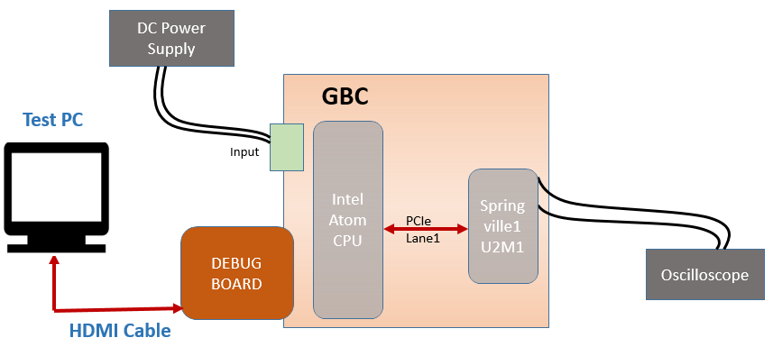
Figure 24. SpringVille1 – PCIe- Test Setup Diagram

Test Case: Springville1 - PCIe (Test ID: CPU.13.1)

Description
- Purpose
The purpose of this test case is to check and validate the electrical parameters and signal integrity of PCIe interface between Intel processor (U3) and Springville1 (U2M1).
- Impact of failure of test case on system

Impact | Applicable | Description
Functional | Yes | Communication between springville1 and Intel will fail resulting in data loss
Performance | NA
Compliance | NA
Table 223. Impact of Failure – Springville1 – PCIe Lane1
- Measurement Locations
- Transmitter Lane1:
Measurement Parameter | Measurement location
PCIE1_TXP_LAN | C2B30.1
PCIE1_TXN_LAN | C2B29.1
Table 224. Measurement Locations – Transmitter Springville1 – PCIe Lane1
- Receiver Lane1:
Measurement Parameter | Measurement location
PCIE1_RXP_LAN | C2M4.1
PCIE1_RXN_LAN | C2M6.1
Table 225. Measurement Locations – Receiver Springville1 – PCIe Lane1

Test Equipment List
- AUX Power supply unit: Agilent E3634A
- Oscilloscope: DSA91304A

Equipment Settings
- DC power supply: E3633A
Supply Voltage: 18V
Current Limit: 1.5A
OVP: 20V
OCP: 2A

Hardware Requisites
- GBC board
- mSATA
- Debug board
- Monitor

Software Requisites
NA

Test Condition
Test condition | Value | Remarks
Voltage | 18V | Nominal Input voltage
Temperature | +25 C | Normal Room temperature
Table 226. Test Condition – Springville1 – PCIe Lane1

DUT Settings for Transmitter tests
Remove Springville1 IC (U2M1). Terminate the Tx lane1 lines from Intel processor by mounting a 50-ohm resistor on pin no 23 and 24 of U2M1. By doing so, PCIe compliance pattern as per section 4.2.8 of PCIe base specification ver. 2.1 is generated.

DUT Settings for Receiver tests
Mount back Springville1 IC (U2M1). Terminate the Rx lane1 lines from Springville1 (U2M1) by lifting capacitor side C2M4.1 and C2M6.1 and terminating the line by mounting a 50-ohm resistor. By doing so, PCIe compliance pattern as per section 4.2.8 of PCIe base specification ver. 2.1 is generated.

Requirements
NA

Test Procedure
- Transmitter Test:
- Probe PCIE1_TXP_LAN and PCIE1_TXN_LAN at C2B30.1 and C2B29.1 respectively.
- Run the test utility N5393D in the infiniium oscilloscope. To configure the test suite, select PCIe version as 2.0, Transmitter tests, Device1, Lane1, and speed as 2.5GT/s. In select tests option in utility, select transmitter tests and run all the selected test cases.
- The test utility generates the test report for all the test cases selected with the pass or fail criteria and its % margin.

- Receiver Test:
- Probe PCIE1_RXP_LAN and PCIE1_RXN_LAN at C2M4.1 and C2M6.1 respectively.
- Run the test utility N5393D in the infiniium oscilloscope. To configure the test suite, select PCIe version as 2.0, Receiver tests, Device1, Lane1, and speed as 2.5GT/s. In select tests option in utility, select receiver tests and run all the selected test cases.
- The test utility generates the test report for all the test cases selected with the pass or fail criteria and its % margin.

Reference
Further details can be found in Page 9 and 23 of GBC schematic Ver. Life-2.

Springville2 - PCIe

Test Setup
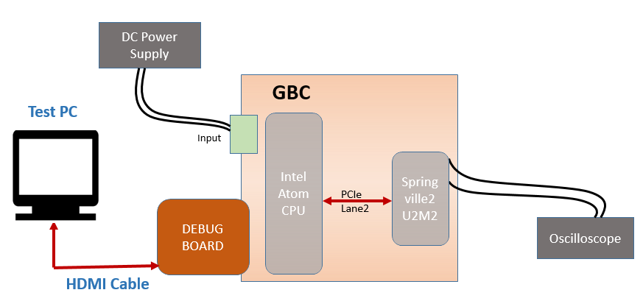
Figure 25. SpringVille2 – PCIe- Test Setup Diagram

Test Case: Springville2 - PCIe (Test ID: CPU.13.2)

Description
- Purpose
The purpose of this test case is to check and validate the electrical parameters and signal integrity of PCIe interface between Intel processor (U3) and Springville2 (U2M2).
- Impact of failure of test case on system

Impact | Applicable | Description
Functional | Yes | Communication between springville2 and Intel will fail resulting in data loss
Performance | NA
Compliance | NA
Table 227. Impact of Failure – Springville2 – PCIe Lane2
- Measurement Locations
- Transmitter Lane 2:
Measurement Parameter | Measurement location
PCIE2_TXP_LAN | C2B32.1
PCIE2_TXN_LAN | C2B31.1
Table 228. Measurement Locations – Transmitter Springville2 – PCIe Lane2
- Receiver Lane 2:
Measurement Parameter | Measurement location
PCIE2_RXP_LAN | C2M22.1
PCIE2_RXN_LAN | C2M21.1
Table 229. Measurement Locations – Receiver Springville2 – PCIe Lane2

Test Equipment List
- AUX Power supply unit: Agilent E3634A
- Oscilloscope: DSA91304A

Equipment Settings
- DC power supply: E3633A
Supply Voltage: 18V
Current Limit: 1.5A
OVP: 20V
OCP: 2A

Hardware Requisites
- GBC board
- mSATA
- Debug board
- Monitor

Software Requisites
NA

Test Condition
Test condition | Value | Remarks
Voltage | 18V | Nominal Input voltage
Temperature | +25 C | Normal Room temperature
Table 230. Test Condition – Springville2 – PCIe Lane2

DUT Settings for Transmitter tests
Remove Springville2 IC (U2M2). Terminate the Tx lane2 lines from Intel processor by mounting a 50-ohm resistor on pin no 23 and 24 of U2M2. By doing so, PCIe compliance pattern as per section 4.2.8 of PCIe base specification ver. 2.1 is generated.

DUT Settings for Receiver tests
Mount back Springville2 IC (U2M2). Terminate the Rx lane2 lines from Springville2 (U2M2) by lifting capacitor side C2M22.1 and C2M21.1 and terminating the line by mounting a 50-ohm resistor. By doing so, PCIe compliance pattern as per section 4.2.8 of PCIe base specification ver. 2.1 is generated.

Requirements
NA

Test Procedure
- Transmitter Test:
- Probe PCIE2_TXP_LAN and PCIE2_TXN_LAN at C2B32.1 and C2B31.1 respectively.
- Run the test utility N5393D in the infiniium oscilloscope. To configure the test suite, select PCIe version as 2.0, Transmitter tests, Device1, Lane2, and speed as 2.5GT/s. In select tests option in utility, select transmitter tests and run all the selected test cases.
- The test utility generates the test report for all the test cases selected with the pass or fail criteria and its % margin.

- Receiver Test:
- Probe PCIE2_RXP_LAN and PCIE2_RXN_LAN at C2M22.1 and C2M21.1 respectively.
- Run the test utility N5393D in the infiniium oscilloscope. To configure the test suite, select PCIe version as 2.0, Receiver tests, Device1, Lane2, and speed as 2.5GT/s. In select tests option in utility, select receiver tests and run all the selected test cases.
- The test utility generates the test report for all the test cases selected with the pass or fail criteria and its % margin.

Reference
Further details can be found in Page 9 and 24 of GBC schematic Ver. Life-2

TRXFE - GPIO

Test Setup
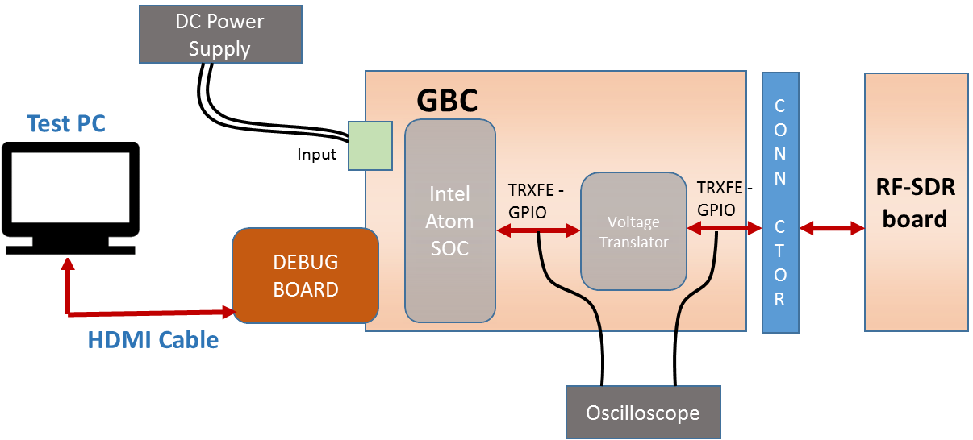
Figure 26. TRXFE GPIO - Test Setup Diagram

Test Case: Control outputs functional validation (Test ID: CPU.15.2)

Description
- Purpose
The purpose of the test case is to execute the control outputs functional validation of TRXFE- GPIO signals.
- Impact of failure of test case on system

Impact | Applicable | Description
Functional | Yes | Failure of this test case will cause the GPIO lines to not toggle and hence not work as per design.
Performance | NA
Compliance | NA
Table 231. Impact of Failure of Control outputs FV – TRXFE GPIO

Test Equipment List
- DC power supply: E3633A

Equipment Settings
- DC power supply: E3633A
Supply Voltage: 18V
Current Limit: 1.5A
OVP: 19V
OCP: 2A

Hardware Requisites
- GBC board
- Debug board
- Monitor

Software Requisites
- OS loaded MSATA

Test Condition
Test condition | Value | Remarks
Voltage | 18V | Nominal input voltage
Temperature | +25 C | Normal Room temperature
Table 232. Test Condition for Control outputs FV – TRXFE GPIO

DUT Settings
NA

Requirements
Test | Measuring Parameter | Result
Control outputs functional validation | Toggling of TRXFE - GPIO signals | Toggle the GPIO lines by using GPIO Sysfs Interface in Linux.
Table 233. Requirements for Control outputs FV – TRXFE GPIO

Test Procedure
- Connect Debug board to GBC board.
- Connect a monitor to debug board using HDMI cable.
- Configure DC power supply to give a voltage of 18V.
- Open the terminal and run the command to toggle the GPIO lines.
- Validate the output as per the above requirement.

Reference
Further details can be found in Page 9, 76 and 84 of GBC schematic Life-2.

Test Case: Signal Characteristics (Test ID: CPU.15.3)

Description
- Purpose
The purpose of the test case is to validate the signal characteristics of TRXFE- GPIO signals.

- Impact of failure of test case on system

Impact | Applicable | Description
Functional | NA
Performance | Yes | Failure of this test case will result in improper functioning of the GPIO lines.
Compliance | NA
Table 234. Impact of Failure of SI – TRXFE GPIO
- Measurement Locations
- R10546, R10547, R10548 and R10549
- R10542, R10543, R10528 and R10529

Test Equipment List
- Oscilloscope: MSO9404A
- DC power supply: E3633A

Equipment Settings
- Oscilloscope: MSO9404A
Voltage per division: 1V
Time scale: 50ms

- DC power supply: E3633A
Supply Voltage: 18V
Current Limit: 1.5A
OVP: 19V
OCP: 2A

Hardware Requisites
- GBC board
- Debug board
- Monitor

Software Requisites
- OS loaded MSATA

Test Condition
Test condition | Value | Remarks
Voltage | 18V | Nominal input voltage
Temperature | +25 C | Normal Room temperature
Table 235. Test Condition for SI – TRXFE GPIO

DUT Settings
Resistor R10540 is removed and Pin 2 of the resistor is connected to ground to enable the level shifter.

Requirements
Test | Measuring Point | Measuring Criteria | Specification
 |  |  | Min(V) | Max(V)
Before Level Shifter
SOC_TRXFE_GPIO1 | R10546 | V_{LOW} (V) | 0 | 0.63
 |  | V_{HIGH} (V) | 1.17 | 1.8
 |  | Positive Over-shoot (V) | 0 | 0.18
 |  | Negative Over-shoot (V) | 0 | 0.18
SOC_TRXFE_GPIO2 | R10547 | V_{LOW} (V) | 0 | 0.63
 |  | V_{HIGH} (V) | 1.17 | 1.8
 |  | Positive Over-shoot (V) | 0 | 0.18
 |  | Negative Over-shoot (V) | 0 | 0.18
SOC_TRXFE_GPIO3 | R10548 | V_{LOW} (V) | 0 | 0.63
 |  | V_{HIGH} (V) | 1.17 | 1.8
 |  | Positive Over-shoot (V) | 0 | 0.18
 |  | Negative Over-shoot (V) | 0 | 0.18
SOC_TRXFE_GPIO4 | R10549 | V_{LOW} (V) | 0 | 0.63
 |  | V_{HIGH} (V) | 1.17 | 1.8
 |  | Positive Over-shoot (V) | 0 | 0.18
 |  | Negative Over-shoot (V) | 0 | 0.18
After Level Shifter
ISO_SOC_TRXFE_GPIO1 | R10542 | V_{LOW} (V) | -0.3 | 0.8
 |  | V_{HIGH} (V) | 2 | 3.6
 |  | Positive Over-shoot (V) | 0 | 0.33
 |  | Negative Over-shoot (V) | 0 | 0.33
ISO_SOC_TRXFE_GPIO2 | R10543 | V_{LOW} (V) | -0.3 | 0.8
 |  | V_{HIGH} (V) | 2 | 3.6
 |  | Positive Over-shoot (V) | 0 | 0.33
 |  | Negative Over-shoot (V) | 0 | 0.33
ISO_SOC_TRXFE_GPIO3 | R10528 | V_{LOW} (V) | -0.3 | 0.8
 |  | V_{HIGH} (V) | 2 | 3.6
 |  | Positive Over-shoot (V) | 0 | 0.33
 |  | Negative Over-shoot (V) | 0 | 0.33
ISO_SOC_TRXFE_GPIO4 | R10529 | V_{LOW} (V) | -0.3 | 0.8
 |  | V_{HIGH} (V) | 2 | 3.6
 |  | Positive Over-shoot (V) | 0 | 0.33
 |  | Negative Over-shoot (V) | 0 | 0.33
Table 236. Requirements for SI – TRXFE GPIO

Test Procedure
- Connect Debug board to GBC board.
- Connect a monitor to debug board using HDMI cable.
- Configure DC power supply to give a voltage of 18V.
- Open the terminal and run the command to toggle the GPIO lines.
- Probe the TRXFE - GPIO lines before level shifter at R10546, R10547, R10548 and R10549 and after level shifter at R10542, R10543, R10528 and R10529 respectively verify the signal characteristics.
- Make sure the measuring criteria for the signal satisfies the above mentioned requirements.

Reference
Further details can be found in Page 9, 76 and 84 of GBC schematic Life-2.

TIVA - GPIO
      - Test Setup
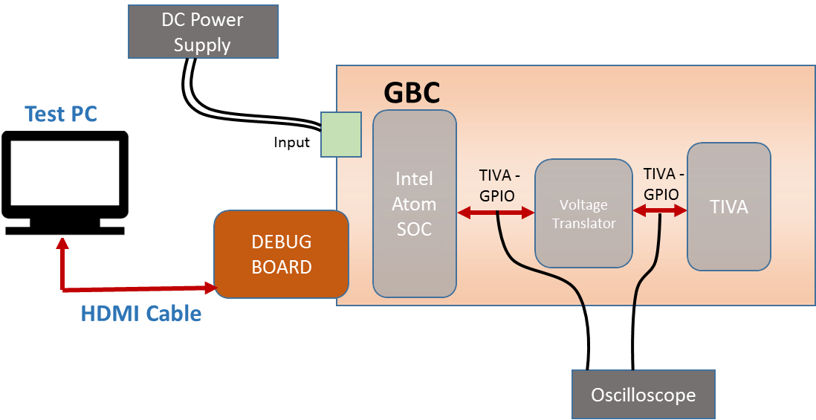
Figure 27. TIVA GPIO - Test Setup Diagram

      - Test Case: Control inputs functional validation (Test ID: CPU.17.1)
        - Description
- Purpose
The purpose of the test case is to execute the control inputs functional validation of TIVA- GPIO signals.

- Impact of failure of test case on system

Impact | Applicable | Description
Functional | Yes | Failure of this test case will cause the GPIO lines to not toggle and hence not work as per design.
Performance | NA
Compliance | NA
Table 237. Impact of Failure of Control inputs FV – TIVA GPIO
        - Test Equipment List
- DC power supply: E3633A

        - Equipment Settings
- DC power supply: E3633A
Supply Voltage: 18V
Current Limit: 1.5A
OVP: 19V
OCP: 2A
        - Hardware Requisites
- GBC board
- Debug board
- Monitor

        - Software Requisites
- OS loaded MSATA

        - Test Condition
Test condition | Value | Remarks
Voltage | 18V | Nominal input voltage
Temperature | +25 C | Normal Room temperature
Table 238. Test Condition for Control inputs FV – TIVA GPIO
        - DUT Settings
NA
        - Requirements
Test | Measuring Parameter | Result
Control inputs functional validation | Toggling of TIVA - GPIO signals | Toggle the GPIO lines by using GPIO Sysfs Interface in Linux.
Table 239. Requirements for Control inputs FV – TIVA GPIO
        - Test Procedure
- Connect Debug board to GBC board.
- Connect a monitor to debug board using HDMI cable.
- Configure DC power supply to give a voltage of 18V.
- Open the terminal and run the command to toggle the GPIO lines.
- Validate the output as per the above requirement.

        - Reference
Further details can be found in Page 12, 60 and 83 of GBC schematic Life-2.

      - Test Case: Control outputs functional validation (Test ID: CPU.17.2)
        - Description
- Purpose
The purpose of the test case is to execute the control outputs functional validation of TIVA- GPIO signals.

- Impact of failure of test case on system

Impact | Applicable | Description
Functional | Yes | Failure of this test case will cause the GPIO lines to not toggle and hence not work as per design.
Performance | NA
Compliance | NA
Table 240. Impact of Failure of Control outputs FV – TIVA GPIO
        - Test Equipment List
- DC power supply: E3633A

        - Equipment Settings
- DC power supply: E3633A
Supply Voltage: 18V
Current Limit: 1.5A
OVP: 19V
OCP: 2A
        - Hardware Requisites
- GBC board
- Debug board
- Monitor

        - Software Requisites
- MSATA with OS loaded

        - Test Condition
Test condition | Value | Remarks
Voltage | 18V | Nominal input voltage
Temperature | +25 C | Normal Room temperature
Table 241. Test Condition for Control outputs FV – TIVA GPIO
        - DUT Settings
NA
        - Requirements
Test | Measuring Parameter | Result
Control outputs functional validation | Toggling of TIVA - GPIO signals | Toggle the GPIO lines by using GPIO Sysfs Interface in Linux.
Table 242. Requirements for Control outputs FV – TIVA GPIO
        - Test Procedure
- Connect Debug board to GBC board.
- Connect a monitor to debug board using HDMI cable.
- Configure DC power supply to give a voltage of 18V.
- Open the terminal and run the command to toggle the GPIO lines.
- Validate the output as per the above requirement.

        - Reference
Further details can be found in Page 12, 60 and 83 of GBC schematic Life-2.

      - Test Case: Signal Characteristics (Test ID: CPU.17.3)
        - Description
- Purpose
The purpose of the test case is to execute the control outputs functional validation of TIVA- GPIO signals.

- Impact of failure of test case on system

Impact | Applicable | Description
Functional | NA
Performance | Yes | Failure of this test case will result in improper functioning of the GPIO lines.
Compliance | NA
Table 243. Impact of Failure of SI – TIVA GPIO
- Measurement Locations
R10514, R10516
        - Test Equipment List
- Oscilloscope: MSO9404A
- DC power supply: E3633A

        - Equipment Settings
- Oscilloscope: MSO9404A
Voltage per division: 1V
Time scale: 1s

- DC power supply: E3633A
Supply Voltage: 18V
Current Limit: 1.5A
OVP: 19V
OCP: 2A
        - Hardware Requisites
- GBC board
- Debug board
- Monitor

        - Software Requisites
- OS loaded MSATA

        - Test Condition
Test condition | Value | Remarks
Voltage | 18V | Nominal input voltage
Temperature | +25 C | Normal Room temperature
Table 244. Test Condition for SI – TIVA GPIO

DUT Settings
Resistor R10511 is removed and Pin 2 of the resistor is connected to ground to enable the level shifter.
        - Requirements
Test | Measuring Point | Measuring Criteria | Specification
 |  |  | Min(V) | Max(V)
Before Level Shifter
ISO_TIVA_SOC_GPIO2 | R10514 | V_{LOW} (V) | 0 | 0.63
 |  | V_{HIGH} (V) | 1.17 | 1.8
 |  | Positive Over-shoot (V) | 0.00 | 0.18
 |  | Negative Over-shoot (V) | 0.00 | 0.18
After Level Shifter
TIVA_SOC_GPIO2 | R10516 | V_{LOW} (V) | 0.00 | 1.16
 |  | V_{HIGH} (V) | 2.15 | 4.00
 |  | Positive Over-shoot (V) | 0.00 | 0.33
 |  | Negative Over-shoot (V) | 0.00 | 0.33
Table 245. Requirements for SI – TIVA GPIO
        - Test Procedure
- Connect Debug board to GBC board.
- Connect a monitor to debug board using HDMI cable.
- Configure DC power supply to give a voltage of 18V.
- Open the terminal and run the command to toggle the GPIO lines.
- Probe the GPIO2 signal at R10514 before level shifter and at R10516 after level shifter and verify the signal characteristics.
- Make sure the measuring criteria for the signal satisfies the above mentioned requirements.

        - Reference
Further details can be found in Page 12, 60 and 83 of GBC schematic Life-2.

TRXFE – FX3 – USB2.0

Test Setup
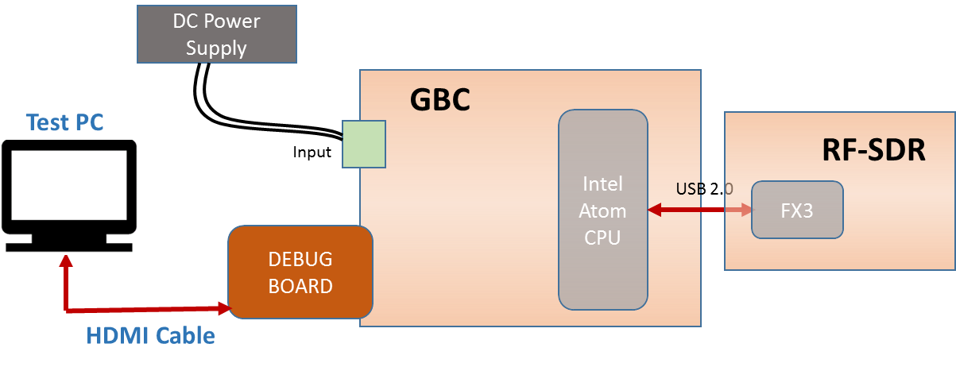
Figure 28. TRXFE FX3 USB2.0 - Test Setup Diagram

Test Case: Electrical Validation (Test ID: CPU.19.1)

Description
- Purpose
The purpose of the test case is to validate the electrical characteristics of USB2.0 interface between GBC and RF-SDR.
- Impact of failure of test case on system

Impact | Applicable | Description
Functional | NA
Performance | Yes | Failure of this test case results in communication failure between GBC and RF-SDR through USB2.0
Compliance | NA
Table 246. Impact of Failure of EV – TRXFE FX3 USB2.0
- Measurement Locations
R206.2, R208.2

Test Equipment List
- Oscilloscope: DSA91304A
- DC power supply: E3633A

Equipment Settings
- Oscilloscope: DSA91304A
Voltage per division: 1V
Time scale: 50µs

- DC power supply: E3633A
Supply Voltage: 18V
Current Limit: 1.5A
OVP: 19V
OCP: 2A

Hardware Requisites
- GBC board
- RF-SDR board
- Debug board
- Monitor

Software Requisites
- OS (Linux 14.4.4) loaded MSATA with Uhd drivers in it
- Core Boot without USB
- Dediprog engineering

Test Condition
Test condition | Value | Remarks
Voltage | 18V | Nominal input voltage
Temperature | +25 C | Normal Room temperature
Table 247. Test Condition for EV – TRXFE FX3 USB2.0

DUT Settings
NA

Requirements
Test | Measuring Parameter | Result
USB 2.0 | Electrical characteristics | All the measuring parameters should pass

Test Procedure
- Flash “without USB core boot” on SPI NOR Flash using SF-100.
- Connect Debug board to GBC board.
- Connect a monitor to Debug board.
- Configure DC power supply to give a voltage of 18V.
- Give “sudo uhd_usrp_probe” command in the terminal.
- Make sure communication is happening between GBC and RF-SDR is through USB 2.0.
- Capture one frame of data (USB 2.0 signals) by probing at R206 (USB_DP0) and R208 (USB_DN0) and save as .csv format.
- Input this .csv file to “USBET20” tool provided by USB.org, an official analysis tool for certifying signal quality and inrush current published by the USB-IF. Please be sure to run captured signal quality and inrush current test data through this tool for an official assessment of the measurement.
- Link to download USBET20 tool is - http://www.usb.org/developers/tools/usb20_tools/
- This will generate a report in .html format.
- Make sure all the measuring parameters are pass.

Reference
Further details can be found in Page 12 and 76 GBC schematic Ver. Life-2 and page 19,18 and 15 of Debug board schematic Life-2.

Test Case: Throughput measurement (Test ID: CPU.19.2)

Description
- Purpose
The purpose of the test case is to validate USB 2.0 throughput.

- Impact of failure of test case on system

Impact | Applicable | Description
Functional | Yes | System requirement will not be met in case of failure of this test case.
Performance | NA
Compliance | NA
Table 248. Impact of Failure of Throughput measurement – USB 2.0

Test Equipment List
- DC power supply: E3633A

Equipment Settings
- DC power supply: E3633A
Supply Voltage: 18V
Current Limit: 1.5A
OVP: 19V
OCP: 2A

Hardware Requisites
- GBC board
- Debug board
- Monitor

Software Requisites
OS loaded MSATA with cyusb_linux application

Test Condition
Test condition | Value | Remarks
Voltage | 18V | Nominal input voltage
Temperature | +25 C | Normal Room temperature
Table 249. Test Condition for Throughput measurement – USB 2.0

DUT Settings
NA

Requirements
Test | Measuring Parameter | Result
Memory DDR | Throughput | 25 MB/s
Table 250. Requirements for Throughput measurement – USB 2.0

Test Procedure
- Connect Debug board to GBC board.
- Connect a monitor to debug board using HDMI cable.
- Configure DC power supply to give a voltage of 18V.
- Install the FX3 Utility, by running the installation script. (./install.sh).
- Run the cyusb_linux application.
- Select the device from the list, and under the program tab download the USBIso image, .img file with burst 8 and mult 3.
- Under the Descriptors tab, select the device from the list of devices.
- Under the Data Transfers tab, start the process to know the throughput achieved.

Reference
Further details can be found in Page 12 and 76 GBC schematic Ver. Life-2

Test Case: Functional Validation (Test ID: CPU.19.3)

Description
- Purpose
The purpose of the test case is to validate USB 2.0 interface between GBC and RF-SDR board.
- Impact of failure of test case on system

Impact | Applicable | Description
Functional | Yes | Failure of this test case results in communication failure between GBC and RF-SDR through USB2.0
Performance | NA
Compliance | NA
Table 251. Impact of Failure of TRXFE – FX3 – USB2.0

Test Equipment List
- DC power supply: E3633A

Equipment Settings
- DC power supply: E3633A
Supply Voltage: 18V
Current Limit: 1.5A
OVP: 19V
OCP: 2A

Hardware Requisites
- GBC board
- Debug board
- RF-SDR board
- Monitor

Software Requisites
- OS (Linux 14.4.4) loaded MSATA with Uhd drivers in it
- CoreBoot without USB
- Dediprog engineering

Test Condition
Test condition | Value | Remarks
Voltage | 18V | Nominal input voltage
Temperature | +25 C | Normal Room temperature
Table 252. Test Condition for FV – TRXFE – FX3 – USB2.0

DUT Settings
NA

Requirements
Test | Result
USB 2.0 Interface | Communication should happen through USB 2.0 when “sudo uhd_usrp_probe” command is given.
Table 253. Requirements for FV – TRXFE – FX3 – USB2.0

Test Procedure
- Flash “without USB core boot” on SPI NOR Flash using SF-100.
- Connect Debug board to GBC board.
- Connect a Test PC to Debug board.
- Configure DC power supply to give a voltage of 18V.
- Give “sudo uhd_usrp_probe” command in the terminal.
- Make sure communication is happening between GBC and RF-SDR is through USB 2.0.

Reference
Further details can be found in Page 12 and 76 GBC schematic Ver. Life-2 and page 19,18 and 15 of Debug board schematic Life-2.

TRXFE – FX3 – USB3.0

Test Setup
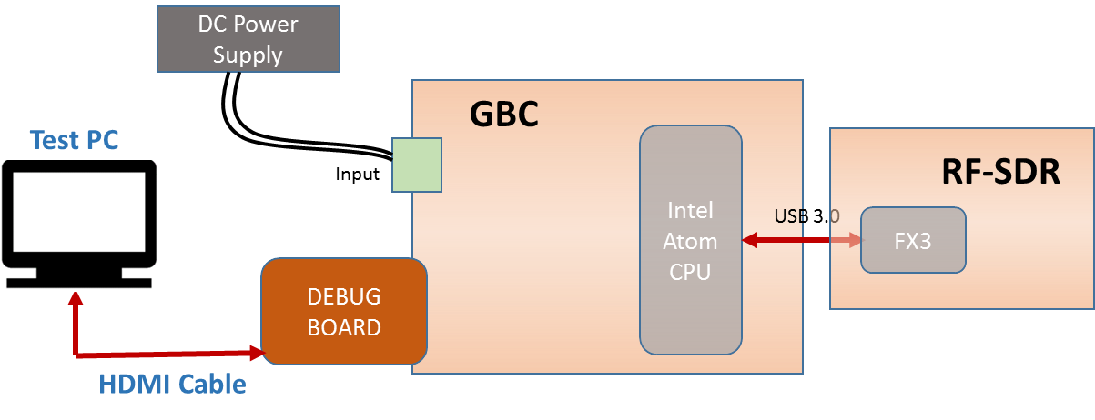
Figure 29. TRXFE – FX3 – USB3.0 - Test Setup Diagram

Test Case Throughput measurement (Test ID: CPU.20.2)

Description
- Purpose
The purpose of the test case is to validate USB 3.0 throughput.

- Impact of failure of test case on system

Impact | Applicable | Description
Functional | Yes | System requirement will not be met in case of failure of this test case.
Performance | NA
Compliance | NA
Table 254. Impact of Failure of Throughput measurement – USB 3.0

Test Equipment List
- DC power supply: E3633A

Equipment Settings
- DC power supply: E3633A
Supply Voltage: 18V
Current Limit: 1.5A
OVP: 19V
OCP: 2A

Hardware Requisites
- GBC board
- Debug board
- Monitor

Software Requisites
OS loaded MSATA with cyusb_linux application

Test Condition
Test condition | Value | Remarks
Voltage | 18V | Nominal input voltage
Temperature | +25 C | Normal Room temperature
Table 255. Test Condition for Throughput measurement – USB 3.0

DUT Settings
Remove the following capacitors and short the path because more number of decoupling capacitors are present in the path:
C1979, C1980, C1984, C1985, C1988 and C1989
Remove the following resistors:
R10627, R10628, R10629 and R10630.

Requirements
Test | Measuring Parameter | Result
Memory DDR | Throughput | 240 MB/s
Table 256. Requirements for Throughput measurement – USB 3.0
NOTE: Expected throughput is 240 MB/s as per image provided by Cypress.

Test Procedure
- Connect Debug board to GBC board.
- Connect a monitor to debug board using HDMI cable.
- Configure DC power supply to give a voltage of 18V.
- Install the FX3 Utility, by running the installation script. (./install.sh).
- Run the cyusb_linux application.
- Select the device from the list, and under the program tab download the USBIso image, .img file with burst 8 and mult 3.
- Under the Descriptors tab, select the device from the list of devices.
- Under the Data Transfers tab, start the process to know the throughput achieved.

Reference
Further details can be found in Page 12, 85 and 76 GBC schematic Ver. Life-2.

Test Case: Functional Validation (Test ID: CPU.20.3)

Description
- Purpose
The purpose of the test case is to validate USB 3.0 interface between GBC and RF-SDR board.
- Impact of failure of test case on system

Impact | Applicable | Description
Functional | Yes | Failure of this test case results in communication failure between GBC and RF-SDR through USB3.0
Performance | NA
Compliance | NA
Table 257. Impact of Failure of TRXFE – FX3 – USB3.0

Test Equipment List
- DC power supply: E3633A

Equipment Settings
- DC power supply: E3633A
Supply Voltage: 18V
Current Limit: 1.5A
OVP: 19V
OCP: 2A

Hardware Requisites
- GBC board
- Debug board
- RF-SDR board
- Monitor

Software Requisites
- OS (Linux 14.4.4) loaded MSATA with Uhd drivers
- CoreBoot with USB
- Dediprog engineering

Test Condition
Test condition | Value | Remarks
Voltage | 18V | Nominal input voltage
Temperature | +25 C | Normal Room temperature
Table 258. Test Condition for FV – TRXFE – FX3 – USB3.0

DUT Settings
Remove the following capacitors and short the path because more number of decoupling capacitors are present in the path:
C1979, C1980, C1984, C1985, C1988 and C1989
Remove the following resistors:
R10627, R10628, R10629 and R10630.

Requirements
Test | Result
USB 3.0 Interface | Communication should happen through USB 3.0 when “sudo uhd_usrp_probe” command is given.
Table 259. Requirements for FV – TRXFE – FX3 – USB3.0

Test Procedure
- Flash “with usb core boot” on SPI NOR Flash using SF-100 to configure FX3.
- Connect Debug board to GBC board.
- Connect a Test PC to debug board.
- Configure DC power supply to give a voltage of 18V.
- Give “sudo uhd_usrp_probe” command in the terminal.
- Make sure communication is happening between GBC and RF-SDR is through USB 3.0.

Reference
Further details can be found in Page 12, 85 and 76 GBC schematic Ver. Life-2 and page 17, 19 and 15 of Debug board schematic Life-2.

Debug USB2.0

Test Setup
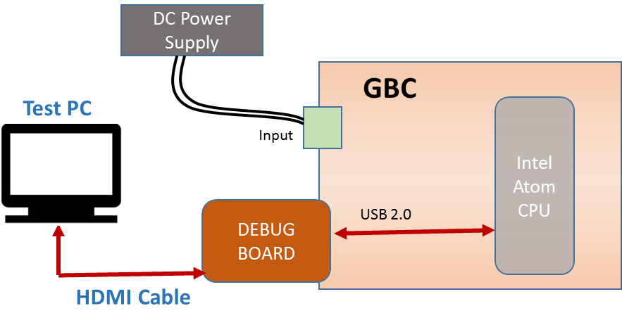
Figure 30. Debug USB2.0 - Test Setup Diagram

Test Case: Functional Validation (Test ID: CPU.21.1)

Description
- Purpose
The purpose of the test case is to validate USB 2.0 in debug board.
- Impact of failure of test case on system

Impact | Applicable | Description
Functional | Yes | Failure of this test case results in communication failure between GBC and USB2.0 device connected to debug board.
Performance | NA
Compliance | NA
Table 260. Impact of Failure of Debug USB2.0

Test Equipment List
- DC power supply: E3633A

Equipment Settings
- DC power supply: E3633A
Supply Voltage: 18V
Current Limit: 1.5A
OVP: 19V
OCP: 2A

Hardware Requisites
- GBC board
- Debug board
- Monitor

Software Requisites
- OS loaded MSATA
- CoreBoot without USB
- Dediprog engineering

Test Condition
Test condition | Value | Remarks
Voltage | 18V | Nominal input voltage
Temperature | +25 C | Normal Room temperature
Table 261. Test Condition for FV – Debug USB2.0

DUT Settings
NA

Requirements
Test | Measuring Parameter | Result
USB 2.0 Interface | Device ID | The USB2.0 device connected to USB 2.0 port in debug board should list under Bus1 when “lsusb –t” command is given.
Table 262. Requirements for FV – Debug USB2.0

Test Procedure
- Flash “without USB core boot” on SPI NOR Flash using SF-100.
- Connect Debug board to GBC board.
- Connect a Test PC to debug board.
- Configure DC power supply to give a voltage of 18V.
- A USB2.0 device(pen drive) is connected to USB2.0 port in debug board.
- Give “lsusb –t” command.
- This will list out all the devices connected through USB.
- Make sure that the USB2.0 device should list under Bus1.

Reference
Further details can be found in Page 12 and 69 of GBC schematic Ver. Life-2 and page 3, 4 and 6 of debug board schematic Life-2.

Debug USB3.0

Test Setup
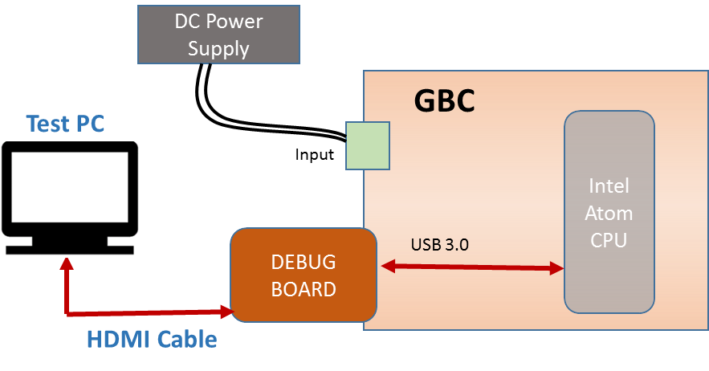
Figure 31. Debug USB3.0 - Test Setup Diagram

Test Case: Functional Validation (Test ID: CPU.22.1)

Description
- Purpose
The purpose of the test case is to validate USB 3.0 in debug board.
- Impact of failure of test case on system

Impact | Applicable | Description
Functional | Yes | Failure of this test case results in communication failure between GBC and USB3.0 device connected to debug board.
Performance | NA
Compliance | NA
Table 263. Impact of Failure of Debug USB3.0

Test Equipment List
- DC power supply: E3633A

Equipment Settings
- DC power supply: E3633A
Supply Voltage: 18V
Current Limit: 1.5A
OVP: 19V
OCP: 2A

Hardware Requisites
- GBC board
- Debug board
- Monitor

Software Requisites
- OS loaded MSATA with Uhd drivers
- CoreBoot with USB
- Dediprog engineering

Test Condition
Test condition | Value | Remarks
Voltage | 18V | Nominal input voltage
Temperature | +25 C | Normal Room temperature
Table 264. Test Condition for FV – Debug USB3.0

DUT Settings
Remove the following capacitors and short the path because more number of decoupling capacitors are present in the path:
C1979, C1980, C1986 and C1987.
Remove the following resistors:
R10627, R10628, R10629 and R10630.
In debug board, remove C4P4 and C4P3 and short the path.

Requirements
Test | Measuring Parameter | Result
USB 3.0 Interface | Device ID | The USB 3.0 device connected to usb 3.0 port in debug board should list under Bus2 when “lsusb –t” command is given.
Table 265. Requirements for FV – Debug USB3.0

Test Procedure
- Flash with “usb core boot” on SPI NOR Flash using SF-100 to configure FX3.
- Connect Debug board to GBC board.
- Connect a Monitor to Debug board.
- Configure DC power supply to give a voltage of 18V.
- A USB3.0 pen drive/HDD is connected to USB3.0 port in debug board.
- The USB3.0 signals at USB switch (U48) is routed to debug connector by toggling operation mode select pin of Mux/Demux switch (U48) using GPIO Sysfs Interface in Linux.
- Give “lsusb –t” command.
- This will list out all the devices connected through USB.
- Make sure that USB3.0 device connected to USB 3.0 port should list under Bus2.

Reference
Further details can be found in Page 12, 85 and 69 GBC schematic Ver. Life-2 and page 6 and 16 of Debug board schematic Life-2.

Debug Ethernet

Test Setup
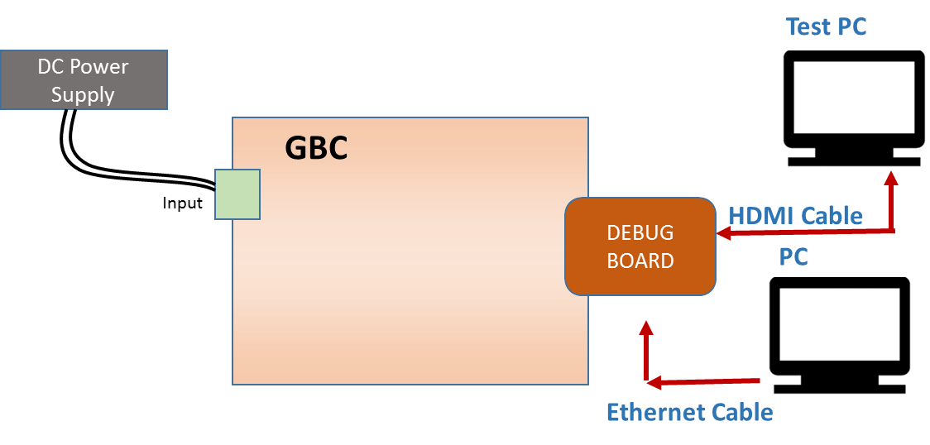
Figure 32. Debug Ethernet - Test Setup Diagram

Test Case: Functional Validation (Test ID: CPU.23.1)

Description
- Purpose
The purpose of the test case is to validate Ethernet port in debug board.
- Impact of failure of test case on system

Impact | Applicable | Description
Functional | Yes | Failure of this test case results in communication failure between GBC System and the system which is connected to Ethernet port of debug board.
Performance | NA
Compliance | NA
Table 266. Impact of Failure of Debug Ethernet

Test Equipment List
- DC power supply: E3633A

Equipment Settings
- DC power supply: E3633A
Supply Voltage: 18V
Current Limit: 1.5A
OVP: 19V
OCP: 2A

Hardware Requisites
- GBC board
- Debug board
- Monitor
- Linux PC

Software Requisites
- OS loaded MSATA

Test Condition
Test condition | Value | Remarks
Voltage | 18V | Nominal input voltage
Temperature | +25 C | Normal Room temperature
Table 267. Test Condition for FV – Debug Ethernet

DUT Settings
Make U238 selection pin high mount R10661 and unmount R10662.

Requirements
Test | Result
Debug Ethernet port | The connection should establish between GBC system and the PC connected to debug Ethernet switch.
Table 268. Requirements for FV – Debug Ethernet

Test Procedure
- Connect Debug board to GBC board.
- Connect a Monitor to Debug board.
- Connect a PC to debug Ethernet port.
- Configure DC power supply to give a voltage of 18V.
- Establish the connection between GBC system and the external PC using “ping” command.
- Make sure the communication is established.

Reference
Further details can be found in Page 86, 87, 26 and 25 of GBC schematic Ver. Life-2 and page 14 and 15 of Debug board schematic Life-2.

Display - HDMI

Test Setup
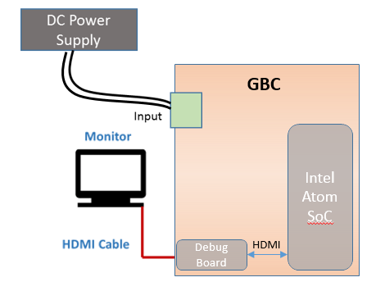
Figure 33. Display HDMI - Test Setup Diagram

      - Test Case: Functional Validation (Test ID: CPU.24.1)
        - Description
- Purpose
The purpose of the test case is to validate HDMI interface in debug board.

- Impact of failure of test case on system

Impact | Applicable | Description
Functional | Yes | Failure of this test case will cause the display not to come up which will affect user interaction with the system
Performance | NA
Compliance | NA
Table 269. Impact of Failure of FV – Display HDMI
        - Test Equipment List
- DC power supply: E3633A

        - Equipment Settings
- DC power supply: E3633A
Supply Voltage: 18V
Current Limit: 1.5A
OVP: 19V
OCP: 2A

        - Hardware Requisites
- GBC board
- Debug board

        - Software Requisites
- Test PC
- OS loaded MSATA

        - Test Condition
Test condition | Value | Remarks
Voltage | 18V | Nominal input voltage
Temperature | +25 C | Normal Room temperature
Table 270. Test Condition for FV – Display HDMI
        - DUT Settings
NA
        - Requirements
Test | Measuring Parameter | Result
HDMI Interface | Display | User can interact with the DUT for all sorts of functions
Table 271. Requirements for FV – Display HDMI
        - Test Procedure
- Connect Debug board to GBC board.
- Connect a PC to the HDMI port (J4N1) of debug board.
- Configure DC power supply to give a voltage of 18V.
- If required power rail and HDMI interface are operational, display is seen on the monitor

        - Reference
Further details can be found in Page 7 and 69 of GBC schematic Life-2 and Page 2 of Debug Schematic Life-2.

Debug - UART

Test Setup
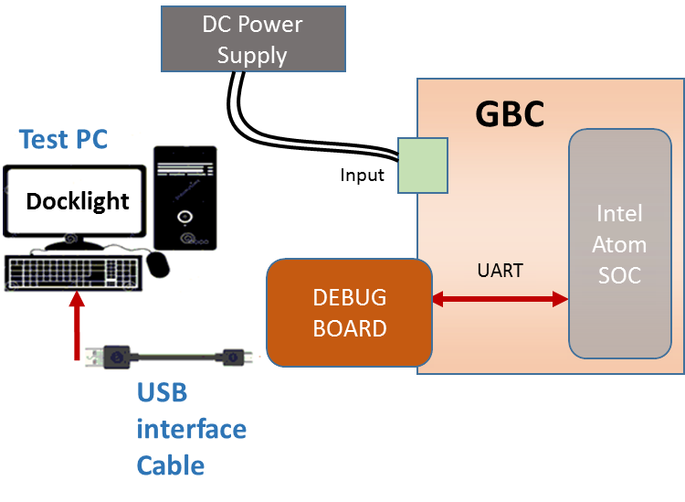
Figure 34. Debug UART - Test Setup Diagram

      - Test Case: Functional Validation (Test ID: CPU.25.1)
        - Description
- Purpose
The purpose of the test case is to validate UART interface in debug board.
- Impact of failure of test case on system

Impact | Applicable | Description
Functional | Yes | Failure of this test case will cause the GPIO lines to not toggle and hence not work as per design.
Performance | NA
Compliance | NA
Table 272. Impact of Failure of FV – Debug UART
        - Test Equipment List
- DC power supply: E3633A

        - Equipment Settings
- DC power supply: E3633A
Supply Voltage: 18V
Current Limit: 1.5A
OVP: 19V
OCP: 2A

        - Hardware Requisites
- GBC board
- Debug board

        - Software Requisites
- Test PC with Docklight software
- OS loaded MSATA

        - Test Condition
Test condition | Value | Remarks
Voltage | 18V | Nominal input voltage
Temperature | +25 C | Normal Room temperature
Table 273. Test Condition for FV – Debug UART
        - DUT Settings
Debug board:
- Bypass U2L1.
- Remove R64 and R76, R88 and R91
- Connect R88.1 to R76.2
- Connect R91.1 to R64.2
        - Requirements
Test | Measuring Parameter | Result
UART Interface | Boot Log | The Intel Atom processor sends boot log through the USB port to the PC during board power up. The data sent can be verified in the application software.
Table 274. Requirements for FV – Debug UART
        - Test Procedure
- Connect Debug board to GBC board.
- Connect a PC (with Docklight software) to the USB port (J1N4) of debug board.
- The Docklight software will be running in the PC.
- Configure DC power supply to give a voltage of 18V.
- The Intel Atom processor sends boot log through the USB port to the PC during board power up.
- The data sent can be verified in the application software.

        - Reference
Further details can be found in Page 12 and 69 of GBC schematic Life-2 and Page 5, 6 and 10 of Debug Schematic Life-2

RFSDR – PCIe

Test Setup
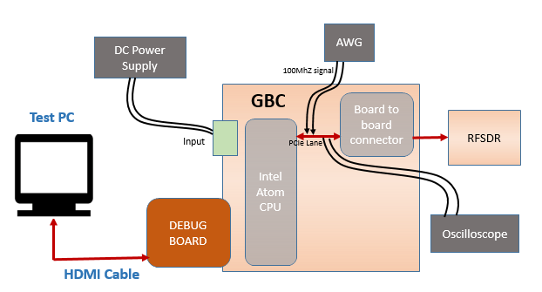
Figure 35. RFSDR – PCIe- Test Setup Diagram

Test Case: RFSDR - PCIe (Test ID: CPU.26.1)

Description
- Purpose
The purpose of this test case is to check and validate the electrical parameters and signal integrity of PCIe interface at 5GT/s between Intel processor (U3) and RFSDR board.
- Impact of failure of test case on system

Impact | Applicable | Description
Functional | Yes | Communication between RFSDR and Intel will fail resulting in data loss
Performance | NA
Compliance | NA
Table 275. Impact of Failure – Transmitter RFSDR – PCIe Lane0
- Measurement Location
Measurement Parameter | Measurement location
PCIE0_TXP | C2000.1
PCIE0_TXN | C1999.1
Table 276. Measurement Locations – Transmitter RFSDR – PCIe Lane0

Test Equipment List
- AUX Power supply unit: Agilent E3634A
- Oscilloscope: DSA91304A

Equipment Settings
- DC power supply: E3633A
Supply Voltage: 18V
Current Limit: 1.5A
OVP: 20V
OCP: 2A

Hardware Requisites
- GBC board
- mSATA
- Debug board
- Monitor

Software Requisites
NA

Test Condition
Test condition | Value | Remarks
Voltage | 18V | Nominal Input voltage
Temperature | +25 C | Normal Room temperature
Table 277. Test Condition – Transmitter RFSDR – PCIe Lane0

DUT Settings for Transmitter tests
- Terminate PCIe transmitter lane 0 lines with a 50-ohm resistor. By doing so, PCIe compliance pattern as per section 4.2.8 of PCIe base specification ver. 2.1 is generated.
- From AWG (arbitrary waveform generator), generate bursts a 100MHz signal for 1ms duration. Connect the output of AWG to PCIE0_RXP. This ensures the PCIe Tx lines to be transmitting data at 5GT/s speed.

Requirements
NA

Test Procedure
- Transmitter Test:
- Probe PCIE0_TXP PCIE0_TXN at C2000.1 and C1999.1 respectively.
- Run the test utility N5393D in the infiniium oscilloscope. To configure the test suite, select PCIe version as 2.0, Transmitter tests, Device1, Lan0, and speed as 5GT/s. In select tests option in utility, select transmitter tests and run all the selected test cases. The test utility generates the test report for all the test cases selected with the pass or fail criteria and its % margin.
- The test utility generates the test report for all the test cases selected with the pass or fail criteria and its % margin.

Reference
Further details can be found in Page 9 and 76 of GBC schematic Ver. Life-2.

TIVA

Test Purpose and Description
The purpose of TIVA microcontroller is to perform housekeeping operations whose main function will be to control and monitor all power rails, battery charging tasks and various control / configuration / diagnostic tasks (for ex. Configuration of TRX front end etc.).

TIVA Sub-system constitutes of below components
- TIVA – Configuration / System reset sequence
- PSE - I2C
- Power Monitor - I2C
- RF SDR IO Exp- I2C
- Temp Sensor - I2C
- Sync board - I2C
- LED board - I2C
- TIVA GPIO - Control inputs functional validation
- TIVA GPIO - Control outputs functional validation

TIVA

Test Setup
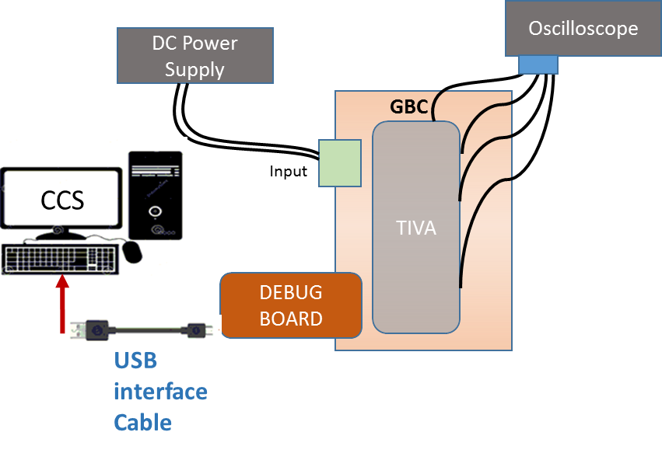
NOTE:
- Oscilloscope not required for Tiva Configuration.
Figure 36. TIVA - Test Setup Diagram

Test Case: TIVA Configuration (Test ID: TIV.1.1)

Description
- Purpose
The purpose of this test case is to access TIVA through JTAG and configuring with the help of CCS debug software.

- Impact of failure of test case on system

Impact | Applicable | Description
Functional | Yes | Failure of this test case will result in abnormal functionality of the system.
Performance | NA
Compliance | NA
Table 278. Impact of Failure of TIVA Configuration
- Measurement Locations
NA

Test Equipment List
- DC power supply: E3633A

Equipment Settings
- DC power supply: E3633A
Supply Voltage: 18V
Current Limit: 1.5A
OVP: 19V
OCP: 2A

Hardware Requisites
- GBC board
- Debug board

Software Requisites
- Code Composer Studio Tool
- TIVA Configuration code

Test Condition
Test condition | Value | Remarks
Voltage | 18V | Nominal input voltage
Temperature | +25 C | Normal Room temperature
Table 279. Test Condition for TIVA Configuration

DUT Settings
NA

Requirements
TIVA Configuration Code

Test Procedure
- Connect Debug board to GBC board to flash the code.
- Connect a Test PC with CCS to debug board.
- Import the code in Code Composer Studio and configure the debugger.
- Run the code in CCS
- Configure DC power supply to give a voltage of 18V.
- Ensure successfully accessing and programming TIVA controller
- Make sure the behaviour of TIVA controller as desired.

Reference
Further details can be found in Page 60 and 74 of GBC schematic Life-2 and Page 8 of Debug Schematic Life-2

Test Case: System Reset sequence (Test ID: TIV.1.2)

Description
- Purpose
The purpose of the test case is to validate TIVA system reset sequence.
- Impact of failure of test case on system

Impact | Applicable | Description
Functional | Yes | Failure of this test case will result in abnormal functionality of the system.
Performance | NA
Compliance | NA
Table 280. Impact of Failure of System Reset sequence
- Measurement Locations
R10523, R10438, R10165, R10519

Test Equipment List
- Oscilloscope: MSO9404A
- DC power supply: E3633A

Equipment Settings
- Oscilloscope: MSO9404A
Logic Analyzer Threshold setting: 2V
Time scale: 50ms

- DC power supply: E3633A
Supply Voltage: 18V
Current Limit: 1.5A
OVP: 19V
OCP: 2A

Hardware Requisites
- GBC board
- Debug board

Software Requisites
- Code Composer Studio Tool
- System Reset Sequence code

Test Condition
Test condition | Value | Remarks
Voltage | 18V | Nominal input voltage
Temperature | +25 C | Normal Room temperature
Table 281. Test Condition for System Reset sequence

DUT Settings
NA

Requirements
Sl. No | Expected sequence | Measurement Points
1 | TIVA_RESET_TO_PROC | R10523
2 | TIVA_ETHSW_RESET | R10438
3 | TIVA_TRXFE_RESET | R10165
4 | TIVA_SYNC_RESET | R10519
Table 282. Requirements for System Reset sequence

Test Procedure
- Connect Debug board to GBC board to flash the code.
- Connect a Test PC with CCS to debug board.
- Import the code in Code Composer Studio.
- Run the code in CCS.
- Configure DC power supply to give a voltage of 18V.
- Set the Logic Analyzer in oscilloscope as mentioned above in Equipment Settings.
- Probe the reset signals at R10523, R10438, R10165 and R10519 to measure the system reset sequence.
- Make sure the measuring criteria for the signal satisfies the above mentioned requirements.

Reference
Further details can be found in Page 60, 68 and 80 of GBC schematic Life-2.

PSE – I2C (LTC4274AIUHF)

Test Setup
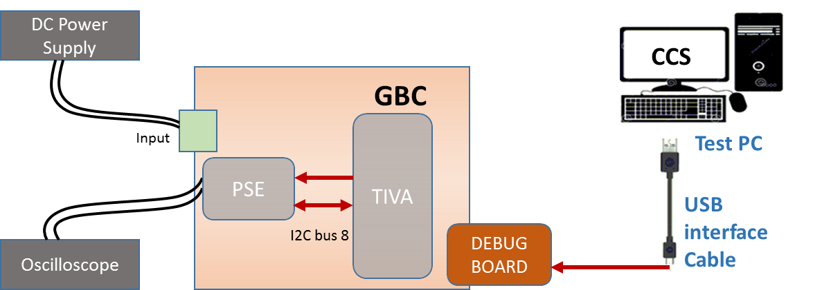
Figure 37. PSE I2C -- Test Setup Diagram

Test Case: Electrical Validation (Test ID: TIV.2.1)

Description
- Purpose
The purpose of the test case is to validate the electrical characteristics of I2C interface of PSE controller.
- Impact of failure of test case on system

Impact | Applicable | Description
Functional | NA
Performance | Yes | Failure of this test case will result in improper data from PSE controller.
Compliance | NA
Table 283. Impact of Failure of EV – PSE I2C
- Measurement Locations
U206.3/ U206.2, U206.6/ U206.7

Test Equipment List
- Oscilloscope: MSO9404A
- LTPoE++ PSE injector - PS-201G++

Equipment Settings
- Oscilloscope: MSO9404A
Voltage per division: 1V
Time scale: 50µs

- LTPoE++ PSE injector - PS-201G++
Supply Voltage: 53.75 to 56V
Current Limit: 1.6A

Hardware Requisites
- GBC board
- Debug board

Software Requisites
- Code Composer Studio Tool
- Tiva-PSE I2C code

Test Condition
Test condition | Value | Remarks
Voltage | 18V | Nominal input voltage
Temperature | +25 C | Normal Room temperature
Table 284. Test Condition for EV– PSE I2C

DUT Settings
NA

Requirements
Test | Measuring Point | Measuring Criteria | Specification
 |  |  | Min | Max
Before Isolator
TIVA_PSE_I2C8_SCLK | U206.3 | VLOW (max) (V) | 0 | 0.5
 |  | VHIGH (min) (V) | 2.31 | 3.3
 |  | Rise time (ns) | 0 | 1000
 |  | Fall time (ns) | 0 | 300
 |  | Frequency (kHz) | 0 | 100
TIVA_PSE_I2C8_SDA | U206.2 | VLOW (max) (V) | 0 | 0.5
 |  | VHIGH (min) (V) | 2.31 | 3.3
 |  | Rise time (ns) | 0 | 1000
 |  | Fall time (ns) | 0 | 300
After Isolator
PSE_I2CSCL | U206.6 | VLOW (max) (V) | -0.5 | 0.8
 |  | VHIGH (min) (V) | 2.2 | 3.8
 |  | Rise time (ns) | 0 | 1000
 |  | Fall time (ns) | 0 | 300
 |  | Frequency (kHz) | 0 | 100
PSE_I2CSDA | U206.7 | VLOW (max) (V) | -0.5 | 0.8
 |  | VHIGH (min) (V) | 2.2 | 3.8
 |  | Rise time (ns) | 0 | 1000
 |  | Fall time (ns) | 0 | 300
Table 285. Requirements for EV– PSE I2C

Test Procedure
- Connect Debug board to GBC board to flash the code.
- Connect a Test PC with CCS to debug board.
- Import the code in Code Composer Studio.
- Configure DC power supply to give a voltage of 18V.
- Probe the I2C signal at U206.3 (SCL), U206.2 (SDA) for before isolator and U206.6 (SCL), U206.7 (SDA) for after isolator.
- Run the code in CCS.
- Make sure the measuring criteria for the signal satisfies the above mentioned requirements.

Reference
Further details can be found in Page 45 and 46 of GBC schematic Life-2.

Test Case: Signal Integrity (Test ID: TIV.2.2)

Description
- Purpose
The purpose of the test case is to validate the signal integrity of PSE controller.
- Impact of failure of test case on system

Impact | Applicable | Description
Functional | NA
Performance | Yes | Failure of this test case will result in improper data from PSE controller.
Compliance | NA
Table 286. Impact of Failure of SI – PSE I2C
- Measurement Locations
U206.3/ U206.2, U206.6/ U206.7

Test Equipment List
- Oscilloscope: MSO9404A
- LTPoE++ PSE injector - PS-201G++

Equipment Settings
- Oscilloscope: MSO9404A
Voltage per division: 1V
Time scale: 50µs

- LTPoE++ PSE injector - PS-201G++
Supply Voltage: 53.75 to 56V
Current Limit: 1.6A

Hardware Requisites
- GBC board
- Debug board

Software Requisites
- Code Composer Studio Tool
- Tiva-PSE I2C code

Test Condition
Test condition | Value | Remarks
Voltage | 18V | Nominal input voltage
Temperature | +25 C | Normal Room temperature
Table 287. Test Condition for SI – PSE I2C

DUT Settings
NA

Requirements
Test | Measuring Point | Measuring Criteria | Specification
 |  |  | Min | Max
Before Isolator
TIVA_PSE_I2C8_SCLK | U206.3 | Positive Over-shoot (V) | 0 | 0.33
 |  | Negative Over-shoot (V) | 0 | 0.33
TIVA_PSE_I2C8_SDA | U206.2 | data set-up time (ns) | 240 | 10000
 |  | data hold time (ns) | 240 | 10000
 |  | Positive Over-shoot (V) | 0 | 0.33
 |  | Negative Over-shoot (V) | 0 | 0.33
After Isolator
PSE_I2CSCL | U206.6 | Positive Over-shoot (V) | 0 | 0.33
 |  | Negative Over-shoot (V) | 0 | 0.33
PSE_I2CSDA | U206.7 | data set-up time (ns) | 240 | 10000
 |  | data hold time (ns) | 240 | 10000
 |  | Positive Over-shoot (V) | 0 | 0.33
 |  | Negative Over-shoot (V) | 0 | 0.33
Table 288. Requirements for SI – PSE I2C

Test Procedure
- Connect Debug board to GBC board to flash the code.
- Connect a Test PC with CCS to debug board.
- Import the code in Code Composer Studio.
- Configure DC power supply to give a voltage of 18V.
- Probe the I2C signal at U206.3 (SCL), U206.2 (SDA) for before isolator and U206.6 (SCL), U206.7 (SDA) for after isolator.
- Run the code in CCS.
- Make sure the measuring criteria for the signal satisfies the above mentioned requirements.

Reference
Further details can be found in Page 45 and 46 of GBC schematic Life-2.

Test Case: Functional Validation (Test ID: TIV.2.3)

Description
- Purpose
The purpose of the test case is to validate the I2C interface of PSE controller.
- Impact of failure of test case on system

Impact | Applicable | Description
Functional | Yes | Registers of PSE controller become inaccessible on failure of this test case.
Performance | NA
Compliance | NA
Table 289. Impact of Failure of FV – PSE I2C

Test Equipment List
- LTPoE++ PSE injector - PS-201G++

Equipment Settings
- LTPoE++ PSE injector - PS-201G++
Supply Voltage: 53.75 to 56V
Current Limit: 1.6A

Hardware Requisites
- GBC board
- Debug board

Software Requisites
- Code Composer Studio Tool
- Tiva-PSE I2C code

Test Condition
Test condition | Value | Remarks
Voltage | 18V | Nominal input voltage
Temperature | +25 C | Normal Room temperature
Table 290. Test Condition for FV – PSE I2C

DUT Settings
NA

Requirements
Test | Measuring Parameter | Result
I2C Interface | Device ID | Read Device ID, 70
Table 291. Requirements for FV – PSE I2C

Test Procedure
- Connect Debug board to GBC board to flash the code.
- Connect a Test PC with CCS to debug board.
- Import the code in Code Composer Studio.
- Configure DC power supply to give a voltage of 18V.
- Run the code in CCS.
- Validate the output as per the above requirement.

Reference
Further details can be found in Page 45 and 46 of GBC schematic Life-2.

Power Monitor – I2C (INA226)

Test Setup
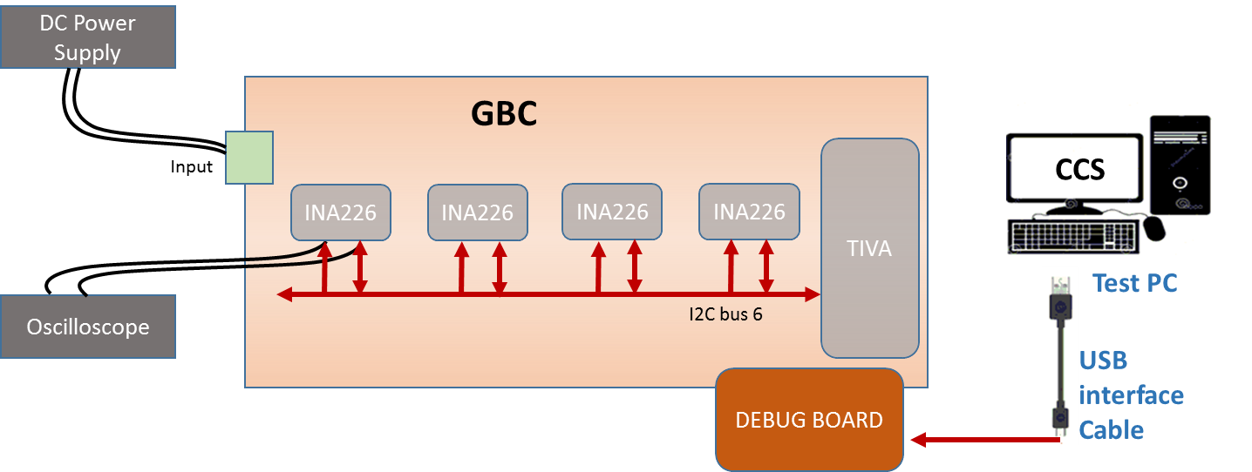
Figure 38. Power Monitor I2C - Test Setup Diagram

Test Case: Electrical Validation (Test ID: TIV.3.1)

Description
- Purpose
The purpose of the test case is to validate the electrical characteristics of I2C interface of Power monitor IC.
- Impact of failure of test case on system

Impact | Applicable | Description
Functional | NA
Performance | Yes | Failure of this test case will result in improper load current and power readings.
Compliance | NA
Table 292. Impact of Failure of EV – Power Monitor I2C
- Measurement Locations
U185.5, U185.4

Test Equipment List
- Oscilloscope: MSO9404A
- DC power supply: E3633A

Equipment Settings
- Oscilloscope: MSO9404A
Voltage per division: 1V
Time scale: 50µs

- DC power supply: E3633A
Supply Voltage: 18V
Current Limit: 1.5A
OVP: 19V
OCP: 2A

Hardware Requisites
- GBC board
- Debug board

Software Requisites
- Code Composer Studio Tool
- Tiva-power monitor I2C code

Test Condition
Test condition | Value | Remarks
Voltage | 18V | Nominal input voltage
Temperature | +25 C | Normal Room temperature
Table 293. Test Condition for EV – Power Monitor I2C

DUT Settings
NA

Requirements
Test | Measuring Point | Measuring Criteria | Specification
 |  |  | Min | Max
TIVA_PWRMNTR_I2C6_SCLK | U185.5 | VLOW (max) (V) | -0.5 | 0.99
 |  | VHIGH (min) (V) | 2.31 | 6
 |  | Rise time (ns) | 0 | 1000
 |  | Fall time (ns) | 0 | 300
 |  | Frequency (kHz) | 0 | 100
TIVA_PWRMNTR_I2C6_SDA | U185.4 | VLOW (max) (V) | -0.5 | 0.99
 |  | VHIGH (min) (V) | 2.31 | 6
 |  | Rise time (ns) | 0 | 1000
 |  | Fall time (ns) | 0 | 300
Table 294. Requirements for EV – Power Monitor I2C

Test Procedure
- Connect Debug board to GBC board to flash the code.
- Connect a Test PC with CCS to debug board.
- Import the code in Code Composer Studio.
- Configure DC power supply to give a voltage of 18V.
- Probe the I2C signal at U185.5 (SCL), U185.4 (SDA).
- Run the code in CCS.
- Make sure the measuring criteria for the signal satisfies the above mentioned requirements.

Reference
Further details can be found in Page 21, 28, 55, 60 and 75 of GBC schematic Ver. Life-2.

Test Case: Signal Integrity (Test ID: TIV.3.2)

Description
- Purpose
The purpose of the test case is to validate the signal integrity of I2C interface of Power monitor IC.
- Impact of failure of test case on system

Impact | Applicable | Description
Functional | NA
Performance | Yes | Failure of this test case will result in improper load current and power readings.
Compliance | NA
Table 295. Impact of Failure of SI– Power Monitor I2C
- Measurement Locations
U185.5, U185.4

Test Equipment List
- Oscilloscope: MSO9404A
- DC power supply: E3633A

Equipment Settings
- Oscilloscope: MSO9404A
Voltage per division: 1V
Time scale: 50µs

- DC power supply: E3633A
Supply Voltage: 18V
Current Limit: 1.5A
OVP: 19V
OCP: 2A

Hardware Requisites
- GBC board
- Debug board

Software Requisites
- Code Composer Studio Tool
- Tiva-power monitor I2C code

Test Condition
Test condition | Value | Remarks
Voltage | 18V | Nominal input voltage
Temperature | +25 C | Normal Room temperature
Table 296. Test Condition for SI – Power Monitor I2C

DUT Settings
NA

Requirements
Test | Measuring Point | Measuring Criteria | Specification
 |  |  | Min | Max
TIVA_PWRMNTR_I2C6_SCLK | U185.5 | Positive Over-shoot (V) | 0 | 0.33
 |  | Negative Over-shoot (V) | 0 | 0.33
TIVA_PWRMNTR_I2C6_SDA | U185.4 | data set-up time (ns) | 250 | 10000
 |  | data hold time (ns) | 300 | 10000
 |  | Positive Over-shoot (V) | 0 | 0.33
 |  | Negative Over-shoot (V) | 0 | 0.33
Table 297. Requirements for SI – Power Monitor I2C

Test Procedure
- Connect Debug board to GBC board to flash the code.
- Connect a Test PC with CCS to debug board.
- Import the code in Code Composer Studio.
- Configure DC power supply to give a voltage of 18V.
- Probe the I2C signal at U185.5 (SCL), U185.4 (SDA).
- Run the code in CCS.
- Make sure the measuring criteria for the signal satisfies the above mentioned requirements.

Reference
Further details can be found in Page 21, 28, 55, 60 and 75 of GBC schematic Ver. Life-2.

Test Case: Functional Validation (Test ID: TIV.3.3)

Description
- Purpose
The purpose of the test case is to validate the I2C interface of Power monitor IC.
- Impact of failure of test case on system

Impact | Applicable | Description
Functional | Yes | Registers of the power monitor IC become inaccessible on failure of this test case.
Performance | NA
Compliance | NA
Table 298. Impact of Failure of FV – Power Monitor I2C

Test Equipment List
- DC power supply: E3633A

Equipment Settings
- DC power supply: E3633A
Supply Voltage: 18V
Current Limit: 1.5A
OVP: 19V
OCP: 2A

Hardware Requisites
- GBC board
- Debug board

Software Requisites
- Code Composer Studio Tool
- Tiva-power monitor I2C code

Test Condition
Test condition | Value | Remarks
Voltage | 18V | Nominal input voltage
Temperature | +25 C | Normal Room temperature
Table 299. Test Condition for FV – Power Monitor I2C

DUT Settings
NA

Requirements
Test | Measuring Parameter | Result
I2C Interface | Manufacture ID | Read Manufacture ID, 5449 from Address FEh
Table 300. Requirements for FV – Power Monitor I2C

Test Procedure
- Connect Debug board to GBC board to flash the code.
- Connect a Test PC with CCS to Debug board.
- Import the code in Code Composer Studio.
- Configure DC power supply to give a voltage of 18V.
- Run the code in CCS.
- Validate the output as per the above requirement.

Reference
Further details can be found in Page 21, 28, 55, 60 and 75 of GBC schematic Ver. Life-2.

RF-SDR board – I2C (PCA9557PW, 118)

Test Setup
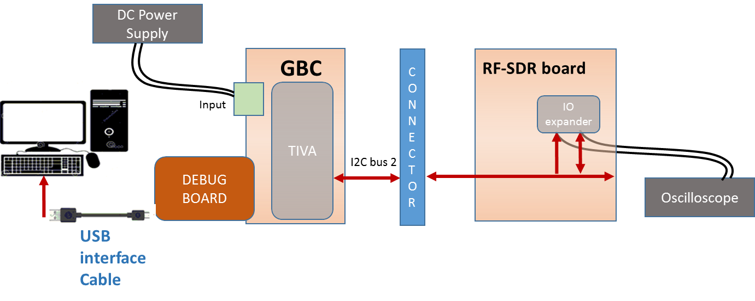
Figure 39. RF-SDR board I2C - Test Setup Diagram

Test Case: Electrical Validation (Test ID: TIV.4.1)

Description
- Purpose
The purpose of the test case is to validate the electrical characteristics of I2C interface of IO expander in RF-SDR board.
- Impact of failure of test case on system

Impact | Applicable | Description
Functional | NA
Performance | Yes | Failure of this test case will result in improper data from IO expander.
Compliance | NA
Table 301. Impact of Failure of EV – RF-SDR board I2C
- Measurement Locations
R1089.2/ R1088.2, R2034/ R2033 (RF-SDR board)

Test Equipment List
- Oscilloscope: MSO9404A
- DC power supply: E3633A

Equipment Settings
- Oscilloscope: MSO9404A
Voltage per division: 1V
Time scale: 50µs

- DC power supply: E3633A
Supply Voltage: 18V
Current Limit: 1.5A
OVP: 19V
OCP: 2A

Hardware Requisites
- GBC board
- Debug board
- RF-SDR board

Software Requisites
- Code Composer Studio Tool
- Tiva-IO expander (RF-SDR board) I2C code

Test Condition
Test condition | Value | Remarks
Voltage | 18V | Nominal input voltage
Temperature | +25 C | Normal Room temperature
Table 302. Test Condition for EV – RF-SDR board I2C

DUT Settings
NA

Requirements
Test | Measuring Point | Measuring Criteria | Specification
 |  |  | Min | Max
Before Level Shifter
TIVA_TRXFECONN_I2C2_SCLK | R1089.2 | VLOW (max) (V) | -0.5 | 0.99
 |  | VHIGH (min) (V) | 2.31 | 5.5
 |  | Rise time (ns) | 0 | 300
 |  | Fall time (ns) | 0 | 300
 |  | Frequency (kHz) | 0 | 400
TIVA_TRXFECONN_I2C2_SDA | R1088.2 | VLOW (max) (V) | -0.5 | 0.99
 |  | VHIGH (min) (V) | 2.31 | 5.5
 |  | Rise time (ns) | 0 | 300
 |  | Fall time (ns) | 0 | 300
After Level Shifter
SYS_I2C_2_SCL | R2034 | VLOW (max) (V) | -0.5 | 0.99
 |  | VHIGH (min) (V) | 2.31 | 5.5
 |  | Rise time (ns) | 0 | 300
 |  | Fall time (ns) | 0 | 300
 |  | Frequency (kHz) | 0 | 400
SYS_I2C_2_SDA | R2033 | VLOW (max) (V) | -0.5 | 0.99
 |  | VHIGH (min) (V) | 2.31 | 5.5
 |  | Rise time (ns) | 0 | 300
 |  | Fall time (ns) | 0 | 300
Table 303. Requirements for EV – RF-SDR board I2C

Test Procedure
- Connect RF-SDR board to GBC board.
- Connect Debug board to GBC board to flash the code.
- Connect a Test PC with CCS to debug board.
- Import the code in Code Composer Studio.
- Configure DC power supply to give a voltage of 18V.
- Probe the I2C signal at R1089.2 (SCL), R1088.2 (SDA) for before level shifter and R2034 (SCL), R2033 (SDA) for after level shifter.
- Run the code in CCS.
- Make sure the measuring criteria for the signal satisfies the above mentioned requirements.

Reference
Further details can be found in Page 60 and 73 and page 76 of GBC schematic Ver. Life-2 and page 44 of RF-SDR board schematic Ver. Life-2.

Test Case: Signal Integrity (Test ID: TIV.4.2)

Description
- Purpose
The purpose of the test case is to validate the signal integrity of IO expander in RF-SDR board.
- Impact of failure of test case on system

Impact | Applicable | Description
Functional | NA
Performance | Yes | Failure of this test case will result in improper data from IO expander.
Compliance | NA
Table 304. Impact of Failure of SI – RF-SDR board I2C
- Measurement Locations
R1089.2/ R1088.2, R2034/ R2033 (RF-SDR board)

Test Equipment List
- Oscilloscope: MSO9404A
- DC power supply: E3633A

Equipment Settings
- Oscilloscope: MSO9404A
Voltage per division: 1V
Time scale: 50µs

- DC power supply: E3633A
Supply Voltage: 18V
Current Limit: 1.5A
OVP: 19V
OCP: 2A

Hardware Requisites
- GBC board
- Debug board
- RF-SDR board

Software Requisites
- Code Composer Studio Tool
- Tiva-IO expander (RF-SDR board) I2C code

Test Condition
Test condition | Value | Remarks
Voltage | 18V | Nominal input voltage
Temperature | +25 C | Normal Room temperature
Table 305. Test Condition for SI – RF-SDR board I2C

DUT Settings
NA

Requirements
Test | Measuring Point | Measuring Criteria | Specification
 |  |  | Min | Max
Before Level Shifter
TIVA_TRXFECONN_I2C2_SCLK | R1089.2 | Positive Over-shoot (V) | 0 | 0.33
 |  | Negative Over-shoot (V) | 0 | 0.33
TIVA_TRXFECONN_I2C2_SDA | R1088.2 | data set-up time (ns) | 100 | 2500
 |  | data hold time (ns) | 300 | 2500
 |  | Positive Over-shoot (V) | 0 | 0.33
 |  | Negative Over-shoot (V) | 0 | 0.33
After Level Shifter
SYS_I2C_2_SCL | R2034 | Positive Over-shoot (V) | 0 | 0.33
 |  | Negative Over-shoot (V) | 0 | 0.33
SYS_I2C_2_SDA | R2033 | data set-up time (ns) | 100 | 2500
 |  | data hold time (ns) | 300 | 2500
 |  | Positive Over-shoot (V) | 0 | 0.33
 |  | Negative Over-shoot (V) | 0 | 0.33
Table 306. Requirements for SI – RF-SDR board I2C

Test Procedure
- Connect RF-SDR board to GBC board.
- Connect Debug board to GBC board to flash the code.
- Connect a Test PC with CCS to debug board.
- Import the code in Code Composer Studio.
- Configure DC power supply to give a voltage of 18V.
- Probe the I2C signal at R1089.2 (SCL), R1088.2 (SDA) for before level shifter and R2034 (SCL), R2033 (SDA) for after level shifter.
- Run the code in CCS.
- Make sure the measuring criteria for the signal satisfies the above mentioned requirements.

Reference
Further details can be found in Page 60 and 73 and page 76 of GBC schematic Ver. Life-2 and page 44 of RF-SDR board schematic Ver. Life-2.

Test Case: Functional Validation (Test ID: TIV.4.3)

Description
- Purpose
The purpose of the test case is to validate the I2C interface of IO expander in RF-SDR board.
- Impact of failure of test case on system

Impact | Applicable | Description
Functional | Yes | Registers of the IO expander become inaccessible on failure of this test case.
Performance | NA
Compliance | NA
Table 307. Impact of Failure of FV – RF-SDR board I2C

Test Equipment List
- DC power supply: E3633A

Equipment Settings
- DC power supply: E3633A
Supply Voltage: 18V
Current Limit: 1.5A
OVP: 19V
OCP: 2A

Hardware Requisites
- GBC board
- Debug board
- RF-SDR board

Software Requisites
- Code Composer Studio Tool
- Tiva-IO expander (RF-SDR board) I2C code

Test Condition
Test condition | Value | Remarks
Voltage | 18V | Nominal input voltage
Temperature | +25 C | Normal Room temperature
Table 308. Test Condition for FV – RF-SDR board I2C

DUT Settings
NA

Requirements
Test | Measuring Parameter | Result
I2C Interface | Input register data | Register 0x3 written with value 0xfe (slave address 0x1b)  or  Register 0x1 written with value 0xaa (slave address 0x1e)
Table 309. Requirements for FV – RF-SDR board I2C

Test Procedure
- Connect RF-SDR board to GBC board.
- Connect Debug board to GBC board to flash the code.
- Connect a Test PC with CCS to debug board.
- Import the code in Code Composer Studio.
- Configure DC power supply to give a voltage of 18V.
- Run the code in CCS.
- Validate the output as per the above requirement.

Reference
Further details can be found in Page 60 and 73 and page 76 of GBC schematic Ver. Life-2 and page 44 of RF-SDR board schematic Ver. Life-2.

Temp Sensor – I2C (SE98ATP, 547)

Test Setup
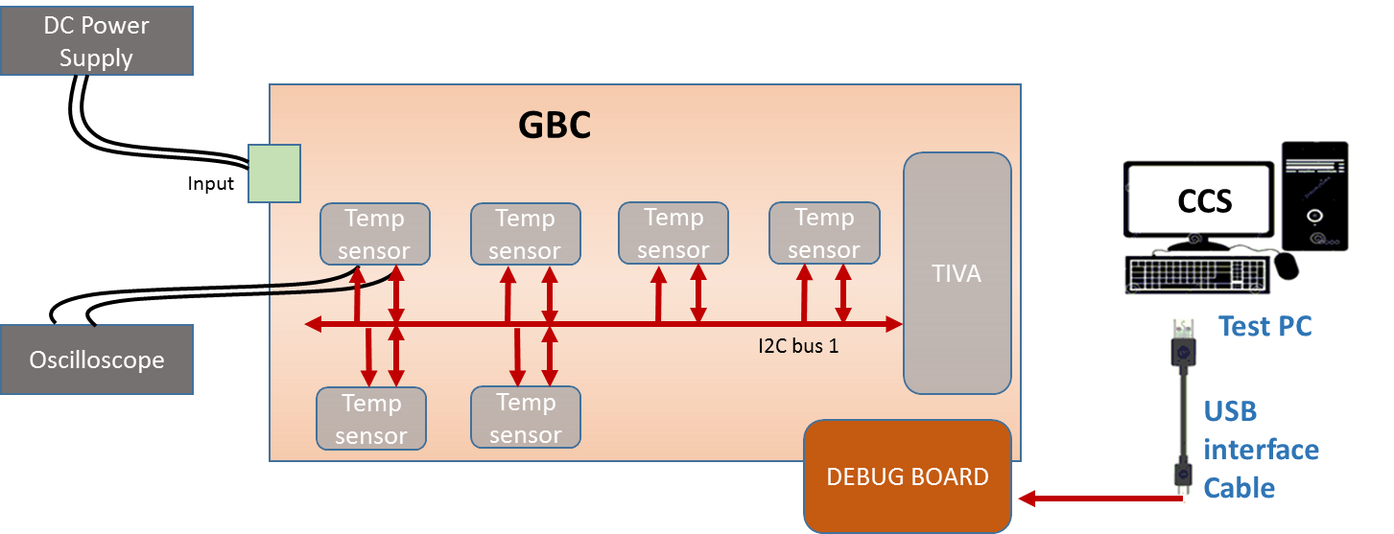
Figure 40. Temp Sensor I2C - Test Setup Diagram

Test Case: Electrical Validation (Test ID: TIV.5.1)

Description
- Purpose
The purpose of the test case is to validate the electrical characteristics of I2C interface of temperature sensor.
- Impact of failure of test case on system

Impact | Applicable | Description
Functional | NA
Performance | Yes | Failure of this test case will result in improper temperature readings.
Compliance | NA
Table 310. Impact of Failure of EV – Temp Sensor I2C
- Measurement Locations
R10255.2/ R10256.2, R10221.2/ R10222.2

Test Equipment List
- Oscilloscope: MSO9404A
- DC power supply: E3633A

Equipment Settings
- Oscilloscope: MSO9404A
Voltage per division: 1V
Time scale: 50µs

- DC power supply: E3633A
Supply Voltage: 18V
Current Limit: 1.5A
OVP: 19V
OCP: 2A

Hardware Requisites
- GBC board
- Debug board

Software Requisites
- Code Composer Studio Tool
- Tiva-temperature sensor I2C code

Test Condition
Test condition | Value | Remarks
Voltage | 18V | Nominal input voltage
Temperature | +25 C | Normal Room temperature
Table 311. Test Condition for EV – Temp Sensor I2C

DUT Settings
NA

Requirements
Test | Measuring Point | Measuring Criteria | Specification
 |  |  | Min | Max
U215 (Near Tiva)
TIVA_TEMPSEN_I2C1_SCLK | R10255.2 | VLOW (max) (V) | -0.5 | 0.99
 |  | VHIGH (min) (V) | 2.31 | 4.3
 |  | Rise time (ns) | 0 | 1000
 |  | Fall time (ns) | 0 | 300
 |  | Frequency (kHz) | 0 | 100
TIVA_TEMPSEN_I2C1_SDA | R10256.2 | VLOW (max) (V) | -0.5 | 0.99
 |  | VHIGH (min) (V) | 2.31 | 4.3
 |  | Rise time (ns) | 0 | 1000
 |  | Fall time (ns) | 0 | 300
U210 (Far from Tiva)
TIVA_TEMPSEN_I2C1_SCLK | R10221.2 | VLOW (max) (V) | -0.5 | 0.99
 |  | VHIGH (min) (V) | 2.31 | 4.3
 |  | Rise time (ns) | 0 | 1000
 |  | Fall time (ns) | 0 | 300
 |  | Frequency (kHz) | 0 | 100
TIVA_TEMPSEN_I2C1_SDA | R10222.2 | VLOW (max) (V) | -0.5 | 0.99
 |  | VHIGH (min) (V) | 2.31 | 4.3
 |  | Rise time (ns) | 0 | 1000
 |  | Fall time (ns) | 0 | 300
Table 312. Requirements for EV – Temp Sensor I2C

Test Procedure
- Connect Debug board to GBC board to flash the code.
- Connect a Test PC with CCS to debug board.
- Import the code in Code Composer Studio.
- Configure DC power supply to give a voltage of 18V.
- Probe the I2C signal at R10255.2 (SCL), R10256.2 (SDA) for near Tiva and R10221.2 (SCL), R10222.2 (SDA) for far from Tiva.
- Run the code in CCS.
- Make sure the measuring criteria for the signal satisfies the above mentioned requirements.

Reference
Further details can be found in Page 70 and 71 of GBC schematic Ver. Life-2.

Test Case: Signal Integrity (Test ID: TIV.5.2)

Description
- Purpose
The purpose of the test case is to validate the signal integrity of I2C interface of temperature sensor.
- Impact of failure of test case on system

Impact | Applicable | Description
Functional | NA
Performance | Yes | Failure of this test case will result in improper temperature readings.
Compliance | NA
Table 313. Impact of Failure of SI – Temp Sensor I2C
- Measurement Locations
R10255.2/ R10256.2, R10221.2/ R10222.2

Test Equipment List
- Oscilloscope: MSO9404A
- DC power supply: E3633A

Equipment Settings
- Oscilloscope: MSO9404A
Voltage per division: 1V
Time scale: 50µs

- DC power supply: E3633A
Supply Voltage: 18V
Current Limit: 1.5A
OVP: 19V
OCP: 2A

Hardware Requisites
- GBC board
- Debug board

Software Requisites
- Code Composer Studio Tool
- Tiva-temperature sensor I2C code

Test Condition
Test condition | Value | Remarks
Voltage | 18V | Nominal input voltage
Temperature | +25 C | Normal Room temperature
Table 314. Test Condition for SI – Temp Sensor I2C

DUT Settings
NA

Requirements
Test | Measuring Point | Measuring Criteria | Specification
 |  |  | Min | Max
U215 (Near Tiva)
TIVA_TEMPSEN_I2C1_SCLK | R10255.2 | Positive Over-shoot (V) | 0 | 0.33
 |  | Negative Over-shoot (V) | 0 | 0.33
TIVA_TEMPSEN_I2C1_SDA | R10256.2 | data set-up time (ns) | 250 | 10000
 |  | data hold time (ns) | 200 | 3450
 |  | Positive Over-shoot (V) | 0 | 0.33
 |  | Negative Over-shoot (V) | 0 | 0.33
U210 (Far from Tiva)
TIVA_TEMPSEN_I2C1_SCLK | R10221.2 | Positive Over-shoot (V) | 0 | 0.33
 |  | Negative Over-shoot (V) | 0 | 0.33
TIVA_TEMPSEN_I2C1_SDA | R10222.2 | data set-up time (ns) | 250 | 10000
 |  | data hold time (ns) | 200 | 3450
 |  | Positive Over-shoot (V) | 0 | 0.33
 |  | Negative Over-shoot (V) | 0 | 0.33
Table 315. Requirements for SI – Temp Sensor I2C

Test Procedure
- Connect Debug board to GBC board to flash the code.
- Connect a Test PC with CCS to Debug board.
- Import the code in Code Composer Studio.
- Configure DC power supply to give a voltage of 18V.
- Probe the I2C signal at R10255.2 (SCL), R10256.2 (SDA) for near Tiva and R10221.2 (SCL), R10222.2 (SDA) for far from Tiva.
- Run the code in CCS.
- Make sure the measuring criteria for the signal satisfies the above mentioned requirements.

Reference
Further details can be found in Page 70 and 71 of GBC schematic Ver. Life-2.

Test Case: Functional Validation (Test ID: TIV.5.3)

Description
- Purpose
The purpose of the test case is to validate the I2C interface of temperature sensor.
- Impact of failure of test case on system

Impact | Applicable | Description
Functional | Yes | Registers of the temperature sensor become inaccessible on failure of this test case.
Performance | NA
Compliance | NA
Table 316. Impact of Failure of FV – Temp Sensor I2C

Test Equipment List
- DC power supply: E3633A

Equipment Settings
- DC power supply: E3633A
Supply Voltage: 18V
Current Limit: 1.5A
OVP: 19V
OCP: 2A

Hardware Requisites
- GBC board
- Debug board

Software Requisites
- Code Composer Studio Tool
- Tiva-temperature sensor I2C code

Test Condition
Test condition | Value | Remarks
Voltage | 18V | Nominal input voltage
Temperature | +25 C | Normal Room temperature
Table 317. Test Condition for FV – Temp Sensor I2C

DUT Settings
NA

Requirements
Test | Measuring Parameter | Result
I2C Interface | - Device ID  - Manufacture ID | - Register 0x6 is read with 0x1131.  - Register 0x7 is read with 0xa102.
Table 318. Requirements for FV – Temp Sensor I2C

Test Procedure
- Connect Debug board to GBC board to flash the code.
- Connect a Test PC with CCS to Debug board.
- Import the code in Code Composer Studio.
- Configure DC power supply to give a voltage of 18V.
- Run the code in CCS.
- Validate the output as per the above requirement.

Reference
Further details can be found in Page 70 and 71 of GBC schematic Ver. Life-2.

Sync board – I2C (PCA9557PW, 118)

Test Setup
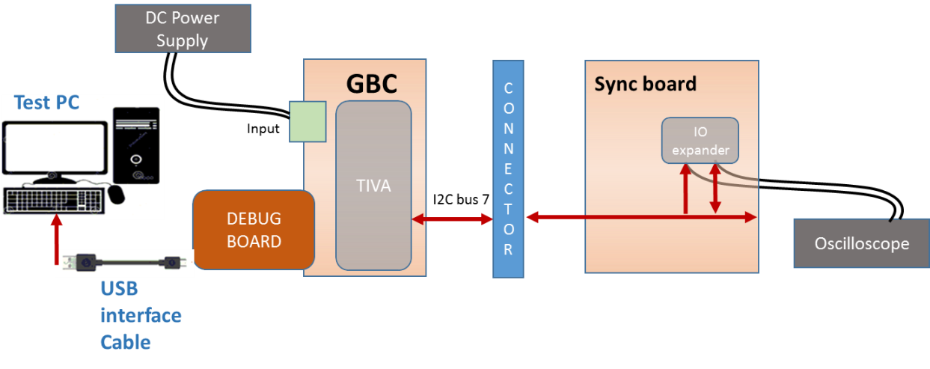
Figure 41. Sync board I2C - Test Setup Diagram

Test Case: Electrical Validation (Test ID: TIV.6.1)

Description
- Purpose
The purpose of the test case is to validate the electrical characteristics of I2C interface of IO expander in sync board.
- Impact of failure of test case on system

Impact | Applicable | Description
Functional | NA
Performance | Yes | Failure of this test case will result in improper data from IO expander.
Compliance | NA
Table 319. Impact of Failure of EV – Sync board I2C
- Measurement Locations
U1.1, U1.2 (Sync board)

Test Equipment List
- Oscilloscope: MSO9404A
- DC power supply: E3633A

Equipment Settings
- Oscilloscope: MSO9404A
Voltage per division: 1V
Time scale: 50µs

- DC power supply: E3633A
Supply Voltage: 18V
Current Limit: 1.5A
OVP: 19V
OCP: 2A

Hardware Requisites
- GBC board
- Debug board
- Sync board

Software Requisites
- Code Composer Studio Tool
- Tiva-IO expander (Sync board) I2C code

Test Condition
Test condition | Value | Remarks
Voltage | 18V | Nominal input voltage
Temperature | +25 C | Normal Room temperature
Table 320. Test Condition for EV – Sync board I2C

DUT Settings
NA

Requirements
Test | Measuring Point | Measuring Criteria | Specification
 |  |  | Min | Max
TIVA_SYNCCONN_I2C7_SCLK | U1.1 | VLOW (max) (V) | -0.5 | 0.99
 |  | VHIGH (min) (V) | 2.31 | 5.5
 |  | Rise time (ns) | 0 | 1000
 |  | Fall time (ns) | 0 | 300
 |  | Frequency (kHz) | 0 | 100
TIVA_SYNCCONN_I2C7_SDA | U1.2 | VLOW (max) (V) | -0.5 | 0.99
 |  | VHIGH (min) (V) | 2.31 | 5.5
 |  | Rise time (ns) | 0 | 1000
 |  | Fall time (ns) | 0 | 300
Table 321. Requirements for EV – Sync board I2C

Test Procedure
- Connect Sync board to GBC board.
- Connect Debug board to GBC board to flash the code.
- Connect a Test PC with CCS to Debug board.
- Import the code in Code Composer Studio.
- Configure DC power supply to give a voltage of 18V.
- Probe the I2C signal at U1.1 (SCL), U1.2 (SDA).
- Run the code in CCS.
- Make sure the measuring criteria for the signal satisfies the above mentioned requirements.

Reference
Further details can be found in Page 60 and 74 of GBC schematic Ver. Life-2 and page 4 of Sync board schematic Life-1.

Test Case: Signal Integrity (Test ID: TIV.6.2)

Description
- Purpose
The purpose of the test case is to validate the signal integrity of IO expander in sync board.
- Impact of failure of test case on system

Impact | Applicable | Description
Functional | NA
Performance | Yes | Failure of this test case will result in improper data from IO expander.
Compliance | NA
Table 322. Impact of Failure of SI – Sync board I2C
- Measurement Locations
U1.1, U1.2 (Sync board)

Test Equipment List
- Oscilloscope: MSO9404A
- DC power supply: E3633A

Equipment Settings
- Oscilloscope: MSO9404A
Voltage per division: 1V
Time scale: 50µs

- DC power supply: E3633A
Supply Voltage: 18V
Current Limit: 1.5A
OVP: 19V
OCP: 2A

Hardware Requisites
- GBC board
- Debug board
- Sync board

Software Requisites
- Code Composer Studio Tool
- Tiva-IO expander (Sync board) I2C code

Test Condition
Test condition | Value | Remarks
Voltage | 18V | Nominal input voltage
Temperature | +25 C | Normal Room temperature
Table 323. Test Condition for SI – Sync board I2C

DUT Settings
NA

Requirements
Test | Measuring Point | Measuring Criteria | Specification
 |  |  | Min | Max
TIVA_SYNCCONN_I2C7_SCLK | U1.1 | Positive Over-shoot (V) | 0 | 0.33
 |  | Negative Over-shoot (V) | 0 | 0.33
TIVA_SYNCCONN_I2C7_SDA | U1.2 | data set-up time (ns) | 250 | 10000
 |  | data hold time (ns) | 300 | 10000
 |  | Positive Over-shoot (V) | 0 | 0.33
 |  | Negative Over-shoot (V) | 0 | 0.33
Table 324. Requirements for SI – Sync board I2C

Test Procedure
- Connect Sync board to GBC board.
- Connect Debug board to GBC board to flash the code.
- Connect a Test PC with CCS to Debug board.
- Import the code in Code Composer Studio.
- Configure DC power supply to give a voltage of 18V.
- Probe the I2C signal at U1.1 (SCL), U1.2 (SDA).
- Run the code in CCS.
- Make sure the measuring criteria for the signal satisfies the above mentioned requirements.

Reference
Further details can be found in Page 60 and 74 of GBC schematic Ver. Life-2 and page 4 of Sync board schematic Life-1.

Test Case: Functional Validation (Test ID: TIV.6.3)

Description
- Purpose
The purpose of the test case is to validate the I2C interface of IO expander in sync board.
- Impact of failure of test case on system

Impact | Applicable | Description
Functional | Yes | Registers of the IO expander become inaccessible on failure of this test case.
Performance | NA
Compliance | NA
Table 325. Impact of Failure of FV – Sync board I2C

Test Equipment List
- DC power supply: E3633A

Equipment Settings
- DC power supply: E3633A
Supply Voltage: 18V
Current Limit: 1.5A
OVP: 19V
OCP: 2A

Hardware Requisites
- GBC board
- Debug board
- Sync board

Software Requisites
- Code Composer Studio Tool
- Tiva-IO expander (Sync board) I2C code

Test Condition
Test condition | Value | Remarks
Voltage | 18V | Nominal input voltage
Temperature | +25 C | Normal Room temperature
Table 326. Test Condition for FV – Sync board I2C

DUT Settings
NA

Requirements
Test | Measuring Parameter | Result
I2C Interface | Input register data | Register 0x3 written with value 0x1f
Table 327. Requirements for FV – Sync board I2C

Test Procedure
- Connect Sync board to GBC board.
- Connect Debug board to GBC board to flash the code.
- Connect a Test PC with CCS to debug board.
- Import the code in Code Composer Studio.
- Configure DC power supply to give a voltage of 18V.
- Run the code in CCS.
- Validate the output as per the above requirement.

Reference
Further details can be found in Page 60 and 74 of GBC schematic Ver. Life-2 and page 4 of Sync board schematic RevLife-1A.

LED board – I2C (SX1509BIULTRT)

Test Setup
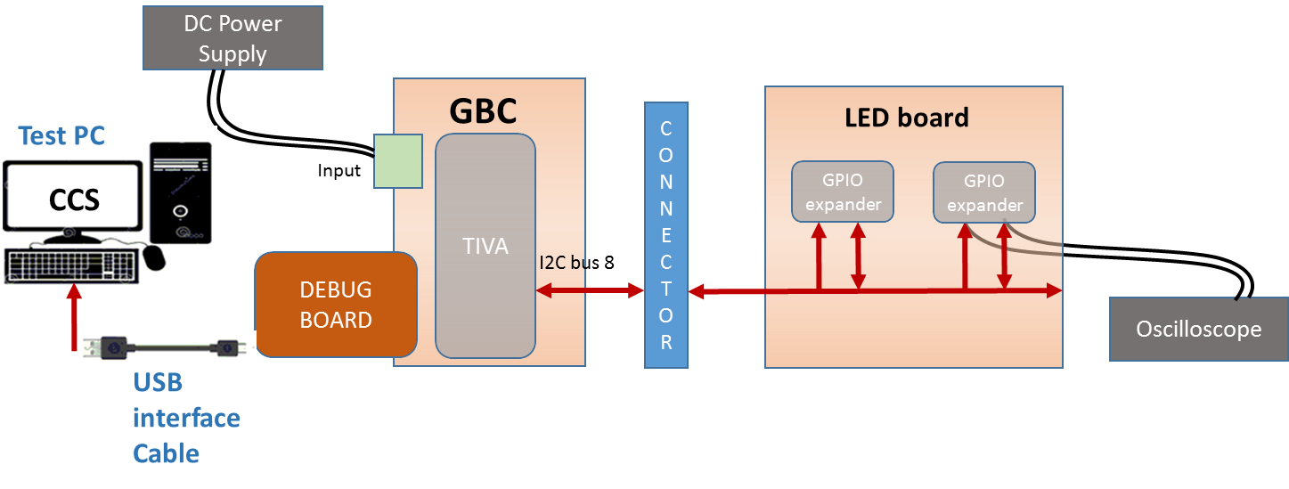
Figure 42. LED board I2C - Test Setup Diagram

Test Case: Electrical Validation (Test ID: TIV.7.1)

Description
- Purpose
The purpose of the test case is to validate the electrical characteristics of I2C interface of GPIO expander in LED board.
- Impact of failure of test case on system

Impact | Applicable | Description
Functional | NA
Performance | Yes | Failure of this test case will result in improper data from GPIO expander.
Compliance | NA
Table 328. Impact of Failure of EV – LED board I2C
- Measurement Locations
U1.25, U1.24 (LED board)

Test Equipment List
- Oscilloscope: MSO9404A
- DC power supply: E3633A

Equipment Settings
- Oscilloscope: MSO9404A
Voltage per division: 1V
Time scale: 50µs

- DC power supply: E3633A
Supply Voltage: 18V
Current Limit: 1.5A
OVP: 19V
OCP: 2A

Hardware Requisites
- GBC board
- Debug board
- LED board

Software Requisites
- Code Composer Studio Tool
- Tiva-GPIO expander (LED board) I2C code

Test Condition
Test condition | Value | Remarks
Voltage | 18V | Nominal input voltage
Temperature | +25 C | Normal Room temperature
Table 329. Test Condition for EV – LED board I2C

DUT Settings
NA

Requirements
Test | Measuring Point | Measuring Criteria | Specification
 |  |  | Min | Max
LED_I2C_SCL | U1.25 | VLOW (max) (V) | -0.4 | 0.99
 |  | VHIGH (min) (V) | 2.31 | 3.3
 |  | Rise time (ns) | 0 | 1000
 |  | Fall time (ns) | 0 | 300
 |  | Frequency (kHz) | 0 | 100
LED_I2C_SDA | U1.24 | VLOW (max) (V) | -0.4 | 0.99
 |  | VHIGH (min) (V) | 2.31 | 3.3
 |  | Rise time (ns) | 0 | 1000
 |  | Fall time (ns) | 0 | 300
Table 330. Requirements for EV – LED board I2C

Test Procedure
- Connect LED board to GBC board.
- Connect Debug board to GBC board to flash the code.
- Connect a Test PC with CCS to Debug board.
- Import the code in Code Composer Studio.
- Configure DC power supply to give a voltage of 18V.
- Probe the I2C signal at U1.25 (SCL), U1.24 (SDA).
- Run the code in CCS.
- Make sure the measuring criteria for the signal satisfies the above mentioned requirements.

Reference
Further details can be found in Page 46 and 87 of GBC schematic Ver. Life-2 and Page 1 the LED schematic Ver. Life-2.

Test Case: Signal Integrity (Test ID: TIV.7.2)

Description
- Purpose
The purpose of the test case is to validate the signal integrity of GPIO expander in LED board.
- Impact of failure of test case on system

Impact | Applicable | Description
Functional | NA
Performance | Yes | Failure of this test case will result in improper data from GPIO expander.
Compliance | NA
Table 331. Impact of Failure of SI – LED board I2C
- Measurement Locations
U1.25, U1.24 (LED board)

Test Equipment List
- Oscilloscope: MSO9404A
- DC power supply: E3633A

Equipment Settings
- Oscilloscope: MSO9404A
Voltage per division: 1V
Time scale: 50µs

- DC power supply: E3633A
Supply Voltage: 18V
Current Limit: 1.5A
OVP: 19V
OCP: 2A

Hardware Requisites
- GBC board
- Debug board
- LED board

Software Requisites
- Code Composer Studio Tool
- Tiva-GPIO expander (LED board) I2C code

Test Condition
Test condition | Value | Remarks
Voltage | 18V | Nominal input voltage
Temperature | +25 C | Normal Room temperature
Table 332. Test Condition for SI – LED board I2C

DUT Settings
NA

Requirements
Test | Measuring Point | Measuring Criteria | Specification
 |  |  | Min | Max
LED_I2C_SCL | U1.25 | Positive Over-shoot (V) | 0 | 0.33
 |  | Negative Over-shoot (V) | 0 | 0.33
LED_I2C_SDA | U1.24 | data set-up time (ns) | 250 | 10000
 |  | data hold time (ns) | 300 | 10000
 |  | Positive Over-shoot (V) | 0 | 0.33
 |  | Negative Over-shoot (V) | 0 | 0.33
Table 333. Requirements for SI – LED board I2C

Test Procedure
- Connect LED board to GBC board.
- Connect Debug board to GBC board to flash the code.
- Connect a Test PC with CCS to debug board.
- Import the code in Code Composer Studio.
- Configure DC power supply to give a voltage of 18V.
- Probe the I2C signal at U1.25 (SCL), U1.24 (SDA).
- Run the code in CCS.
- Make sure the measuring criteria for the signal satisfies the above mentioned requirements.

Reference
Further details can be found in Page 46 and 87 of GBC schematic Ver. Life-2 and Page 1 the LED schematic Ver. Life-2.

Test Case: Functional Validation (Test ID: TIV.7.3)

Description
- Purpose
The purpose of the test case is to validate the I2C interface of GPIO expander in LED board.
- Impact of failure of test case on system

Impact | Applicable | Description
Functional | Yes | Registers of the gpio expander become inaccessible on failure of this test case.
Performance | NA
Compliance
Table 334. Impact of Failure of FV – LED board I2C

Test Equipment List
- DC power supply: E3633A

Equipment Settings
- DC power supply: E3633A
Supply Voltage: 18V
Current Limit: 1.5A
OVP: 19V
OCP: 2A

Hardware Requisites
- GBC board
- Debug board
- LED board

Software Requisites
- Code Composer Studio Tool
- Tiva-GPIO expander (LED board) I2C code

Test Condition
Test condition | Value | Remarks
Voltage | 18V | Nominal input voltage
Temperature | +25 C | Normal Room temperature
Table 335. Test Condition for FV – LED board I2C

DUT Settings
NA

Requirements
Test | Measuring Parameter | Result
I2C Interface | - REG_CLOCK  - REG_MISC | Slave: 3e  - REG_CLOCK: 0x0  - REG_MISC: 0x24
Table 336. Requirements for FV– LED board I2C

Test Procedure
- Connect LED board to GBC board.
- Connect Debug board to GBC board to flash the code.
- Connect a Test PC with CCS to debug board.
- Import the code in Code Composer Studio.
- Configure DC power supply to give a voltage of 18V.
- Run the code in CCS.
- Validate the output as per the above requirement.

Reference
Further details can be found in Page 46 and 87 of GBC schematic Ver. Life-2 and Page 1 the LED schematic Ver. Life-2.

TIVA GPIO

Test Setup
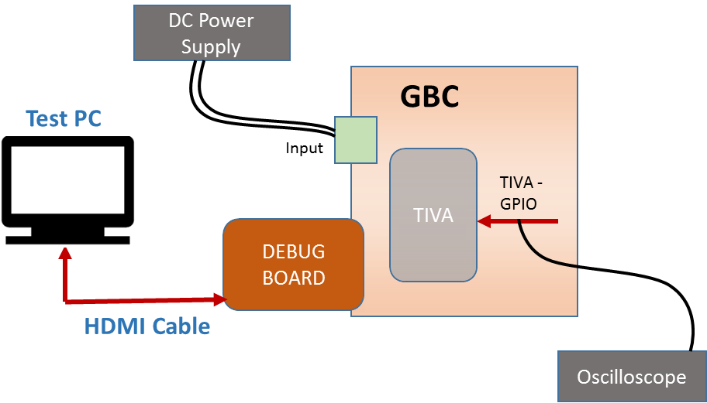
Figure 43. TIVA GPIO - Test Setup Diagram

      - Test Case: Control inputs functional validation (Test ID: TIV.10.1)
        - Description
- Purpose
The purpose of the test case is to execute the control inputs functional validation of TIVA- GPIO signals.
- Impact of failure of test case on system

Impact | Applicable | Description
Functional | Yes | Failure of this test case will cause the GPIO lines to not toggle and hence not work as per design.
Performance | NA
Compliance | NA
Table 337. Impact of Failure of Control inputs FV – TIVA GPIO
        - Test Equipment List
- Oscilloscope: MSO9404A
- DC power supply: E3633A

        - Equipment Settings
- DC power supply: E3633A
Supply Voltage: 18V
Current Limit: 1.5A
OVP: 19V
OCP: 2A
- Oscilloscope: MSO9404A
Voltage per division: 1V
Time scale: 50ms
        - Hardware Requisites
- GBC board

        - Software Requisites
NA
        - Test Condition
Test condition | Value | Remarks
Voltage | 18V | Nominal input voltage
Temperature | +25 C | Normal Room temperature
Table 338. Test Condition for Control inputs FV – TIVA GPIO
        - DUT Settings
NA
        - Requirements
Test | Measuring Parameter | Result
Control inputs functional validation | Toggling of TIVA - GPIO signals | Toggle the GPIO lines which are input to TIVA through hardware. GPIO lines should toggle between High and Low voltages.
Table 339. Requirements for Control inputs FV – TIVA GPIO
        - Test Procedure
- Configure DC power supply to give a voltage of 18V.
- Toggling the GPIO lines which are input to TIVA through hardware in GBC board.
- Validate the output as per the above requirement.

        - Reference
Further details can be found in Page 60 of GBC schematic Life-2.

TIVA GPIO

Test Setup
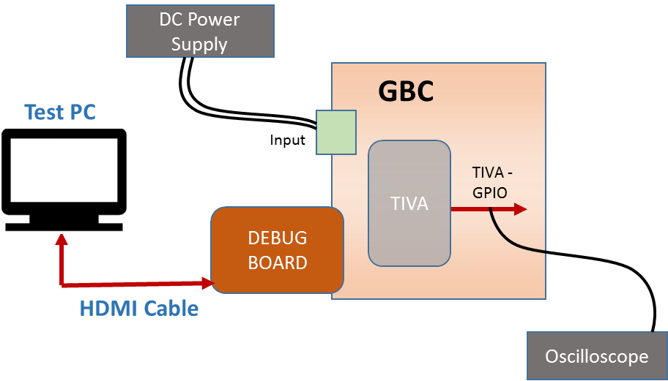
Figure 44. TIVA GPIO - Test Setup Diagram

      - Test Case: Control outputs functional validation (Test ID: TIV.11.1)
        - Description
- Purpose
The purpose of the test case is to execute the control outputs functional validation of TIVA- GPIO signals.
- Impact of failure of test case on system

Impact | Applicable | Description
Functional | Yes | Failure of this test case will cause the GPIO lines to not toggle and hence not work as per design.
Performance | NA
Compliance | NA
Table 340. Impact of Failure of Control outputs FV – TIVA GPIO
        - Test Equipment List
- Oscilloscope: MSO9404A
- DC power supply: E3633A

        - Equipment Settings
- DC power supply: E3633A
Supply Voltage: 18V
Current Limit: 1.5A
OVP: 19V
OCP: 2A
- Oscilloscope: MSO9404A
Voltage per division: 1V
Time scale: 50ms
        - Hardware Requisites
- GBC board
- Debug board

        - Software Requisites
- Code Composer Studio Tool
- Tiva-GPIO code
        - Test Condition
Test condition | Value | Remarks
Voltage | 18V | Nominal input voltage
Temperature | +25 C | Normal Room temperature
Table 341. Test Condition for Control outputs FV – TIVA GPIO
        - DUT Settings
NA
        - Requirements
Test | Measuring Parameter | Result
Control outputs functional validation | Toggling of TIVA - GPIO signals | Toggle the GPIO lines which are output from TIVA by software control. GPIO lines should toggle between High and Low voltages.
Table 342. Requirements for Control outputs FV – TIVA GPIO
        - Test Procedure
- Connect Debug board to GBC board to flash the code.
- Connect a Test PC with CCS to debug board.
- Import the code in Code Composer Studio.
- Configure DC power supply to give a voltage of 18V.
- Probe the GPIO signals.
- Run the code in CCS.
- Validate the output as per the above requirement.

        - Reference
Further details can be found in Page 60 of GBC schematic Life-2.

ETH SW MGMT Interface
      - Test Case: Functional Validation (Test ID: TIV.12.1)
        - Description
- Purpose
The purpose of the test case is to validate the TIVA in order to control and configure the Marvell switch.
- Impact of failure of test case on system

Impact | Applicable | Description
Functional | Yes | Failure of this test case will not able to route MDI signals across modules / devices.
Performance | NA
Compliance | NA
Table 343. Impact of Failure of ETH SW MGMT Interface
        - Test Equipment List
- Oscilloscope: MSO9404A
- DC power supply: E3633A
        - Equipment Settings
- DC power supply: E3633A
Supply Voltage: 18V
Current Limit: 1.5A
OVP: 19V
OCP: 2A
- Oscilloscope: MSO9404A
Voltage per division: 1V
Time scale: 50ms
        - Hardware Requisites
- GBC board
- Debug board

        - Software Requisites
- Code Composer Studio Tool
- Tiva-Marvell code
        - Test Condition
Test condition | Value | Remarks
Voltage | 18V | Nominal input voltage
Temperature | +25 C | Normal Room temperature
Table 344. Test Condition for ETH SW MGMT Interface
        - DUT Settings
NA
        - Requirements
Test | Measuring Parameter | Result
Functional validation | Reading Device ID | Able to read Device ID – 0X0141
Table 345. Requirements for ETH SW MGMT Interface
        - Test Procedure
- Connect Debug board to GBC board to flash the code.
- Connect a Test PC with CCS to debug board.
- Import the code in Code Composer Studio.
- Configure DC power supply to give a voltage of 18V.
- Run the code in CCS.
- TIVA uses GPIO bit banging method to control and configure the Marvell switch as there is no dedicated MDIO module in TM4c1294NCPDT controller
- Read SMI register values including fixed Device ID registers
- Validate the output as per the above requirement.

        - Reference
Further details can be found in Page 56 and 60 of GBC schematic Life-2.

Ethernet

Test Purpose and Description
The GBC board shall provide an Ethernet switch for providing Ethernet connectivity between Port A, Port B, Main processor, housekeeping microcontroller, for transferring IQ samples and provision for future adaptor board containing IEEE1588 PTP processor.

Ethernet Sub-system constitutes of below components
- PoE(PD) – MDI
- TIVA Ethernet

PoE (PD) - MDI

Test Setup
Figure 45.INTEL POE (PD) - MDI - Test Setup Diagram

Test Case: Electrical validation (Test ID: ETH.1.1)

Description
- Purpose
The purpose of this test case is to verify MDI signal characteristics (Interface between Marvell Switch (88E6071) to POE PD port. (PORT A)

- Impact of failure of test case on system

Impact | Applicable | Description
Functional | Yes | Packet loss and data inconsistency
Performance | Yes | Data transfer will be affected
Compliance | NA
Table 346. Impact of Failure of EV – POE (PD) - MDI
- Measurement Locations
J1A.1, J1A.2, J1A.3 and J1A.6

Test Equipment List
- Oscilloscope: DPO7354C
- DC power supply: E3633A

Equipment Settings
- Oscilloscope: DPO7354C
Voltage per division: 500mV
Time scale: 50ns

- DC power supply: E3633A
Supply Voltage: 18V
Current Limit: 1.5A
OVP: 19V
OCP: 2A

Hardware Requisites
- GBC board
- Debug board
- HDMI Monitor

Software Requisites
- Ethernet driver
- OS loaded MSATA

Test Condition
Test condition | Value | Remarks
Voltage | 18V | Nominal input voltage
Temperature | +25 C | Normal Room temperature
Table 347. Test Condition for EV – POE (PD) - MDI

DUT Settings
NA

Requirements
Test | Measuring Point | Measuring Criteria | Specification
 |  |  | Min | Max
LANSW_ETHSW_P1_TXP / TXN (From Port to Switch)
TXP  TXN | J1A.1  J1A.2 | Vp-p (V) | 1.9 | 2.63
 |  | Overshoot (%) | 0 | 10
 |  | Undershoot (%) | 0 | 10
 |  | Data rate (Mbps) |  | 100
ETHSW_LANSW_P1_RXP / RXN (From Switch to Port)
RXP  RXN | J1A.3  J1A.6 | Vp-p (V) | 1.9 | 2.63
 |  | Overshoot (%) | 0 | 10
 |  | Undershoot (%) | 0 | 10
 |  | Data rate (Mbps) |  | 100
Table 348. Requirements for EV – POE (PD) - MDI

Test Procedure
- Connect Debug board to GBC board with OS and Ethernet driver installed
- Connect a monitor to debug board using HDMI cable
- Connect a Linux PC to port A of GBC board.
- Configure DC power supply to give a voltage of 18V.
- Assign static IP address at both GBC and Linux PC.
- Establish communication by pinging each other.
- The MDI transmit signals (from Port to Switch) are measured at J1A.1 (TXP) and J1A.2 (TXN).
- The MDI receiving signals (from Switch to Port) are measured at J1A.3 (RXP) and J1A.6 (RXN).
- Make sure the measuring criteria for the signal satisfies the above mentioned requirements.

Reference
Further details can be found in Page 41, 56 and 57 of GBC schematic Life-2.

Test Case: Functional Validation (Test ID: ETH.1.2)

Description
- Purpose
The purpose of the test case is to validate the function of POE (PD)-MDI.

- Impact of failure of test case on system

Impact | Applicable | Description
Functional | Yes | Registers of SOC become inaccessible on failure of this test case and data transfer can be affected.
Performance | NA
Compliance | NA
Table 349. Impact of Failure of FV – POE (PD) MDI

Test Equipment List
- Oscilloscope: DPO7354C
- DC power supply: E3633A

Equipment Settings
- Oscilloscope: DPO7354C
Voltage per division: 500mV
Time scale: 50ns

- DC power supply: E3633A
Supply Voltage: 18V
Current Limit: 1.5A
OVP: 19V
OCP: 2A

Hardware Requisites
- GBC board
- Debug board
- HDMI Monitor

Software Requisites
- Ethernet driver
- OS loaded MSATA

Test Condition
Test condition | Value | Remarks
Voltage | 18V | Nominal input voltage
Temperature | +25 C | Normal Room temperature
Table 350. Test Condition of FV – POE (PD) MDI

DUT Settings
NA.

Requirements
Test | Measuring Parameter | Result
Ethernet Interface | IP Address | Ping each other using static IP address and ensure the data transfer with no packet loss
Table 351. Requirements for FV – POE (PD) MDI

Test Procedure

- Connect Debug board to GBC board with OS and Ethernet driver installed
- Connect a monitor to debug board using HDMI cable
- Connect a Linux PC to port A of GBC board.
- Configure DC power supply to give a voltage of 18V.
- Assign static IP address at both GBC and Linux PC.
- Establish communication by pinging each other.
- Validate the output as per the above requirement.

Reference
Further details can be found in Page 41, 56 and 57 of GBC schematic Life-2.

TIVA Ethernet

Test Setup
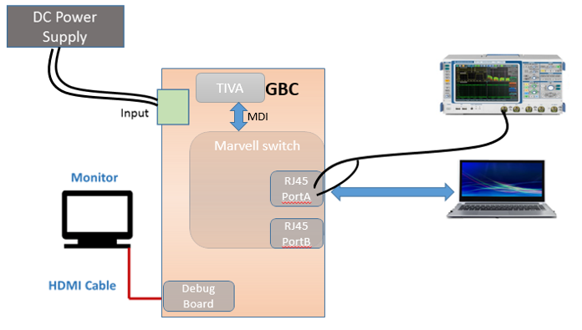
Figure 46.TIVA Ethernet - Test Setup Diagram

Test Case: Electrical validation (Test ID: ETH.3.1)

Description
- Purpose
The purpose of this test case is to verify MDI electrical characteristics Interface between Marvell Switch (88E6071) and TIVA

- Impact of failure of test case on system

Impact | Applicable | Description
Functional | Yes | Packet loss and data inconsistency
Performance | Yes | Data transfer will be affected
Compliance | NA
Table 352. Impact of Failure of EV – TIVA Ethernet
- Measurement Locations
T10.16, T10.14, T10.11 AND T10.9

Test Equipment List
- Oscilloscope: DPO7354C
- DC power supply: E3633A

Equipment Settings
- Oscilloscope: DPO7354C
Voltage per division: 500mV
Time scale: 50ns

- DC power supply: E3633A
Supply Voltage: 18V
Current Limit: 1.5A
OVP: 19V
OCP: 2A

Hardware Requisites
- GBC board
- Debug board
- HDMI Monitor

Software Requisites
- Ethernet driver
- OS loaded MSATA

Test Condition
Test condition | Value | Remarks
Voltage | 18V | Nominal input voltage
Temperature | +25 C | Normal Room temperature
Table 353. Test Condition for EV – TIVA Ethernet

DUT Settings
NA

Requirements
Test | Measuring Point | Measuring Criteria | Specification
 |  |  | Min | Max
T_ETHSW_TIVA_P0_TXP/ TXN (From Port to Switch)
TXP  TXN | T10.16, T10.14 | Vp-p (V) | 1.9 | 2.63
 |  | Overshoot (%) | 0 | 10
 |  | Undershoot (%) | 0 | 10
T_TIVA_ETHSW_P0_RXP / RXN (From Switch to TIVA)
RXP  RXN | T10.11 T10.9 | Vp-p (V) | 1.9 | 2.63
 |  | Overshoot (%) | 0 | 10
 |  | Undershoot (%) | 0 | 10
Table 354. Requirements for EV – TIVA Ethernet

Test Procedure
- Connect Debug board to GBC board with OS and Ethernet driver installed
- Connect a monitor to debug board using HDMI cable
- Connect a Linux PC to port A of GBC board.
- Configure DC power supply to give a voltage of 18V.
- Flash the relevant code to TIVA so that signals between Port 0 of Marvell switch and TIVA are initiated
- The MDI transmit signals (from Port to Switch) are measured at T10.16 (TXP) and T10.14 (TXN).
- The MDI receiving signals (from Switch to TIVA) are measured at T10.11 (RXP) and T10.9 (RXN).
- Make sure the measuring criteria for the signal satisfies the above mentioned requirements.

Reference
Further details can be found in Page 56 and 59 of GBC schematic Life-2.

Test Case: Functional Validation (Test ID: ETH.3.2)

Description
- Purpose
The purpose of the test case is to validate the function of TIVA – Marvel switch MDI transfer.

- Impact of failure of test case on system

Impact | Applicable | Description
Functional | Yes | Registers of SOC become inaccessible on failure of this test case and data transfer can be affected.
Performance | NA
Compliance | NA
Table 355. Impact of Failure of FV – TIVA Ethernet

Test Equipment List
- Oscilloscope: DPO7354C
- DC power supply: E3633A

Equipment Settings
- Oscilloscope: DPO7354C
Voltage per division: 500mV
Time scale: 50ns

- DC power supply: E3633A
Supply Voltage: 18V
Current Limit: 1.5A
OVP: 19V
OCP: 2A

Hardware Requisites
- GBC board
- Debug board
- HDMI Monitor

Software Requisites
- Ethernet driver
- OS loaded MSATA

Test Condition
Test condition | Value | Remarks
Voltage | 18V | Nominal input voltage
Temperature | +25 C | Normal Room temperature
Table 356. Test Condition of FV – TIVA Ethernet

DUT Settings
NA.

Requirements
Test | Measuring Parameter | Result
Ethernet Interface | Data transfer | Flash the relevant code to TIVA so that signals between Port 0 of Marvell switch and TIVA are initiated. Once IP address is assigned to TIVA, initiate the communication by pinging from PC using the “TCPSendRecieve “executable file
Table 357. Requirements for FV – TIVA Ethernet

Test Procedure

- Connect Debug board to GBC board with OS and Ethernet driver installed
- Connect a monitor to debug board using HDMI cable
- Connect a Linux PC to port A of GBC board.
- Configure DC power supply to give a voltage of 18V.
- Assign IP address.
- Establish communication by pinging each other.
- Validate the output as per the above requirement.

Reference
Further details can be found in Page 56 and 59 of GBC schematic Life-2.

Clock

Test Purpose and Description
The purpose is to measure the frequency accuracy, jitter and signal integrity of different clocks available in the system.

Clock Sub-system constitutes of below components
- Clock sources
- PCIe - GBE clock
- 40MHz Ref clock
- HDMI clock
- GPS 1pps clock

Clock Sources

Test Setup
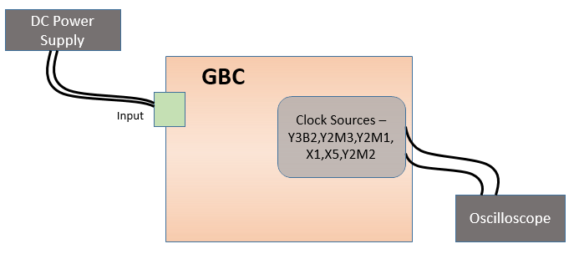
Figure 47. Clock Sources - Test Setup Diagram

Test Case: Frequency Accuracy (Test ID: CLK.1.1)

Description
- Purpose
The purpose of this test case is to validate the frequency accuracy of crystal sources for 25MHz and 32.768 kHz.
- Impact of failure of test case on system

Impact | Applicable | Description
Functional | Yes | If clock source is improper, it affects the internal software functionality.
Performance | NA
Compliance | NA
Table 358. Impact of failure - Clock Sources – Frequency Accuracy
- Measurement Locations
Measurement Parameter | Measurement location
Y3B2 | C3B22.1
Y2M3 | C2M26.2
Y2M1 | C2M2.2
X1 | C475.1
X5 | C521.1
Y2M2 | C2N1.2
Table 359. Measurement Locations – Clock Sources – Frequency Accuracy

Test Equipment List
- AUX Power supply unit: Agilent E3634A
- Oscilloscope: DSA91304A

Equipment Settings
- DC power supply: E3633A
Supply Voltage: 18V
Current Limit: 1.5A
OVP: 20V
OCP: 2A

Hardware Requisites
- GBC board

Software Requisites
NA

Test Condition
Test condition | Value | Remarks
Voltage | 18V | Nominal Input voltage
Temperature | +25 C | Normal Room temperature
Table 360. Test Condition – Clock Sources – Frequency Accuracy

DUT Settings
- Isolate input side of Tiva controller by removing the resistor R10054.
- Isolate input side of Intel microprocessor by removing the resistor R10067.

Requirements
Measurement Parameter | Measurement location | Range
25MHz crystal frequency | C3B22.1, C2M26.2, C2M2.2, C475.1, C521.1 | 25MHz
32.768kHz RTC crystal frequency | C2N1.2 | 32.768kHz
Table 361. Requirements – Clock Sources – Frequency Accuracy

Test Procedure
- This test is conducted for the following 25MHz crystals:
    - Y3B2 at C3B22.1
    - Y2M3 at C2M26.2
    - Y2M1 at C2M2.2
    - X1 at C475.1
    - X5 at C521.1
- This test is also conducted for the following 32.768kHz crystal:
    - Y2M2 at C2N1.2
- The values are captured by a frequency counter. For frequency accuracy and stability measured value (Hz) is converted to ppb by following the below procedure:
- The difference between the ideal clock frequency and maximum frequency value is calculated (df).
- Ppb is calculated by the equation: ppb= (df (Hz)*〖10〗^6*1000) / (f (Hz))

Reference
Further details can be found in Page 9, 23, 25, 56 and 58 of GBC schematic Ver. Life-2.

Test Case: Timing Jitter (Test ID: CLK.1.2)

Description
- Purpose
The purpose of this test case is to validate the timing jitter of crystal clock sources.
- Impact of failure of test case on system

Impact | Applicable | Description
Functional | Yes | If clock source is improper, it affects the internal software functionality.
Performance | NA
Compliance | NA
Table 362. Impact of failure - Clock Sources – Frequency Accuracy
- Measurement Locations
Measurement Parameter | Measurement location
Y3B2 | C3B22.1
Y2M3 | C2M26.2
Y2M1 | C2M2.2
X1 | C475.1
X5 | C521.1
Table 363. Measurement Locations – Clock Sources – Timing Jitter

Test Equipment List
- AUX Power supply unit: Agilent E3634A
- Oscilloscope: DSA91304A

Equipment Settings
- DC power supply: E3633A
Supply Voltage: 18V
Current Limit: 1.5A
OVP: 20V
OCP: 2A

Hardware Requisites
- GBC board

Software Requisites
NA

Test Condition
Test condition | Value | Remarks
Voltage | 18V | Nominal Input voltage
Temperature | +25 C | Normal Room temperature
Table 364. Test Condition – Clock Sources – Timing Jitter

DUT Settings
- Isolate input side of Tiva controller by removing the resistor R10054.
- Isolate input side of Intel microprocessor by removing the resistor R10067.

Requirements
Measurement Parameter | Measurement location | Range (ps)
Cycle-to-cycle Jitter(ps) | Y3B2 | 0 – 300
 | X5 | 0 – 50
 | X1 | 0 – 300
Table 365. Requirements – Clock Sources – Timing Jitter

Test Procedure
- This test is conducted for the following 25MHz crystals:
  - Y3B2 at C3B22.1.
  - Y2M3 at C2M26.2.
  - Y2M1 at C2M2.2.
  - X1 at C475.1.
  - X5 at C521.1
- The jitter values are captured by an oscilloscope.

Reference
Further details can be found in Page 9, 23, 25, 56 and 58 of GBC schematic Ver. Life-2.

PCIe - GBE clock

Test Setup
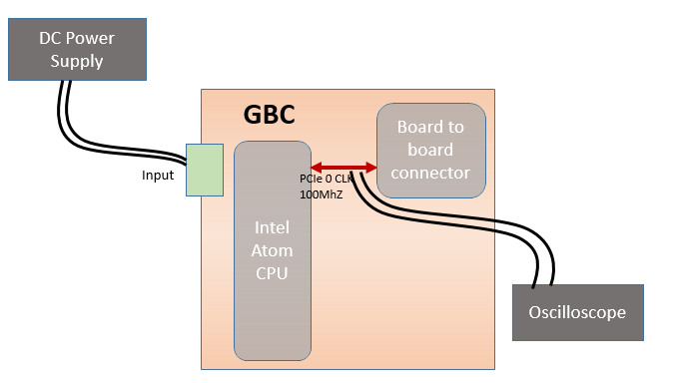
Figure 48. PCIe – GBE Clock - Test Setup Diagram

Test Case: Frequency Accuracy (Test ID: CLK.2.1)

Description
- Purpose
Purpose of this test case is to validate the frequency accuracy of 100MHz PCIe reference clock: PCIE0_GBE_CLKP.
- Impact of failure of test case on system

Impact | Applicable | Description
Functional | Yes | If clock source is improper, it affects the internal software functionality.
Performance | NA
Compliance | NA
Table 366. Impact of failure - PCIe – GBE Clock – Frequency Accuracy
- Measurement Locations
Measurement Parameter | Measurement location
PCIE0_GBE_CLKP | R10647.1
Table 367. Measurement Locations – PCIe – GBE Clock – Frequency Accuracy

Test Equipment List
- AUX Power supply unit: Agilent E3634A
- Oscilloscope: DSA91304A

Equipment Settings
- DC power supply: E3633A
Supply Voltage: 18V
Current Limit: 1.5A
OVP: 20V
OCP: 2A

Hardware Requisites
- GBC board

Software Requisites
NA

Test Condition
Test condition | Value | Remarks
Voltage | 18V | Nominal Input voltage
Temperature | +25 C | Normal Room temperature
Table 368. Test Condition – PCIe – GBE Clock – Frequency Accuracy

DUT Settings
NA

Requirements
Measurement Parameter | Measurement location | Range
PCIE0_GBE_CLKP | R10647.1 | 100MHz
Table 369. Requirements – PCIe – GBE Clock – Frequency Accuracy

Test Procedure
- This test is conducted by probing 100MHz clock at R10647.1.
- The value is captured by a frequency counter for 6 iterations.
- For frequency accuracy and stability measured value (Hz) is converted to ppb by following the below procedure:
- The difference between the ideal clock frequency and maximum frequency value is calculated (df).
- Ppb is calculated by the equation: $ppb=\frac{df\left(Hz\right)*{10}^{6}*1000}{f(Hz)}$

Reference
Further details can be found in Page 9 and 76 of GBC schematic Ver. Life-2.

Test Case: Signal Integrity (Test ID: CLK.2.2)

Description
- Purpose
Purpose of the test case is to validate the electrical characteristics of 100 MHz PCIe clock
- Impact of failure of test case on system

Impact | Applicable | Description
Functional | Yes | If clock source is improper, it affects the PCIe communication and functionality.
Performance | NA
Compliance | NA
Table 370. Impact of failure - PCIe – GBE Clock – Signal Integrity
- Measurement Locations
Measurement Parameter | Measurement location
PCIE0_GBE_CLKP | R10647.1
Table 371. Measurement Locations – PCIe – GBE Clock – Signal Integrity

Test Equipment List
- AUX Power supply unit: Agilent E3634A
- Oscilloscope: DSA91304A

Equipment Settings
- DC power supply: E3633A
Supply Voltage: 18V
Current Limit: 1.5A
OVP: 20V
OCP: 2A

Hardware Requisites
- GBC board

Software Requisites
NA

Test Condition
Test condition | Value | Remarks
Voltage | 18V | Nominal Input voltage
Temperature | +25 C | Normal Room temperature
Table 372. Test Condition – PCIe – GBE Clock – Signal Integrity

DUT Settings
NA

Requirements
Measurement Parameter | Measurement location | Range (V)
Positive Over-shoot | R10647.1 | 0 – 0.18
Negative Over-shoot | R10648.1 | 0 – 0.18
Table 373. Requirements – PCIe – GBE Clock – Signal Integrity

Test Procedure
- This test is conducted by probing 100MHz clock at R10647.1.
- The value is captured on an oscilloscope and is within the prescribed limit by Intel microcontroller.

Reference
Further details can be found in Page 9and 76 of GBC schematic Ver. Life-2.

Test Case: Timing Jitter (Test ID: CLK.2.3)

Description
- Purpose
Purpose of the test case is to validate the Timing Jitter of 100 MHz
- Impact of failure of test case on system

Impact | Applicable | Description
Functional | Yes | If clock source is improper, it affects the PCIe communication and functionality.
Performance | NA
Compliance | NA
Table 374. Impact of failure - PCIe – GBE Clock – Timing Jitter
- Measurement Locations
Measurement Parameter | Measurement location
PCIE0_GBE_CLKP | R10647.1
PCIE0_GBE_CLKN | R10648.1
Table 375. Measurement Locations – PCIe – GBE Clock – Timing Jitter

Test Equipment List
- AUX Power supply unit: Agilent E3634A
- Oscilloscope: DSA91304A

Test Equipment List
- DC power supply: E3633A
Supply Voltage: 18V
Current Limit: 1.5A
OVP: 20V
OCP: 2A

Hardware Requisites
- GBC board

Software Requisites
NA

Test Condition
Test condition | Value | Remarks
Voltage | 18V | Nominal Input voltage
Temperature | +25 C | Normal Room temperature
Table 376. Test Condition – PCIe – GBE Clock – Timing Jitter

DUT Settings
NA

Requirements
Measurement Parameter | Measurement location | Range
PCIE0_GBE_CLKP  PCIE0_GBE_CLKN | R10647.1  R10648.1 | 100MHz
Table 377. Requirements – PCIe – GBE Clock – Timing Jitter

Test Procedure
- This test is conducted by terminating PCIE0_GBE_CLKP and with a 2.2pF capacitor at R10647.1 and R10648.1.
- Probe at R10647.1 and R10648.1. Run the test utility N5393D in the infiniium oscilloscope.
- To configure the test suite, select PCIe version as 2.0, Refclk tests, Device1, Lan0. In select tests option in utility, select common clock tests and run all the selected test cases.
- The test utility generates the test report for all the test cases selected with the pass or fail criteria and its % margin.

Reference
Further details can be found in Page 9and 76 of GBC schematic Ver. Life-2.

40 MHz - GPSDO clock

Test Setup
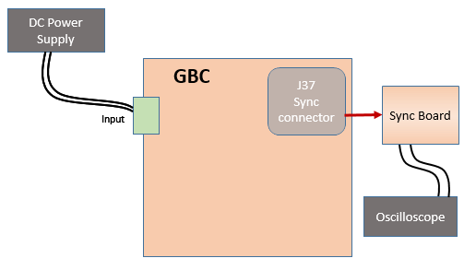
Figure 49. 40 MHz GPSDO– Clock - Test Setup Diagram

Test Case: Frequency Accuracy (Test ID: CLK.3.1)

Description
- Purpose
Purpose of this test case is to validate the frequency accuracy of 40MHz reference clock for GPSDO.
- Impact of failure of test case on system

Impact | Applicable | Description
Functional | Yes | If clock source is improper, it affects the GPS sync frequency and sync time functionality.
Performance | NA
Compliance | NA
Table 378. Impact of failure – 40 MHz GPSDO– Clock – Frequency Accuracy
- Measurement Locations
Measurement Parameter | Measurement location
R_LTE_REF_OUT_10MHz | R19.2
Table 379. Measurement Locations – 40 MHz GPSDO– Clock – Frequency Accuracy

Test Equipment List
- AUX Power supply unit: Agilent E3634A
- Oscilloscope: DSA91304A

Equipment Settings
- DC power supply: E3633A
Supply Voltage: 18V
Current Limit: 1.5A
OVP: 20V
OCP: 2A

Hardware Requisites
- GBC board
- Sync board

Software Requisites
NA

Test Condition
Test condition | Value | Remarks
Voltage | 18V | Nominal Input voltage
Temperature | +25 C | Normal Room temperature
Table 380. Test Condition – 40 MHz GPSDO– Clock – Frequency Accuracy

DUT Settings
NA

Requirements
Measurement Parameter | Measurement location | Range
R_LTE_REF_OUT_10MHz | R19.2 | 40MHz
Table 381. Requirements – 40 MHz GPSDO– Clock – Frequency Accuracy

Test Procedure
- This test is conducted by probing 40MHz clock at R19.2.
- The value is captured by a frequency counter.

Reference
Further details can be found in Page 3 of Sync Schematic Ver. Life-1.

Test Case: Signal Integrity (Test ID: CLK.3.2)

Description
- Purpose
Purpose of the test case is to validate the electrical characteristics of 40 MHz GPSDO clock.
- Impact of failure of test case on system

Impact | Applicable | Description
Functional | Yes | If clock source is improper, it affects the GPS sync frequency and sync time functionality.
Performance | NA
Compliance | NA
Table 382. Impact of failure – 40 MHz GPSDO– Clock – Signal Integrity
- Measurement Locations
Measurement Parameter | Measurement location
R_LTE_REF_OUT_10MHz | R19.2
Table 383. Measurement Locations – 40 MHz GPSDO– Clock – Signal Integrity

Test Equipment List
- AUX Power supply unit: Agilent E3634A
- Oscilloscope: DSA91304A

Equipment Settings
- DC power supply: E3633A
Supply Voltage: 18V
Current Limit: 1.5A
OVP: 20V
OCP: 2A

Hardware Requisites
- GBC board
- Sync board

Software Requisites
NA

Test Condition
Test condition | Value | Remarks
Voltage | 18V | Nominal Input voltage
Temperature | +25 C | Normal Room temperature
Table 384. Test Condition – 40 MHz GPSDO– Clock – Signal Integrity

DUT Settings
NA

Requirements
Measurement Parameter | Measurement location | Range (V)
R19.2 | VLOW | 0 – 0.4
 | VHIGH | 0.8 – 3.3
Table 385. Requirements – 40 MHz GPSDO– Clock – Signal Integrity

Test Procedure
- This test is conducted by probing the GPSDO Clock signal at R19.2 (Near Via).
- The measured values must be well with-in the limit as specified in the LTE-Lite Module datasheet specification.

Reference
Further details can be found in Page 3 of Sync Schematic Ver. Life-1.

Test Case: Timing Jitter (Test ID: CLK.3.3)

Description
- Purpose
The purpose of the test case is to validate the Timing Jitter of 40 MHz GPSDO Clock.

- Impact of failure of test case on system

Impact | Applicable | Description
Functional | Yes | If clock source is improper, it affects the GPS sync frequency and sync time functionality.
Performance | NA
Compliance | NA
Table 386. Impact of failure – 40 MHz GPSDO– Clock – Timing Jitter
- Measurement Locations
Measurement Parameter | Measurement location
R_LTE_REF_OUT_10MHz | R19.2
Table 387. Measurement Locations – 40 MHz GPSDO– Clock – Timing Jitter

Test Equipment List
- AUX Power supply unit: Agilent E3634A
- Oscilloscope: DSA91304A

Equipment Settings
- DC power supply: E3633A
Supply Voltage: 18V
Current Limit: 1.5A
OVP: 20V
OCP: 2A

Hardware Requisites
- GBC board
- Sync board

Software Requisites
NA

Test Condition
Test condition | Value | Remarks
Voltage | 18V | Nominal Input voltage
Temperature | +25 C | Normal Room temperature
Table 388. Test Condition – 40 MHz GPSDO– Clock – Timing Jitter

DUT Settings
NA

Requirements
Measurement Parameter | Measurement location | Range
R_LTE_REF_OUT_10MHz | R19.2 | 40MHz
Table 389. Requirements – 40 MHz GPSDO– Clock – Timing Jitter

Test Procedure
- This test is conducted by probing the GPSDO Clock Signal Timing Jitter at R19.2 (Near Via). The measurement data will be compared with the measured data that will be made available by Jacksons Lab.
- Steps to measure RMS jitter through signal analyzer:
  - Connect Sync board to GBC board.
  - Configure DC power supply to give a voltage of 18V.
  - Set the central frequency to 40MHz in MXA signal Analyzer.
  - Carrier frequency will be automatically detected.
  - Go to Mode option, Select Phase Noise.
  - Go to Measure option and select Log Plot.
  - In Span option set start and stop offset values to 8kHz and 22MHz respectively
  - Select marker go to Integrated RMS Noise then select Jitter option.
  - Go to Band adjust set the left band (10 KHz) and right band (22MHz).
  - Measure the Jitter on the analyzer in pico second.
  - Select auto tune in frequency option at the end of each step.

Reference
Further details can be found in Page 3 of Sync Schematic Ver. Life-1.

HDMI clock

Test Setup
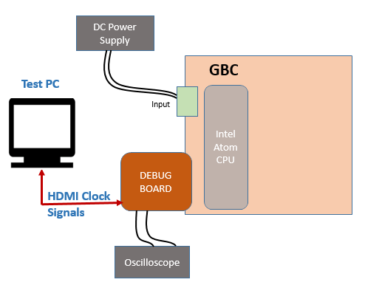
Figure 50. HDMI– Clock - Test Setup Diagram

Test Case: Frequency Accuracy (Test ID: CLK.4.1)

Description
- Purpose
Purpose of this test case is to validate the frequency accuracy of HDMI clock.
- Impact of failure of test case on system

Impact | Applicable | Description
Functional | Yes | If clock source is improper, it affects the HDMI communication between Intel and external HDMI device
Performance | NA
Compliance | NA
Table 390. Impact of failure – HDMI Clock – Frequency Accuracy
- Measurement Locations
Measurement Parameter | Measurement location
HDMI_CLK_DP | C4N2.2
HDMI_CLK_DN | C4N1.2
Table 391. Measurement Locations – HDMI Clock – Frequency Accuracy

Test Equipment List
- AUX Power supply unit: Agilent E3634A
- Oscilloscope: DSA91304A

Equipment Settings
- DC power supply: E3633A
Supply Voltage: 18V
Current Limit: 1.5A
OVP: 20V
OCP: 2A

Hardware Requisites
- GBC board
- Sync board

Software Requisites
NA

Test Condition
Test condition | Value | Remarks
Voltage | 18V | Nominal Input voltage
Temperature | +25 C | Normal Room temperature
Table 392. Test Condition – HDMI Clock – Frequency Accuracy

DUT Settings
NA

Requirements
Measurement Parameter | Measurement location | Range
HDMI_CLK_DP | C4N2.2 | 100MHz
HDMI_CLK_DN | C4N1.2
Table 393. Requirements – HDMI Clock – Frequency Accuracy

Test Procedure
- This test is conducted by probing 40MHz clock at R19.2.
- The value is captured by a frequency counter.

Reference
Further details can be found in Page 7 and 69 of GBC schematic Ver. Life-2 and also on page 2 of Debug Schematic Ver. Life-2.

Test Case: Signal Integrity (Test ID: CLK.4.2)

Description
- Purpose
The purpose of the test case is to validate the electrical characteristics of 100 MHz HDMI Clock.
- Impact of failure of test case on system

Impact | Applicable | Description
Functional | Yes | If clock source is improper, it affects the HDMI communication between Intel and external HDMI device
Performance | NA
Compliance | NA
Table 394. Impact of failure – HDMI Clock – Signal Integrity
- Measurement Locations
Measurement Parameter | Measurement location
HDMI_CLK_DP | C4N2.2
HDMI_CLK_DN | C4N1.2
Table 395. Measurement Locations – HDMI Clock – Signal Integrity

Test Equipment List
- AUX Power supply unit: Agilent E3634A
- Oscilloscope: DSA91304A

Equipment Settings
- DC power supply: E3633A
Supply Voltage: 18V
Current Limit: 1.5A
OVP: 20V
OCP: 2A

Hardware Requisites
- GBC board
- Sync board

Software Requisites
NA

Test Condition
Test condition | Value | Remarks
Voltage | 18V | Nominal Input voltage
Temperature | +25 C | Normal Room temperature
Table 396. Test Condition – HDMI Clock – Signal Integrity

DUT Settings
NA

Requirements
Measurement Parameter | Measurement location | Range (V)
Positive Over-shoot | C4N2.2 &  C4N1.2 | 0 – 0.78
Negative Over-shoot |  | 0 – 0.2
Table 397. Requirements – HDMI Clock – Signal Integrity

Test Procedure
- Connect debug board to GBC. Probe HDMI_CLK_DP and HDMI_CLK_DN at C4N2.2 and C4N1.2 respectively.
- Measure the overshoot and undershoot parameters for HDMI clock using oscilloscope.

Reference
Further details can be found in Page 7 and 69 of GBC schematic Ver. Life-2 and also on page 2 of Debug Schematic Ver. Life-2.

GPS – 1pps clock

Test Setup
Figure 51. GPS 1pps Clock - Test Setup Diagram

Test Case: Frequency Accuracy (Test ID: CLK.5.1)

Description
- Purpose
The purpose of this test case is to validate the 1pps clock.
- Impact of failure of test case on system

Impact | Applicable | Description
Functional | Yes | If clock source is improper, it affects the GPS sync frequency and sync time functionality.
Performance | NA
Compliance | NA
Table 398. Impact of failure – GPS 1pps Clock – Frequency Accuracy
- Measurement Locations
Measurement Parameter | Measurement location
R_LTE_1_PPS_OUT | R48.1
Table 399. Measurement Locations – GPS 1pps Clock – Frequency Accuracy

Test Equipment List
- AUX Power supply unit: Agilent E3634A
- Oscilloscope: DSA91304A

Equipment Settings
- DC power supply: E3633A
Supply Voltage: 18V
Current Limit: 1.5A
OVP: 20V
OCP: 2A

Hardware Requisites
- GBC board
- Sync board

Software Requisites
NA

Test Condition
Test condition | Value | Remarks
Voltage | 18V | Nominal Input voltage
Temperature | +25 C | Normal Room temperature
Table 400. Test Condition – GPS 1pps Clock – Frequency Accuracy

DUT Settings
NA

Requirements
Measurement Parameter | Measurement location | Range
R_LTE_1_PPS_OUT | R48.1 | 1Hz
Table 401. Requirements – GPS 1pps Clock – Frequency Accuracy

Test Procedure
- Connect Sync board to GBC board. Probe R48.1 on sync board in order to check 1pps clock.
- Measure the frequency using frequency counter.

Reference
Further details can be found in Page 3 of Sync Schematic Ver. Life-1.

Test Case: Signal Integrity (Test ID: CLK.5.2)

Description
- Purpose
The purpose of the test case is to validate the electrical characteristics of 1pps clock.
- Impact of failure of test case on system

Impact | Applicable | Description
Functional | Yes | If clock source is improper, it affects the GPS sync frequency and sync time functionality.
Performance | NA
Compliance | NA
Table 402. Impact of failure – GPS 1pps Clock – Signal Integrity
- Measurement Locations
Measurement Parameter | Measurement location
R_LTE_1_PPS_OUT | R48.1
Table 403. Measurement Locations – GPS 1pps Clock – Signal Integrity

Test Equipment List
- AUX Power supply unit: Agilent E3634A
- Oscilloscope: DSA91304A

Equipment Settings
- DC power supply: E3633A
Supply Voltage: 18V
Current Limit: 1.5A
OVP: 20V
OCP: 2A
OCP: 2A

Hardware Requisites
- GBC board
- Sync board

Software Requisites
NA

Test Condition
Test condition | Value | Remarks
Voltage | 18V | Nominal Input voltage
Temperature | +25 C | Normal Room temperature
Table 404. Test Condition – GPS 1pps Clock – Signal Integrity

DUT Settings
NA

Requirements
Measurement Parameter | Measurement location | Range
R_LTE_1_PPS_OUT | R48.1 | 1Hz
Table 405. Requirements – GPS 1pps Clock – Signal Integrity

Test Procedure
- Connect Sync board to GBC board. This test is conducted by probing 1pps clock at R48.1 on the sync board.
- The value is captured on an oscilloscope.

Reference
Further details can be found in Page 3 of Sync Schematic Ver. Life-1.

