|  |  |
| --- | --- |
| **OpenCellular – Connect-1**  **Environmental Test Specification Document** | Version 1.0 |
|  |  |

History.

|  |  |  |  |  |
| --- | --- | --- | --- | --- |
| SL.no | Date | Version | Author | Comments |
| 1 | February 9th, 2017 | 1.0 | OpenCellular Team | First Release |

Contents

List of Figures 4

List of Tables 5

1. Purpose and Scope. 6

2. Abbreviation 7

3. Environmental Testing 8

3.1 Preconditioning 8

3.1.1 Test Case: Mechanical Precondition 8

3.1.2 Test Case: Climatic precondition 10

3.2 Water Ingress Test 12

3.2.1 Test Case: Effect of IPX5 Test 12

3.3 Dust Ingress Test 15

3.3.1 Test Case: Effect of IP6X test 15

3.4 Rain & Blowing Rain 18

3.4.1 Test Case: Effect of Blowing Rain 18

3.5 Earthquake 21

3.5.1 Test Case: Effect of Earthquake (Zone 2 spectra) 21

3.6 Salt Fog 25

3.6.1 Test Case: Effect of Corrosion 25

3.7 Vibration 28

3.7.1 Test Case: Sinusoidal vibration 28

3.7.2 Test Case: Random vibration 30

3.7.3 Test Case: Shock 33

3.8 Thermal 36

3.8.1 Test Case: Thermal Imaging 36

3.8.2 Test Case: Thermal Validation 38

3.8.3 Test Case: Thermal Cycling 41

3.9 HALT 44

3.9.1 Test Case: High Accelerated Life Test 44

3.10 HASS 48

3.10.1 Test Case: Highly Accelerated Stress Audit 48

List of Figures

Figure 1. Sinusoidal Vibration Test Setup 8

Figure 2. Three Perpendicular directions 9

Figure 3. IPX5 Test Setup 14

Figure 4. IP6X Test Setup 15

Figure 5. Rain Test Setup 18

Figure 6. Earthquake Test Setup 21

Figure 7. Salt Test Setup 26

Figure 8. Sinusoidal Vibration Test Setup 28

Figure 9. Three Perpendicular directions 30

Figure 10. Sinusoidal Vibration Test Setup 31

Figure 11. Three Perpendicular directions 32

Figure 12. Sinusoidal Vibration Test Setup 34

Figure 13. Thermal validation Test Setup 38

Figure 14. HALT Test setup 45

Figure 15. HASS Test setup 48

List of Tables

Table 1 : Thermal Validation Test Results Summary 39

Table 2 : Thermal Cycling Test Profile 42

# Purpose and Scope.

The purpose of this document is to capture the Connect-1 Environmental Test Specifications and Test Procedure. This intended to be used by R&D teams including testing team.

This document captures Connect-1 Environmental Test Specifications and detailed Test Procedure.

* + Water Ingression IPX5
  + Dust Ingression IP6X
  + Rain & Blowing Rain
  + Earthquake
  + Salt Fog
  + Operation Vibration
  + Thermal
  + HALT
  + HASS

# Abbreviation

|  |  |
| --- | --- |
| ANT | Antenna |
| BOM | Bill of Material |
| BTS | Base Transceiver Station |
| ETSI | European Telecommunications Standards Institute |
| GBC | General Purpose Baseband and Computing |
| GPRS | General Packet Radio Service |
| GSM | Global System for Mobile |
| HW | Hardware |
| LED | Light Emitting Diode |
| LNA | Low Noise Amplifier |
| PA | Power Amplifier |
| PCB | Printed Circuit Board |

# Environmental Testing

## Preconditioning

### Test Case: Mechanical Precondition

#### Description

1. **Purpose**

The purpose of preconditioning test before IP65 test is to subject the unit to mechanical stress.

1. **Impact of failure**

The mechanical precondition determines if there is effect to gaskets & screws due to vibration that occur during the unit transportation and also during assembly. In this phase we run sinusoidal vibration, random vibration and shock test cases.

#### Test Equipment List

1. Vibration shaker testing equipment
2. Setup to measure & monitor functionality of unit
3. Cables & Accessories

#### Test Setup

1. **Unit Preparation**

Before the test units need to be ensured to work normal as per field condition. Unit to be mounted on test bed as per field condition (Pole mounting condition) & subjected for non-operational vibration as per the below given spec

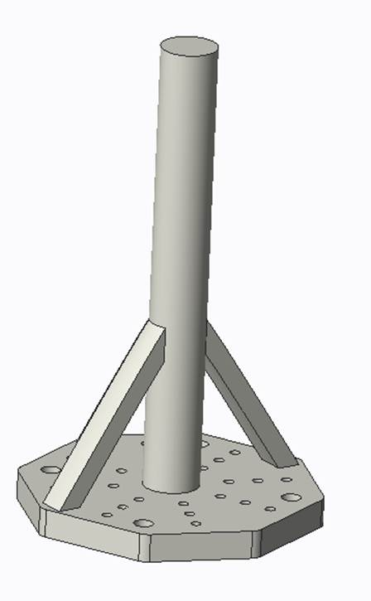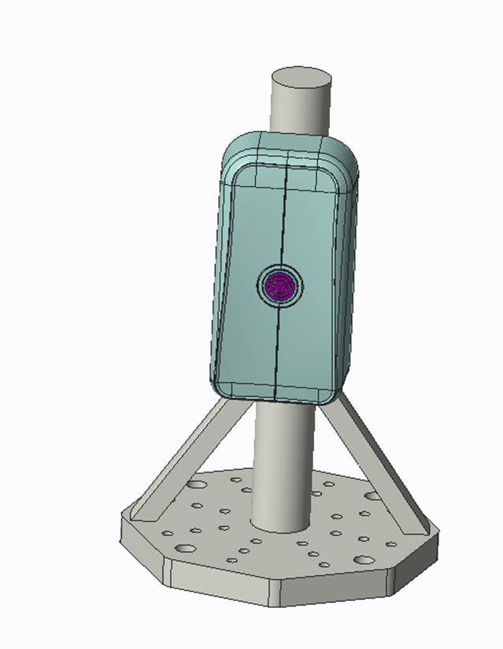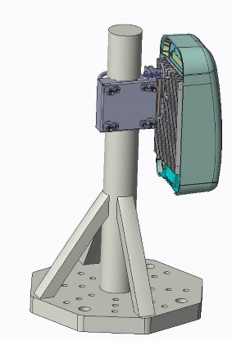

Figure 1. Sinusoidal Vibration Test Setup

1. **Equipment Settings**
2. Non-operational working condition.
3. **Software settings**

* Nil

#### Control & Measurements

Measure and control the displacement and acceleration of the vibration shaker table as per the required test standard

#### Test Specification

1. **Sinusoidal vibration**

Displacement (mm) : 1.2

Acceleration (m/s2 ) : 4

Frequency range (Hz) : 5-9 9-200

Duration : 3 x 5 sweep cycles

Axes of Vibration : 3

1. **Random vibration**

ASD (m2/ s3) : 0.04

(dB/oct) : +12 -12

Frequency range (Hz) : 5-10 10-50 50-100

Duration : 3 x 30 minutes

Axes of Vibration : 3

1. **Shock**

Shock spectrum : half sine

Duration (ms) : 11

Acceleration (m/s2) : 50

Number of bumps : 100 in each direction

Direction of bumps : 6

#### Test Procedure

1. Mount the unit to the shaker table similar to how it will be installed in field (Pole mounting condition)
2. Subject the unit for vibration in three perpendicular directions as shown below fig .



Figure 2. Three Perpendicular directions

1. After the completion of the test, thoroughly inspect the equipment and note all changes to its physical condition
2. Record any reductions in anchor or fastener torques & mounting accessories

#### Reference

* 1. OC Connect 1 Environmental Test Specification document
  2. 3D & 2D Design document
  3. Product specification
  4. Industry Standards
  5. Datasheets for critical components

### Test Case: Climatic precondition

#### Description

1. **Purpose**

The purpose of preconditioning test before IP65 test is to subject the unit to climatic stress.

1. **Impact of failure**

To determine how much impact severe temperature cycling has on the unit’s gaskets, grommets, and fastener screws.

#### Test Equipment List

1. Thermal chamber
2. Cables & Accessories

#### Test Setup

1. **Unit Preparation**

Before the test units need to be ensured to work normal as per field condition. Unit to be mounted on test bed as per field condition (Pole mounting condition) & subjected for non-operational Thermal cycling as per the below given spec

1. **Equipment Settings**
2. Non-operational working condition.
3. **Software settings**

* Nil

#### Control & Measurements

Chamber Temperature should be monitored during test to ensure they are within the test condition limits

#### Test Specification

Temperature cycle -45°C to +60°C, test duration 10 days, Temperature change rate for thermal chamber is 3°C/min. Dwell period at -45°C & +60°C is 40 min each.

#### Test Procedure

Mount the unit inside the thermal chamber similar to that installed in the field (Pole mounting condition)

Apply thermal stress on unit as per the specification & after the completion of the test, thoroughly inspect the equipment and note all changes to its physical condition.

* Record any reductions in anchor or fastener torques & mounting accessories
* Following are some of the parts and its locations which are checked after the test

1. Connectors (can get loosened)
2. Gaskets (can get damaged)
3. Screws (can get unscrewed from the unit)
4. Adhesive / Label (can get damaged)
5. Components (can get de-soldered)

#### Reference

1. OC Connect 1 Environmental Test Specification document
2. 3D & 2D Design document
3. Product specification
4. Industry Standards
5. Datasheets for critical components

## Water Ingress Test

### Test Case: Effect of IPX5 Test

#### Description

1. **Purpose**

The purpose of this test is to define unit tightness against water and to possible leaks of the cabinets.

1. **Impact of failure**

If IPX5 requirement is not met, there could be chance of water ingress in the unit & system would not work as intended if water enter into the unit.

#### Test Equipment List

1. 6.3mm water nozzle
2. Flow meter
3. Stop watch
4. Pin point colorimeter

#### Test Setup

1. **Unit Preparation**

Subject the unit to precondition before subjecting the unit to IPX5 test. Before Precondition, Connect-1 unit to be painted from inside by Pin Point colorimeter developer WDP-217 paint. This paint detects water leaks by colour change white to green.

1. **Measurement Locations**
2. Functionality of the unit should be checked during the test & after test
3. Following are some of the parts and its locations which are checked after the test
4. Connectors (can get loosened)
5. Gaskets (can get damaged)
6. Screws (can get unscrewed from the unit)
7. Adhesive / Label (can get damaged)
8. Components (can get de-soldered)
9. **Equipment Settings**
10. Non-operational working condition.
11. **Software settings**

* Nil

#### Control & Measurements

1. Water temperature to be maintained same as room temperature
2. Water pressure to be adjusted to achieve the specified volume flow rate of 12.5 l/min +/- 5 %
3. Distance from water nozzle to enclosure surface to be 2.5m to 3m
4. Water Flow rate to be kept constant throughout the test & monitored using flow rate measuring device attached to water outlet valve.

#### Test Specification

1. The Test need to carry out as per the test standard IEC 60529 Standards.
2. Unit should be configured as per actual field condition (Exception case: Electronic PWB assemblies could be removed as per the test conditions)
3. Unit mounting: Pole mounting condition
4. Pass / Fail criteria

Pass: At the end of the test there shall not be any water detected in the IPX5 area.

Fail: Water marks seen inside the IPX5 area

#### Test Procedure

1. After completing Precondition as explained above, subject the unit for water test with unit mounted in vertical orientation i.e., pole mounting condition
2. Water should be sprayed from every direction of the cabinet 30 sec. at all 5 sides of the unit Total Test time should be 3 minutes / 180 secs (30 sec. per side)
3. Use Stop watch for accurate start and stop of the test.
4. After completion of test without disturbing the unit it is to be placed inside Thermal chamber at 50 Degree ambient to dried up all water before opening up the unit for observation
5. After drying out the water open the unit & visually inspect the unit for any water leak inside IPx5 area as give below
   * + Connector joints
     + Gaskets
     + Screws
     + Adhesive / Label
     + Electronic circuit board
     + Cables

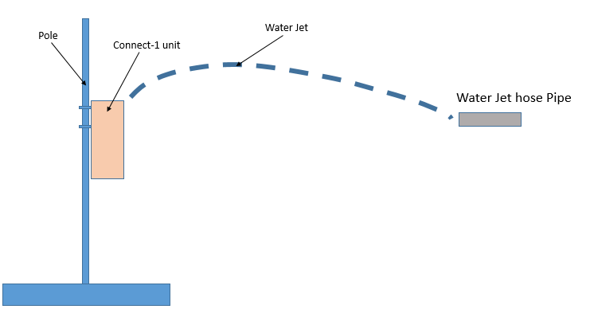

Figure 3. IPX5 Test Setup

#### Reference

1. OC Connect 1 Environmental Test Specification document
2. 3D & 2D Design document
3. Product specification
4. Industry Standards
5. Datasheets for critical components

## Dust Ingress Test

### Test Case: Effect of IP6X test

#### Description

1. **Purpose**

The purpose of this test is to define unit tightness against dust and to possible leaks of the cabinets.

1. **Impact of failure**

If IP6X requirement is not met, there could be chance of dust ingress in the unit & system would not work as intended if dust enters into the unit.

#### Test Equipment List

1. Dust chamber

#### Test Setup

1. **Unit Preparation**

Subject the unit to precondition before subjecting the unit to IP6X test. Below are the details of precondition process to be performed.

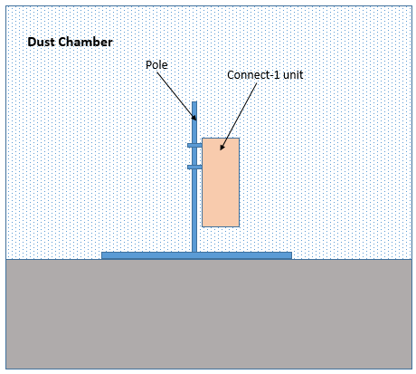

Figure 4. IP6X Test Setup

1. **Measurement Locations**
2. Functionality of the unit should be checked during the test & after test
3. Following are some of the parts and its locations which are checked after the test
4. Connectors (can get loosened)
5. Gaskets (can get damaged)
6. Screws (can get unscrewed from the unit)
7. Adhesive / Label (can get damaged)
8. Components (can get de-soldered)
9. **Equipment Settings**
10. Non-operational working condition
11. **Software settings**

* Nil

#### Control & Measurements

* 1. Maintain atmospheric conditions during the tests as follows:
  2. Temperature range: 15°C to 35 °C
  3. Relative humidity: 25 % to 75 %
  4. Air pressure: 86 kPa to 106 kPa (860 mbar to 1 060 mbar)
  5. Monitor test running time in the equipment.
  6. Monitor Pressure indicator & Suction level indicator.

#### Test Specification

1. The Test need to carry out as per the test standard IEC 60529 Standards.
2. Unit should be configured as per actual field condition (Exception case: Electronic PWB assemblies could be removed as per the test conditions)
3. Unit mounting: Pole mounting condition
4. Pass / Fail criteria

Pass : At the end of the test there shall not be any dust detected in the IP6X area.

Fail : Dust seen inside the IP6X area

#### Test Procedure

1. The talcum powder used for test shall be able to pass through a square-meshed sieve the nominal wire diameter of which is 50 µm and the nominal width between wires 75 µm.
2. The amount of talcum powder to be used is 2 kg per cubic meter of the test chamber volume. Powder shall not have been used for more than 20 tests.
3. Unit should be placed inside the test chamber as per field mounting position)
4. For connect-1 the dust test shall be carried for 8 hours.

**Reference:**

1. The object of the test is to draw into the enclosure, by means of depression, a volume of air 80 times the volume of the sample enclosure tested without exceeding the extraction rate of 60 volumes per hour. In no event shall the depression exceed 2 KPa (20 mbar) on the manometer shown.
2. If an extraction rate of 40 to 60 volumes per hour is obtained, then the duration of the test is 2 h.
3. If, with a maximum depression of 2 KPa (20 mbar), the extraction rate is less than 40 volumes per hour, then the test is continued until 80 volumes have been drawn through, or a period of 8 h has elapsed.
4. After completion of 8 hours tests open the unit and visually inspect the unit for any dust leak inside IP6x area as give below
   * + - Connector joints
       - Gaskets
       - Screws
       - Adhesive / Label
       - Electronic circuit board
       - Cables

#### Reference

1. OC Connect 1 Environmental Test Specification document
2. 3D & 2D Design document
3. Product specification
4. Industry Standards
5. Datasheets for critical components

## Rain & Blowing Rain

### Test Case: Effect of Blowing Rain

#### Description

1. **Purpose**

The purpose of this test is to define unit tightness against Rain & Blowing Rain and to possible leaks of the unit.

1. **Impact of failure**

If Rain test requirement is not met, there could be chance of water ingress in to the unit & system would not work as intended if water enter into the unit.

#### Test Equipment List

1. Rain & Blowing Rain test setup
2. Stop watch
3. Pin point colorimeter

#### Test Setup

1. **Unit Preparation**

Before starting the test, Connect-1 unit is painted from inside by Pin Point colorimeter developer WDP-217 paint. This paint detects water leaks by colour change white to green.

Unit should be configured as per actual field condition (Exception case: Electronic PWB assemblies could be removed if required).

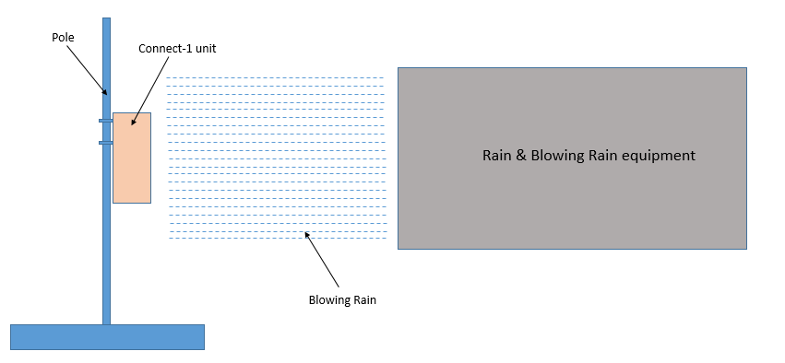

Figure 5. Rain Test Setup

1. **Measurement Locations**
2. Functionality of the unit should be checked during the test & after test
3. Following are some of the parts and its locations which are checked after the test
4. Connectors (can get loosened)
5. Gaskets (can get damaged)
6. Screws (can get unscrewed from the unit)
7. Adhesive / Label (can get damaged)
8. Components (can get de-soldered)
9. **Equipment Settings**
10. Non-operational working condition
11. **Software settings**

* Nil

#### Control & Measurements

1. Rain fall rate & Wind velocity are set as below
   1. Rain fall rate: 2.8 mm/min
   2. Wind velocity: 18 m/s
2. Water Flow rate & Wind velocity to be kept constant throughout the test & it should be monitored using flow rate measuring device attached to water outlet valve.
3. Position the wind source with respect to the test item so that it will cause the rain to beat directly, with variations up to 45° from the horizontal.
4. Measure the wind velocity at the position of the test item before placement of the test item in the facility
5. Rotate the unit so that each surface will be exposed for 30 minutes.
6. Total testing time will be for 2 hours.
7. Using stop watch for accurate time measurement.

#### Test Specification

1. The Test need to carry out as per the test standard MIL STD-810G Method 506.5 procedure
2. Unit should be configured as per actual field condition (Exception case: Electronic PWB assemblies could be removed as per the test conditions)
3. Unit mounting: Pole mounting condition
4. Pass / Fail criteria

Pass : At the end of the test there shall not be any water detected in the IPX5 area.

Fail : Water marks seen inside the IPX5 area

#### Test Procedure

1. Install the unit as per field installation (Pole mounting condition)
2. The simulated wind to be directed horizontally to blow through the water spray and drive it against the surfaces of the unit.
3. Ensure the rain is dispersed completely over the test item when accompanied by the prescribed wind.
4. Rotate the unit to expose each surface for 30mins, with total testing time of 2hrs.
5. After completion of test, without disturbing the unit place the unit inside thermal chamber and dry the unit for minimum of 2 hours at 50 degree before opening up the unit for observation.
6. Finally open the unit & visually inspect the unit for any water leak inside IPx5 area as give below
   * + - Connector joints
       - Gaskets
       - Screws
       - Adhesive / Label
       - Electronic circuit board
       - Cables

#### Reference

1. OC Connect 1 Environmental Test Specification document
2. 3D & 2D Design document
3. Product specification
4. Industry Standards
5. Datasheets for critical components

## Earthquake

### Test Case: Effect of Earthquake (Zone 2 spectra)

#### Description

1. **Purpose**

During an earthquake, equipment is subjected to motions that can over-stress equipment framework, circuit boards, and connectors. The goal of earthquake test is to see if the equipment can withstand earthquake vibration as per zone 2 spectra.

1. **Impact of failure**

If Earthquake requirement is not met, the unit would not be operational or work as intended due to Seismic shock.

#### Test Equipment List

1. Earthquake test setup and its control system
2. Setup to measure & monitor functionality of unit
3. Accessories including fixture & cables

#### Test Setup

1. **Unit Preparation**

Before the test units need to be ensured to work normal as per field condition. All wiring to be connected & mounted on test bed as per field condition (Pole mounting condition).

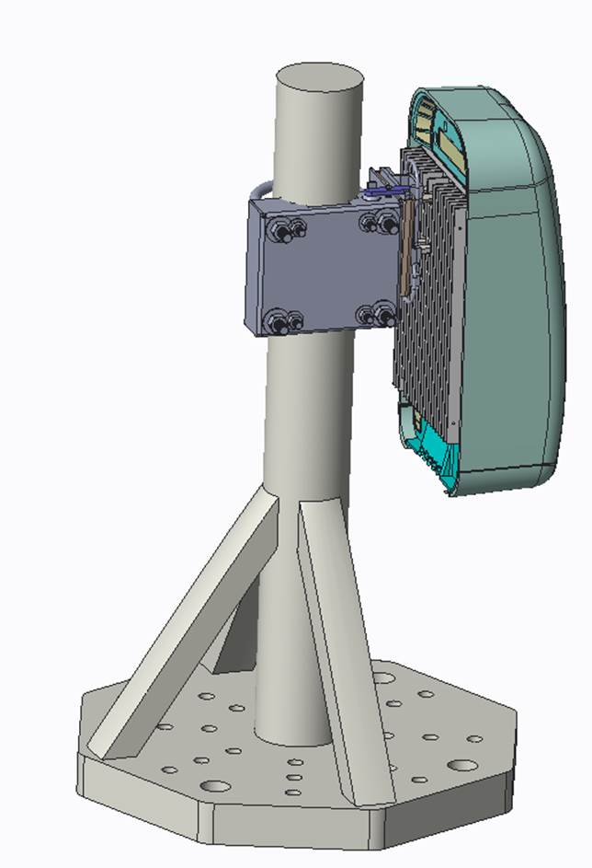

Figure 6. Earthquake Test Setup

1. **Measurement Locations**
   1. Functionality of the unit should be checked during the test & after test
   2. Following are some of the parts and its locations which are checked after the test
2. Connectors (can get loosened)
3. Gaskets (can get damaged)
4. Screws (can get unscrewed from the unit)
5. Adhesive / Label (can get damaged)
6. Components (can get de-soldered)
7. **Equipment Settings**
8. Normal power on condition stressed with RF load.
9. 2 chains can be configured at Band 900; +30 dBm output power to be monitored
10. **Software settings**
11. Temperature data will be read periodically from Tiva

#### Control & Measurements

1. Measure and control the displacement and acceleration of the earth quake shaker table as per the required test standard
2. Measure and control the waveform as per the required standard.

#### Test Specification

1. The Test unit should be configured as per actual field working condition & need to carry out as per the test standard GR-63-CORE zone 2 spectra.
2. Unit mounting: Pole mounting condition
3. A swept sine survey with an acceleration amplitude of 0.2 g from 0.3 to 50 Hz at a sweep rate of 1.0 octave per minute to be performed (Below given graph of frequency-Acceleration / Frequency & Acceleration table provide detailed requirement of test requirement)
4. Axis of vibration : X (North-South), Y (East-West) &

Z-axis (Vertical) individually

1. Damping Coefficient : 2 %
2. Required Response Spectrum (RPS) : As per GR-63-CORE zone 2 spectra
3. Status of test sample during testing : Powered ON

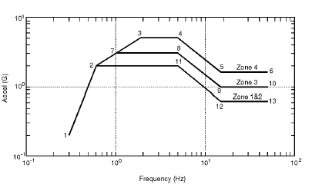

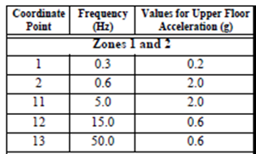

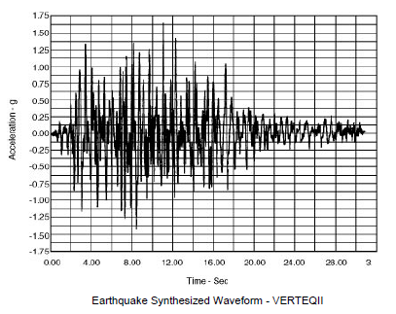

1. Functionality Check after the test

**Electrical functionality to be checked after the test:**

After the test unit should be functional such that Intel, Tiva, RF, temperature sensors, current sensing devices, UART interfaces, Ethernet interface & USB should be up & running.

**Mechanical parameters to be checked after the test:**

No Permanent deformation, dislocation, breakage or cracks to be observed after the test & No loosening of components / equipment from their original mounting.

#### Test Procedure

1. Mount the unit on the earthquake shaker table similar to how it will be installed in field (Pole mounting condition)
2. Check the equipment functionality and physical condition before starting the test
3. Subject the equipment to test with required waveform
4. Record the displacement and acceleration data during the shaking
5. Thoroughly inspect the equipment and note all changes to its physical condition & functionality as mentioned in the test specification section.
6. Record any reductions in anchor or fastener torques & mounting accessories

#### Reference

1. OC Connect 1 Environmental Test Specification document
2. 3D & 2D Design document
3. Product specification
4. Industry Standards
5. Datasheets for critical components

## Salt Fog

### Test Case: Effect of Corrosion

#### Description

1. **Purpose**

The salt fog test is performed to determine the effectiveness of protective coatings and finishes on materials. It may also be applied to determine the effects of salt deposits on the physical and electrical aspects of material.

1. **Impact of failure**
   1. Corrosion effects.
      1. Corrosion due to electrochemical reaction.
      2. Accelerated stress corrosion.
      3. Formation of acidic/alkaline solutions following salt ionization in water.
   2. Electrical effects.
2. Impairment of electrical material due to salt deposits.
3. Production of conductive coatings.
4. Corrosion of insulating materials and metals.
   1. Physical effects.
5. Clogging or binding of moving parts of mechanical components and assemblies.
6. Blistering of paint as a result of electrolysis.

#### Test Equipment List

1. Salt fog test setup
2. Accessories & Cables

#### Test Setup

1. **Unit Preparation**

Before the test units need to be ensured to work normal as per field condition. All wiring to be connected as per field condition (Pole mounting condition). Unit to be off during the test.

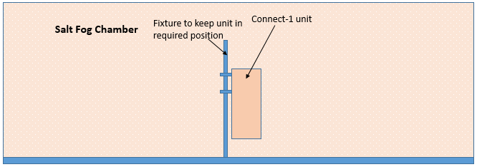

Figure 7. Salt Test Setup

1. **Measurement Locations**
2. Functionality of the unit should be checked during the test & after test
3. Conduct a complete visual examination of the test item with attention to:
4. High-stress areas.
5. Areas where dissimilar metals are in contact.
6. Electrical and electronic components - especially those having closely spaced, unpainted or exposed circuitry.
7. Metallic surfaces.
8. Enclosed volumes where condensation has occurred or may occur.
9. Components or surfaces provided with coatings or surface treatments for corrosion protection.
10. Cathodic protection systems; mechanical systems subject to malfunction if clogged or coated with salt deposits.
11. Electrical and thermal insulators
12. Functional test to be performed after completion of the test
13. **Equipment Settings**
14. Non-operational working condition
15. **Software settings**

* Nil

#### Control & Measurements

1. Following parameters are set and controlled inside salt chamber
2. Fall rate : 1 to 3 ml of solution per hour for each 80 cm3 of horizontal collecting area
3. Salt Concentration: Unless otherwise identified, use a 5% ± 1%
4. Temperature: 35 ±2°C
5. Ensure the air velocity in test chambers is minimal

#### Test Specification

1. Test will be carried out as per the test standard MIL-STD-810G, METHOD 509.5

#### Test Procedure

1. Check unit functionality as required
2. Place the unit inside the test chamber
3. Duration of test: Subject the unit for Salt fog exposure Alternating 24-hour periods of salt fog exposure and drying conditions for a minimum of four 24-hour periods (two wet and two dry)
4. After completion of test clean up the unit to remove salt deposition on unit surface
5. Check unit functionality as intended to work
6. Finally open the unit & visually inspect the unit at High-stress areas, areas where dissimilar metals are in contact , electrical and electronic components, metallic surfaces, components or surfaces provided with coatings or surface treatments for corrosion deposition

#### Reference

1. OC Connect 1 Environmental Test Specification document
2. 3D & 2D Design document
3. Product specification
4. Industry Standards
5. Datasheets for critical components

## Vibration

### Test Case: Sinusoidal vibration

#### Description

1. **Purpose**

The purpose of vibration test is to check resistibility of equipment against various vibration factors that may occur during normal operation of the units in the field. With this test product reliability could be checked & improved by estimating life of the product with greater reliability.

1. **Impact of failure**

If Sinusoidal Vibration requirements is not met, the unit would result with operational failures or malfunctions or other interruptions.

#### Test Equipment List

1. Vibration shaker testing equipment
2. Setup to measure & monitor functionality of unit
3. Cables & Accessories

#### Test Setup

1. **Unit Preparation**

Before the test units need to be ensured to work normal as per field condition. All wiring to be connected & mounted on test bed as per field condition (Pole mounting condition).



Figure 8. Sinusoidal Vibration Test Setup

1. **Measurement Locations**
2. Functionality of the unit should be checked during the test & after test
3. Following are some of the parts and its locations which are checked after the test
4. Connectors (can get loosened)
5. Gaskets (can get damaged)
6. Screws (can get unscrewed from the unit)
7. Adhesive / Label (can get damaged)
8. Components (can get de-soldered)
9. **Equipment Settings**
10. Normal power on condition stressed with RF load.
11. 2 chains can be configured at Band 900; +30 dBm output power to be monitored
12. **Software settings**
13. Temperature data will be read periodically from Tiva

#### Control & Measurements

1. Measure and control the displacement and acceleration of the vibration shaker table as per the required test standard

#### Test specification

1. Perform the vibration test as per ETSI 300 019-2-4 i.e. is IEC 60721 3-4 class 4M5 standard with the specification mentioned below

Displacement (mm) : 1.2

Acceleration (m/s2) : 4

Frequency range (Hz) : 5-9 9-200

Duration : 3 x 5 sweep cycles

Axes of Vibration : 3

1. Unit mounting: Pole mounting condition
2. Functionality Checks after the test

**Electrical functionality to be checked after the test:**

After the test unit should be functional such that Intel, Tiva, RF, temperature sensors, current sensing devices, UART interfaces, Ethernet interface & USB should be up & running.

**Mechanical parameters to be checked after the test:**

No Permanent deformation, dislocation, breakage or cracks to be observed after the test & No loosening of components / equipment from their original mounting.

#### Test Procedure

1. Mount the unit to the shaker table similar to how it will be installed in field (Pole mounting condition)
2. Subject the unit for sinusoidal vibration in three perpendicular directions as shown below fig .



Figure 9. Three Perpendicular directions

1. After the completion of the test ,thoroughly inspect the equipment and note all changes to its physical condition & functionality
2. Record any reductions in anchor or fastener torques & mounting accessories

#### Reference

1. OC Connect 1 Environmental Test Specification document
2. 3D & 2D Design document
3. Product specification
4. Industry Standards
5. Datasheets for critical components

### Test Case: Random vibration

If Random Vibration requirements is not met, the unit would result with operational failures or malfunctions or other interruptions.

#### Test Equipment List

1. Vibration shaker testing equipment
2. Setup to measure & monitor functionality of unit
3. Cables & Accessories

#### Test Setup

1. **Unit Preparation**

Before the test units is ensured to work normal as per field condition. All wiring to be connected & mounted on test bed as per field condition (Pole mounting condition).



Figure 10. Sinusoidal Vibration Test Setup

1. **Measurement Locations**
2. Functionality of the unit should be checked during the test & after test
3. Following are some of the parts and its locations which are checked after the test
4. Connectors (can get loosened)
5. Gaskets (can get damaged)
6. Screws (can get unscrewed from the unit)
7. Adhesive / Label (can get damaged)
8. Components (can get de-soldered)
9. **Equipment Settings**
10. Normal power on condition stressed with RF load.
11. 2 chains can be configured at Band 900; +30 dBm output power to be monitored
12. **Software settings**
13. Temperature data will be read periodically from Tiva

#### Control & Measurements

1. Measure and control the displacement and acceleration of the vibration shaker table as per the required test standard

#### Test specification

1. Subject the equipment to Vibration test as per ETSI 300 019-2-4 i.e. is IEC 60721 3-4 class 4M5 standard with the specification mentioned below

ASD (m2/ s3) : 0.04

(dB/oct) : +12 -12

Frequency range (Hz) : 5-10 10-50 50-100

Duration : 3 x 30 minutes

Axes of Vibration : 3

1. Unit mounting: Pole mounting condition
2. Functionality Check after the test

**Electrical functionality to be checked after the test:**

After the test unit should be functional such that Intel, Tiva, RF, temperature sensors, current sensing devices, UART interfaces, Ethernet interface & USB should be up & running.

**Mechanical parameters to be checked after the test:**

No Permanent deformation, dislocation, breakage or cracks to be observed after the test & No loosening of components / equipment from their original mounting.

#### Test Procedure

1. Mount the unit to the shaker table similar to how it will be installed in field (Pole mounting condition)
2. Subject the unit for sinusoidal vibration in three perpendicular directions as shown below.



Figure 11. Three Perpendicular directions

1. After the completion of the test ,thoroughly inspect the equipment and note all changes to its physical condition & functionality
2. Record any reductions in anchor or fastener torques & mounting accessories

#### Reference

1. OC Connect 1 Environmental Test Specification document
2. 3D & 2D Design document
3. Product specification
4. Industry Standards
5. Datasheets for critical components

### Test Case: Shock

#### Description

1. **Purpose**

The purpose of vibration test is to check resistibility of equipment against various Shocks that may occur during normal operation of the units in the field. With this test product reliability could be checked & improved by estimating life of the product with greater reliability.

1. **Impact of failure**

If the Shock requirements is not met, the unit would result with operational failures or malfunctions or other interruptions.

#### Test Equipment List

1. Shock equipment

#### Test Setup

1. **Unit Preparation**

Before the test units is ensured to work normal as per field condition. All wiring to be connected & mounted on test bed as per field condition (Pole mounting condition).



Figure 12. Sinusoidal Vibration Test Setup

1. **Measurement Locations**
2. Functionality of the unit should be checked during the test & after test
3. Following are some of the parts and its locations which are checked after the test
4. Connectors (can get loosened)
5. Gaskets (can get damaged)
6. Screws (can get unscrewed from the unit)
7. Adhesive / Label (can get damaged)
8. Components (can get de-soldered)
9. **Equipment Settings**
10. Normal power on condition stressed with RF load.
11. 2 chains can be configured at Band 900; +30 dBm output power to be monitored
12. **Software settings**
13. Temperature data will be read periodically from Tiva

#### Control & Measurement

1. Measure and control the Shock spec parameters as per the required test standard

#### Test Specification

1. Equipment is subjected to shock as per ETSI 300 019-2-4 i.e. is IEC 60721 3-4 class 4M5 standard with the specification mentioned below

Shock spectrum : half sine

Duration (ms) : 11

Acceleration (m/s2) : 50

Number of bumps : 100 in each direction

Direction of bumps : 6

1. Functionality Check after the test

**Electrical functionality to be checked after the test:**

After the test unit should be functional such that Intel, Tiva, RF, temperature sensors, current sensing devices, UART interfaces, Ethernet interface & USB should be up & running.

**Mechanical parameters to be checked after the test:**

No Permanent deformation, dislocation, breakage or cracks to be observed after the test & No loosening of components / equipment from their original mounting.

#### Test Procedure

1. Mount the unit to the shaker table similar to how it will be installed in field (Pole mounting condition)
2. After the completion of the test ,thoroughly inspect the equipment and note all changes to its physical condition & functionality
3. Record any reductions in anchor or fastener torques & mounting accessories

#### Reference

1. OC Connect 1 Environmental Test Specification document
2. 3D & 2D Design document
3. Product specification
4. Industry Standards
5. Datasheets for critical components

## Thermal

### Test Case: Thermal Imaging

#### Description

1. **Purpose**

The purpose of thermal imaging is to measure the temperature level /hotspots of electronic devices and component by the infrared energy emitted by surfaces.

1. **Impact of failure**

Hot spots located in the thermal imaging are used as reference for improving cooling mechanics of the unit & components.

#### Test Equipment List

1. IR Camera

#### Test Setup

1. **Unit Preparation**
2. The unit must be cleaned of dirt, grease, and other contaminants prior to the thermal imaging. Unit shall be functionally operated at full load condition.
3. Stack the boards (GBC & RF) using mounting spacers
4. **Measurement Locations**
5. High power dissipating components surfaces
6. Board surfaces near to the high power dissipating components
7. Enclosure surface
8. **Equipment Settings**
9. Thermal imaging will be carried out with open board condition i.e., without mechanics to monitor the hot region in the board level
10. Thermal imaging should also be carried out with system level i.e., with mechanics & boards.
11. **Software settings**
12. Temperature data to be read periodically from Tiva

#### Control & Measurements

1. Place the unit in clean room at an ambient of 25 Deg C
2. Operating condition stressing the unit to required load.

#### Test Specification

1. The IR images of the test unit will be captured in room ambient conditions i.e., at 25 degrees centigrade.
2. The hot spots of components obtained from Thermal imaging are compared with their Max junction limit and analyzed for better cooling & improve thermal margins.
3. Unit mounting: Pole mounting condition

#### Test Procedure

1. Keep the unit in clean room ambient and ensure that there is not much variations in the ambient temperature
2. Operate the unit stressing it functionally to full load conditions. Where setup to be powered on at room temperature & below stress load will be included during testing

* iperf to load Marvel and Sprinville
* stress -ng tool to load the CPU
* FIO tool to stress mSATA and CPU
* 2 TRX chain data flowing from GBC to RFSDR (OSMO stack can have transmission at maximum power from only one chain at any given time )
* TIVA monitoring current sensors
* Monitor CPU load status (Max CPU utilization will be taken only to 100%)

1. Allow the equipment to stabilize
2. Take the IR images to capture all the hotspots on the PCB

#### Reference

1. OC Connect 1 Environmental Test Specification document
2. 3D & 2D Design document
3. Product specification
4. Industry Standards
5. Datasheets for critical components

### Test Case: Thermal Validation

#### Description

1. **Purpose**

The purpose of thermal validation test is to measure the case/board/ambient temperature of critical components as the component temperature characterization provides the data for qualification of the thermal management method employed on a particular product. This is done to verify that component junction temperatures are within manufacturers maximum recommended limits.

1. **Impact of failure**

Failure in thermal validation results in the electrical malfunction of components caused by high temperature and also results in thermal degradation of components.

#### Test Equipment List

1. Environmental Test Chamber
2. Test fixture
3. Power supply
4. Thermocouples
5. Multichannel data logger
6. Thermal paste/tape

#### Test Setup

1. **Unit Preparation**
2. Ensure components considered for measurements are cleaned with Isopropanol solution which removes dust and other particles.
3. Measure the thermocouple resistance using the digital multi meter.
4. Place the thermocouple on geometric centre of component case making 0° angle attachment as shown in the below fig.

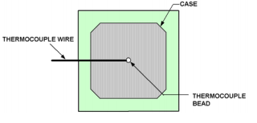

Figure 13. Thermal validation Test Setup

1. Utilize a small dot of Loctite paste as a seed surface coating to connect the thermocouple to component case and allow it to cure for 12 to 18 hours.
2. **Measurement Locations**

Functionality of the unit should be checked during the test & after test

1. **Equipment Settings**
2. Unit to be powered on at room temperature & Normal power on condition stressed with RF load.
3. 2 chains can be configured at Band 900; +30 dBm output power to be monitored
4. **Software settings**
5. Temperature data to be read periodically from Tiva

#### Control & Measurements

Summary of test results will be represented in the form as shown below

Junction temperature is calculated from the measured case temperature using the following formula:

**Tj** = **Tc** + **Rjc** * **P**

**Tj** is the Junction Temperature

**Tc** is the Case temperature measured

**Rjc** is the Junction to Case Thermal resistance

**P** is the Thermal design power

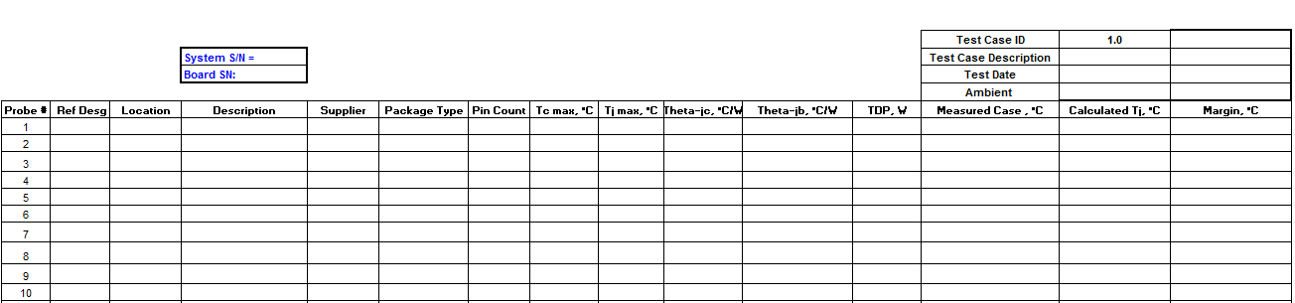

#### Table 1 : Thermal Validation Test Results Summary

#### Test Condition

1. The thermal validation test to be carried out as per GR-63 Core standard.

#### Test Specification & Procedure

1. Mount the unit inside the thermal chamber similar to that installed in the field(Pole mounting condition)
2. Working condition of thermocouple is checked using Agilent software
3. Thermocouples are connected to Multiplexer to acquire the temperature data through data logger for the required testing period.
4. The unit should be stressed for full load conditions and power entering through the unit to be monitored and below stress load will be included during testing

* iperf to load Marvel and Springville
* stress -ng tool to load the CPU
* FIO tool to stress mSATA and CPU
* 2 TRX chain data flowing from GBC to RFSDR (OSMO stack can have transmission at maximum power from only one chain at any given time )
* TIVA monitoring current sensors
* Monitor CPU load status (Max CPU utilization will be taken only to 100%)

1. Set the thermal chamber temperature to desired value and allow the unit to reach the steady state temperature
2. Once the system is stabilized, the temperature measurement is logged and compared with their Max junction limit and analyzed for better cooling & improve thermal margins.

#### Reference

1. OC Connect 1 Environmental Test Specification document
2. 3D & 2D Design document
3. Product specification
4. Industry Standards
5. Datasheets for critical components

### Test Case: Thermal Cycling

#### Description

1. **Purpose**

The purpose of thermal cycling test is to determine the ability of unit/components to withstand mechanical stresses induced by alternating high- and low-temperature extremes

1. **Impact of failure**

Failure in the thermal cycling results in the electrical malfunction and loss of functional capability of component due to thermal distortion of the material with the mechanical warpage

#### Test Equipment List

1. Environmental Test Chamber
2. Test fixture
3. Power supply

#### Test Setup

1. **Unit Preparation**

The unit must be cleaned of dirt, grease, and other contaminants prior to the thermal exposure.

Operate the unit to test for the functionality, before the unit is placed inside the thermal chamber.

1. **Measurement Locations**
2. Functionality of the unit should be checked during the test & after test
3. Visual examination of the high power dissipating components and test equipment
4. **Equipment Settings**
5. Normal power on condition stressed with RF load.
6. 2 chains can be configured at Band 900; +30 dBm output power to be monitored
7. **Software settings**
8. Temperature data to be read periodically from Tiva

#### Control & Measurements

1. Temperature and power should be monitored during test to ensure they are within the test condition limits

#### Test Specification

1. The thermal validation test to be carried out as per ETSI EN 300019-2-4 d.
2. Unit mounting: Pole mounting condition
3. The unit should be functional during the negative and positive temperature cycle where Intel, Tiva, RF, temperature sensors, current sensing devices, UART interfaces, Ethernet interface & USB should be up & running and with no thermal shutdown, then the test is considered as pass.

#### Test Procedure

1. Mount the unit inside the thermal chamber similar to that installed in the field (Pole mounting condition)
2. Use thermocouple or any equivalent temperature measurement apparatus to ensure that the unit is reaching the temperature extremes
3. Set the chamber working zone profile to specified temperatures and cycle time as given below
4. There shall be 2 thermal cycles and each thermal cycle is run for 8.66 hrs.
   * 1. In each cycle the unit is exposed to extreme positive (+ve) and negative (-ve) temperatures for 3 hours and then to return to 25°C.
     2. The temperatures and time duration for temperature cycling test shall correspond to the specifications given in the below table

|  |  |  |  |
| --- | --- | --- | --- |
| **Step** | **Temperature** | **Event** | **Duration in minutes** |
| 1 | 25oC | Start | 20 |
| 2 | -100C | Ramp | 60 |
| 3 | -100C | Soak | 180 |
| 4 | 200C | Ramp | 60 |
| 5 | 400C | Ramp | 40 |
| 6 | 400C | Soak | 180 |
| 7 | 200C | Ramp | 40 |
| 8 | Step 2 to 7 constitutes 1 cycle. Total 2 cycles | | |
| 9 | 25oC | Soak | 30 |

#### Table 2 : Thermal Cycling Test Profile

#### Reference

1. OC Connect 1 Environmental Test Specification document
2. 3D & 2D Design document
3. Product specification
4. Industry Standards
5. Datasheets for critical components

## HALT

### Test Case: High Accelerated Life Test

#### Description

1. **Purpose**

The purpose of HALT test is to subject the unit to thermal, vibration and other product specific stresses to a level beyond the product’s specifications or intended use of environment, in order to force the latent defects in product design, allowing them to be detected and corrected before the product release. The stresses are incremented during the test to force the weakest link in the unit to fail first.

1. **Impact of failure of test case on system**

Typically the Unit subjected to HALT tests reaches “Hard Failure” or Non-recoverable failure which will define the destruct limit of the unit .The unit subjected to HALT test will exhibit reliability characterized by a bathtub shaped curve as shown in below figure with three distinct failure rate regions. The first region is the “infant mortality” section of the curve, which has a decreasing failure rate and is associated with built-in (i.e., not designed-in) defects. These are the types of defects that often can be identified by HALT testing. The amount of time required for a subsequent HASS test is determined by the width of the infant mortality region of the reliability curve. In general, the higher the stress, the sooner the failures, the narrower the infant mortality region and the shorter the HASS test period.

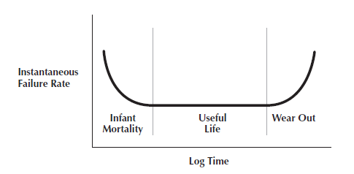.

#### Test Equipment List

1. HALT Chamber
2. Mounting fixture
3. Setup to measure & monitor functionality of unit
4. Accessories including fixture & cables

#### Test Setup

1. **Unit Preparation**

In HALT, temperature and vibration stress conditions are used during product development to find weak spots in the product design and its planned fabrication processes.

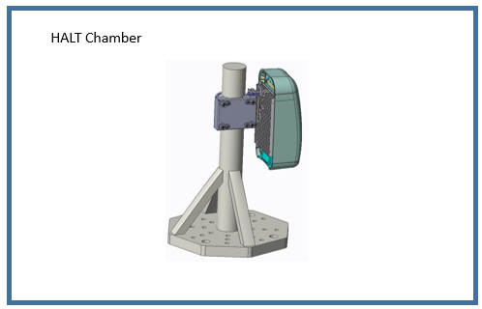

Figure 14. HALT Test setup

1. **Measurement Locations**
2. Unit response to the extreme stress level of Temperature and vibration test are measured during the entire test
3. Test graph to be plotted at the end of the test
4. **Equipment Settings**
5. Unit to be placed inside the chamber & Power on the unit normally & stress the unit with load in the operational condition
6. 2 chains can be configured at Band 900; +30 dBm output power to be monitored
7. Profile to be created as per the specifications and test to be executed with automatic operation
8. **Software settings**
9. Temperature data to be read periodically from Tiva

#### Control & Measurements

1. Measure and control the HALT test spec parameters as per the required test parameters
2. Reboot the unit during dwell period and check the functionality during Cold & Hot step stress test

#### Test Specification

**Cold Step Stress Test:** Startingfrom 20ºC to -20ºC, at 5ºC step and then from -20°C in 10°C step till the failure is been observed. Dwell in each step for 30 min approximately, with ramp rate of 60ºC/min.

**Hot Step Stress Test:** Starting from 20ºC to 50ºC, at 10ºC step and again from 50ºC at 5ºC step till the failure is been observed. Dwell in each step for 15 min minimum, with ramp rate of 60ºC/min.

**Vibration Step Stress Test:** Starting from 5 Grms till the failure is observed with an increment of 5 Grms at every step. Dwell in each step for 15 min with temperature maintained at 25ºC

The failure limits derived from the above tests are the limits to be considered for the combined thermal cycling & vibration test

**Combined Thermal Cycling & Vibration Test:**

|  |  |  |  |
| --- | --- | --- | --- |
| **Step** | **Temperature** | **Event** | **Duration** |
| 1 | 250 C | Start | 5 min |
| 2 | Negative temperature limit obtained from Cold stress test | Ramp | 600 C/min |
| 3 | Negative temperature limit obtained from Cold stress test | Soak | 20 min |
| 4 | Positive temperature limit obtained from Cold stress test | Ramp | 600 C/min |
| 5 | Positive temperature limit obtained from Cold stress test | Soak | 20 min |
| 6 | 250 C | Ramp | 600 C/min |
| 7 | Step 2 to 6 constitutes 1 cycle and same is repeated for total 5 cycles. Vibration to be increased in steps of ‘X’ Grms for every cycle from ‘X’ Grms to the failure limit.  Note: ‘X’ = Failure Limit / 5 | | |
| 8 | 250 C | Soak | 10 min |

#### Test Procedure

1. Mount the unit to the shaker table similar to how it will be installed in field (Pole mounting condition)
2. Unit should be powered on with normal power on condition & unit should be stressed with RF load
3. Below are the different stress test procedure
4. Temperature Profiling:
5. Determine the minimum and maximum product operating temperature limits
6. Accelerate the aging process of the unit by applying extreme temperatures
7. Burn-in the unit under elevated temperatures at a high duration rate
8. Vibration Profiling:
9. Determine the maximum product operating vibration levels
10. Find mechanical defects early in the work-in-process cycle
11. Simulate global transportation conditions on the unit

#### Reference

1. OC Connect 1 Environmental Test Specification document
2. 3D & 2D Design document
3. Product specification
4. Industry Standards
5. Datasheets for critical components

## HASS

### Test Case: Highly Accelerated Stress Audit

#### Description

1. **Purpose**

The purpose of HASS is to mitigate the risks of manufacturing related errors and the resulting negative effects for the users which is being performed on sample production units.

1. **Impact of failure**

The main goal of HASS is to precipitate and detect hidden or latent failures. It is used to verify that no new “weak link” has crept into the product, since HALT that has shifted the limits found in HALT. Ultimately, its purpose is to prevent flawed units from reaching the end-user/customer.

#### Test Equipment List

1. HASS Chamber
2. Setup to measure & monitor functionality of unit
3. Accessories including fixture & cables

#### Test Setup

1. **Unit Preparation**

Typically, HASS stress levels are less than those used in HALT. However, they are generally more severe than anticipated in actual service. The goal is to use enough stress to find faults - but not enough to remove a significant amount of the product’s life.

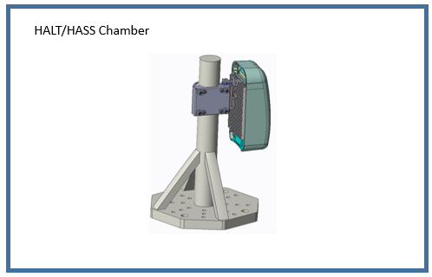

Figure 15. HASS Test setup

1. **Measurement Locations**
2. Unit response to the extreme stress level of Temperature and vibration test are measured during the entire test
3. Test graph to be plotted at the end of the test
4. **Equipment Settings**
5. Unit to be placed inside the chamber & Power on the unit normally & stress the unit with load in the operational condition
6. 2 chains can be configured at Band 900; +30 dBm output power to be monitored
7. Profile to be created as per the specifications and test to be executed with automatic operation
8. **Software settings**
9. Temperature data to be read periodically from Tiva

#### Control & Measurements

Measure and control the HASS test spec parameters as per the required test standard

#### Test Specification

Combined Thermal Cycling & Vibration Test to be carried out as per the results derived from HALT tests

|  |  |  |  |
| --- | --- | --- | --- |
| **Step** | **Temperature** | **Event** | **Duration** |
| 1 | 250 C | Start | 5 min |
| 2 | Consider 5 deg C less from the Negative temperature limit obtained in HALT Test | Ramp | 600 C/min |
| 3 | Consider 5 deg C less from the Negative temperature limit obtained in HALT Test | Soak | 20 min |
| 4 | Consider 5 deg C less from the positive temperature limit obtained in HALT Test | Ramp | 600 C/min |
| 5 | Consider 5 deg C less from the positive temperature limit obtained in HALT Test | Soak | 20 min |
| 6 | 250 C | Ramp | 600 C/min |
| 7 | Step 2 to 6 constitutes 1 cycle and same is repeated for total 5 cycles. Vibration to be constant at X Grms throughout the test.  Note: ‘X’ = 80% of (Failure Limit / 5) | | |
| 8 | 250 C | Soak | 10 min |

#### Test Procedure

1. Mount the unit to the shaker table similar to how it will be installed in field (Pole mounting condition)
2. Unit should be powered on with normal power on condition & unit should be stressed with RF load.
3. Below are the different stress test procedure
4. Temperature profile & Vibration limits are set lower than that identified from operational destructive condition during HALT
5. Accelerate the aging process of the unit by applying extreme temperatures & Vibration set for HASS
6. Burn-in the unit under elevated temperatures at a high duration rate & check for mechanical defects.

#### Reference

1. OC Connect 1 Environmental Test Specification document
2. 3D & 2D Design document
3. Product specification
4. Industry Standards
5. Datasheets for critical components