Qualification Report
OpenCellular - Connect1
Environmental Testing

  - Revision: 1.0

1. Purpose 9
2. Scope 9
3. References 9
4. Device-Under-Test (DUT) Details 9
5. Qualification Result Summary 10
6. Qualification Tests Results 11
6.1. Preconditioning 11
6.1.1. Test ID: ENV 1.1 11
6.1.2. Purpose 11
6.1.3. Test Method 11
6.1.4. Test setup 12
6.1.5. Test Result 12
6.2. Water Ingress Test (IPX5) 13
6.2.1. Test ID: ENV 1.2 13
6.2.2. Purpose 13
6.2.3. Test and Measurement Method 13
6.2.4. Test Condition 14
6.2.5. DUT Sample information 14
6.2.6. Test Result 14
6.2.7. Inference 21
6.3. Dust Ingressions IP6X 23
6.3.1. Test ID: ENV 1.3 23
6.3.2. Purpose 23
6.3.3. Test and Measurement Method 23
6.3.4. Test Condition 23
6.3.5. DUT Sample information 24
6.3.6. Test Results 24
6.3.7. Inference 30
6.4. Rain & Blowing Rain 31
6.4.1. Test ID: ENV 1.4 31
6.4.2. Purpose 31
6.4.3. Test and Measurement Method 31
6.4.4. Test Condition 31
6.4.5. DUT Sample information 32
6.4.6. Test Results 33
6.4.7. Inference 34
6.5. Earthquake 35
6.5.1. Test ID: ENV 1.5 35
6.5.2. Purpose 35
6.5.3. Test and Measurement Method 35
6.5.4. Test Condition 35
6.5.5. DUT Sample information 36
6.5.6. Test Results 36
6.5.7. Functional log 37
6.5.8. Inference 37
6.6. Salt Fog Test 38
6.6.1. Test ID: ENV 1.6 38
6.6.2. Purpose 38
6.6.3. Test and Measurement Method 38
6.6.4. Test Condition 38
6.6.5. DUT Sample information 38
6.6.6. Test Results 39
6.6.7. Functional test 44
6.6.8. Inference 44
6.7. Operational Vibration: 45
6.7.1. Sinusoidal vibration Test 45
6.7.1.1. Test ID: ENV 1.7 45
6.7.1.2. Purpose 45
6.7.1.3. Test and Measurement Method 45
6.7.1.4. Test Condition 45
6.7.1.5. DUT Sample information 46
6.7.1.6. Test Results 47
6.7.1.7. Functional log 50
6.7.1.8. Inference 50
6.7.2. Random vibration (Operational) 51
6.7.2.1. Test ID: ENV 1.7 51
6.7.2.2. Purpose 51
6.7.2.3. Test and Measurement Method 51
6.7.2.4. Test Condition 51
6.7.2.5. DUT Sample information 52
6.7.2.6. Test Results 52
6.7.2.7. Functional log 54
6.7.2.8. Inference 54
6.7.3. Shock 55
6.7.3.1. Test ID: ENV 1.7 55
6.7.3.2. Purpose 55
6.7.3.3. Test and Measurement Method 55
6.7.3.4. Test Condition 55
6.7.3.5. DUT Sample information 56
6.7.3.6. Test Results 56
6.7.3.7. Functional log 57
6.7.3.8. Inference 57
6.8. Thermal: 59
6.8.1. Thermal Imaging 59
6.8.1.1. Test ID: ENV 1.8 59
6.8.1.2. Purpose 59
6.8.1.3. Test and Measurement Method 59
6.8.1.4. Test Condition 59
6.8.1.5. DUT Sample information 59
6.8.1.6. Test Results 60
6.8.1.7. Inference 63
6.8.2. Thermal Validation 64
6.8.2.1. Test ID: ENV 1.8 64
6.8.2.2. Purpose 64
6.8.2.3. Test and Measurement Method 64
6.8.2.4. Test Condition 64
6.8.2.5. DUT Sample information 64
6.8.2.6. Test Results 65
6.8.2.7. Inference 66
6.8.3. Thermal Cycling 67
6.8.3.1. Test ID: ENV 1.8 67
6.8.3.2. Purpose 67
6.8.3.3. Test and Measurement Method 67
6.8.3.4. Test Condition 67
6.8.3.5. DUT Sample information 68
6.8.3.6. Test Results 68
6.8.3.7. Functional log 69
6.8.3.8. Inference 69
6.9. HALT 70
6.9.1. Test ID: ENV 1.9 70
6.9.2. Purpose 70
6.9.3. Test and Measurement Method 70
6.9.4. Test Condition 70
6.9.5. DUT Sample information 71
6.9.6. Test Results 71
6.9.7. Inference 73
6.10. HASS 74
6.10.1. Test ID: ENV 1.10 74
6.10.2. Purpose 74
6.10.3. Test and Measurement Method 74
6.10.4. Test Condition 74
6.10.5. DUT Sample information 74
6.10.6. Test Results 75
6.10.7. Inference 75
7. Revision History 76

Figure 1: Glue locations inside the unit 12
Figure 2: Mechanical & Climatic preconditioning Test setup 12
Figure 3: IPX5 testing 14
Figure 4: Front panel connector area 15
Figure 5: Shorty Antenna area 15
Figure 6: GBC board 15
Figure 7: Inside Front cover 16
Figure 8: Battery area 16
Figure 9: Inside unit 17
Figure 10: GBC board / Heat spreader sides 17
Figure 11: Inside unit 18
Figure 12: GBC Board 18
Figure 13: Inside RF SDR Heat spreader plate 19
Figure 14: RF SDR Board 19
Figure 15: RF SDR board 20
Figure 16: Battery 20
Figure 17: Inside unit 21
Figure 18: IPx5 - Water entry thru top plate 21
Figure 19: IPx5 - Water entry thru louver 22
Figure 20: Water entry thru connectors 22
Figure 21: IP6X test setup 23
Figure 22: After IP6X visual inspection test photos 24
Figure 23: Front panel with cables 25
Figure 24: Front panel 25
Figure 25: Inside the unit – front panel 26
Figure 26: Inside the unit - Battery 26
Figure 27: GBC Board 27
Figure 28: Front panel connector area from inside 27
Figure 29: RF SDR board kept inside the unit 28
Figure 30: Inside the unit without RF SDR board 28
Figure 31: Inside the unit with RF SDR board & Heat spreader plate 29
Figure 32: RF SDR board 29
Figure 33: Inside GBC Heat spreader plate 30
Figure 34: IP6x – Dust leak thru opening in sheet metal 30
Figure 35: IP6x – Dust leak thru louver 30
Figure 36: Rain & Blowing rain test setup 31
Figure 37: Rain & Blowing rain measuring equipment 31
Figure 38: Rain & Blowing rain – rain fall measurement 32
Figure 39: Rain & Blowing testing 32
Figure 40: GBC Board 33
Figure 41: Shorty Antenna 33
Figure 42: Front cover 34
Figure 43: Earthquake test specification 35
Figure 44: Earthquake testing 36
Figure 45: Assembled Unit 39
Figure 46: Unit kept inside the salt chamber 39
Figure 47: Unit after salt fog test 39
Figure 48: Rust formation were observed on DUT Clamps 40
Figure 49: Salt powder deposition found at the screw areas marked red 40
Figure 50: GBC Board 41
Figure 51: GBC Board Heat spreader plate 41
Figure 52: Sync Board 42
Figure 53: RF SDR Board 42
Figure 54: RF SDR Board 43
Figure 55: GPS Antenna 43
Figure 56: Battery Area 44
Figure 57: Post salt fog test functionality photo 44
Figure 58: Sine vibration x axis control graph 47
Figure 59: Sine vibration x axis response graph 47
Figure 60: Sine vibration y axis control graph 48
Figure 61: Sine vibration y axis response graph 48
Figure 62: Sine vibration z axis control graph 49
Figure 63: Sine vibration z axis response graph 49
Figure 64: Random vibration x axis graph 52
Figure 65: Random vibration y axis graph 53
Figure 66: Random vibration z axis graph 53
Figure 67: Shock z axis graph 56
Figure 68: Post vibration test photo 57
Figure 69: Vibration testing 58
Figure 70: GBC board Intel Processor side 60
Figure 71: GBC Board Bottom Side 60
Figure 72: RF SDR Board PA Top Side 60
Figure 73: RF Board PA Bottom Side 61
Figure 74: GBC and RF SDR Board in Stack up condition with GBC board facing Intel Side 61
Figure 75: GBC and RF SDR Board in Stack up condition with RF SDR board facing PA side 61
Figure 76: With Mechanics facing Back Side 62
Figure 77: With Mechanics facing Front Side 62
Figure 78: Unit placed inside Thermal Chamber 68
Figure 79: Thermal cycling test graph 69
Figure 80: Unit kept inside the HALT Chamber 71
Figure 81: Cold Step Stress 72
Figure 82: Hot Step stress 72
Figure 83: Vibration step stress 72
Figure 84: Combined thermal cycling & vibration 73
Figure 85: Unit kept inside the Chamber 75
Figure 86: Combined Thermal cycling and vibration test 75

Purpose
The purpose of this document is to capture Environmental test data for Open Cellular Base Transceiver Station (BTS). The document provides formal report of measured and validated parameters to qualify Open Cellular Base Transceiver Station as part of design validation testing to ensure consistent and reliable operation across all supported operating and environmental conditions.

Scope
Scope of this Environmental test for Open Cellular Base Transceiver Station (BTS) document is to qualify different environmental test conditions as mentioned below
  - Water Ingression IPX5
  - Dust Ingression IP6X
  - Rain & Blowing Rain
  - Earthquake
  - Salt Mist
  - Operation Vibration
  - Thermal
  - HALT
  - HASS

References
- OC Connect 1 Environmental Test Specification document
https://github.com/markhor/OpenCellular
- 3D & 2D Design document
https://github.com/markhor/OpenCellular
- Product specification
https://github.com/markhor/OpenCellular
- Industry Standards
- Datasheets for critical components

Device-Under-Test (DUT) Details
- System : Open cellular Connect -1
- Hardware version : Life -2
- Software version : Ubuntu – 14.04.64 bit
Coreboot- coreboot-4.4-575-gfee24cc-dirty (This
comes in boot log)
RTOS- 2_16_00_08 (This is base RTOS)
Coreboot: SVn version 7
System software: 51
- Sample count : 1 unit each test

Qualification Result Summary

Test ID | Function | Test cases/specification | Status | Remarks
ENV 1.1 | Precondition | Preconditioning | Pass
ENV 1.2 | Water Ingression | Water ingression IPX5 | Fail | Water marks seen inside the unit  Next plan of action: Redesign of mechanics
ENV 1.3 | Dust Ingression | Dust ingression IP6X | Fail | Dust particle seen inside the unit  Next plan of Action: Redesign of mechanics
ENV 1.4 | Water Ingression | Rain & Blowing Rain | Fail | Water marks seen inside the unit  Next plan of Action: Redesign of mechanics
ENV 1.5 | Reliability | Earthquake | Pass
ENV 1.6 | Unit Corrosion | Salt Fog | Pass
ENV 1.7 | Unit reliability | Vibration | Pass
ENV 1.8 | Unit reliability | Thermal | Pass
ENV 1.9 | Unit reliability | HALT | Fail | Error seen on OSMO BTS Stack, when running the memtester software utility  Next plan of action: Software debug
ENV 1.10 | Unit reliability | HASS | Fail | Error seen on OSMO BTS Stack, when running the memtester software utility  Next plan of action: Software debug

Qualification Tests Results

Preconditioning

Test ID: ENV 1.1

Purpose
The purpose of preconditioning test before IP65 test is to subject the unit to mechanical & thermal stress.
The mechanical precondition determines if there is effect to gaskets & screws due to vibration that occur during the unit transportation and also during assembly. In this phase we run sinusoidal vibration, random vibration and shock test cases.
The climatic precondition test determines effect of severe temperature cycling on the unit’s gaskets, grommets, and fastener screws.

Test Method
- Mechanical Precondition
- Sinusoidal vibration
- Displacement (mm) : 1.2
- Acceleration (m/s²⁾ : 4
- Frequency range (Hz) : 5-9 9-200
- Duration : 3 x 5 sweep cycles
- Axes of Vibration : 3

- Random vibration
- ASD (m2/ s3) : 0.04
- (dB/oct) : +12 -12
- Frequency range (Hz) : 5-10 10-50 50-100
- Duration : 3 x 30 minutes
- Axes of Vibration : 3

- Shock
- Shock spectrum : half sine
- Duration (ms) : 11
- Acceleration (m/s2) : 50
- Number of bumps : 100 in each direction
- Direction of bumps : 6

- Climatic Precondition
Temperature cycle -45°C to +60°C, test duration 10 days, Temperature change rate for thermal chamber is 3°C/min. Dwell period at -45°C & +60°C is 40 min each.

Test setup
Before precondition process, unit is painted from inside by Pin Point colorimeter developer WDP-217 paint for the unit which will be subjected for IPX5 test. This paint detects water leaks by colour change from white to green. Non-operational unit with GBC & RF SDR boards along with heat spreader were assembled inside the unit.

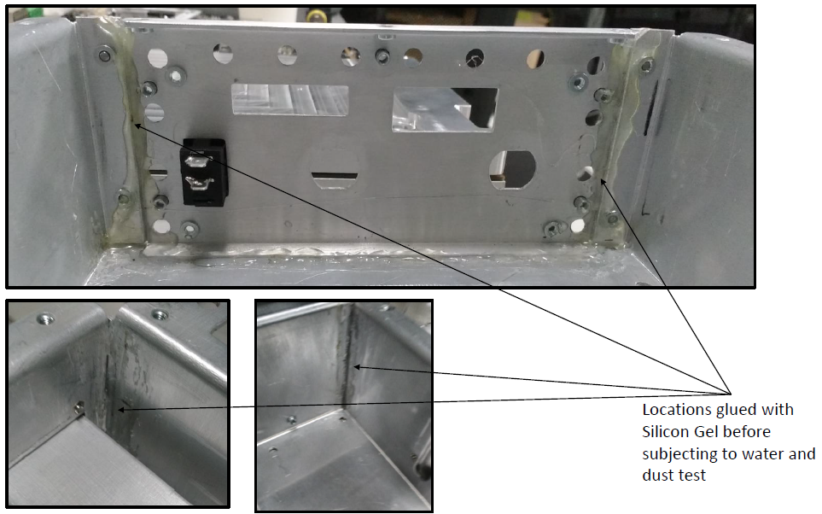
Figure 1: Glue locations inside the unit

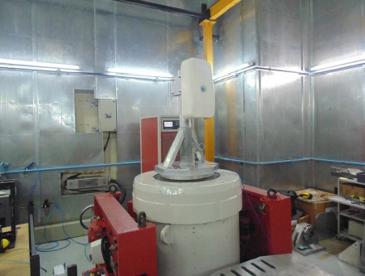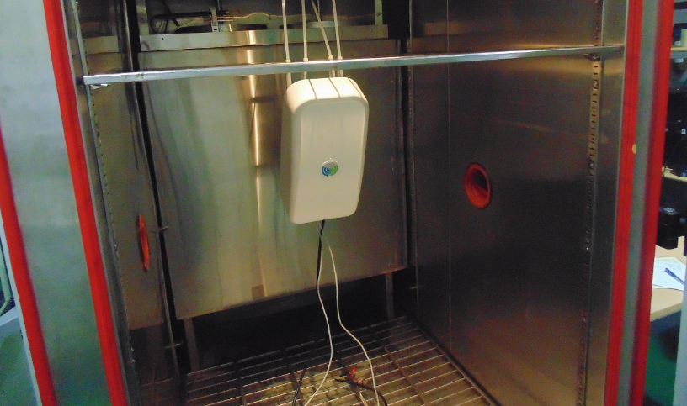

Figure 2: Mechanical & Climatic preconditioning Test setup

Test Result
After precondition test unit was inspected for physical damages & found no any physical damage observed on the DUT & hence unit is taken for Ingress protection test

Water Ingress Test (IPX5)

Test ID: ENV 1.2

Purpose
The purpose of this test is to define unit tightness against water and possible leaks to the cabinet

Test and Measurement Method
The test is made by spraying the enclosure from all practicable directions with a stream of water from a standard test nozzle as shown in figure 6 in IEC 60529.

The conditions observed are as follows:
- Internal diameter of the nozzle: 6.3 mm
- Delivery rate: 12, 5 l/min ± 5 %
- Water pressure adjusted to achieve the specified delivery rate
- Core of the substantial stream: circle of approximately 40 mm diameter at 2.5 m distance from nozzle
- Test duration is 30 secs in all direction
- Total test duration: 3 min
- Distance from nozzle to enclosure surface: between 2.5 m and 3 m

After testing in accordance with the appropriate requirements mentioned above the enclosure shall be inspected for ingress of water.

In general, if any water has entered, it shall not:

- Be sufficient to interfere with the correct operation of the equipment or impair safety;
- Deposit on insulation parts where it could lead to tracking along the creepage distances;
- Reach live parts or windings not designed to operate when wet;
- Accumulate near the cable end or enter the cable if any.

Test Condition
During IPX5 test photos
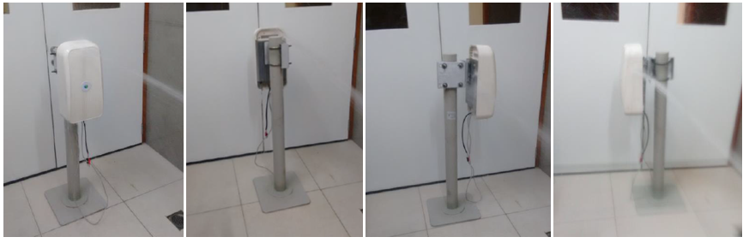
Figure 3: IPX5 testing

DUT Sample information
System Serial Number : NA
GBC & RF SDR board Hardware version : Life 1
GBC Board serial number : PT11605004
RF SDR Board serial number : WZ1622LIFE1SDR0003
Software versions : NA
Since IPX5 is destructive test it is planned to use any non-working board from Life-1 & effectively use Life-2 boards for other test where working boards are mandatory.

Test Result
After IPX5 test visual inspection photos

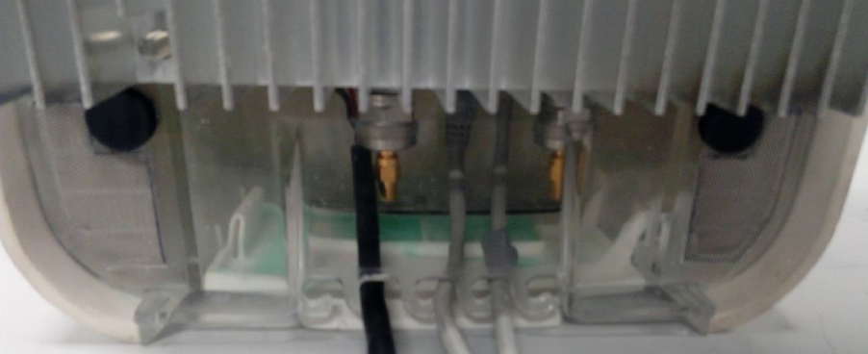

Figure 4: Front panel connector area

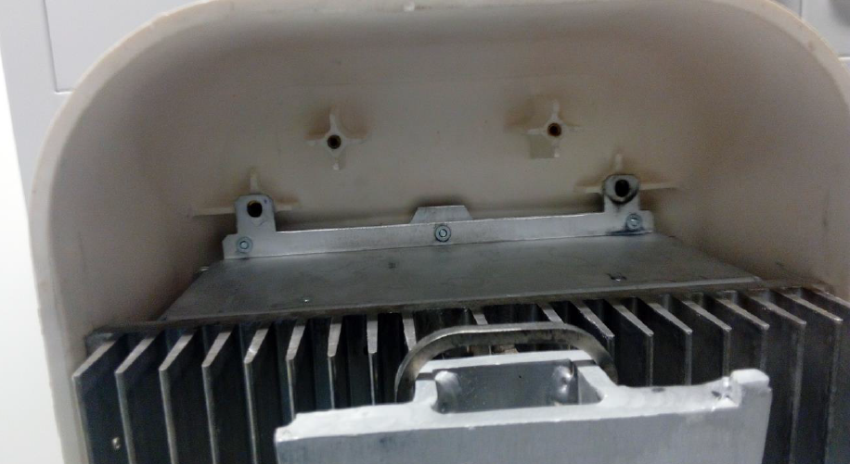

Figure 5: Shorty Antenna area
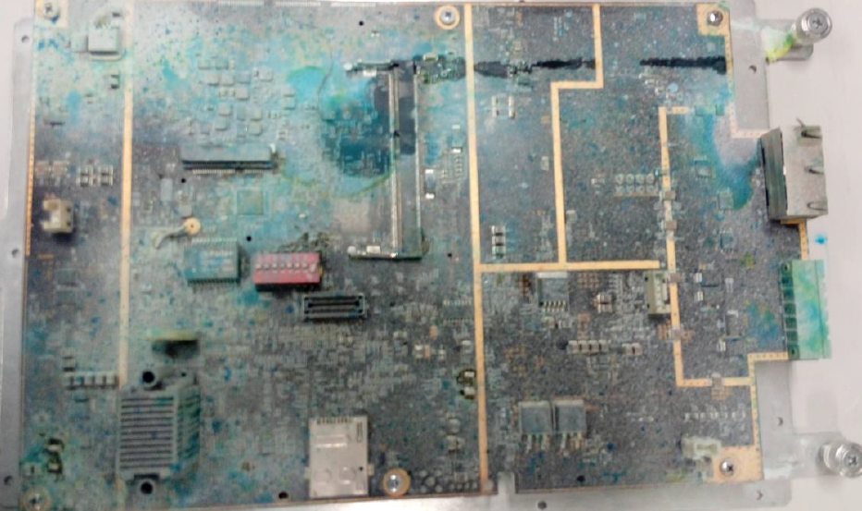
Figure 6: GBC board
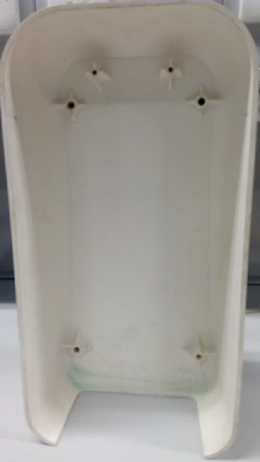
Figure 7: Inside Front cover
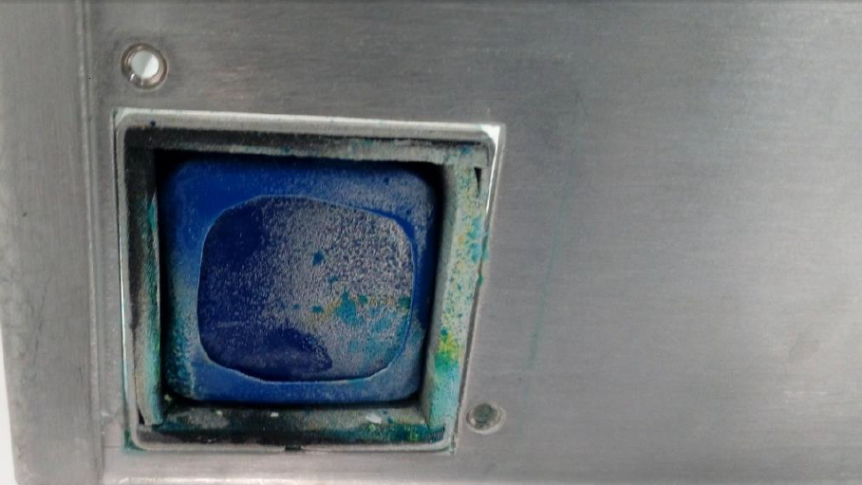
Figure 8: Battery area
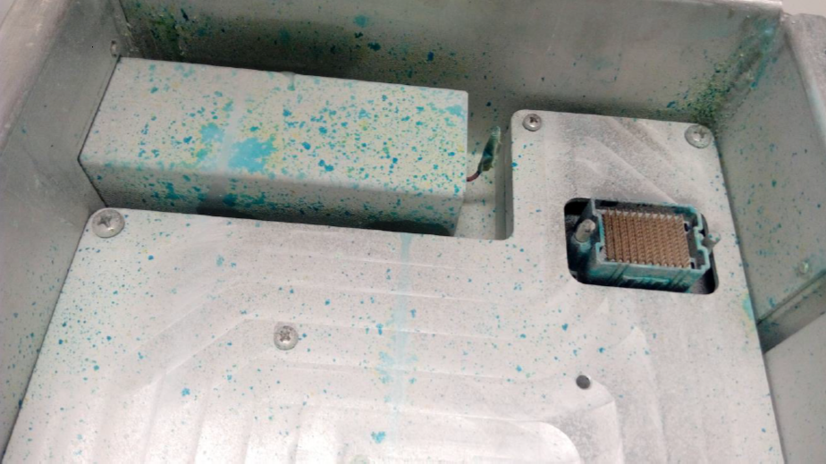
Figure 9: Inside unit
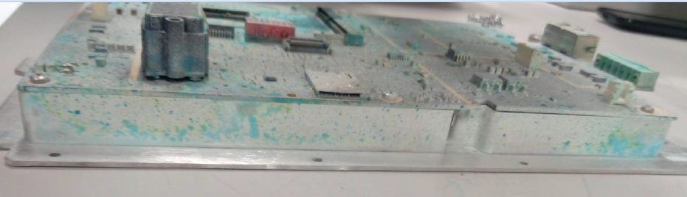
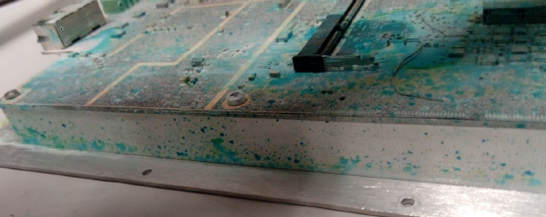
Figure 10: GBC board / Heat spreader sides
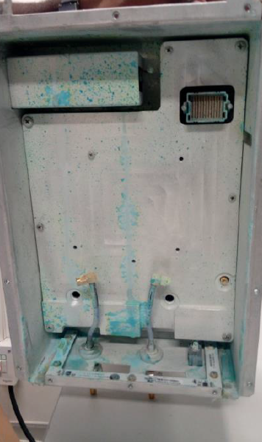
Figure 11: Inside unit
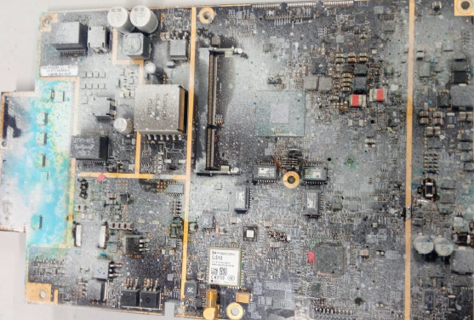
Figure 12: GBC Board
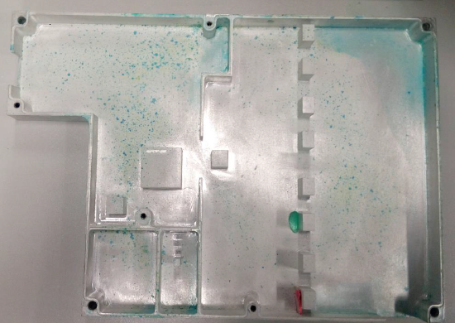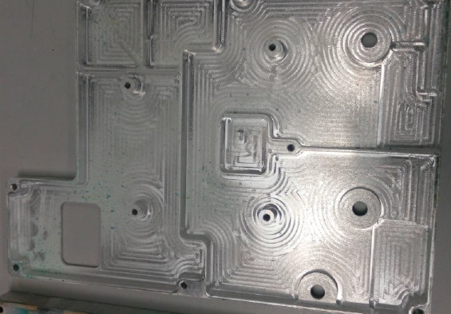
Figure 13: Inside RF SDR Heat spreader plate
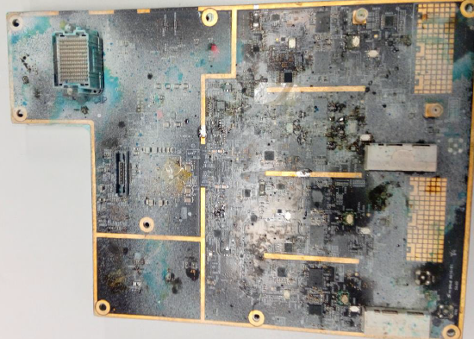
Figure 14: RF SDR Board
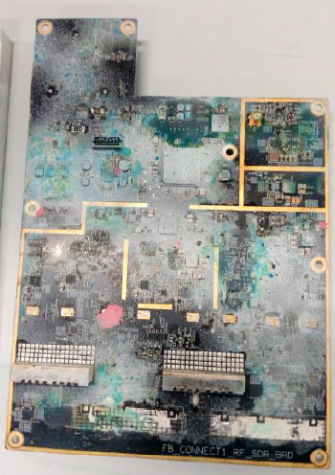
Figure 15: RF SDR board
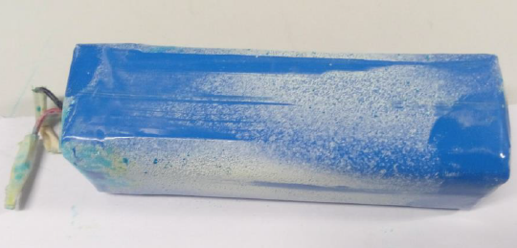
Figure 16: Battery
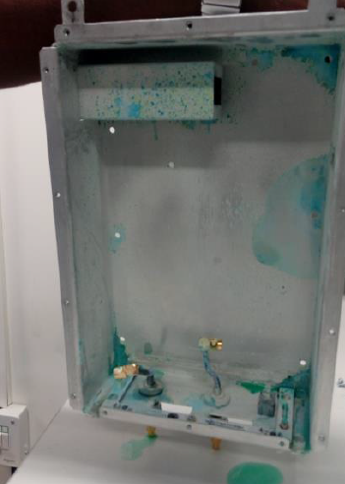
Figure 17: Inside unit

Inference
On Inspection, after the IPX5 test there was water particle found inside the unit & hence test is considered as fail.
Weak areas where water has entered:
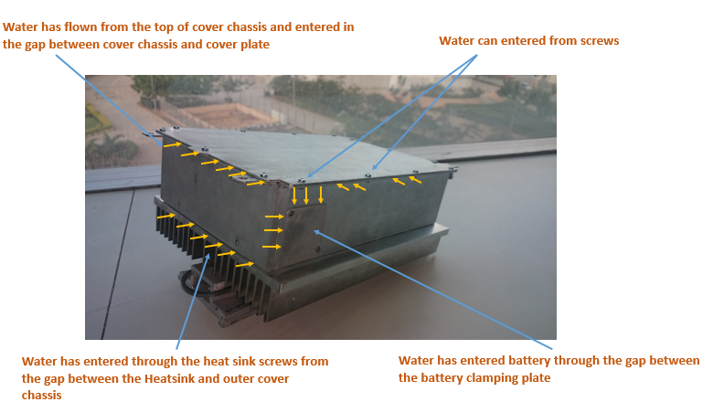
Figure 18: IPx5 - Water entry thru top plate
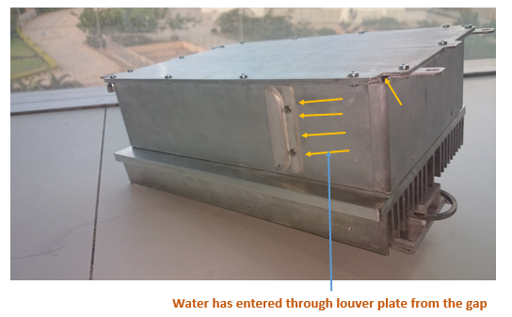
Figure 19: IPx5 - Water entry thru louver
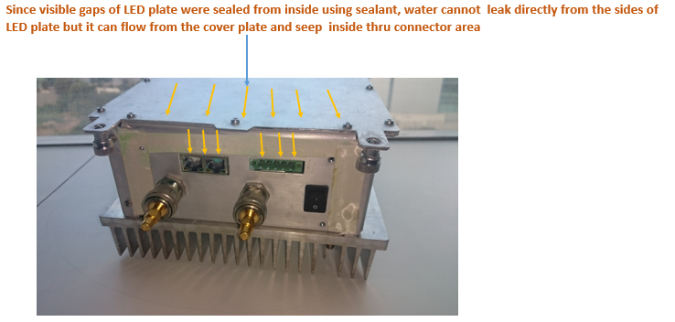
Figure 20: Water entry thru connectors
Next plan of Action: Redesign of mechanics & Sealing methods for ingress protection.

Dust Ingressions IP6X

Test ID: ENV 1.3

Purpose
The purpose of this test is to define unit tightness against dust and to possible leaks to the cabinets

Test and Measurement Method
The enclosure under test is supported in its normal operating position inside the test chamber, the test duration 8 h
The talcum powder is passed through a square-meshed sieve the nominal wire diameter of which is 50 μm and the nominal width of a gap between wires 75 μm. The amount of talcum powder used is 2 kg per cubic meter of the test chamber volume.
The protection is satisfactory if, on inspection, talcum powder has not accumulated in a quantity or location such that, as with any other kind of dust, it could interfere with the correct operation of the equipment or impair safety.
The protection is satisfactory if no deposit of dust is observable inside the enclosure at the end of the test

Test Condition
IP 6X test set up photo:
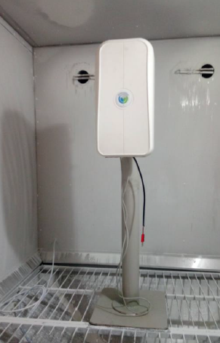
Figure 21: IP6X test setup

DUT Sample information
System Serial Number : NA
GBC & RF SDR Board Hardware version : Life 1
GBC Board serial number : PT11605002
RF SDR Board serial number : WZ1622LIFE1SDR0001
Software versions : NA
Since IP6X is destructive test it is planned to use any non-working board from Life-1 & effectively use Life-2 boards for other tests where working boards are mandatory.

Test Results
After IP 6X test photo
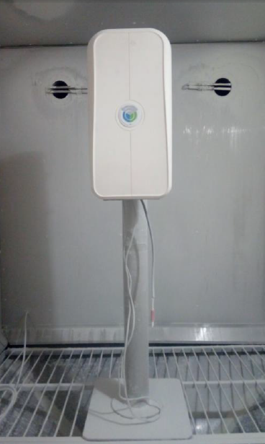
Figure 22: After IP6X visual inspection test photos
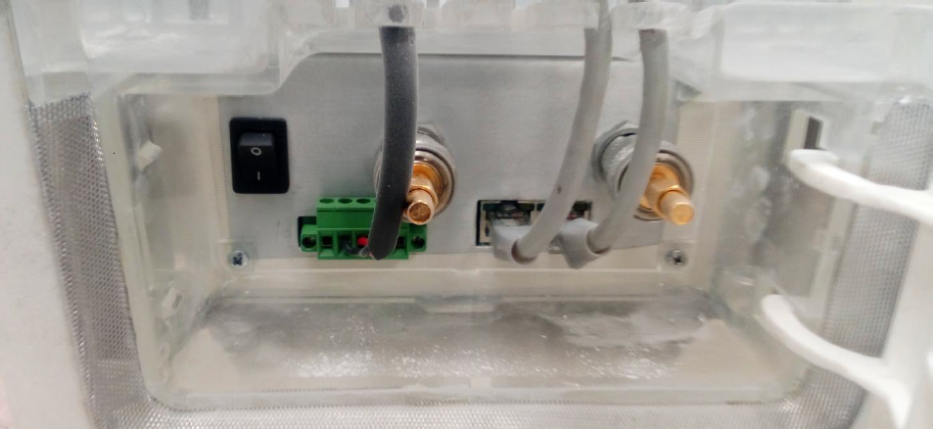
Figure 23: Front panel with cables
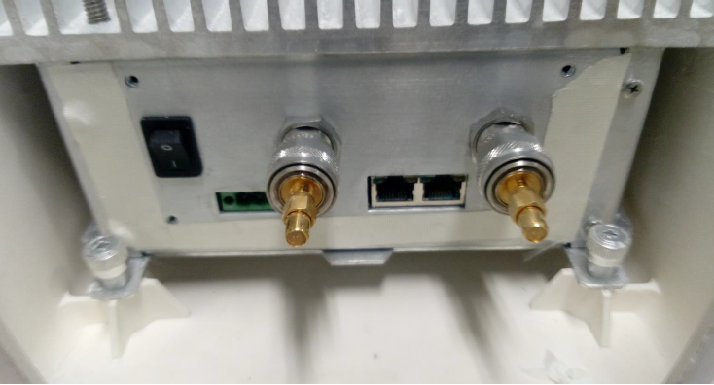
Figure 24: Front panel

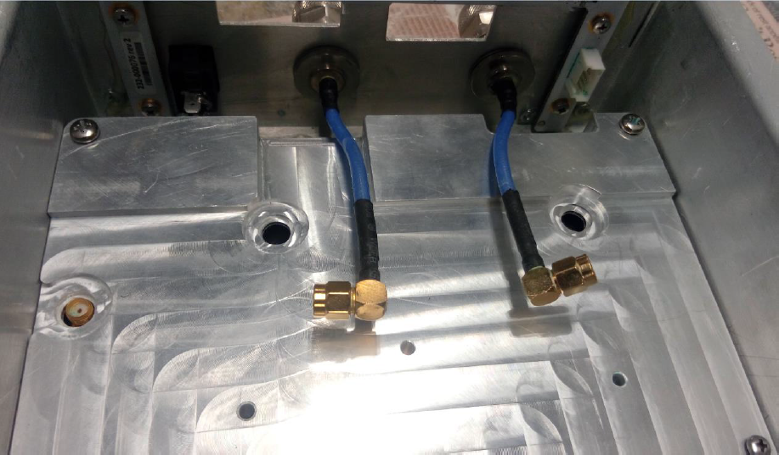
Figure 25: Inside the unit – front panel

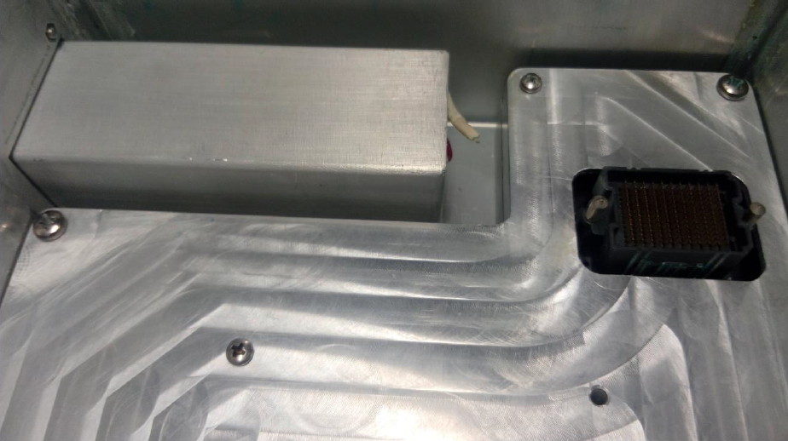
Figure 26: Inside the unit - Battery

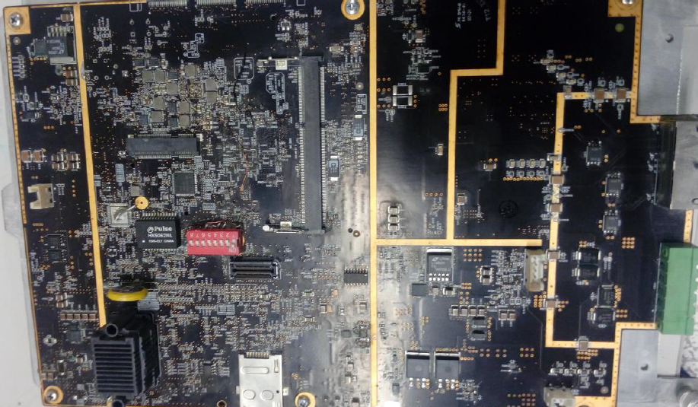
Figure 27: GBC Board

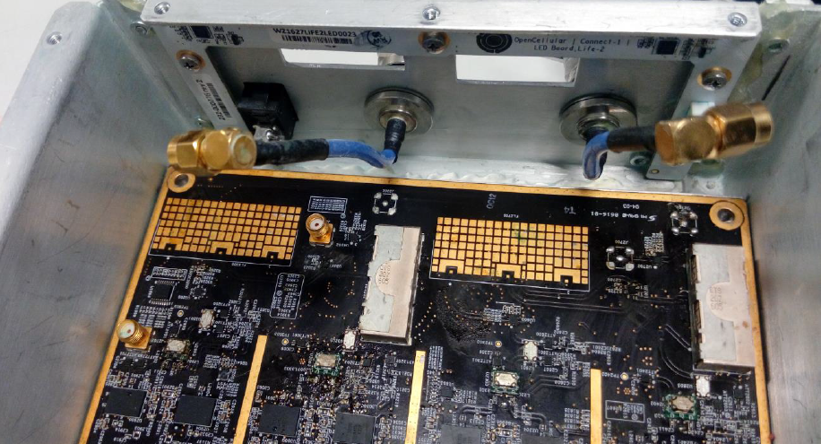
Figure 28: Front panel connector area from inside

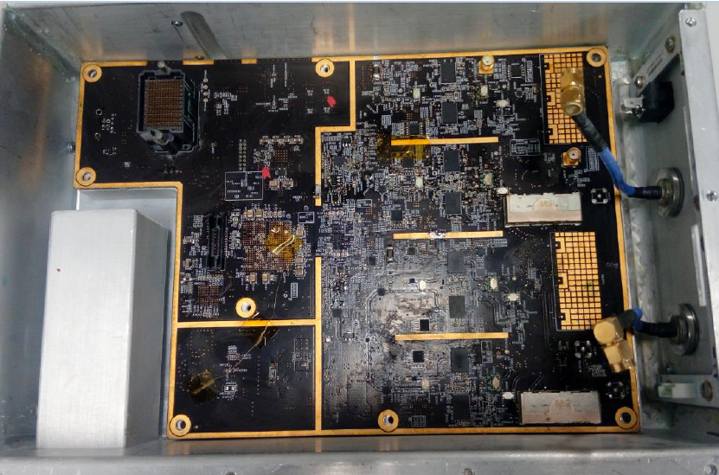
Figure 29: RF SDR board kept inside the unit

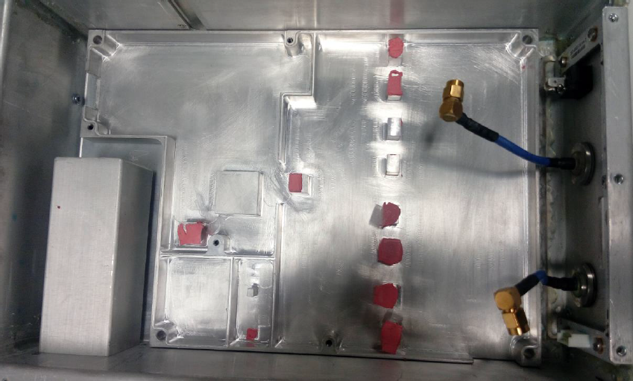
Figure 30: Inside the unit without RF SDR board

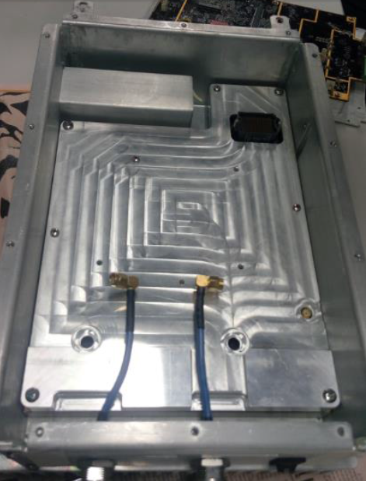
Figure 31: Inside the unit with RF SDR board & Heat spreader plate

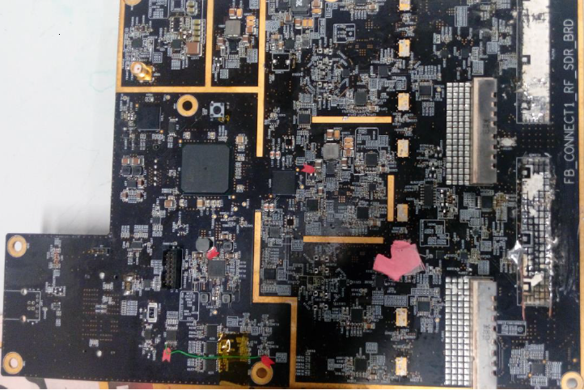

Figure 32: RF SDR board

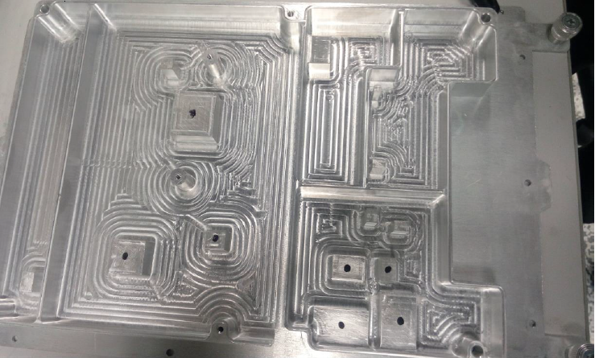
Figure 33: Inside GBC Heat spreader plate

Inference
On Inspection, after the IP6X test there was no major deposition of the talcum powder observed that could interfere with the correct operation of the Equipment. There are weak areas (Opening) observed where dust can enter & hence the test is considered as fail.
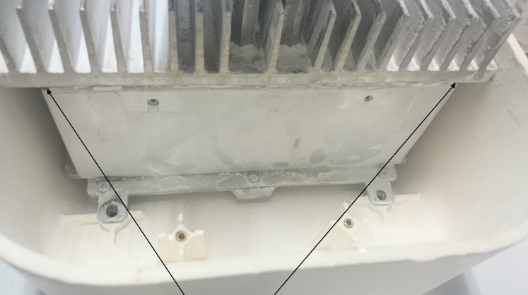
Weak area where dust enter

Figure 34: IP6x – Dust leak thru opening in sheet metal

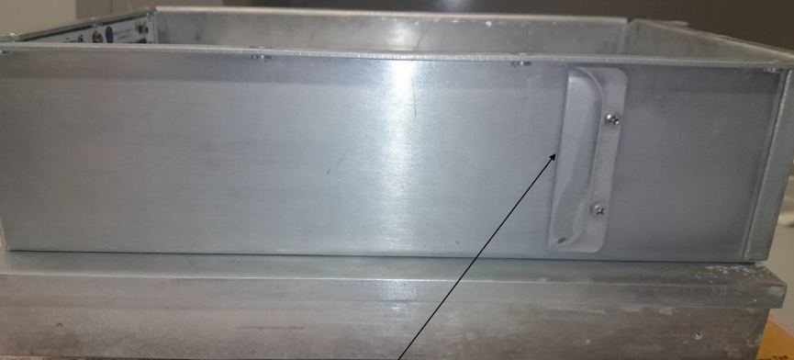
Weak area where dust enter

Figure 35: IP6x – Dust leak thru louver

Next plan of Action: Redesign of mechanics & Sealing methods for ingress protection.

Rain & Blowing Rain

Test ID: ENV 1.4

Purpose
The purpose of this test is to certify that the unit tightness against Rain and Blowing Rain test as per MIL-STD-810G, Method 506.5, Procedure I

Test and Measurement Method
Before test start measured part/air temp 29.8c and water temp 20.7c
Measured rain fall rate: 35 inches in 5 min x 12 = 4.2 in/hr
Started wind and rain test water PSI=60. Wind velocity-3520 feet/minute = 40 mph
End 30-minute rain and wind test side 1
Start wind and rain test side 2 for 30 min
End 30-minute rain and wind test side 2
Start wind and rain test side 3 for 30 min
End 30-minute rain and wind test side 3
Start wind and rain test side 4 for 30 min
End 30-minute rain and wind test side 4
Baked unit at 34c for 1 hour
Open the unit and look for water leakage & take pictures - found water leakage

Test Condition
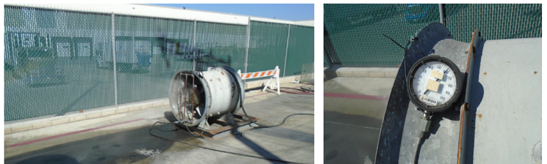
Figure 36: Rain & Blowing rain test setup
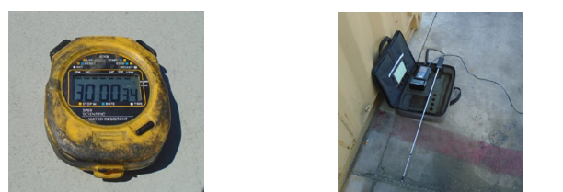
Figure 37: Rain & Blowing rain measuring equipment
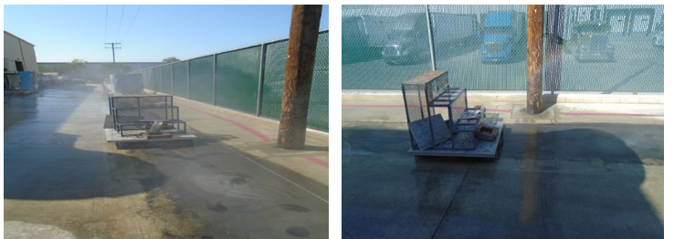
Figure 38: Rain & Blowing rain – rain fall measurement

During Rain and Blowing Rain Test

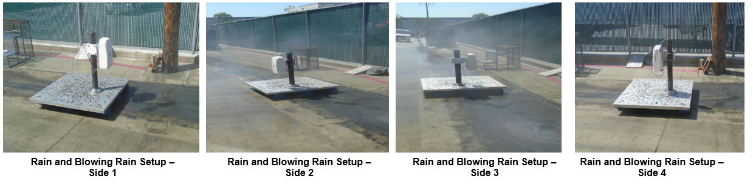
Figure 39: Rain & Blowing testing

DUT Sample information
System Serial Number : NA
GBC Board serial number : WZ1630LIFE2GBC0013
RF SDR Board serial number : WZ1630LIFE2SDR0009
Software versions : NA
Since Rain & Blowing rain test is destructive test it is planned to use any non-working board from Life-1 & effectively use Life-2 boards for other tests where working boards are mandatory.

Test Results
Rain and Blowing Rain Post Test – Water Leakage

. 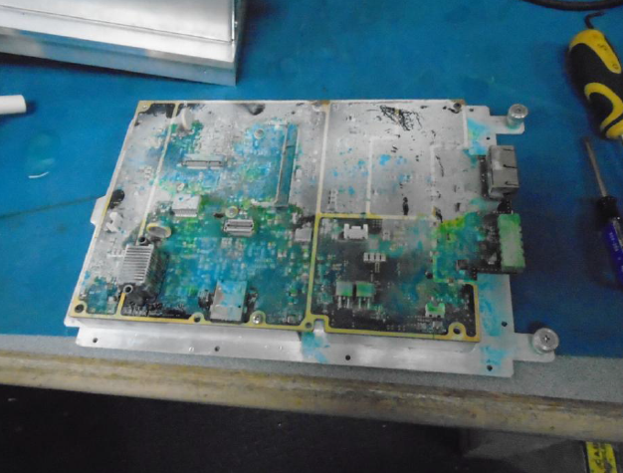

Figure 40: GBC Board

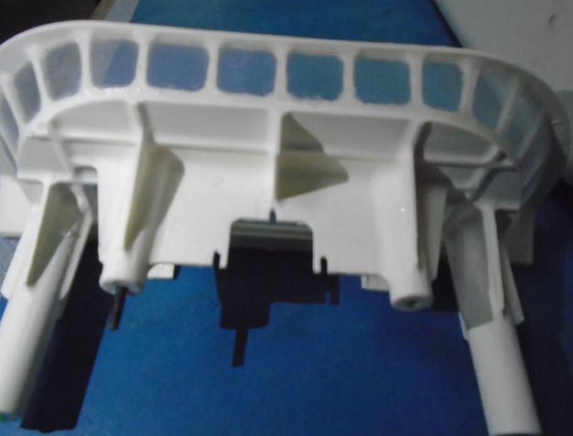

Figure 41: Shorty Antenna

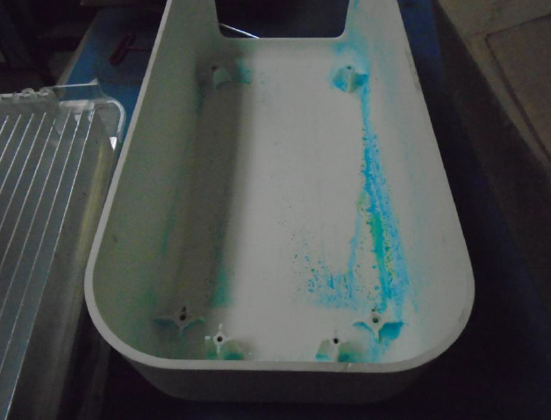

Figure 42: Front cover

Inference
On Inspection, after the Rain & Blowing rain test there was water particle found inside the unit & hence the test is considered as fail.
Next plan of Action: Redesign of mechanics & Sealing methods for ingress protection.

Earthquake

Test ID: ENV 1.5

Purpose
During an earthquake, equipment is subjected to motions that can over-stress equipment framework, circuit boards, and connectors. The goal of earthquake test is to see if the equipment can withstand earthquake vibration as per zone 2 spectra.

Test and Measurement Method
The Test unit should be configured as per actual field working condition & need to carry out as per the test standard GR-63-CORE zone 2 spectra.
Unit mounting: Pole mounting condition
A swept sine survey with an acceleration amplitude of 0.2 g from 0.3 to 50 Hz at a sweep rate of 1.0 octave per minute to be performed (Below given graph of Frequency-Acceleration / Frequency & Acceleration table provide detailed requirement of test requirement)
- Axis of vibration : X (North-South), Y (East-West) &
Z-axis (Vertical) individually
- Damping Coefficient : 2 %
- Required Response Spectrum (RPS) : As per GR-63-CORE zone 2 spectra

Test Condition
Test condition of the unit during test: Power on
Ambient Temperature – 25˚C
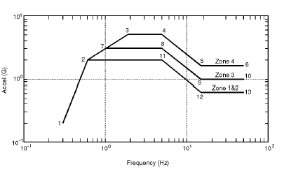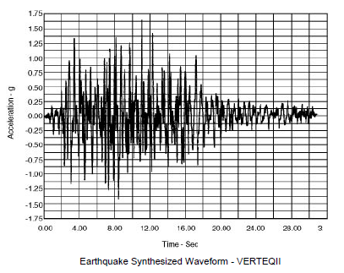
Figure 43: Earthquake test specification

DUT Sample information
System Serial Number : NA

Hardware Version : Life-2

GBC board Serial Number : WZ1630LIFE2GBC0020

RF SDR Board Serial Number : WZ1630LIFE2SDR0011
Software versions : Ubuntu – 14.04.64 bit
Coreboot- coreboot-4.4-575-gfee24cc-dirty (This
comes in boot log)
RTOS- 2_16_00_08 (This is base RTOS)
Coreboot: SVn version 7
System software: 51

Test Results
Three number of accelerometers and one number of strain gauge were mounted on the test specimen.
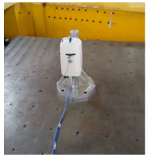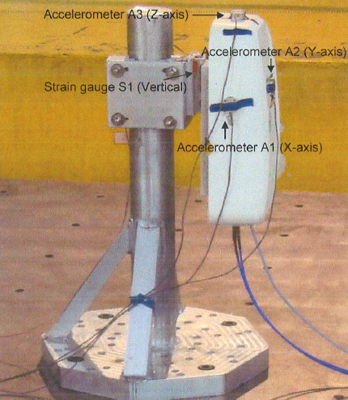
Figure 44: Earthquake testing

Functional log
The attached log confirms the functionality of Intel, Tiva, RF, temperature sensors, current sensing devices, UART interfaces, Ethernet interface & USB where up & running.

System monitor logging from Tiva will be available in Rev “C”, which provides consolidated operational log of individual subsystems.

Inference
Unit was observed functional without any degradation in performance, No Permanent deformation, dislocation, breakage or cracks & No loosening of components / equipment from their original mounting, hence earthquake test is considered as pass mechanically.

Since the system monitor logging from Tiva has to be validated in Rev “C”, this test can be considered as partial pass.

Salt Fog Test

Test ID: ENV 1.6

Purpose
The salt fog test is performed to determine the effectiveness of protective coatings and finishes on materials. It also determines the effects of salt deposits on the physical and electrical aspects of material.

Test and Measurement Method
Before the test unit checked for its working condition. Wiring connected as per field installation requirement & kept inside the salt chamber with unit in power off condition.

Test Condition
Salt Solution : 5%NaCl
Temperature : 35˚±2˚C
Fall rate : 1 and 3ml/80 cm²/hr
Duration : 96hrs (Continuous exposure mode)

DUT Sample information
System Serial Number : NA

Hardware Version : Life-2

GBC board Serial Number : WZ1630LIFE2GBC0001

RF SDR Board Serial Number : WZ1630LIFE2SDR0005
Software versions : Ubuntu – 14.04.64 bit
Coreboot- coreboot-4.4-575-gfee24cc-dirty (This
comes in boot log)
RTOS- 2_16_00_08 (This is base RTOS)
Coreboot: SVn version 7
System software: 51

Test Results
Before Test
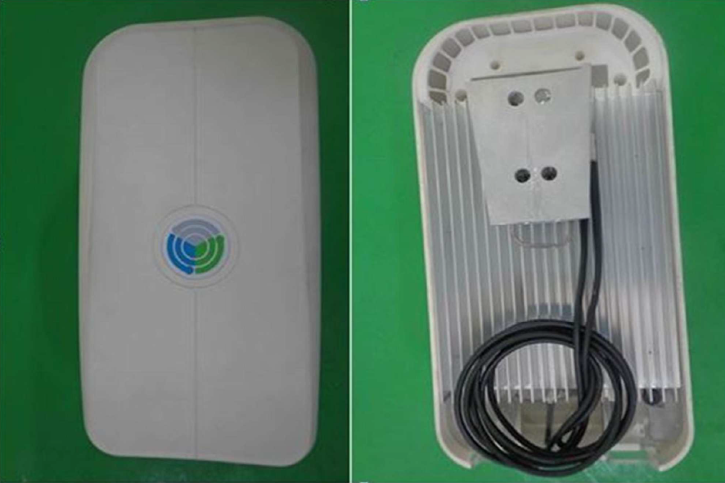

Figure 45: Assembled Unit

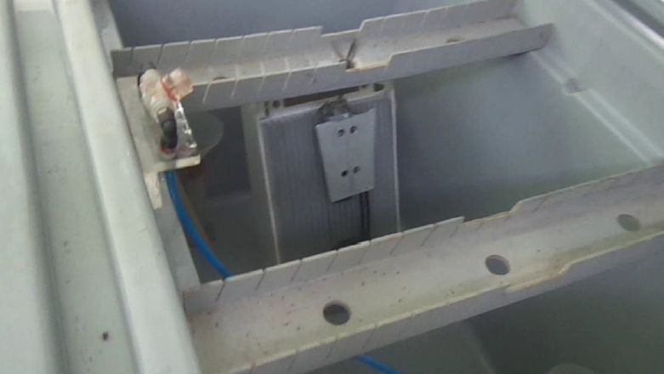

Figure 46: Unit kept inside the salt chamber

After Test
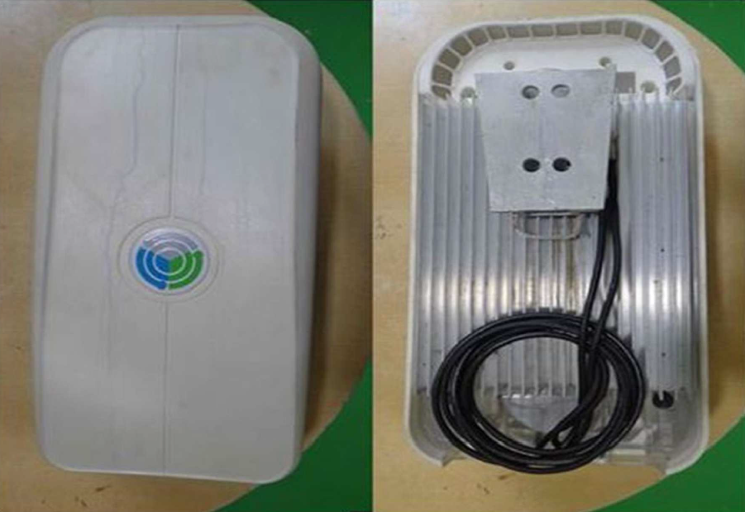

Figure 47: Unit after salt fog test

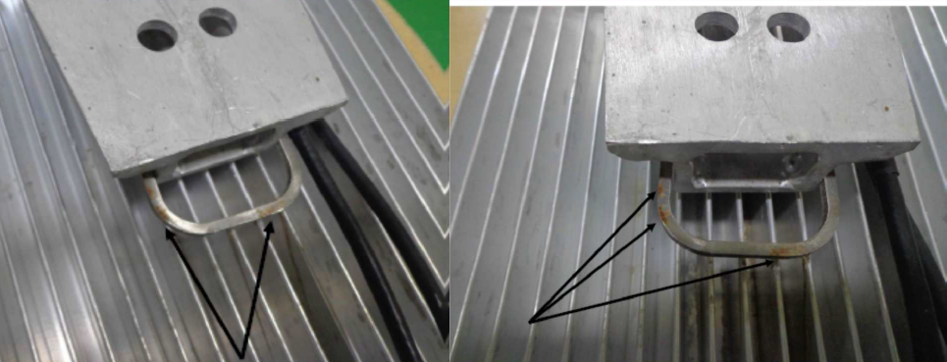

Figure 48: Rust formation were observed on DUT Clamps

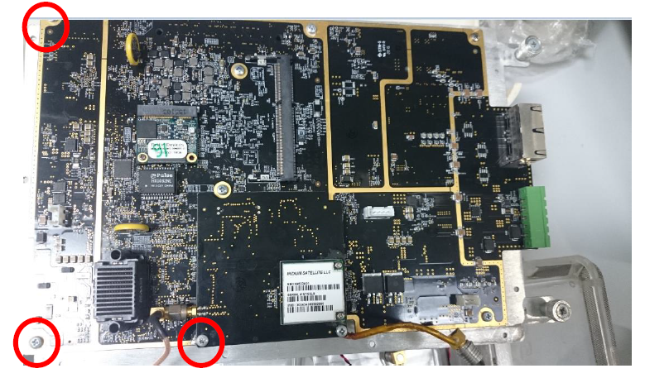
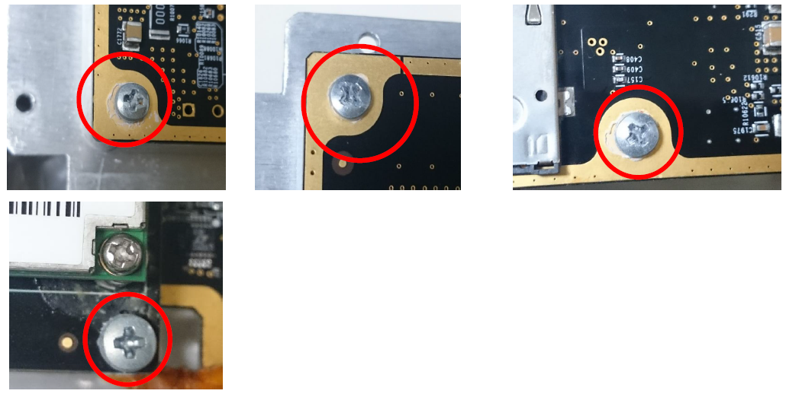

Figure 49: Salt powder deposition found at the screw areas marked red
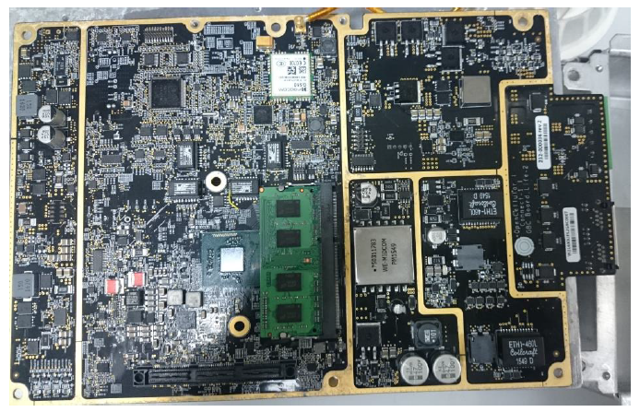

Figure 50: GBC Board

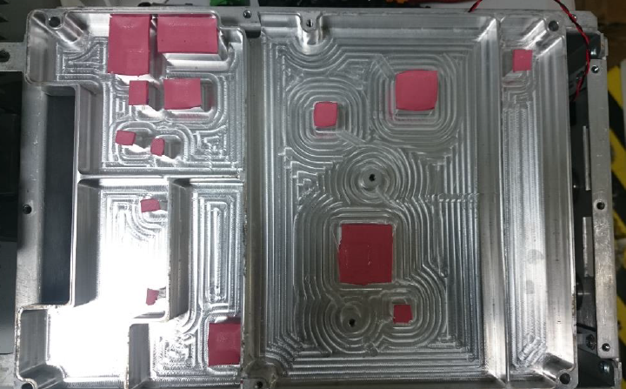

Figure 51: GBC Board Heat spreader plate

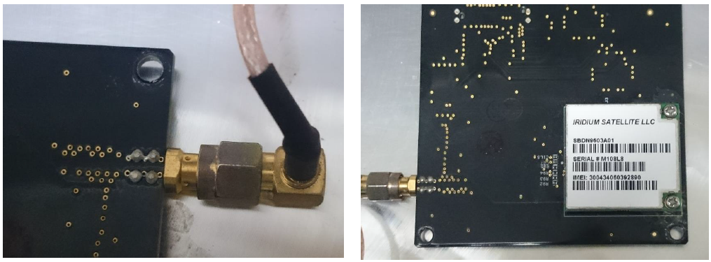

Figure 52: Sync Board

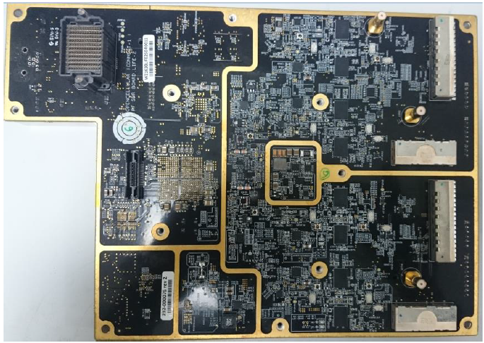

Figure 53: RF SDR Board

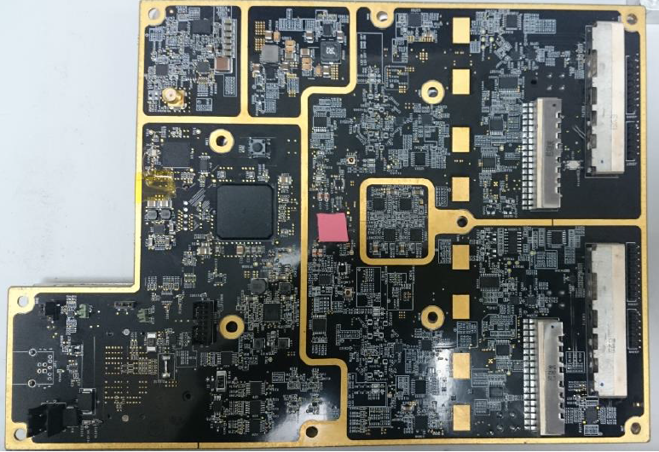

Figure 54: RF SDR Board

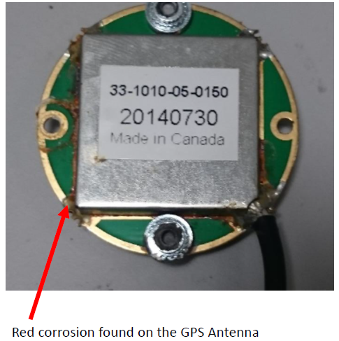

Figure 55: GPS Antenna

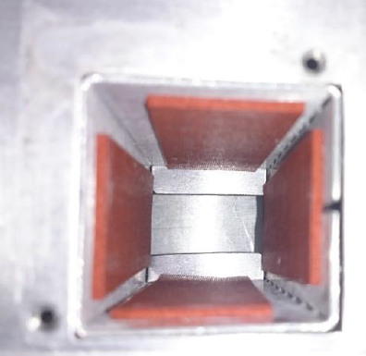
Figure 56: Battery Area

Functional test
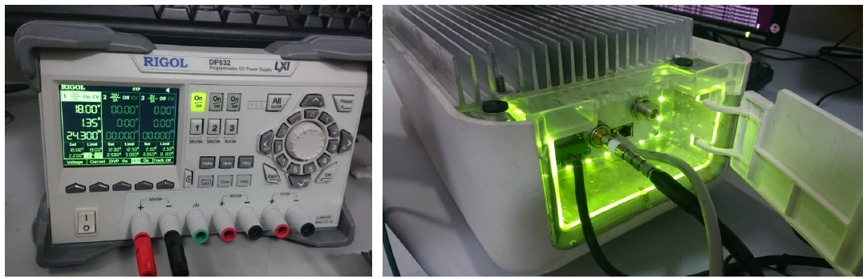
Figure 57: Post salt fog test functionality photo

Inference
After the test unit was powered on & found to be working where Intel, Tiva & RF modules are booted and stable. Current consumption before & after the test is same, hence test is considered as pass.
Observation of minor salt deposits found on few locations as shown in images above.
Next plan of Action: Redesign of mechanics & Sealing methods for better ingress protection.

Operational Vibration:

Sinusoidal vibration Test

Test ID: ENV 1.7

Purpose
The purpose of vibration test is to check resistibility of equipment against various vibration factors that may occur during normal operation of the units in the field.

Test and Measurement Method
During test, the unit was mounted on pole fixture and fixed to vibration table using test fixtures in operational condition

Control accelerometer was placed on the vibration table to control and record the control graph.

After completion of test in each axis, unit was visually inspected for physical damages.
Test graphs were plotted at the end of the test.

Test Condition
Operating condition stressing the unit to required load as given below
- iperf to load Marvel and Springville
- stress -ng tool to load the CPU
- FIO tool to stress mSATA and CPU
- 2 TRX chain data flowing from GBC to RFSDR
- TIVA monitoring current sensors
- Monitor CPU load status (Max CPU utilization will be taken only to 100%)

Perform sinusoidal vibration in X, Y, Z directions as per ETSI 300 019-2-4 i.e. is IEC 60721 3-4 class 4M5 standard with the specification mentioned below
Displacement (mm) : 1.2
Acceleration (m/s2) : 4
Frequency range (Hz) : 5-9 9-200
Duration : 3 x 5 sweep cycles
Axes of Vibration : 3

DUT Sample information
System Serial Number : NA

Hardware Version : Life-2

GBC board Serial Number : WZ1630LIFE2GBC0001

RF SDR Board Serial Number : WZ1630LIFE2SDR0005
Software versions : Ubuntu – 14.04.64 bit
Coreboot- coreboot-4.4-575-gfee24cc-dirty (This
comes in boot log)
RTOS- 2_16_00_08 (This is base RTOS)
Coreboot: SVn version 7
System software: 51

Test Results
Sine Vibration X Axis
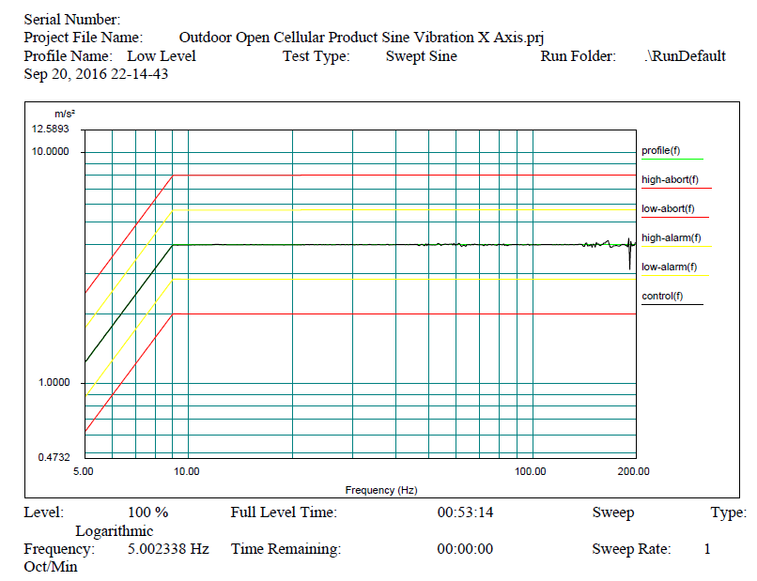
Figure 58: Sine vibration x axis control graph
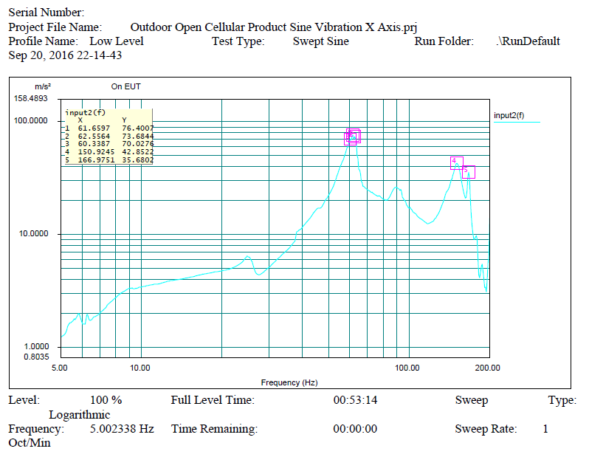
Figure 59: Sine vibration x axis response graph

Sine Vibration Y Axis
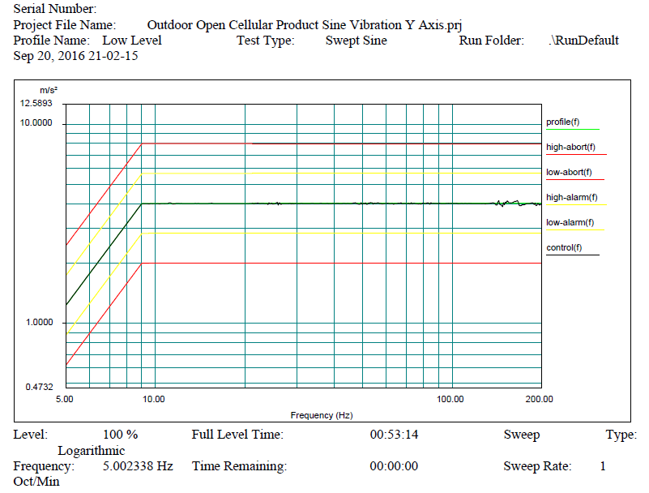
Figure 60: Sine vibration y axis control graph
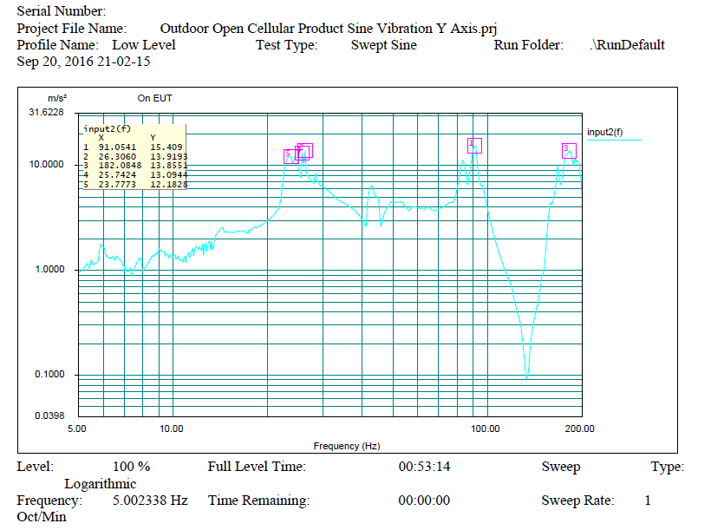
Figure 61: Sine vibration y axis response graph

Sine Vibration Z Axis
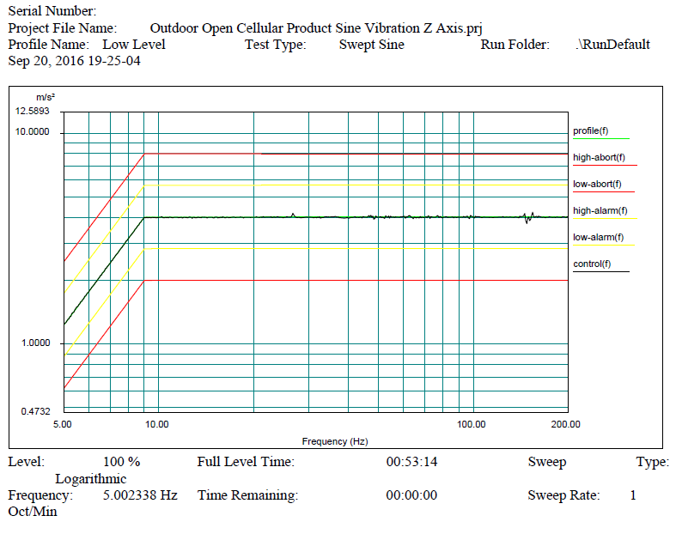
Figure 62: Sine vibration z axis control graph
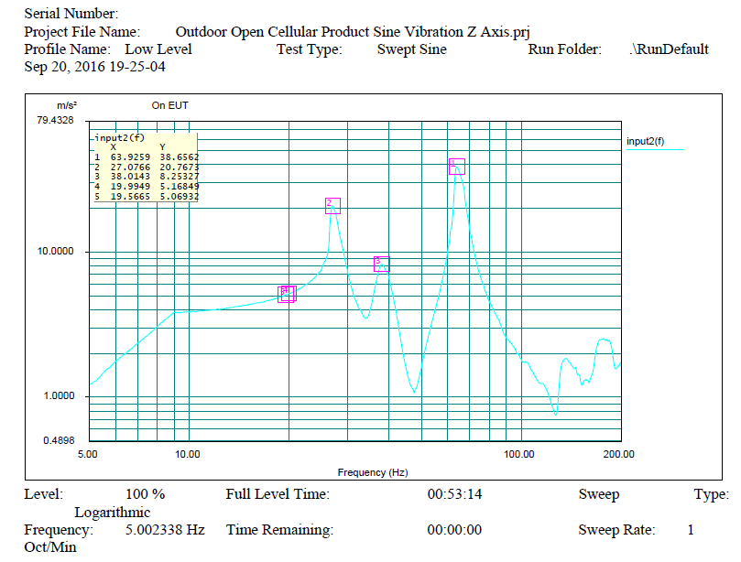
Figure 63: Sine vibration z axis response graph

Functional log
The attached log confirms the functionality of Intel, Tiva, RF, temperature sensors, current sensing devices, UART interfaces, Ethernet interface & USB where up & running.

System monitor logging from Tiva will be available in Rev “C”, which provides consolidated operational log of individual subsystems.

Inference
No Permanent deformation, dislocation, breakage or cracks, no loosening of components / equipment from their original mounting, hence test is considered to be pass mechanically.

Since the system monitor logging from Tiva has to be validated in Rev “C”, this test can be considered as partial pass.

Random vibration (Operational)

Test ID: ENV 1.7

Purpose
The purpose of vibration test is to check resistibility of equipment against various vibration factors that may occur during normal operation of the units in the field.

Test and Measurement Method
During test, the unit was mounted on pole fixture and fixed to vibration table using standard test fixtures in operational condition

Control accelerometer was placed on the vibration table to control and record the control graph.

After completion of test in each axis, unit was visually inspected for physical damages.
Test graphs were plotted at the end of the test.

Test Condition
Operating configuration by stressing the unit to required load as given below

- iperf to load Marvel and Sprinville
- stress -ng tool to load the CPU
- FIO tool to stress mSATA and CPU
- 2 TRX chain data flowing from GBC to RFSDR
- TIVA monitoring current sensors
- Monitor CPU load status (Max CPU utilization will be taken only to 100%)

Perform Random vibration in X, Y, Z directions as per ETSI 300 019-2-4 i.e. is IEC 60721 3-4 class 4M5 standard with the specification mentioned below
ASD (m²/ s³) : 0.04
(dB/oct) : +12 -12
Frequency range (Hz) : 5-10 10-50 50-100
Duration : 3 x 30 minutes
Axes of Vibration : 3

DUT Sample information
System Serial Number : NA

Hardware Version : Life-2

GBC board Serial Number : WZ1630LIFE2GBC0001

RF SDR Board Serial Number : WZ1630LIFE2SDR0005
Software versions : Ubuntu – 14.04.64 bit
Coreboot- coreboot-4.4-575-gfee24cc-dirty (This
comes in boot log)
RTOS- 2_16_00_08 (This is base RTOS)
Coreboot: SVn version 7
System software: 51

Test Results
Random Vibration X Axis
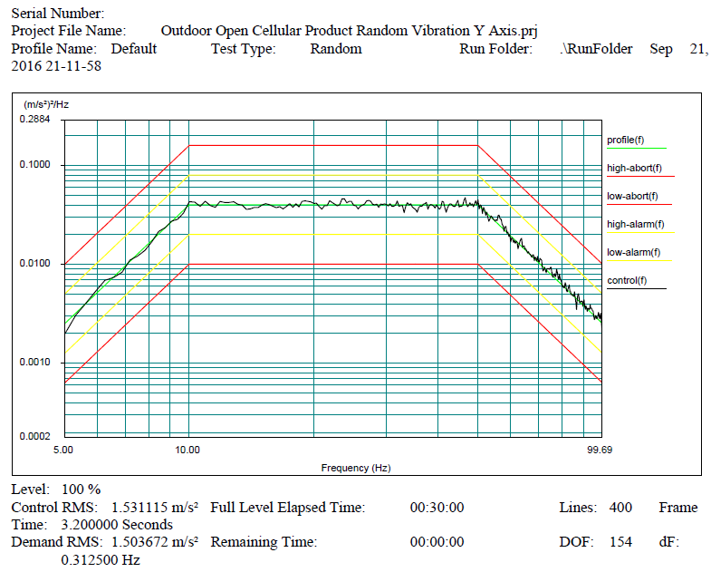
Figure 64: Random vibration x axis graph

Random Vibration Y Axis
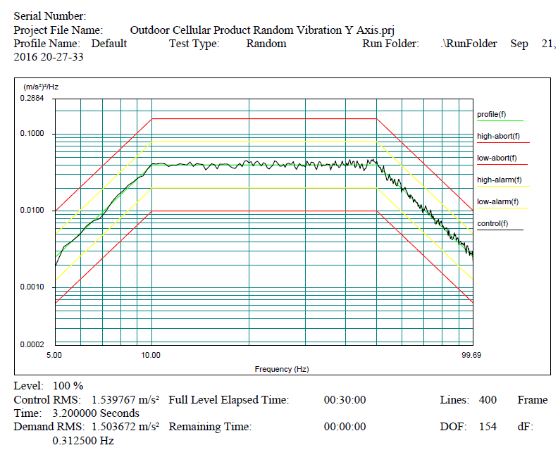
Figure 65: Random vibration y axis graph
Random Vibration Z Axis
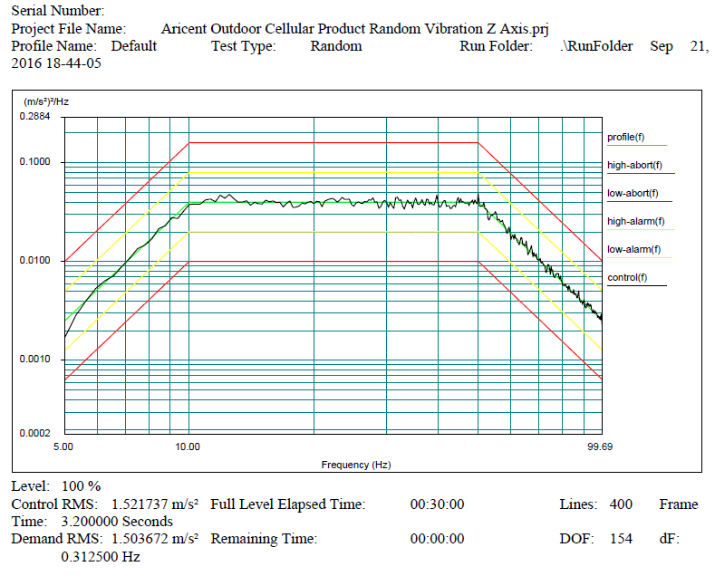
Figure 66: Random vibration z axis graph

Functional log
The attached log confirms the functionality of Intel, Tiva, RF, temperature sensors, current sensing devices, UART interfaces, Ethernet interface & USB where up & running.

System monitor logging from Tiva will be available in Rev “C”, which provides consolidated operational log of individual subsystems.

Inference
No Permanent deformation, dislocation, breakage or cracks, hence test is considered to be pass with observation of pole mounting clamps getting loosened from pole fixture.

Since the system monitor logging from Tiva has to be validated in Rev “C”, this test can be considered as partial pass.

Next plan of action: Improve mounting methods to avoid mounting clamps getting loosen.

Shock

Test ID: ENV 1.7

Purpose
The purpose of vibration test is to check resistibility of equipment against various Shocks that may occur during normal operation of the units in the field.

Test and Measurement Method
During test, the unit was mounted on pole fixture and fixed to Shock table using standard test fixtures in operational condition
Control accelerometer was placed on the Shock table to control and record the control graph.
After completion of test in each axis, unit was visually inspected for physical damages.
Test graphs were plotted at the end of the test.

Test Condition
Operating configuration by stressing to required load as given below

- iperf to load Marvel and Sprinville
- stress -ng tool to load the CPU
- FIO tool to stress mSATA and CPU
- 2 TRX chain data flowing from GBC to RFSDR
- TIVA monitoring current sensors
- Monitor CPU load status (Max CPU utilization will be taken only to 100%)

Perform Shock test in X, Y, Z directions as per ETSI 300 019-2-4 i.e. is IEC 60721 3-4 class 4M5 standard with the specification mentioned below
Shock spectrum : half sine
Duration (ms) : 11
Acceleration (m/s²) : 50
Number of bumps : 100 in each direction
Direction of bumps : 6

DUT Sample information
System Serial Number : NA

Hardware Version : Life-2

GBC board Serial Number : WZ1630LIFE2GBC0001

RF SDR Board Serial Number : WZ1630LIFE2SDR0005
Software versions : Ubuntu – 14.04.64 bit
Coreboot- coreboot-4.4-575-gfee24cc-dirty (This
comes in boot log)
RTOS- 2_16_00_08 (This is base RTOS)
Coreboot: SVn version 7
System software: 51

Test Results
Shock Positive Z Axis
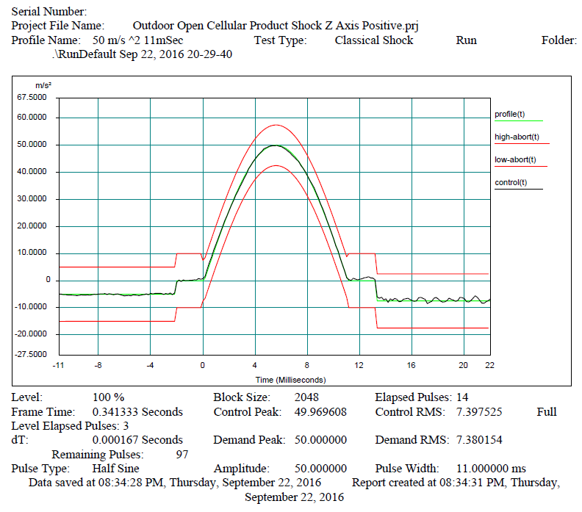
Figure 67: Shock z axis graph

Functional log
The attached log confirms the functionality of Intel, Tiva, RF, temperature sensors, current sensing devices, UART interfaces, Ethernet interface & USB where up & running.

System monitor logging from Tiva will be available in Rev “C”, which provides consolidated operational log of individual subsystems.

Inference
Unit was observed functional without any degradation in performance where power is monitored constant during & after the test, hence test is considered as pass

Since the system monitor logging from Tiva has to be validated in Rev “C”, this test can be considered as partial pass.

- Observed pole mounting clamps & screws were loosened
- Physical damages were observed in mounting brackets
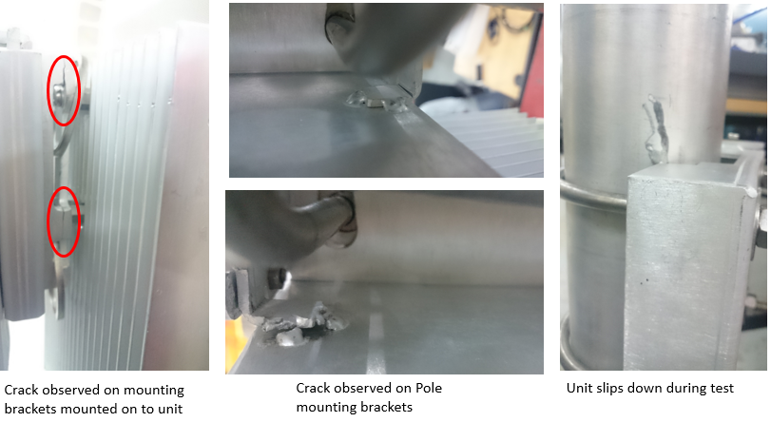
Figure 68: Post vibration test photo
Next plan of Action: Improve mounting clamp design

OPERATIONAL VIBRATION TESTING PHOTOGRAPHS
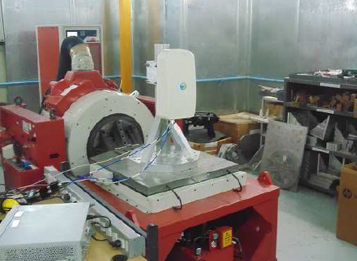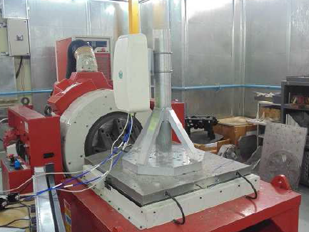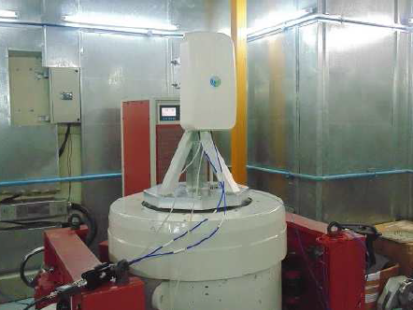
Figure 69: Vibration testing

Thermal:

Thermal Imaging

Test ID: ENV 1.8

Purpose
The purpose of thermal imaging is to measure the temperature level /hotspots of electronic devices and component using IR Camera.

Test and Measurement Method
- Stack the Boards using mounting spacer
- The unit is stressed for full load conditions
- iperf to load Marvel and Springville
- stress -ng tool to load the CPU
- FIO tool to stress mSATA and CPU
- 2 TRX chain data flowing from GBC to RFSDR (OSMO stack can have transmission at maximum power from only one chain at any given time )
- TIVA monitoring current sensors
- Monitor CPU load status (Max CPU utilization will be taken only to 100%)
- Perform Thermal Imaging test to locate the hotspots on the board

Test Condition
- Operating condition stressing the unit to required load.
- Place the unit in clean room at an ambient of 25 Deg C

DUT Sample information
System Serial Number : NA

Hardware Version : Life-2

GBC board Serial Number : WZ1630LIFE2GBC0017

RF SDR Board Serial Number : WZ1630LIFE2SDR0014
Software versions : Ubuntu – 14.04.64 bit
Coreboot- coreboot-4.4-575-gfee24cc-dirty (This
comes in boot log)
RTOS- 2_16_00_08 (This is base RTOS)
Coreboot: SVn version 7
System software: 51

Test Results
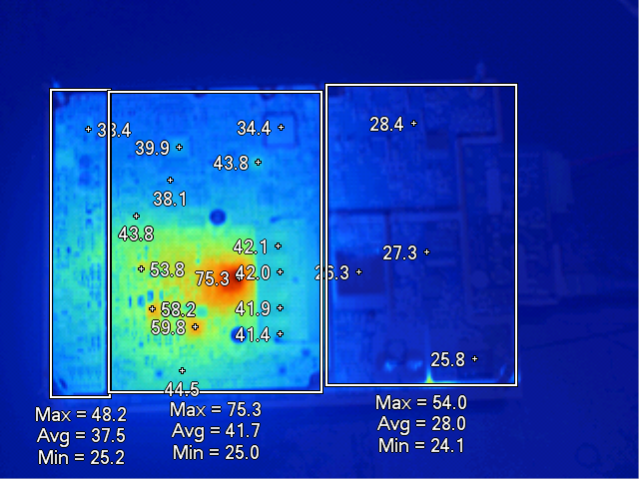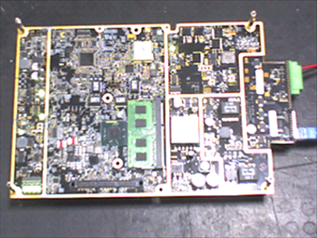

Figure 70: GBC board Intel Processor side

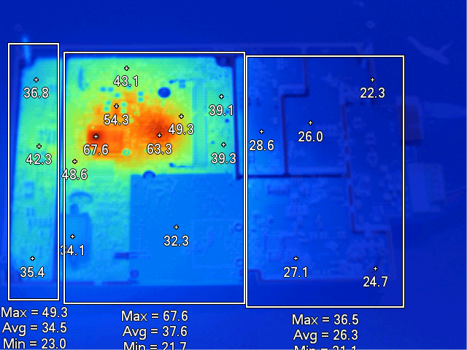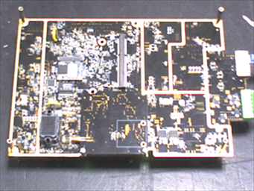

Figure 71: GBC Board Bottom Side

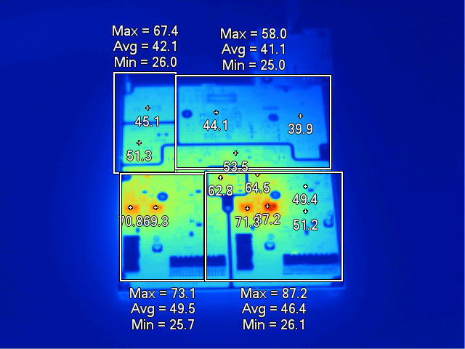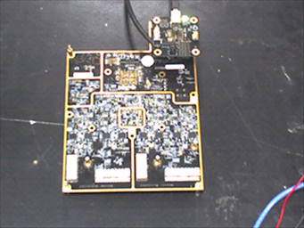

Figure 72: RF SDR Board PA Top Side
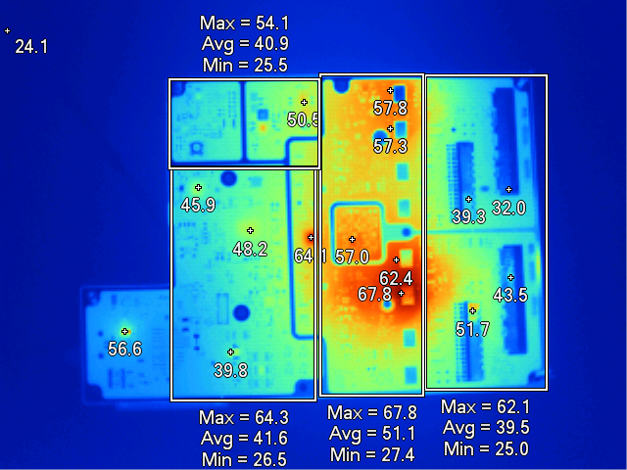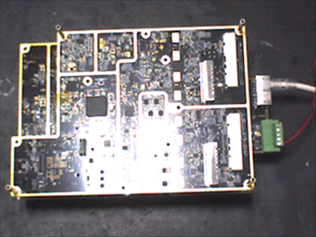

Figure 73: RF Board PA Bottom Side

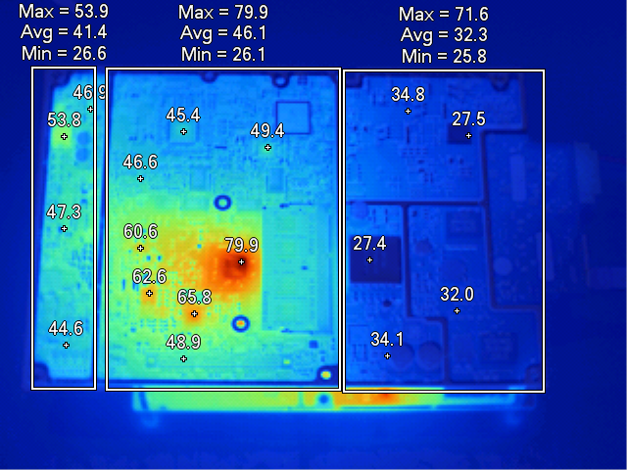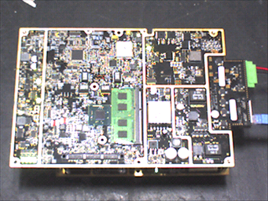

Figure 74: GBC and RF SDR Board in Stack up condition with GBC board facing Intel Side

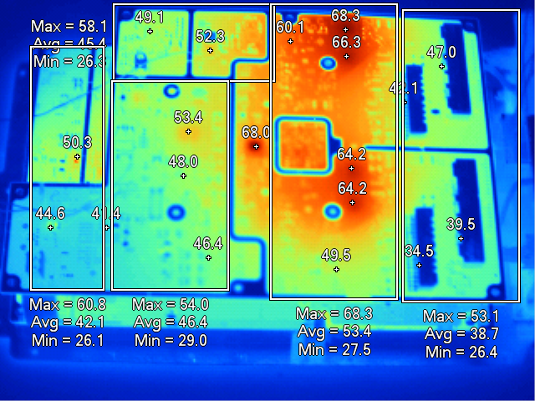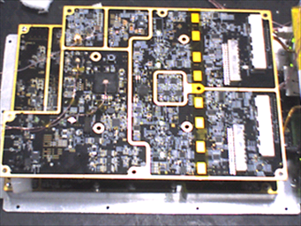

Figure 75: GBC and RF SDR Board in Stack up condition with RF SDR board facing PA side

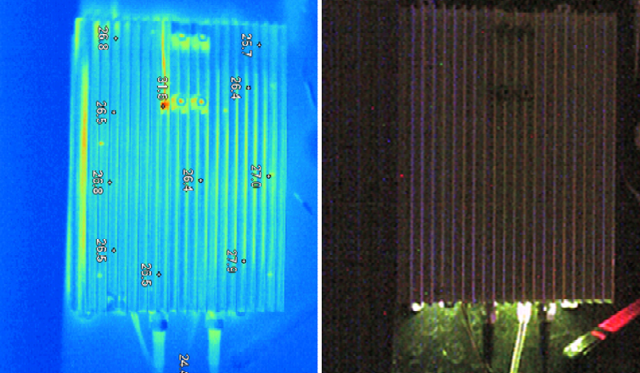

Figure 76: With Mechanics facing Back Side

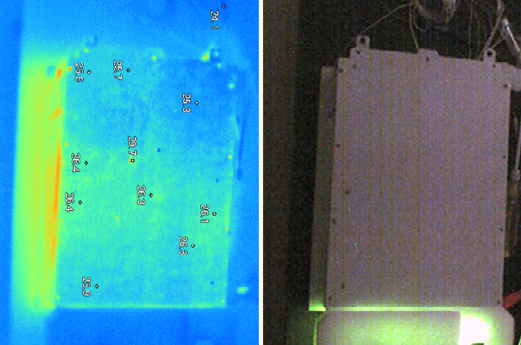

Figure 77: With Mechanics facing Front Side

Inference
Based on thermal imageing below are the additional components where hot spots are seen & it needs cooling tower for better thermal margins.

GBC : IDT PMIC, Springville

RF SDR : Switching regulators & LDO’s

Sl No | Reference designator | Component Name | Measured Case Temp@25 [C] Ambient | Max junction Limit [C]
1 | U2B2 | IDT PMIC | 60.00 | 125
2 | U2M1 | Springville Ethernet controller | 67.60 | (85)
3 | U2M2 | Springville Ethernet controller | 48.60 | (85)
4 | U3501 | Switch Regulator LT8640IUDC | 53.00 | 125.0
5 | U3500 | Switch Regulator LT8640IUDC | 63.00 | 125.0
6 | U3601 | LDO | 58.00 | 125.0
7 | U3600 | LDO | 60.00 | 125.0
8 | U3800 | LDO | 52.00 | 125.0
9 | U3801 | LDO | 53.00 | 125.0
10 | U4100 | LDO | 57.00 | 125.0

Thermal Validation

Test ID: ENV 1.8

Purpose
The purpose of thermal validation test is to measure the case/board/ambient temperature of critical components and verify that component junction temperatures are within manufacturers maximum recommended limits.

Test and Measurement Method
- Place the Thermocouples on the critical components.
- Connect the thermocouple leads to Multiplexer.
- Jack the Multiplexer to the Data logger to acquire the temperature data.
- Mount the unit inside the thermal chamber using Pole fixture.
- The unit is stressed for full load conditions
- iperf to load Marvel and Springville
- stress -ng tool to load the CPU
- FIO tool to stress mSATA and CPU
- 2 TRX chain data flowing from GBC to RFSDR (OSMO stack can have transmission at maximum power from only one chain at any given time )
- TIVA monitoring current sensors
- Monitor CPU load status (Max CPU utilization will be taken only to 100%)
- Allow the unit to reach the steady state temperature and log the temperature data.

Test Condition
- Operating condition stressing the unit to required load.
- Place the unit in thermal chamber for ambient temperature of 55 Deg C

DUT Sample information
System Serial Number : NA

Hardware Version : Life-2

GBC board Serial Number : WZ1630LIFE2GBC0017

RF SDR Board Serial Number : WZ1630LIFE2SDR0014
Software versions : Ubuntu – 14.04.64 bit
Coreboot- coreboot-4.4-575-gfee24cc-dirty (This
comes in boot log)
RTOS- 2_16_00_08 (This is base RTOS)
Coreboot: SVn version 7
System software: 51

Test Results
From the analysis of thermal validation data, the components temperature measurement details are as given below.
Sl. No. | Reference designator | Component Name | Case Temp @55 [C] | Calculated Junction [C] | Max  junction Limit [C] | Thermal Margin | Result
1 | U3C1 | Intel Processor | 90.03 | 100.03 | 110 | 10.0 | Pass
2 | J3D1 | SODIMM 204 | (78.93) | NA | (85) | 6.0 | Pass
3 | U55 | Marvell Lower power Ethernet switch | 75.85 | 84.74 | 125.0 | 40.3 | Pass
4 | Q98 | Infineon P-Mosfet | 69.80 | 69.81 | 175.0 | 105.2 | Pass
5 | M59 | Infineon N-Mosfet | 69.34 | 69.35 | 175.0 | 105.7 | Pass
6 | M62 | Infineon N-Mosfet | 71.20 | 71.21 | 175.0 | 103.8 | Pass
7 | M45 | Texas N-Mosfet | 69.79 | 70.00 | 150.0 | 80.0 | Pass
8 | Q100 | Vishay P-Mosfet | 69.22 | 69.57 | 175 | 105.4 | Pass
9 | U2B2 | IDT PMIC | 85.61 | 89.81 | 125 | 35.2 | Pass
10 | U82 | LT4015-Buck battery charger | 70.81 | 71.01 | 125 | 54.0 | Pass
11 | U88 | Switch buck boost controller | 75.98 | 83.86 | 125.0 | 41.1 | Pass
12 | U3 | LTPoE++/PoE+/PoE  PD Controller | 69.95 | 70.50 | 125.0 | 54.5 | Pass
13 | U5 | PoE+ PSE Controller | 71.09 | 71.29 | 125.0 | 53.7 | Pass
14 | U70 | DC to Dc converter | 78.06 | 82.14 | 125.0 | 42.9 | Pass
15 | U72 | Tiva Micro controller | 73.40 | 79.55 | 125.0 | 45.4 | Pass
16 | U246 | Inrush Current Protector | 67.81 | 67.81 | 125.0 | 57.2 | Pass
17 | U2M1 | Springville Ethernet controller | 92.66 | 93.16 | (85) | -7.7 | Fail
18 | U13 | USB controller | (70.56) | NA | 125.0 | 55 | Pass
19 | U9 | FPGA | 71.01 | 78.71 | 125.0 | 46.3 | Pass
20 | U2900 | PA | 73.30 | 115.30 | 150.0 | 34.7 | Pass
21 | U2904 | PA | 72.78 | 114.78 | 150.0 | 35.2 | Pass
22 | U2301 | PA | 74.11 | 116.11 | 150.0 | 33.9 | Pass
23 | U2304 | PA | 74.02 | 116.02 | 150.0 | 34.0 | Pass
24 | U1400 | RF 2 × 2 transceiver | 74.91 | 79.71 | 110.0 | 30.3 | Pass
25 | U3501 | Switch Regulator LT8640IUDC | 72.65 | 76.73 | 125.0 | 48.3 | Pass
26 | Heat sink | Mechanics | 67.66 | NA | NA | NA | Pass

Inference
The Ethernet controller placed beneath the mSata has less thermal margins and cooling towers should be added to get thermal margins
Thermal margin of SODIMM are within the specified limit.
Thermal margin for Intel Soc was found to be less and can be improved by using high thermal conductivity interface material between the component and the cooling tower.

Thermal Cycling

Test ID: ENV 1.8

Purpose
The purpose of thermal cycling test is to determine the ability of unit/components to withstand mechanical stresses induced by alternating high- and low-temperature extremes

Test and Measurement Method
- Mount the unit inside the thermal chamber using Pole fixture.
- Set the Thermal chamber working zone profile to specified temperatures and cycle time.
- There shall be 2 thermal cycles and each thermal cycle is run for 9.33 hrs.
- In each cycle the unit is exposed to extreme positive (+ve) and negative (-ve) temperatures for 3 hours and then to return to 20°C with ramp up/ down rate of 0.5°C/min
- Test graphs were plotted at the end of the test.

Test Condition
- Operating condition stressing the unit to required load.
- The test temperature and time duration are given below as per ETSI EN 300 019 2-4

Step | Temperature | Event | Duration in minutes
1 | 25ºC | Start | 20
2 | -10⁰C | Ramp | 60
3 | -10⁰C | Soak | 180
4 | 20⁰C | Ramp | 60
5 | 40⁰C | Ramp | 40
6 | 40⁰C | Soak | 180
7 | 20⁰C | Ramp | 40
8 | Step 2 to 7 constitutes 1 cycle. Total 2 cycles
9 | 25ºC | Soak | 30

DUT Sample information
System Serial Number : NA

Hardware Version : Life-2

GBC board Serial Number : WZ1630LIFE2GBC0017

RF SDR Board Serial Number : WZ1630LIFE2SDR0014
Software versions : Ubuntu – 14.04.64 bit
Coreboot- coreboot-4.4-575-gfee24cc-dirty (This
comes in boot log)
RTOS- 2_16_00_08 (This is base RTOS)
Coreboot: SVn version 7
System software: 51

Test Results
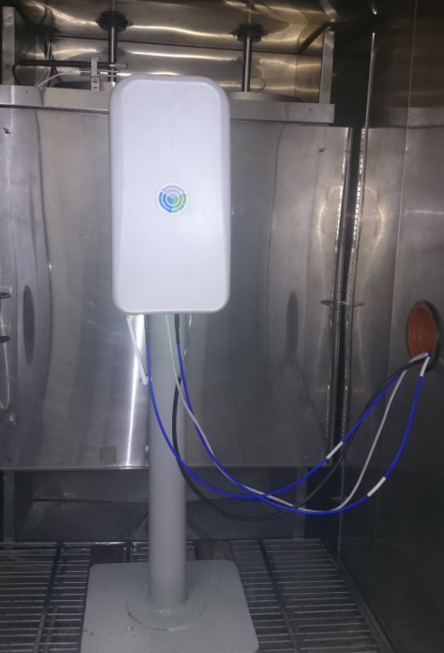
Figure 78: Unit placed inside Thermal Chamber
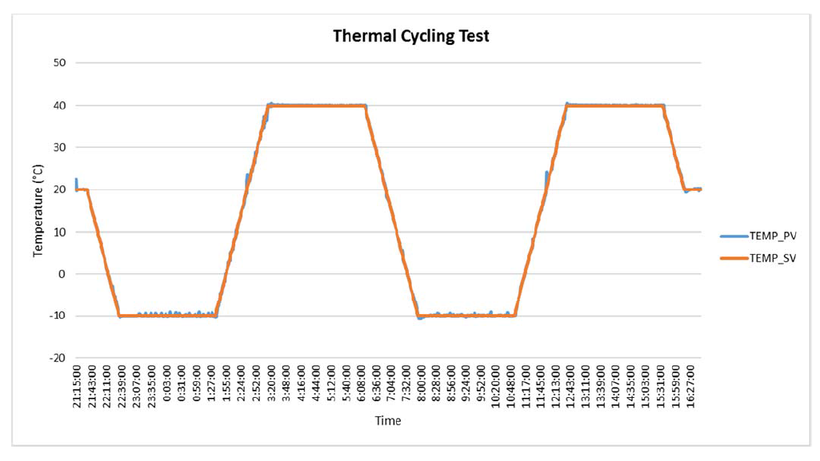
Figure 79: Thermal cycling test graph

Functional log

Inference
From the functionality log it is ensured that during the negative and positive temperature cycle Intel, Tiva, RF, temperature sensors, current sensing devices, UART interfaces, Ethernet interface & USB where up & running and there was no thermal shutdown, hence the test is considered as pass.

HALT

Test ID: ENV 1.9

Purpose
The purpose of HALT test is to subject the unit to thermal, vibration and other product specific stresses to a level beyond the product’s specifications or intended use of environment, in order to force the latent defects in product design, allowing them to be detected and corrected before the product release. The stresses are incremented during the test to force the weakest link in the unit to fail first

Test and Measurement Method
- DUT was placed inside the chamber in the operational condition
- Profile was created as per the specifications and test was executed with automatic operation
- Test graph were plotted at the end of the test.

Test Condition
Cold Step Stress Test: From 20ºC to -20ºC, at 5ºC step and then from -20°C to -30°C in 10°C step. Dwell in each step for 30 min approximately, with ramp rate of 60ºC/min.

Hot Step Stress Test: From 20ºC to 50ºC, at 10ºC step and again from 50ºC to 65ºC, at 5ºC step. Dwell in each step for 15 min minimum, with ramp rate of 60ºC/min.

Vibration Step Stress Test: From 5 Grms to 20 Grms, at 5 Grms step. Dwell in each step for 15 min with temperature maintained at 25ºC.

Combined Thermal Cycling & Vibration Test

Step | Temperature | Event | Duration
1 | 25⁰ C | Start | 5 min
2 | -15⁰ C | Ramp | 60⁰ C/min
3 | -15⁰ C | Soak | 20 min
4 | 55⁰ C | Ramp | 60⁰ C/min
5 | 55⁰ C | Soak | 20 min
6 | 25⁰ C | Ramp | 60⁰ C/min
7 | Step 2 to 6 constitutes 1 cycle and same is repeated for total 5 cycles. Vibration was increased in steps of 3Grms for every cycle from 3Grms to 15Grms.
8 | 25⁰ C | Soak | 10 min

DUT Sample information
System Serial Number : NA

Hardware Version : Life-2

GBC board Serial Number : WZ1630LIFE2GBC0020

RF SDR Board Serial Number : WZ1630LIFE2SDR0011
Software versions : Ubuntu – 14.04.64 bit
Coreboot- coreboot-4.4-575-gfee24cc-dirty (This
comes in boot log)
RTOS- 2_16_00_08 (This is base RTOS)
Coreboot: SVn version 7
System software: 51

Test Results
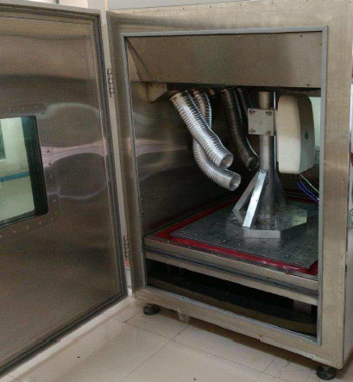
Figure 80: Unit kept inside the HALT Chamber

Cold Step Stress Test:

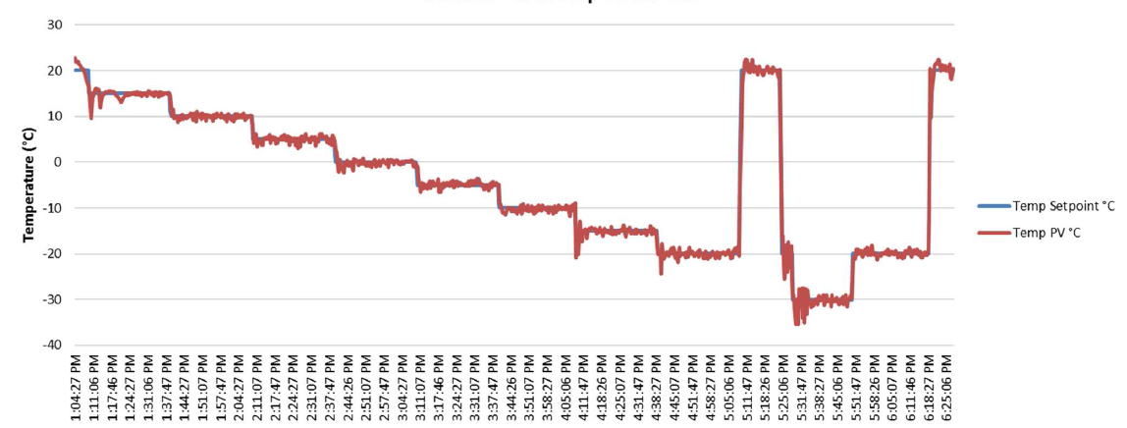
Figure 81: Cold Step Stress

Hot Step Stress Test:

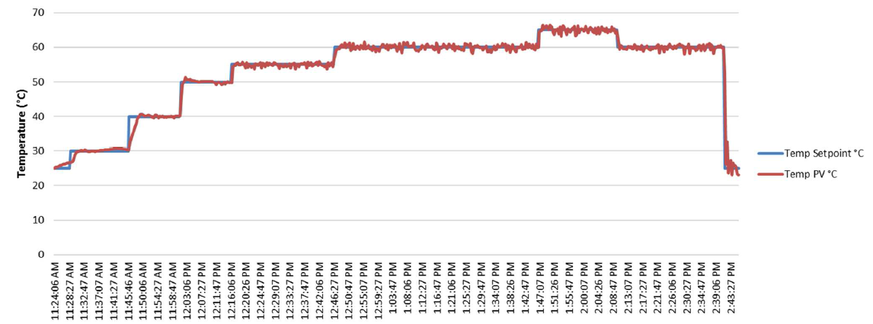
Figure 82: Hot Step stress

Vibration Step Stress Test:

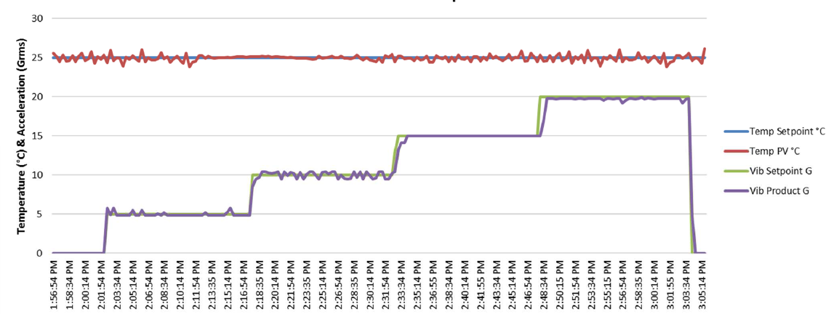
Figure 83: Vibration step stress

Combined Thermal Cycling & Vibration Test:
. 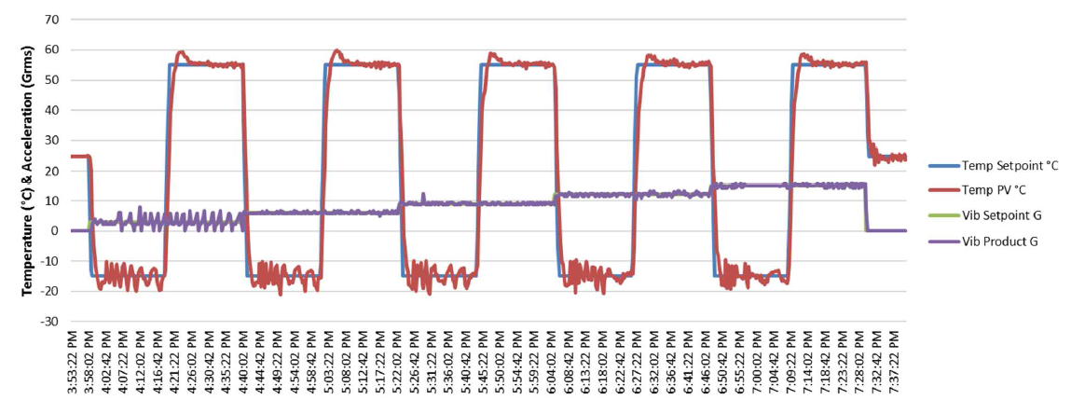

Figure 84: Combined thermal cycling & vibration

Inference
After completion of the test, no visual damage was observed on DUT.
Cold step stress:
Unit was checked for its functionality by rebooting the unit at each temperature intervals starting from -5, -10, -15 and -20 and there were no functionality issues found at these intervals. There was soft shutdown during the dwell time of -30ºC
Hot step stress:
Unit was checked for its functionality by rebooting the unit at temperature interval of 55 and 60 and there were no functionality issues found at these intervals. There was soft shutdown during the dwell time of 65ºC
Vibration step stress:
Unit was functional & no physical damage was observed at 5, 10, 15 Grms. The unit stopped responding at 18 Grms. GPRS Antenna screw & one of the Shorty antenna screw had got loosen.
Combined Thermal cycling & vibration stress:
No physical damage observed, found error message “shutdown timer expired” from osmo bts stack when running the memtester software utility.

HASS

Test ID: ENV 1.10

Purpose
The purpose of HASS is to mitigate the risks of manufacturing related errors and the resulting negative effects for the users which is being performed on sample production units.

Test and Measurement Method
- DUT was placed inside the chamber in the operational condition
- Profile was created as per the specifications and test executed with automatic operation
- Test graph were plotted at the end of the test.

Test Condition
Combined Thermal Cycling & Vibration Test
Step | Temperature | Event | Duration
1 | 25⁰ C | Start | 5 min
2 | -10⁰ C | Ramp | 60⁰ C/min
3 | -10⁰ C | Soak | 20 min
4 | 50⁰ C | Ramp | 60⁰ C/min
5 | 50⁰ C | Soak | 20 min
6 | 25⁰ C | Ramp | 60⁰ C/min
7 | Step 2 to 6 constitutes 1 cycle and same is repeated for total 5 cycles. Vibration was constant at 12 Grms throughout the test.
8 | 25⁰ C | Soak | 10 min

DUT Sample information
System Serial Number : NA

Hardware Version : Life-2

GBC board Serial Number : WZ1630LIFE2GBC0008

RF SDR Board Serial Number : WZ1630LIFE2SDR0004

Software versions : Ubuntu – 14.04.64 bit
Coreboot- coreboot-4.4-575-gfee24cc-dirty (This
comes in boot log)
RTOS- 2_16_00_08 (This is base RTOS)
Coreboot: SVn version 7
System software: 51

Test Results
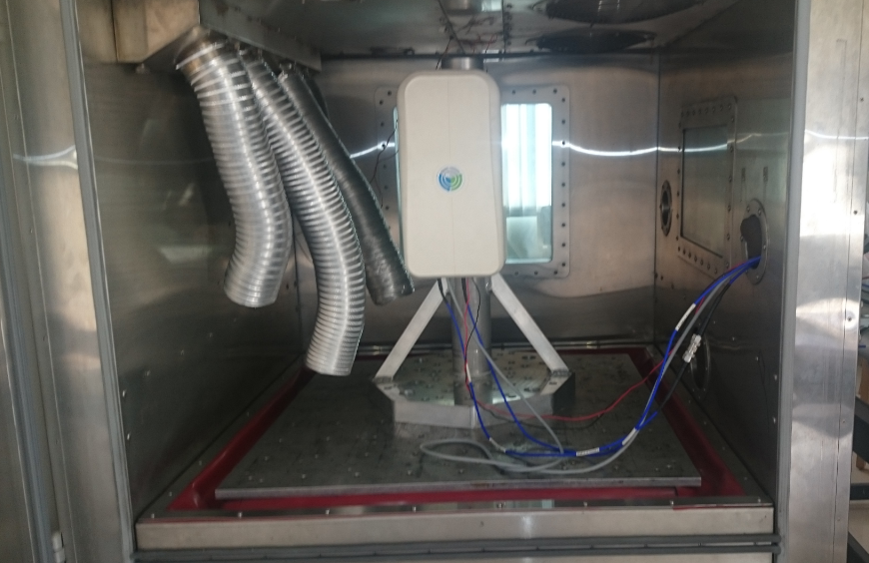
Figure 85: Unit kept inside the Chamber

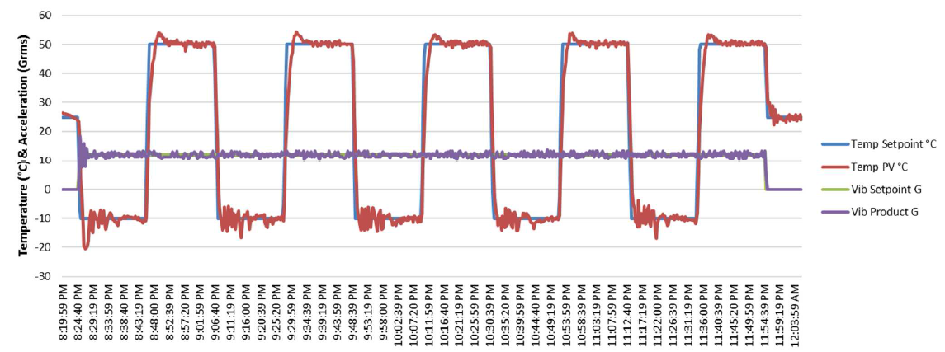
Figure 86: Combined Thermal cycling and vibration test

Inference
No physical damage observed, found error message “shutdown timer expired” from osmo bts stack when running the memtester software utility, hence the test is considered to be fail.

Revision History

SL.no | Date | Version | Author | Comments
1 | February 9th, 2017 | 1.0 | OpenCellular Team | First Release

